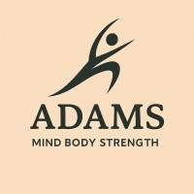 | Claire Smith  5 Woodhorn Colliery Houses  Ashington  NE63 9YF  07339 324881  Email:Claire@adamsmindbodystrength.com  https://adamsmindbodystrength.com/ | 

Cancellation and Late Arrival Policy
To ensure fairness, consistency, and the smooth running of all coaching and training sessions, the following cancellation and attendance terms apply.

1. Session Cancellations
- Clients may cancel or reschedule a session up to 24 hours before the scheduled start time with no charge.
- Cancellations made less than 24 hours before the session are subject to full payment, and the session will be marked as used.
- This applies to all coaching sessions, consultations, assessments, and classes.

2. Late Arrivals
- Clients must arrive on time for their scheduled session.
- A grace period of up to 15 minutes is allowed.
- If a client arrives more than 15 minutes late, the session will be cancelled and no refund or credit will be given.
- Sessions will still end at the originally scheduled time to avoid impacting other clients.

3. No-Shows
- Failure to attend a session without prior notice is treated as a late cancellation and is non-refundable.

4. Trainer Cancellations
- In the rare event that Adams Mind Body Strength must cancel or reschedule a session, clients will be offered an alternative time or a full refund.

5. How to Cancel
Cancellations must be made via Text message AND the Booking system.
The timestamp of the message will determine whether the cancellation falls within the 24-hour window.

