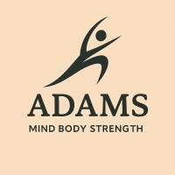 | Claire Smith  5 Woodhorn Colliery Houses  Ashington  NE63 9YF  07339 324881  Email:Claire@adamsmindbodystrength.com  https://adamsmindbodystrength.com/ | 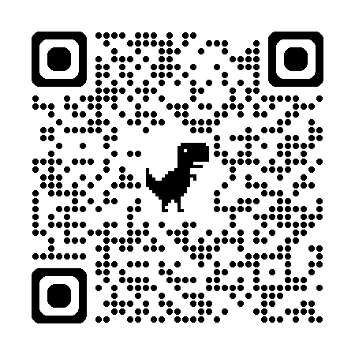

Cookie Policy
Last updated: 7 January 2026

1. Introduction
This Cookie Policy explains how Adams Mind Body Strength Ltd (“we”, “our”, “the business”) uses cookies and similar technologies on our website https://adamsmindbodystrength.com/
We are committed to protecting your privacy and ensuring transparency about how data is collected when you visit our site.
By continuing to browse our website, you agree to the use of cookies as described in this policy (unless you adjust your browser settings to refuse them).

2. What Are Cookies?
Cookies are small text files placed on your device when you visit a website. They help websites function properly, improve user experience, and provide information to website owners.
Cookies may be:
- Session cookies (deleted when you close your browser)
- Persistent cookies (remain on your device for a set period)
- First-party cookies (set by our website)
- Third-party cookies (set by external services we use)

3. How We Use Cookies
We use cookies for the following purposes:

a) Essential Cookies
These cookies are necessary for the website to function and cannot be switched off. They include:
- Security and authentication
- Website performance
- Booking or contact form functionality
Without these cookies, parts of the site may not work correctly.

b) Analytics & Performance Cookies
These cookies help us understand how visitors use our website so we can improve it.
Examples include:
- Page views
- Time spent on pages
- Device and browser type
If you use tools like Google Analytics, Meta Pixel, or similar, I can add them explicitly.

c) Functionality Cookies
These cookies allow the website to remember your preferences, such as:
- Form inputs
- Cookie consent choices
- Display settings

d) Marketing & Advertising Cookies (if applicable)
If you use advertising or tracking tools, these cookies may:
- Track conversions
- Build audiences
- Personalise ads
If you don’t use marketing cookies, I can remove this section.

4. Third-Party Cookies
We may use third-party services that set their own cookies, such as:
- Website hosting providers
- Payment processors (e.g.PayPal)
- Analytics tools
- Social media integrations
These providers have their own privacy and cookie policies.

5. Managing Cookies
You can control or delete cookies at any time through your browser settings.
Most browsers allow you to:
- Block cookies
- Delete existing cookies
- Set preferences for specific websites
Please note:
Disabling certain cookies may affect website functionality, including booking forms or login areas.

6. Consent
When you first visit our website, you may see a cookie banner asking for your consent to use non-essential cookies.
You can withdraw your consent at any time by adjusting your browser settings or clearing your cookies.

7. Updates to This Policy
We may update this Cookie Policy from time to time to reflect changes in technology, legislation, or our website functionality.
The “Last updated” date at the top of this page will be revised accordingly.

8. Contact Us
If you have any questions about this Cookie Policy or how we use cookies, please contact:
Adams Mind Body Strength Ltd
Email: Claire@adamsmindbodystrength.com
Data Protection Lead: Claire Smith

