 | Claire Smith  5 Woodhorn Colliery Houses  Ashington  NE63 9YF  07339 324881  Email:Claire@adamsmindbodystrength.com  https://adamsmindbodystrength.com/ | 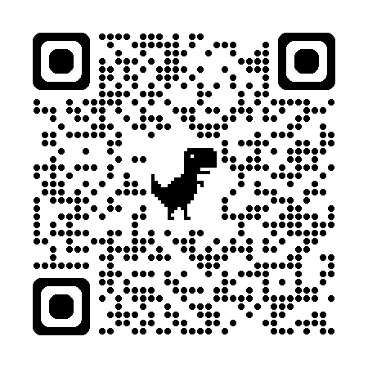
Data Protection Policy

1. Purpose
This policy explains how Adams Mind Body Strength Ltd (“we”, “our”, “the business”) collects, uses, stores, and protects personal data. We are committed to safeguarding the privacy of our clients and complying with the UK GDPR and the Data Protection Act 2018.

2. Scope
This policy applies to:
- All personal data processed by Adams Mind Body Strength Ltd
- All staff, contractors, and partners who handle personal data
- All systems and processes used to store or manage personal data
It covers both online and offline data, including information collected through adamsmindbodystrength.com, coaching sessions, assessments, and communication channels.

3. Data Protection Lead
As a registered ICO data controller, our Data Protection Lead is:
Name: Claire Smith
Role: Data Protection Lead
Email: Claire@adamsmindbodystrength.com
ICO Registration Number: ZC061798
The Data Protection Lead oversees compliance and responds to data protection queries or requests.

4. What Personal Data We Collect
We may collect the following types of personal data:

Client & Enquiry Information
- Name, email address, phone number
- Emergency contact details
- Health and medical information relevant to fitness coaching
- Lifestyle information, goals, and progress notes
- Payment information (processed securely via third-party providers)

Website & Digital Data
- Contact form submissions
- IP address, browser type, and usage analytics
- Cookies Policy

Coaching & Programme Data
- Session notes
- Training plans
- Progress tracking
- Video or photo submissions (if voluntarily provided)

5. Lawful Basis for Processing
We process personal data under the following lawful bases:
- Contract: To deliver coaching, fitness programmes, and related services
- Consent: For collecting health information, marketing communications, and optional data
- Legal obligation: For tax, accounting, and regulatory requirements
- Legitimate interests: For business administration, service improvement, and safeguarding
- Vital interests: In rare cases where health or safety information must be shared in an emergency

6. How We Use Personal Data
We use personal data to:
- Provide personalised fitness and coaching services
- Assess suitability for exercise and manage health risks
- Communicate with clients about sessions, updates, and support
- Process payments and manage accounts
- Improve our services and website
- Meet legal and regulatory obligations
We do not sell personal data.

7. Data Sharing
We may share personal data with:
- Payment processors (e.g.PayPal)
- Website hosting and email service providers
- Professional advisers (e.g., accountants)
- Emergency services (only if necessary for safety)
All third parties are required to comply with data protection law.

8. Data Security
We take appropriate technical and organisational measures to protect personal data, including:
- Secure password-protected systems
- Encrypted devices and secure cloud storage
- Limited access to sensitive data
- Regular security reviews
- Staff awareness and training

9. Health Data
As a fitness and coaching business, we may collect health-related information to ensure safe and effective programme design. This data is treated as special category data and processed only with explicit consent.

10. Data Retention
We retain personal data only for as long as necessary:
- Client records: typically 6 years after last contact (for legal and insurance purposes)
- Health information: retained only while actively coaching unless required longer for legal reasons
- Marketing data: until consent is withdrawn
- Website analytics: retained according to provider policies
After retention periods expire, data is securely deleted or anonymised.

11. Data Subject Rights
Individuals have the right to:
- Access their personal data
- Request correction or deletion
- Restrict or object to processing
- Withdraw consent at any time
- Request data portability
- Raise concerns with the ICO
Requests can be made to the Data Protection Lead and will be handled within statutory timeframes.

12. Data Breaches
Any suspected data breach will be investigated immediately. Where required, the ICO and affected individuals will be notified within 72 hours.

13. Updates to This Policy
This policy is reviewed annually or when significant changes occur in legislation or business operations.

