SaddleBrooke Dog Park Etiquette
This information is compiled from The American Kennel Club, and other sources available online for Tips and Rules on Dog Park Etiquette
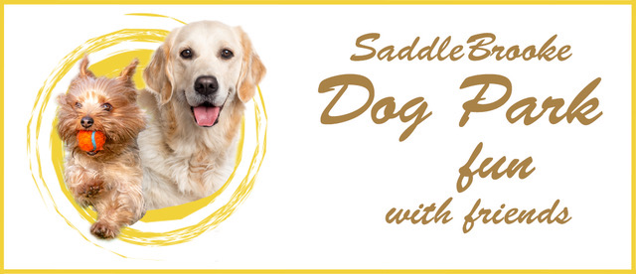
A Dog Park is where your leash-less pet is free to sniff, run, and socialize with other dogs. But like any social activity, it's important to know basic rules of etiquette. In this case, it's not just a matter of a social faux pas—failing to comply can put your dog and other pets at risk. An hour at the dog park is like a dozen walks on a leash in terms of physical and mental benefits for your pet. By following the suggestions below, you and your dog should have enjoyable times in the SaddleBrooke Dog Park.
ENTERING THE DOG PARK:
We have a double entrance. The first is where you take your dog off leash. It is imperative that you pause to look around and if there are 20 dogs swarming the gate, don’t enter the park. A pause will also allow other pooches to get used to yours and not go hyper when you do enter. If there are dogs swarming the gate, you have every right to ask their owners to get control of their dogs and let yours in.
PEOPLE SOCIALIZATION:
One of the benefits of a Dog Park is that it becomes a great place to make new friends and socialize. Unfortunately, this leads to the canines being unattended. Know when your dog has pooped so you can scoop!
WHAT SHOULD YOU DO IF A FIGHT BREAKS OUT?
Despite your best efforts, it can happen. Make sure you're ready and give it a moment. Most doggie duels end as quickly as they started.
• If they go at it for more than a few seconds, try to squirt them with a hose or water bottle. If they’re still fighting after about 5 seconds, you and the other owner should approach the dogs from the rear. Gently grab their back legs at the top of the leg and lift them up like a wheelbarrow then start moving back. Don't reach for the collar. Your dog could bite you by reflex.
• After any altercation, leave the park. Your dog must learn this is not acceptable behavior. Time-out works!
FIRST TIME VISIT:
If you have not been to a dog park before, or new to SaddleBrooke, it is always best to come at a time when the park is not in heavy use. Morning from 6-8 AM and afternoons from 3-5 are busy. Bring your dog at a less active time to become familiar with the new environment.
KNOW WHEN TO GO TO THE PARK:
If your dog has an attitude, go for a walk and let them get over it before entering the park. Don't go to the dog park if your furry pal isn’t current on vaccinations. Dogs that are not spayed or neutered are not good candidates for a dog park.
PUPPIES:
Rabies vaccinations are given at 4 months. No dog may enter the park without a Rabies Vaccination. Puppies who have not completed all vaccinations may be exposed to diseases their immune system is not prepared to fight.
A SUPPORTIVE CULTURE:
Help other members, especially new members, feel welcomed in the park. Always give suggestions with grace and kindness. Please adhere to the Code of Ethics for all SaddleBrooke Residents. The use of profane or abusive language will not be tolerated. If someone is trying to be helpful, accept the comments with grace. If you have a small dog in the large Dog Park and a member comes and suggests you leave, you must comply. They know their dog and are probably trying to avoid conflict. If you fill a swimming pool for your dog, it is your responsibility to empty it. We don’t leave sitting water in AZ. It is a breeding ground for mosquitoes.

