SaddleBrooke Dog Park Rules

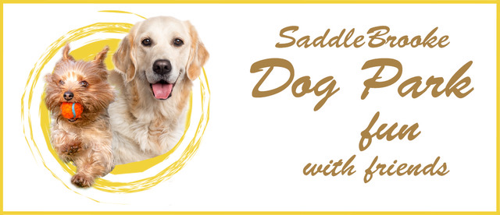
We strive to maintain a beautiful park for both human and dog. You may be new to a dog park and while at first glance the rules appear strict, they are in place to maintain a safe environment for everyone who uses the park. In fact, most dog parks employ the same rules. The reason is simple, they work. Our goal is to keep everyone safe, healthy and happy.
- All activity inside the park is at your own risk and the members and the Board of Directors of the SaddleBrooke Dog Park association will be held harmless for pet injury, injury to any person (s) or loss of property.
- Clean-up after your dog!!! There are receptacles provided. We maintain a healthy environment for our dogs and feces presents a health risk to other dogs and humans.
- If you see the receptacle is full, change it. If you see waste, pick it up. This is a volunteer run amenity and everyone is responsible. We do not have paid maintenance to clean up after you or your dog.
- Aggressive Dogs must be leashed and removed immediately. This may include snarling, growling, snapping or other signs of negative physical behavior. Remember, dogs have moods too. It is better to remove your dog before an incident occurs. If you see that your dog does not appear to like another dog, make arrangements with that owner to come at different times.
- Should an incident occur, there is an INCIDENT REPORT FORM on the web page. Please fill it out completely. It then goes to the Chair of the Safety Committee. The Committee takes into account all information and makes their recommendation to the Board.
- (No member of the safety committee may participate in any case in which their dog is involved in the incident under review.)
- All dogs entering the park must show evidence of current Rabies vaccinations. It is Arizona State Law that all Dogs are vaccinated for Rabies. Dog Park Members must provide renewal vaccination certificates to the Membership Chairman.
- While Rabies is the only vaccination we demand remain current, we highly recommend you keep all other vaccinations up to date such as Parvo.
- Female dogs in heat are not allowed in the park. Sick or injured dogs are not allowed in the park.
- Remove your dog’s leash in the de-leashing area. Do not enter the park with your dog on a leash.
- Limit 3 dogs per handler.
- Supervise your dog(s) at all times.
- Excessive barking is not allowed.

- Pinal County has a Leash Law. Legally, the only time your dog is allowed off leash is inside the park.
- If you are leaving the park and see someone coming down the ramp, wait before you exit the park. If you are entering the park and you see someone leaving, wait at the top of the ramp. Dogs on a leash in a tight area (such as the sidewalk) might get snippy with each other. Pay attention to your surroundings.
- The SaddleBrooke Dog Park is for SaddleBrooke residents only. If you bring a guest, all rules apply.
- Food is prohibited in the park.

Thank you and enjoy the park.

Revision Adopted May 9, 2018

