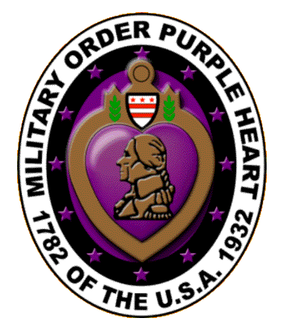

**ALAMO CHAPTER 1836**

**MILITARY ORDER OF THE PURPLE HEART OF THE U.S.A.**

**SAN ANTONIO, TEXAS**

1 July 2020

Dear Fellow Patriots,

It seems like this coronavirus pandemic is going to last forever, but “this too shall pass” and once again we can meet each other as fellow brother-in-arms and greet each other with a “good day and best regards”. My wish is that every member and their family stay safe and healthy.

This July 4th we will be celebrating the 244th anniversary of the Declaration of Independence on July 4, 1776. The war for independence or the Revolutionary War lasted from the battle in Concord in April 1775 until the signing of the peace accord in September 1783. Most of the soldiers were volunteers and were not paid for their service. They were promised land but even that was often taken by speculators. They had no benefits, almost no medical care except what their families could provide, no retirement plan and yet they persevered for eight years. Looking back at the veterans who have come before, we have a lot to be thankful for on this 4th of July and I hope each of you will celebrate it by raising the American Flag, enjoy good food, and maybe light a few fireworks if that is allowed in your location.

Happy 4th of July,

Bill Crumlett, Commander

Alamo Chapter 1836

Military Order of the Purple Heart

San Antonio, Texas

[bcrumlett@satx.rr.com](mailto:bcrumlett@satx.rr.com)

210-326-2231