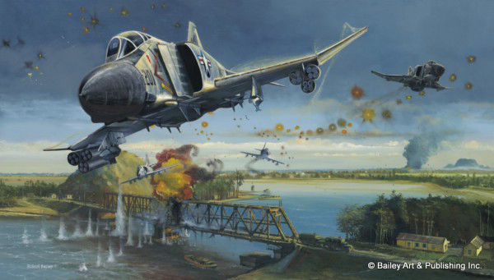
2. Bombing run near Hanoi by Bailey Art & Publishing Inc
`
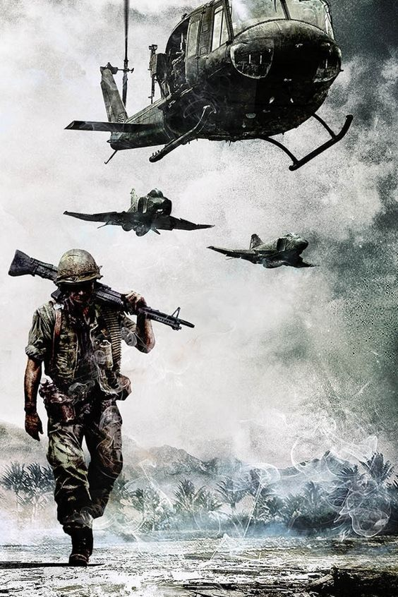
3. Photo by HistoryWar.com
`
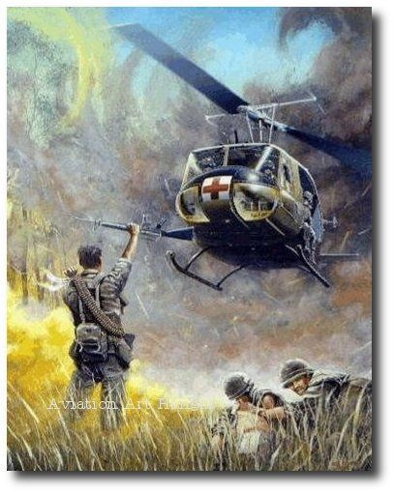4. So that others may live by Joe Kline
`
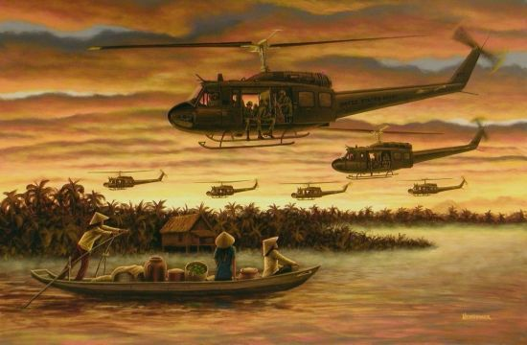
5. The UH-1 Huey (nickname derived from the military “Helicopter Utility”) was the workhorse of the Viet Nam war. Photo by airmailart.com
`
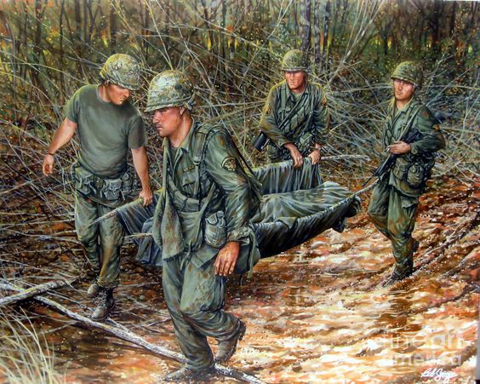
6. No one left behind Saved from militar.org.ua
`
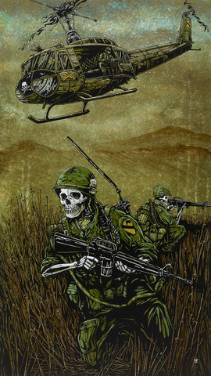
7. First Cav LRRP patrol
`
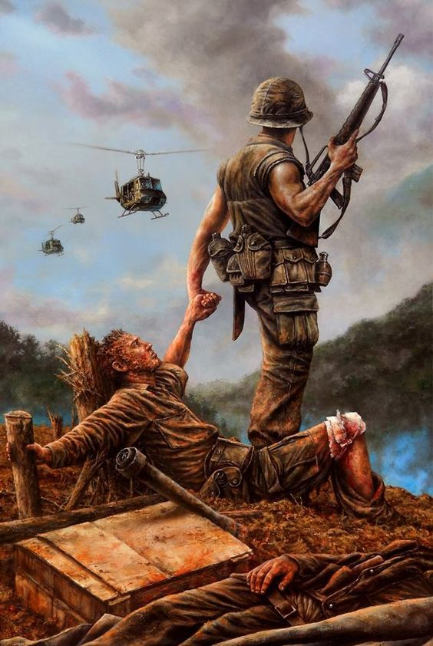
8. “The latest Brothers in Arms” by Dan Nance
`
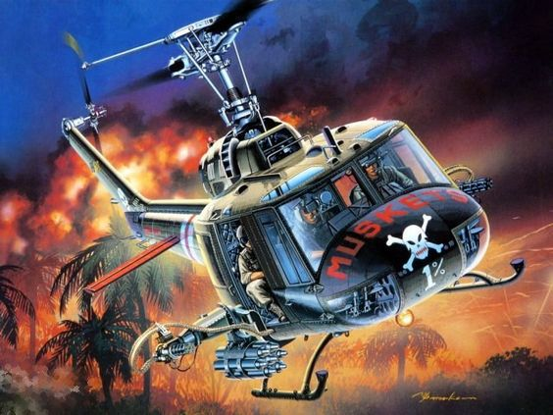
9. 176th Assault Helicopter Company – Muskets
`
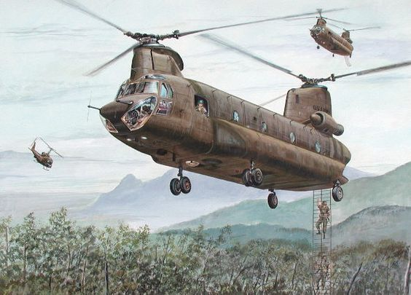
10. 75th Ranger Company extracting from jungle – Joe Kline
`
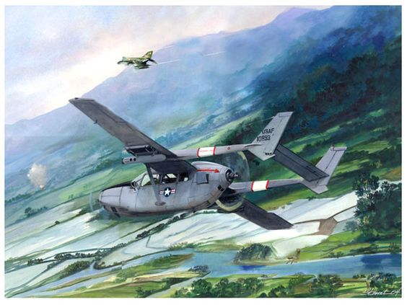
11. Cessna O-2A Bird Dog Forward Air Controller
`
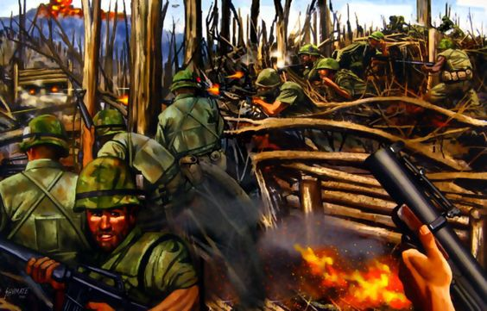
12. Mike Company, 3/3 Marines assaulting Hill 881N on April 29, 1967
`
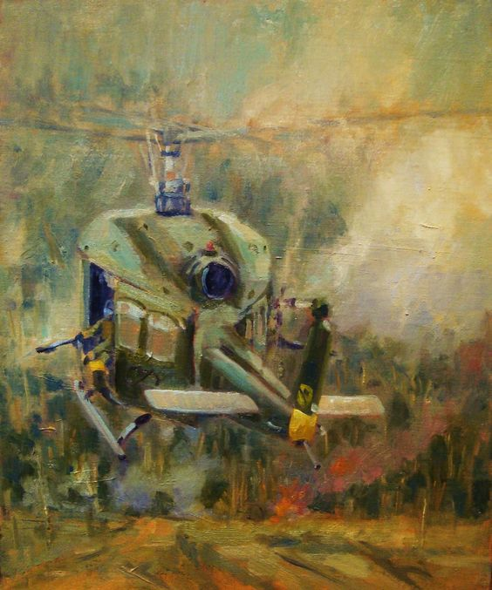
13. Hot LZ
`
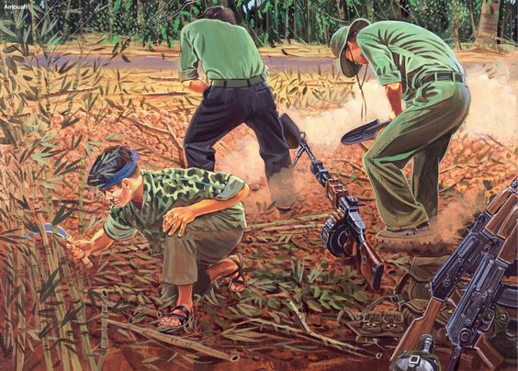
14. Viet Cong fighters prepared for an ambush
`
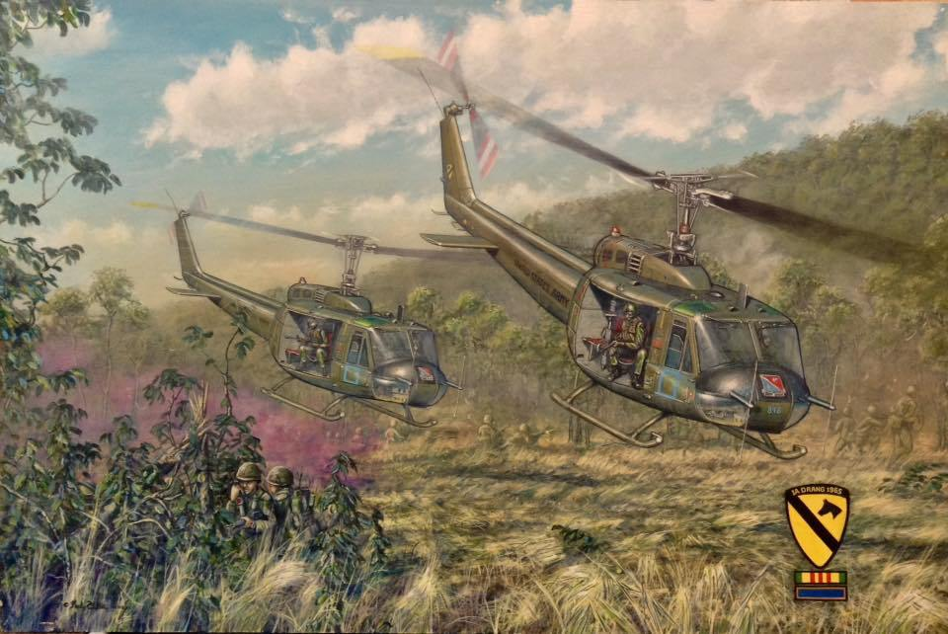
15. Huey’s landing with supplies and reinforcements LZ X-Ray by Paul Tuttle
`
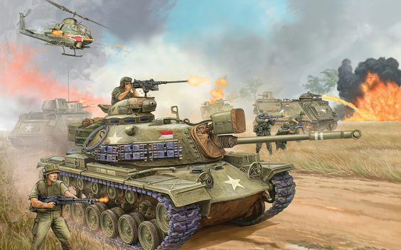
16. M48 Patton Tank photo by pl.forwallpaper.com
`
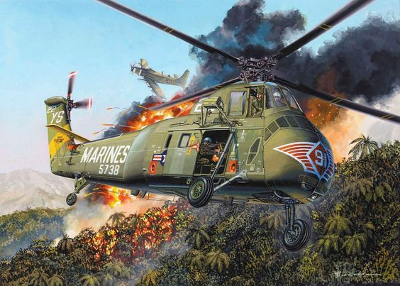
17. U.S. Marine Choctaw helicopter
`
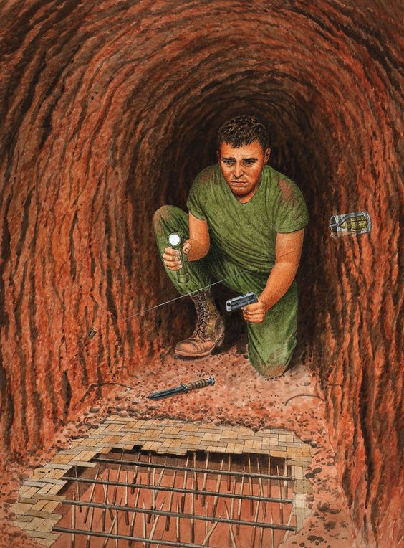
18. Tunnel Rat exposes booby trap within tunnel while conducting his search photo by militar.org.ua
`
`
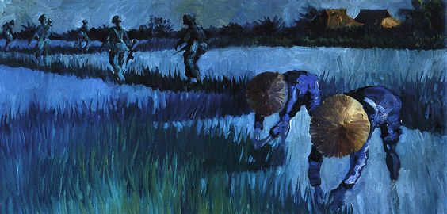
19. Patrol travels on paddy dikes as farmers work on their rice shoots
`
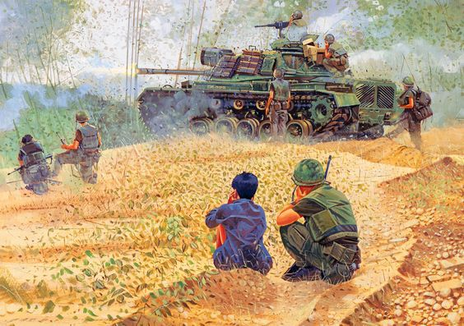
20. Tank-supported patrol checking out the valley south of Marble Mountain
`
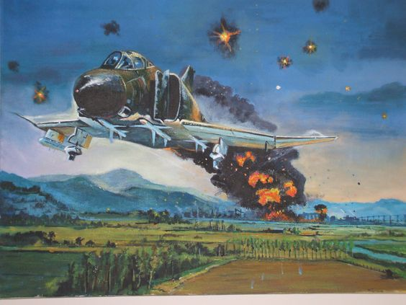
21. F4 Phantom out of Hanoi
`
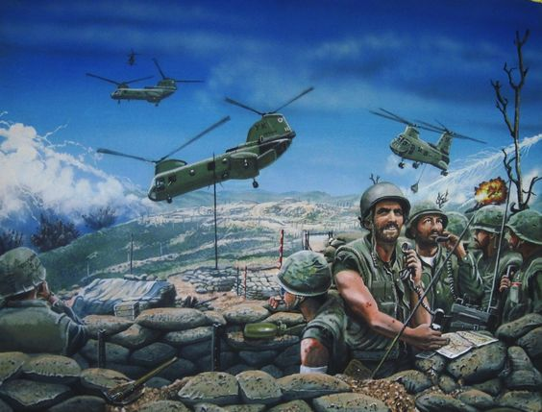
22. India Six and the Super gaggle by oldschoolgarage.tumblr.com
`
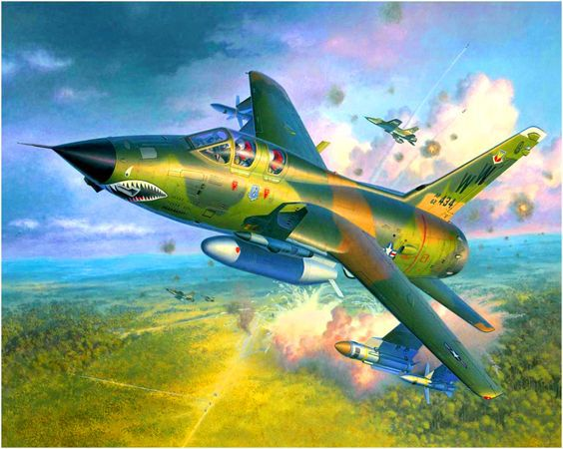
23. F-105G Thunderchief photo by elgrancapitan.org
`
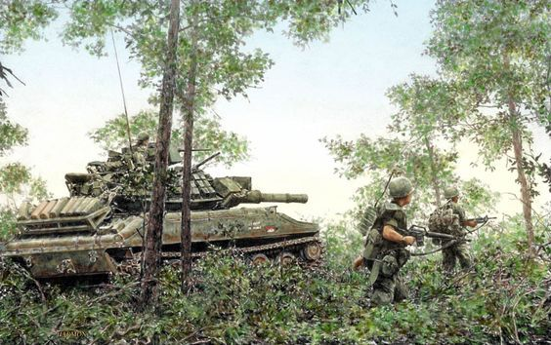
24. Armor patrol with infantry
`
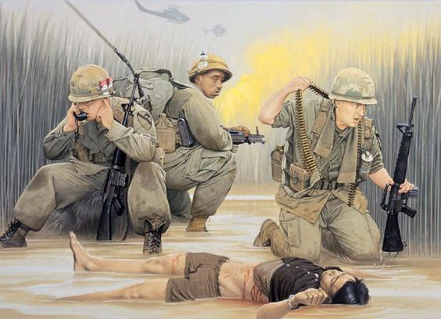
25. Firefight “The Seven Minute War”
`
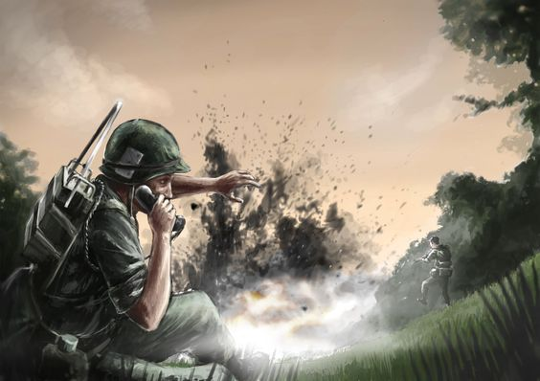
26. Calling in artillery support danger close by skvor.deviantart.com
`
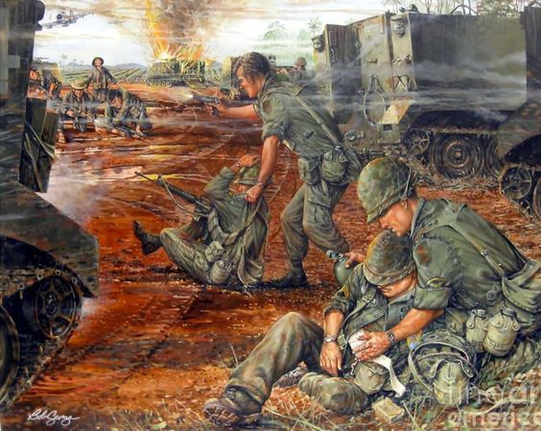
27. The Battle Of Ap Bau Bang by Bob George
`
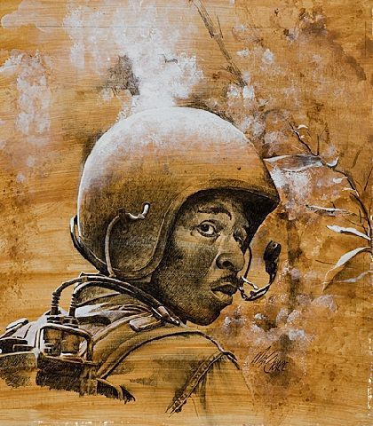
28. “Radioman 11th Armored Cavalry Regiment 1970” by Max Crace
`
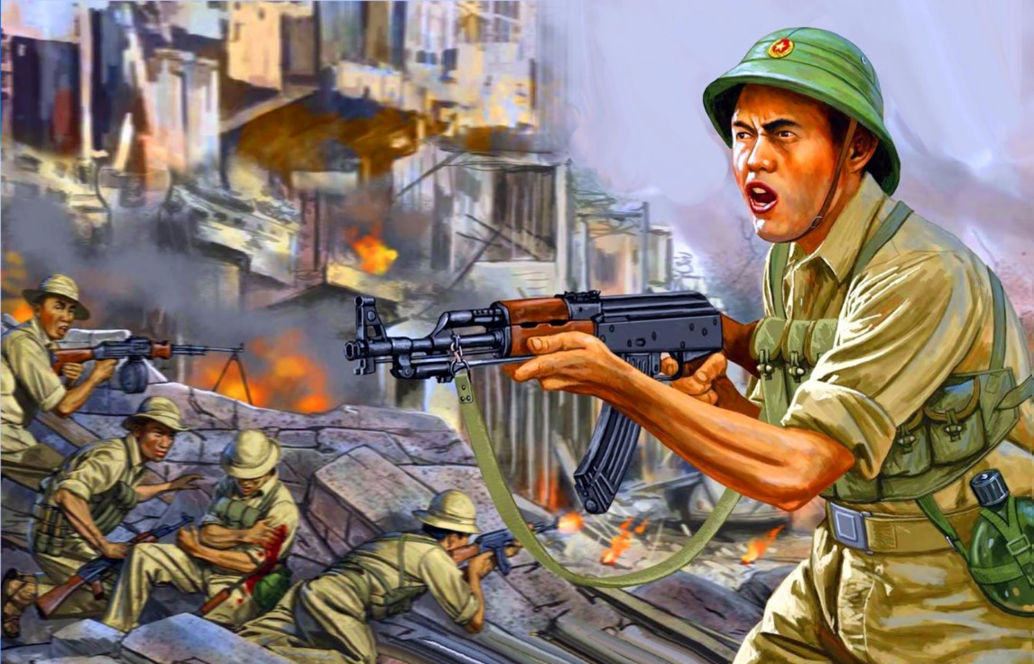
29. NVA participating in urban warfare
`
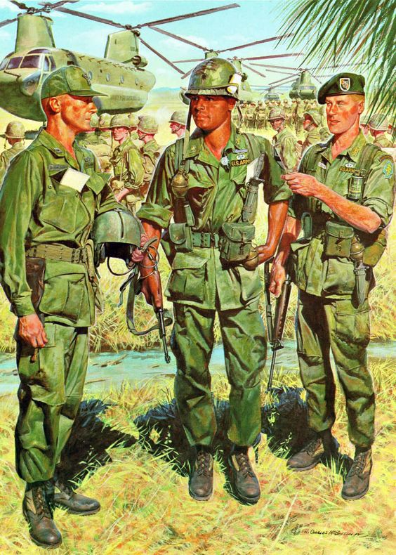
30. Battalion brass conferring prior to troops loading for an air assault
`
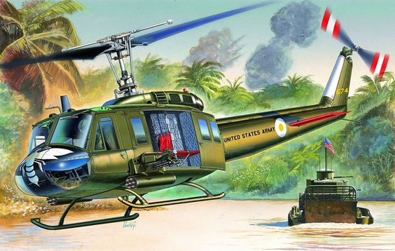
31. Hornet 1st platoon Wasp ship in support of Brown Water Navy in Delta by retrowar.tumblr.com
`
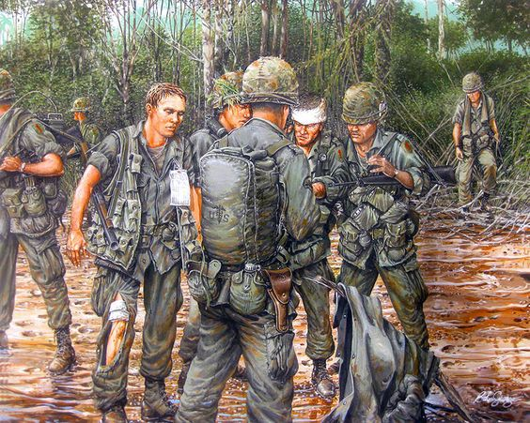
32. After the fight…walking wounded awaiting Medevac
`
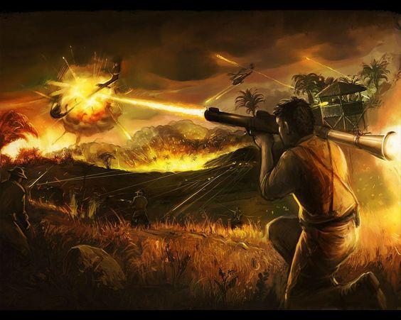
33. NVA soldier firing RPG at helicopter during a battle
`
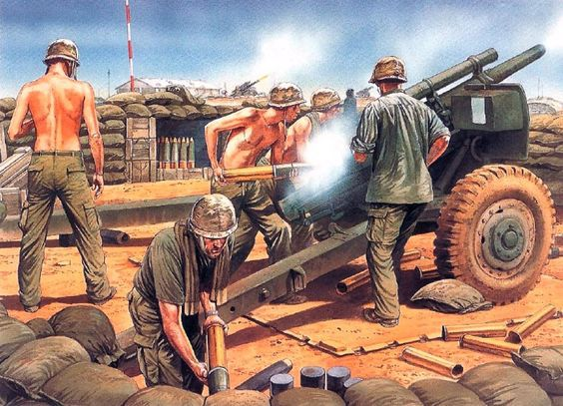
34. 105mm canon firing from a firebase in support to infantry in the field
`
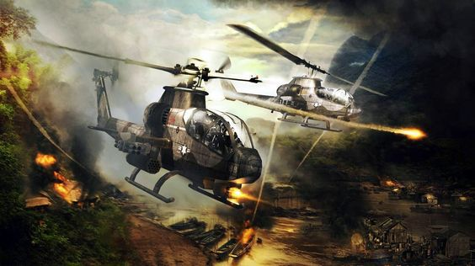
35. US AH1G Cobra attack helicopters on mission in Vietnam
`
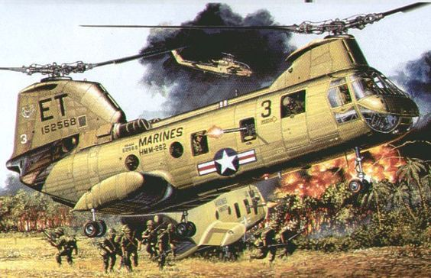
36. Marines landing by Boeing Vertol CH-46 Sea Knight while under fire
`
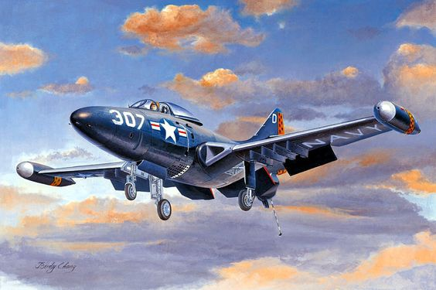
37. F9F Panther VF123 – Birdy Chang
`
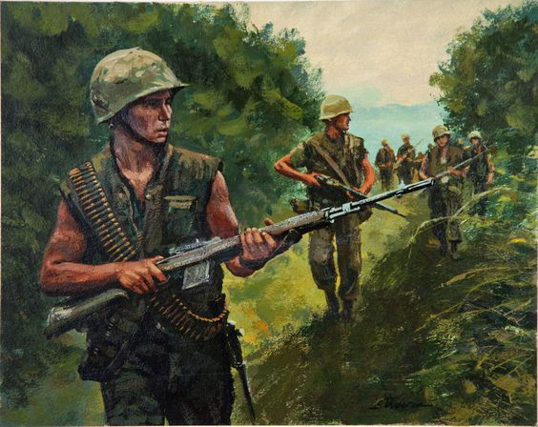38. Marine infantry patrol with M14’s
`
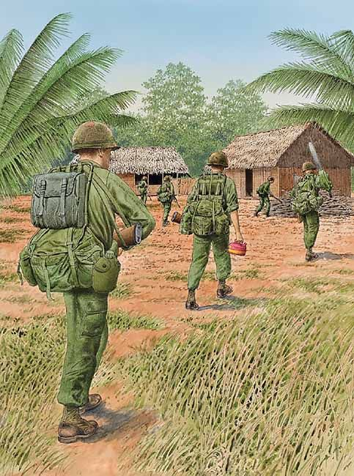
39. Patrol entering village to check for VC – carrying a chainsaw and gas
`
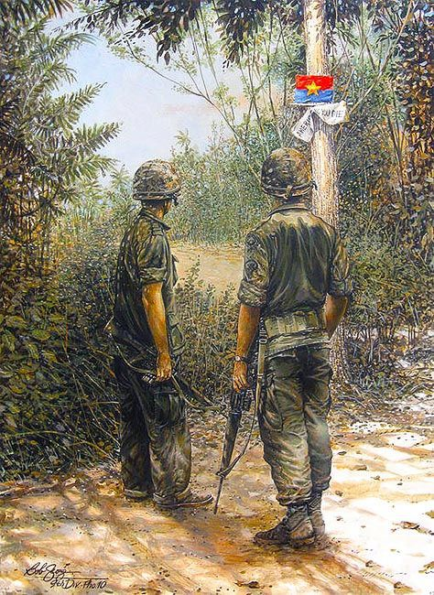
40. Welcome to the Neighborhood – Bob George
`
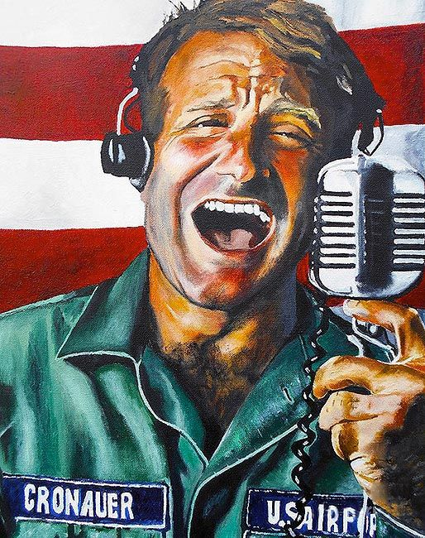
41. Adrian Chronauer played by Robin Williams – morning DJ on Armed Forces Radio in Vietnam
`
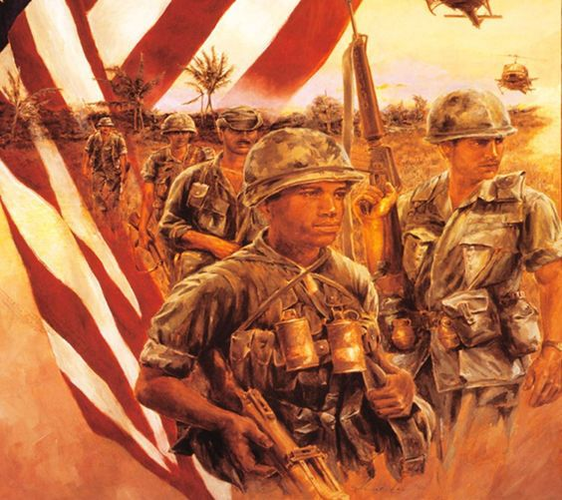
42. Infantry patrol
`
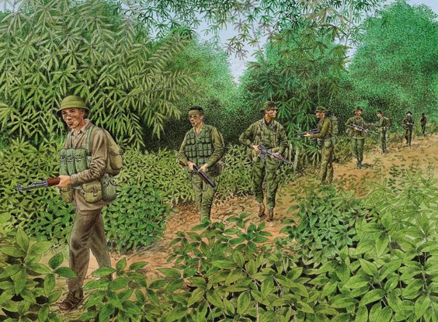
43. US MACV-SOG Reconnaissance Team in Vietnam
`
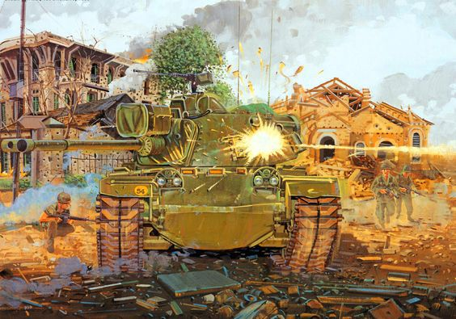
44. Battle of Hue – Tet 1968
`
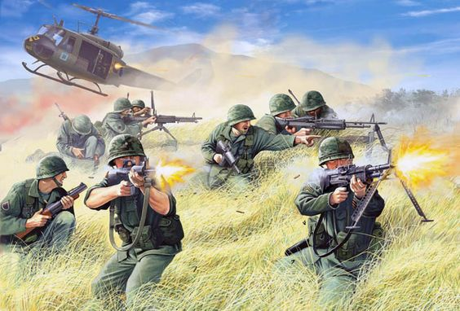
45. IA Drang – Mark Stacey
`
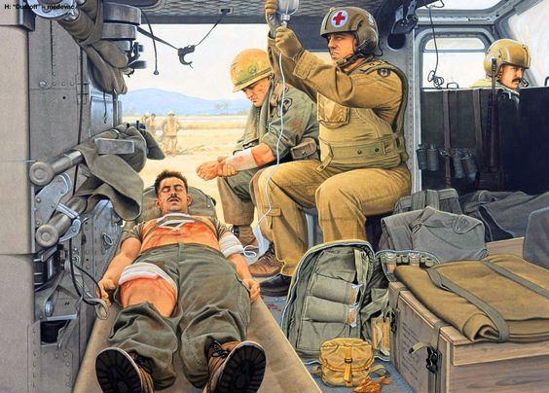
46. Injured soldier on Medevac helicopter enroute to closest hospital
`
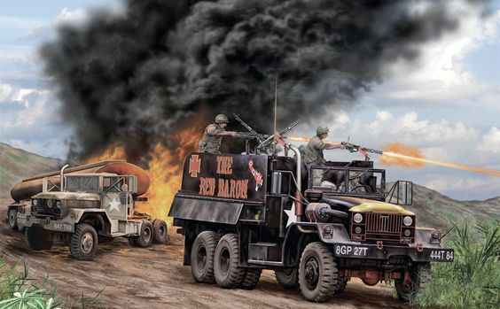
47. Gun Trucks breaking up an ambush on a convoy
`
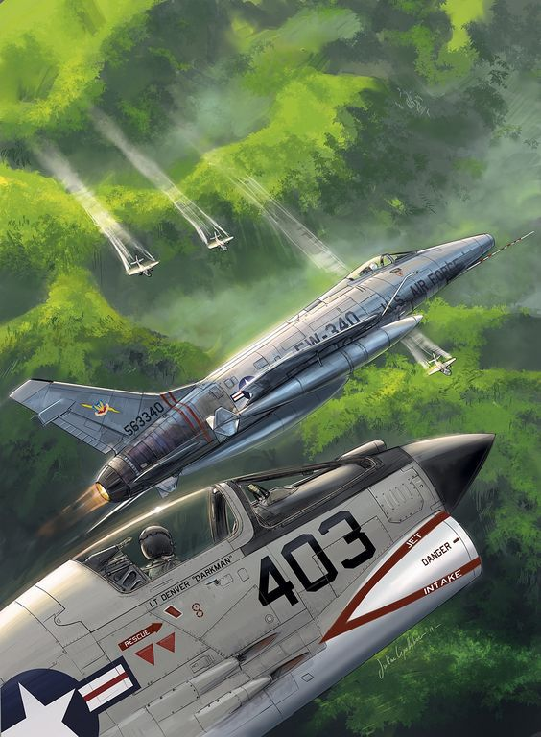
48. Super Sabre and F-8 Crusader escorting spray planes below
`
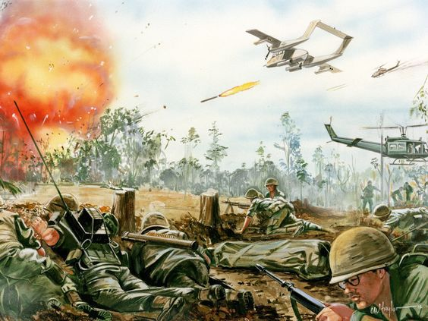
49. OV-10 Bronco helping until jets arrive – hot LZ by CW Taylor
`
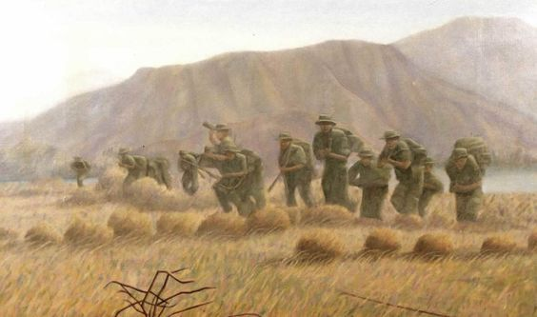
50. U.S. Troops advancing toward tree line
`
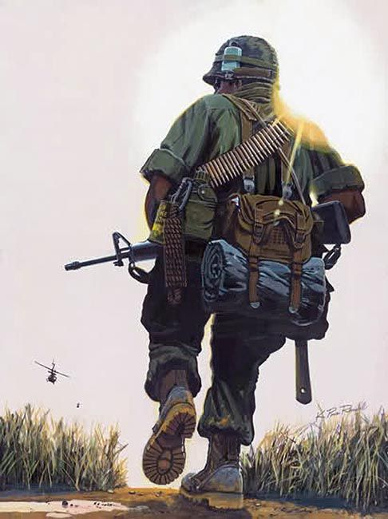
51. Grunt by K. Paul Randall
`
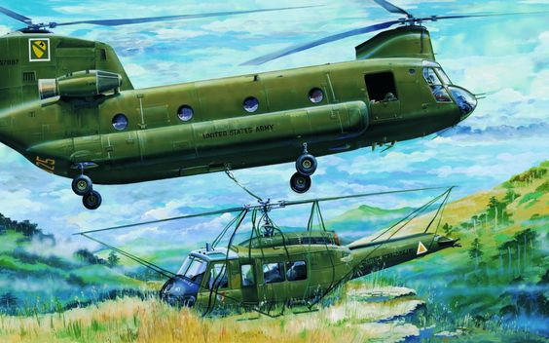
52. Crashed Huey helicopter salvaged by Chinook
`
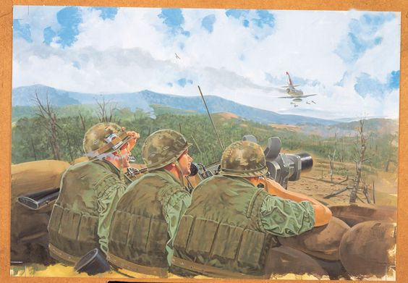
53. Khe Sahn – “The Mightiest Corporal in the World”
`
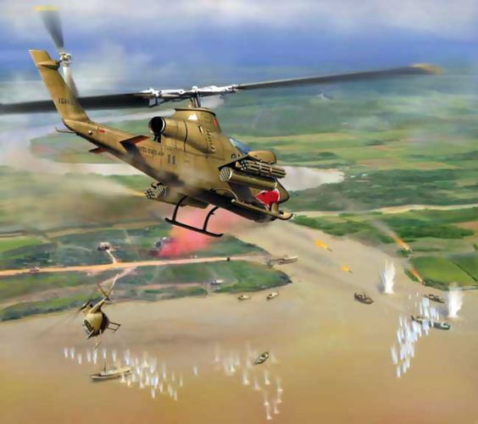
54. Snake Attack” Jim Laurier
`
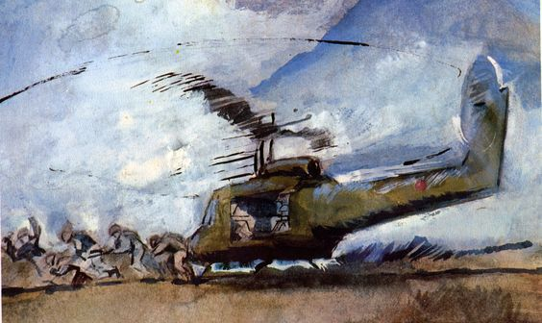
55. Troops disembarking on LZ
`
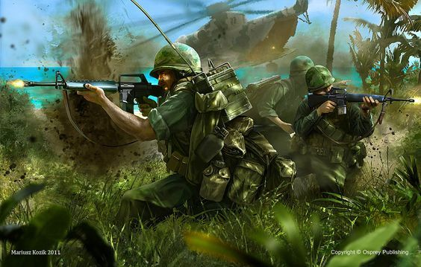
56. Marines ambushed on landing zone by Martusz Kozik
`
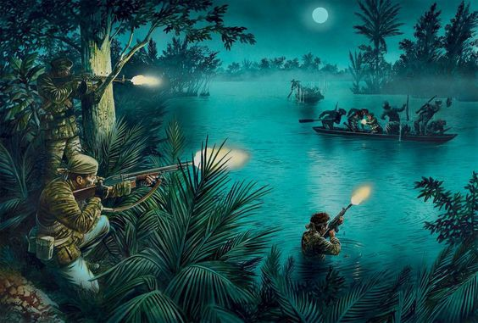
57. US Navy SEALs launch an ambush along a Viet Cong river
`
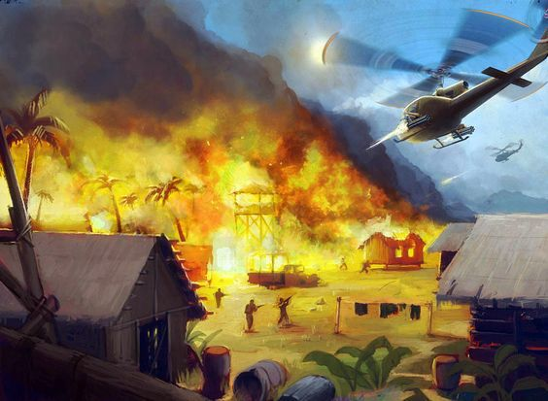
58. Assault on Viet Cong camp
`
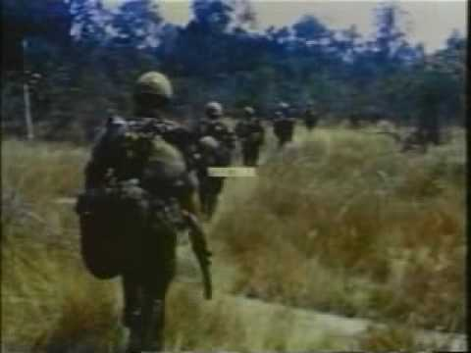
59. Humping through elephant grass to the next location
`
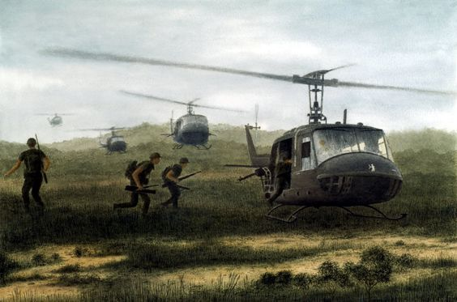
60. Platoon extraction from the bush
`
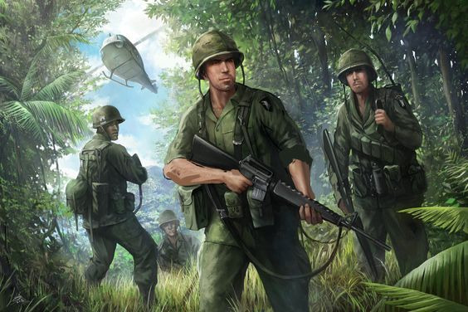
61. 101st Airborne moving into the jungle by deviantart.com
`
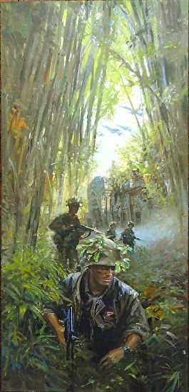
62. Screaming Eagles on patrol
`
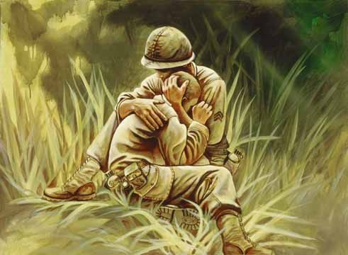
63. Consoling a brother in arms after losing a friend
`
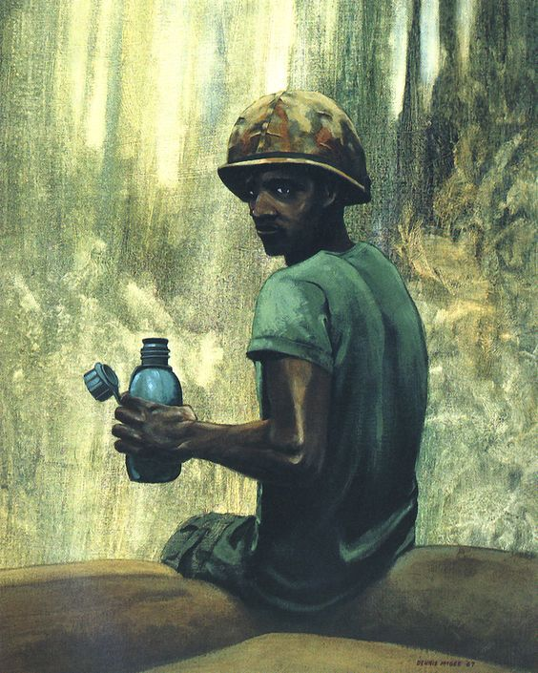
64. Taking a break after filling sandbags by Deuce McGee
`
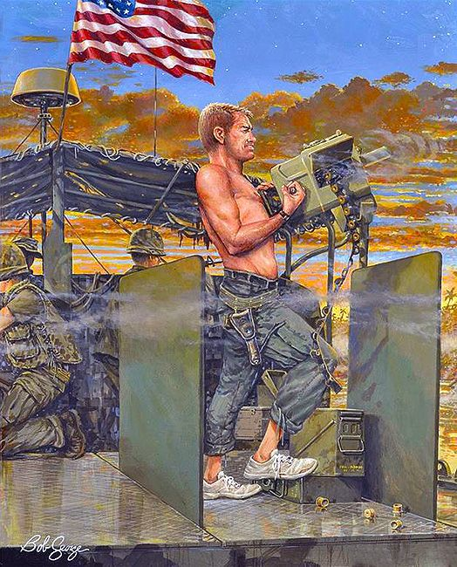
65. Saigon River patrol by Bob George
`

66. Crossing a small s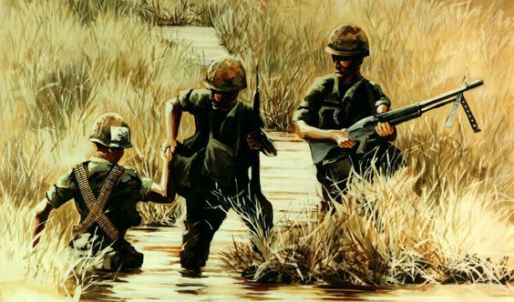tream in the Delta
`
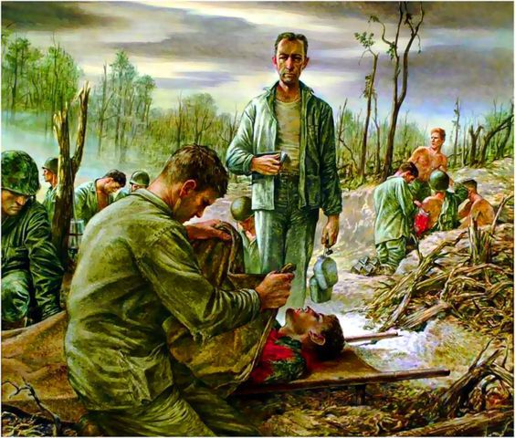
67. Covering the dead by Time.com
`
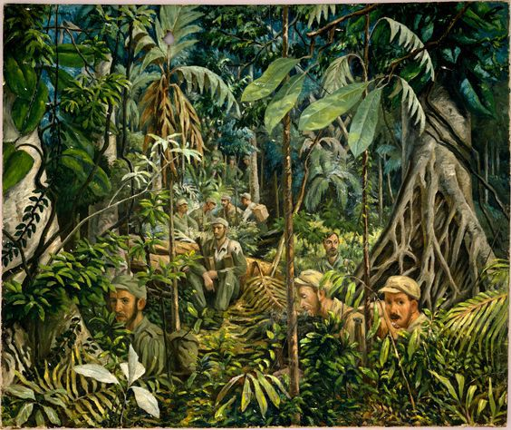
68. Watching a trail from the bush before crossing to the other side
`
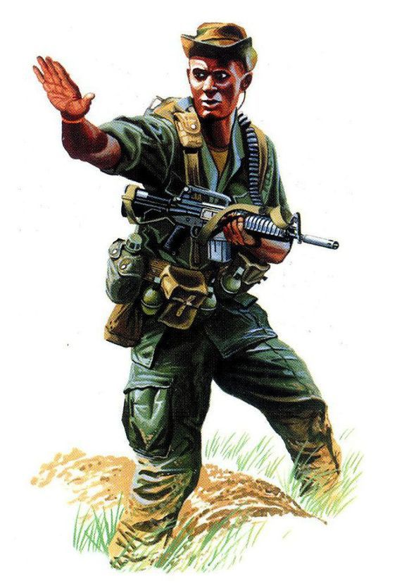
69. LRRP Pointman with CAR-15
`
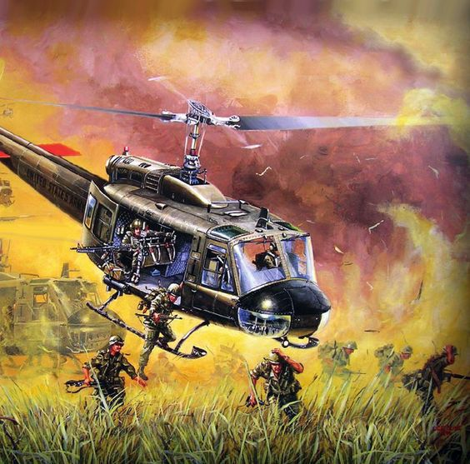
70. IA Drang Valley – 1965 – Joe Kline
`
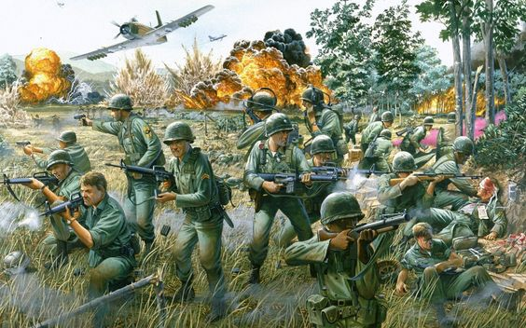
71. Broken Arrow by Tom Freeman (A-1 Skyraider)
`
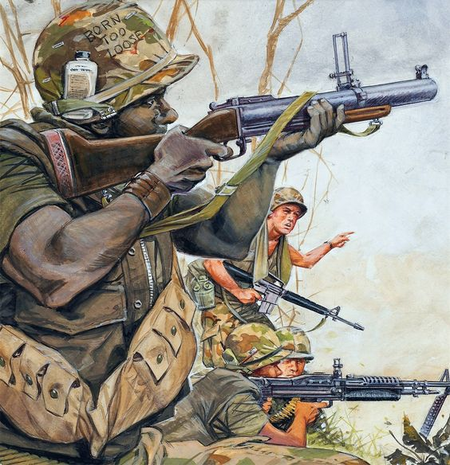
72. Response to an ambush
`
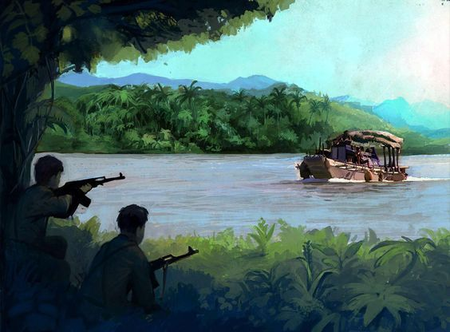
73. Ambush on the Mekong River
`
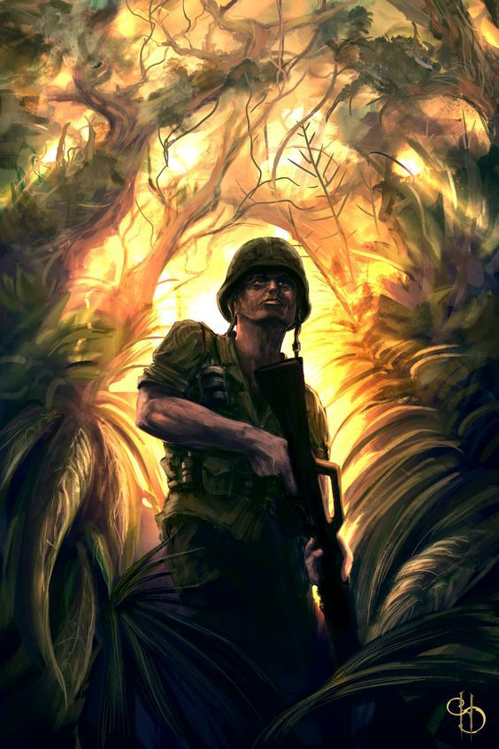
74. U.S. Marine watching out in the jungle by HS
`
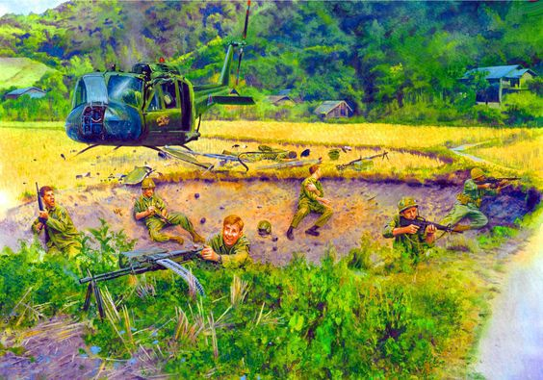
75. Taking refuge in a bomb crater on a hot LZ
`
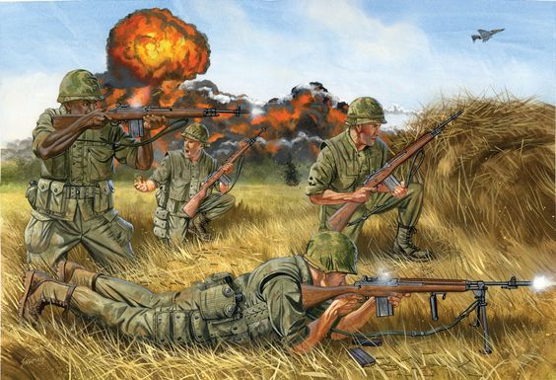
76. M-14 in Vietnam by JohnnySchumate.com
`
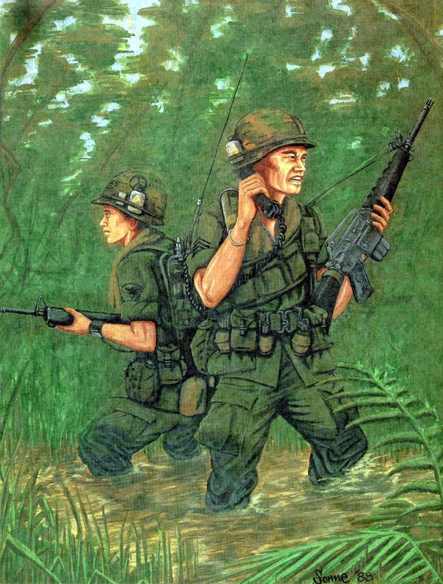
77. Squad leader and RTO reporting in while on patrol by Sonne ’88
`\\
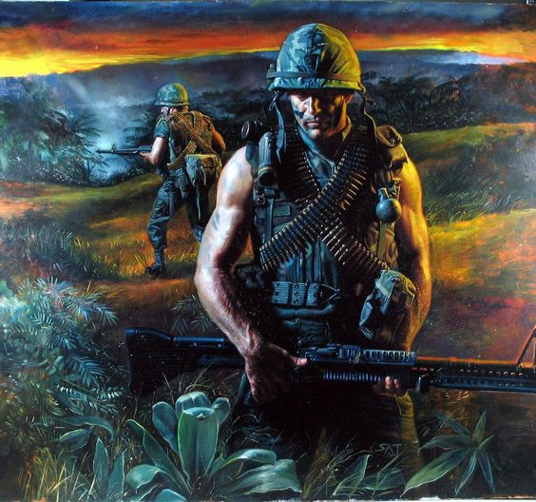
78. Marine night patrol – tail end Charlie bringing up the rear
`
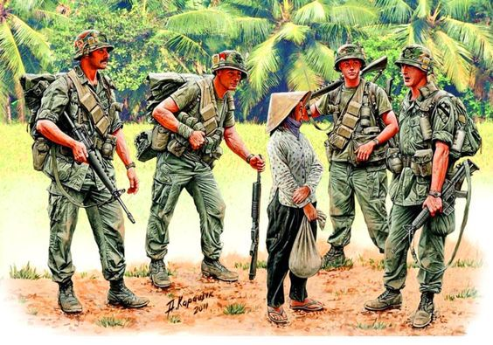
79. 1st Cav patrol questioning an old mama-san on trail by military.org.ua
`
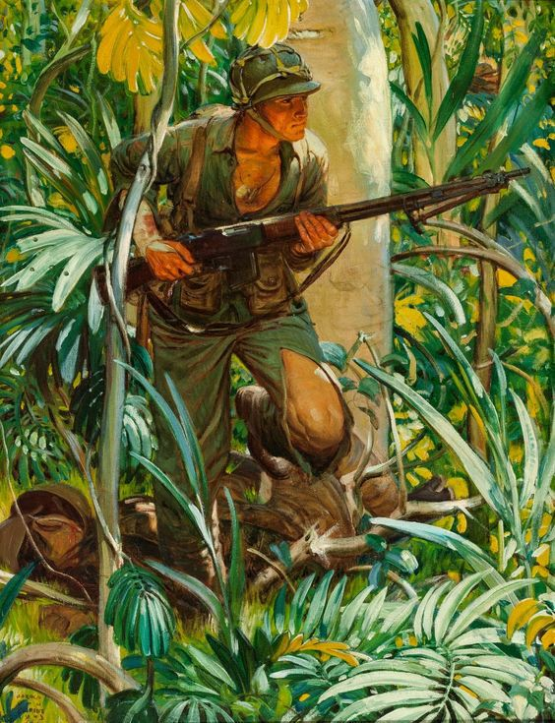
80. Early war – soldier with BAR
`
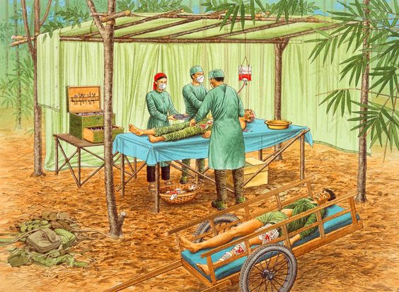
81. Temporary North Vietnamese Army aid station
`
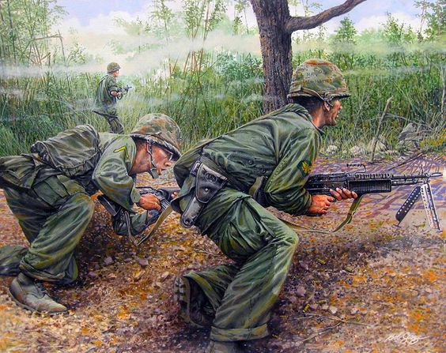
82. M-60 gunner and assistant Saved from militar.org.ua
`
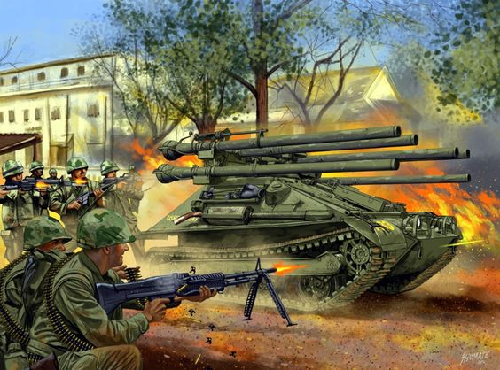
83. M50A1 Ontos at the Battle of Hue – by Johnny Shumate
`
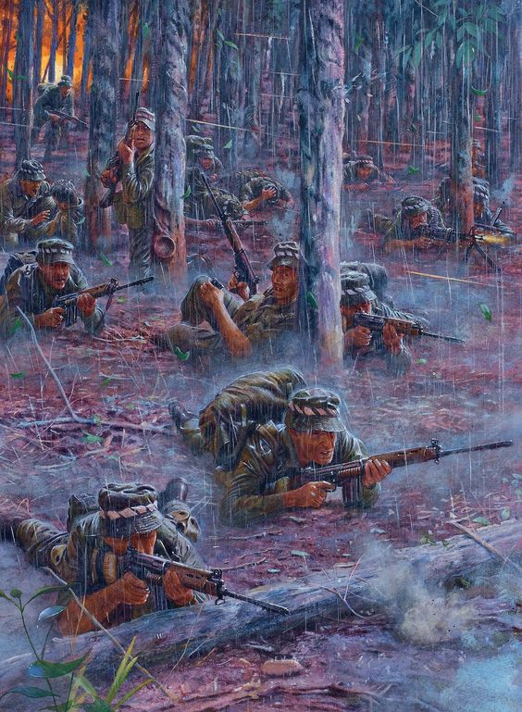
84. Long Tan – The Royal Australian Regiment made contact with NVA
`
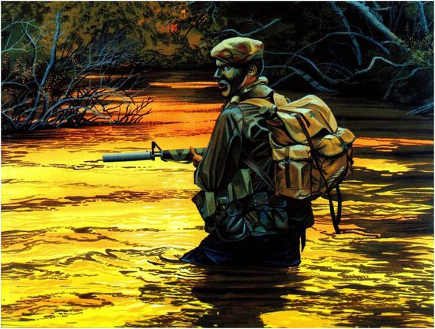
85. Sgt. Thomas Brooks moves up the river in search of VC by elgrancapitan.org
`
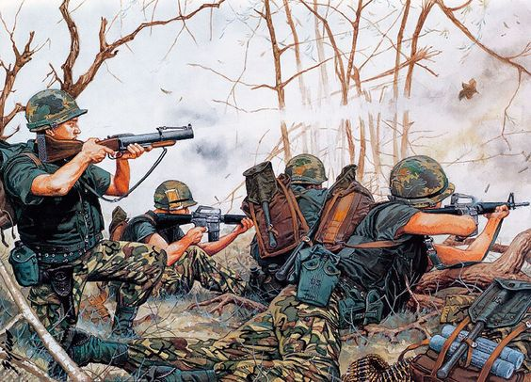
86. Marines return fire during ambush
`
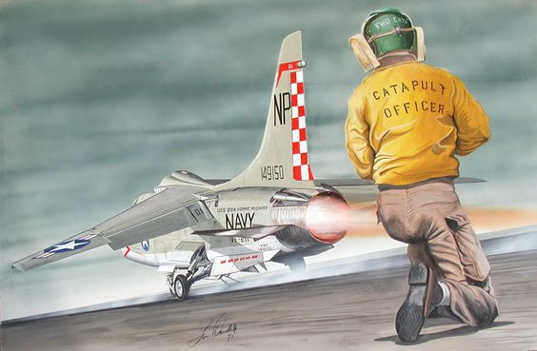
87. F-8 Crusader launching from carrier by Jim Ranch
`
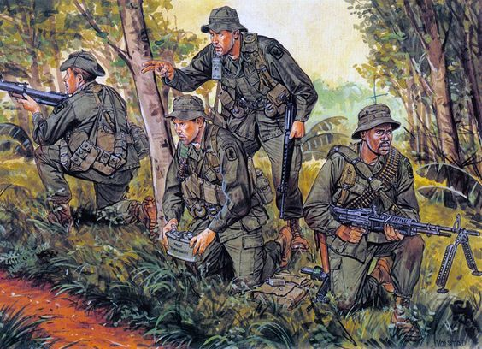
88. US troops setting ambush on trail in the Vietnamese jungle warwall.ru
`
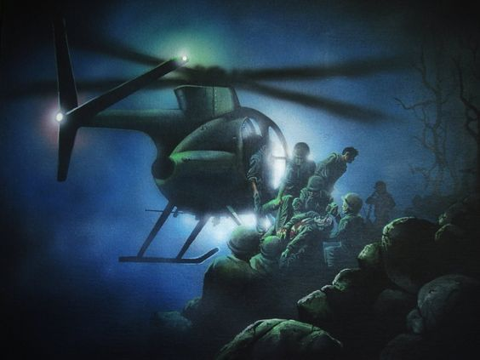
89. Marine rescued by helicopter Vietnam War, painting by veteran Paul Barke
`
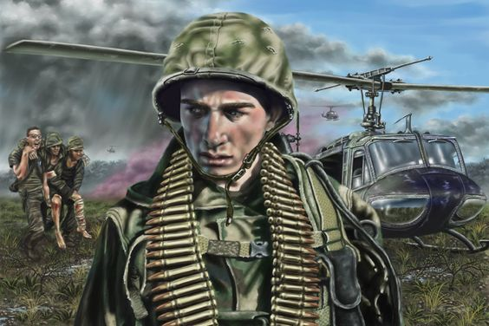
90. Journey Into War by jevinart on DeviantArt
`
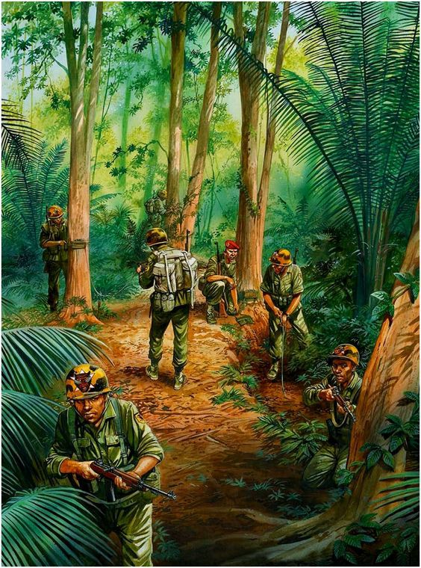
91. US troops in the jungle of Vietnam Saved from sibnarkomat.livejournal.com
`
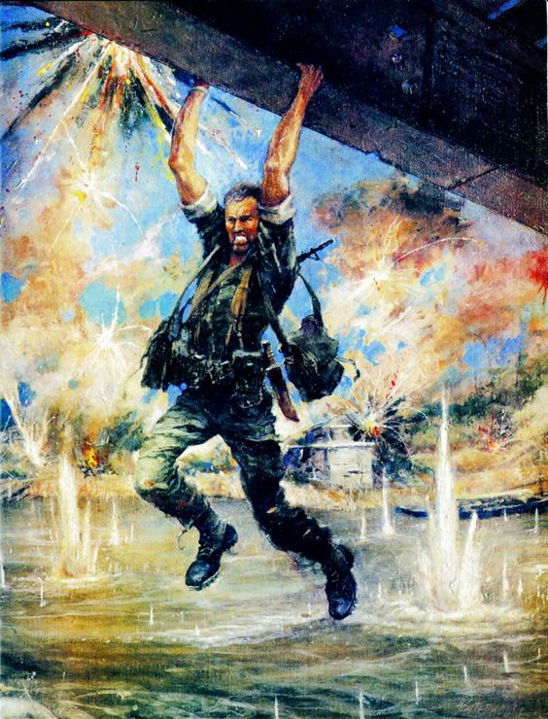
92. Ripley on the bridge Dong Ha 1972
`
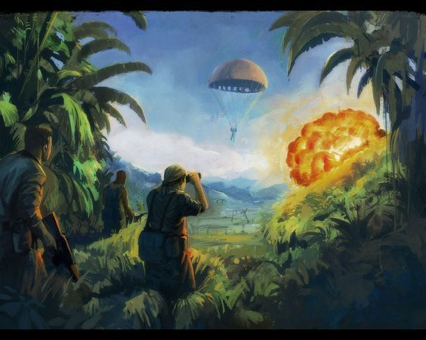
93. Jet pilot ejecting after his plane is hit by SAM missile
`
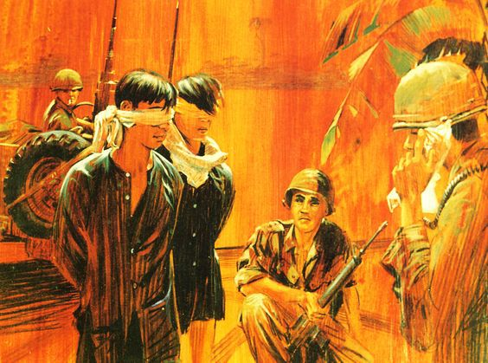
94. VC captured and awaiting pick-up by intelligence troops
`
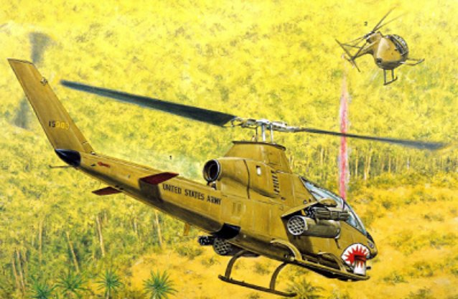
95. 1st Cav Hunter / Killer teams
`
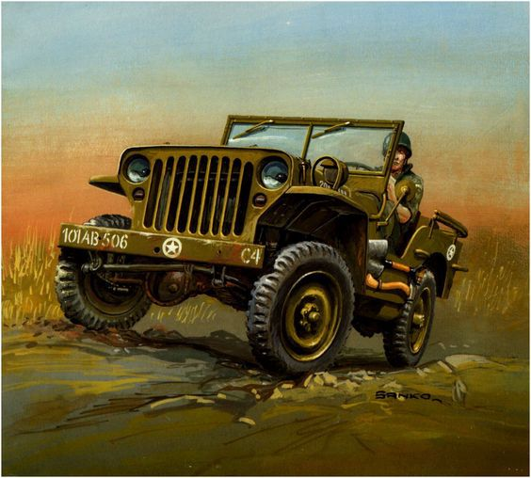
96. Army Jeep traversing roads filled with potholes
`
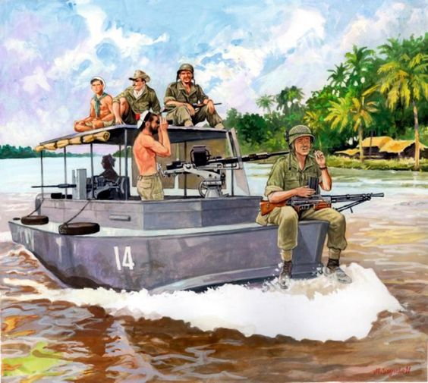
97. Patrol in the Mekong Delta Saved from marekszyszko.com
`
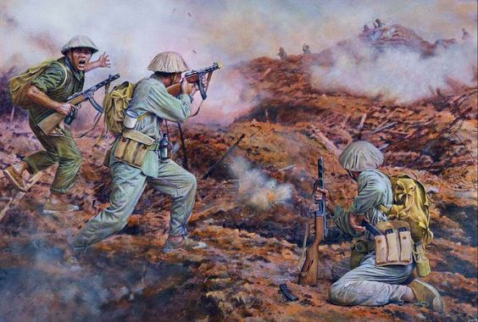
98. NVA attacking U.S. firebase saved from tipolog.livejournal.com
`
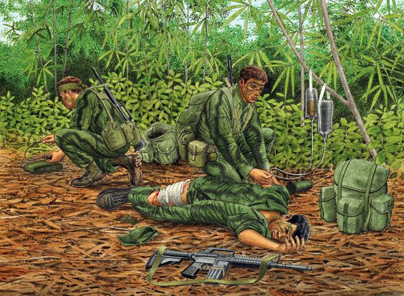
99. US MACV-SOG Reconnaissance Team waiting for an extraction
`
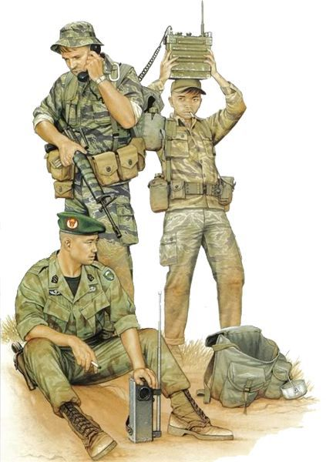
100. GREEN BERET IN VIETNAM 1957-73 | illustrated by Kevin Lyles
`
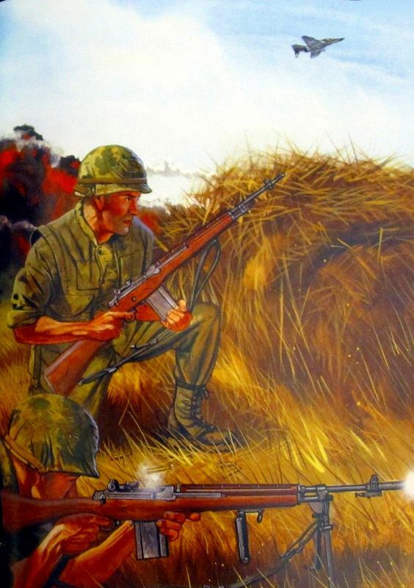
101. M-14’s performed well during its short stay in Vietnam
`
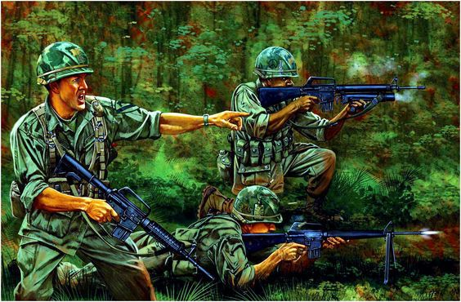
102. Ambush in NAM 1972 elgrancapitan.org
`
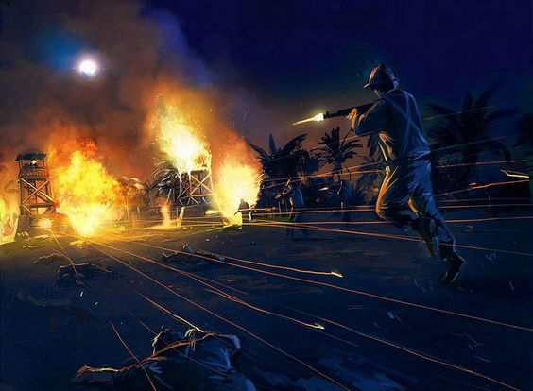
103. NVA attack a firebase

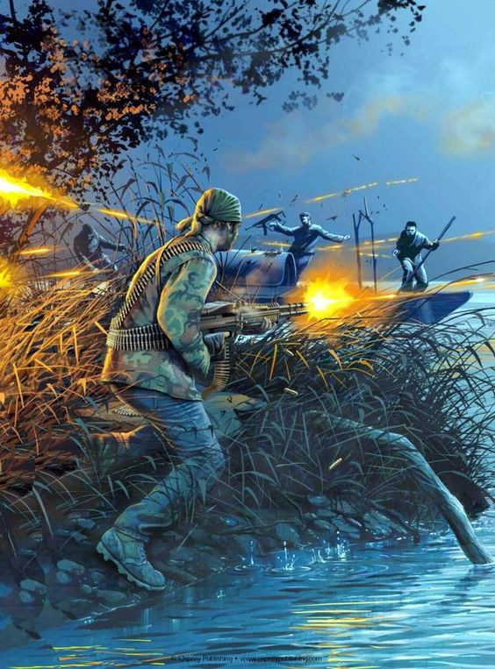104. Green Beret ambush VC Sampan on river
`
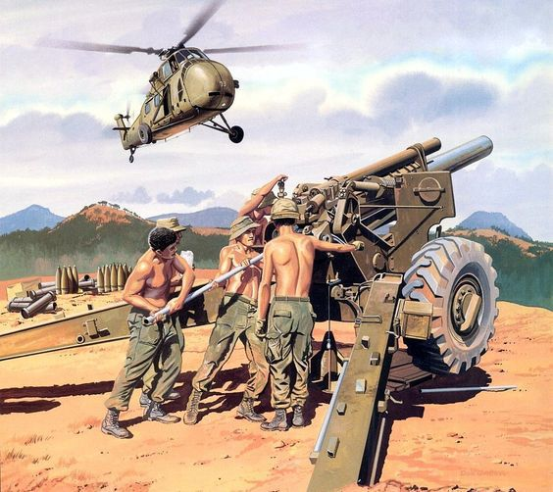
105. M101A1 155mm gun pit in a FSB (Nam) militar.org.ua
`
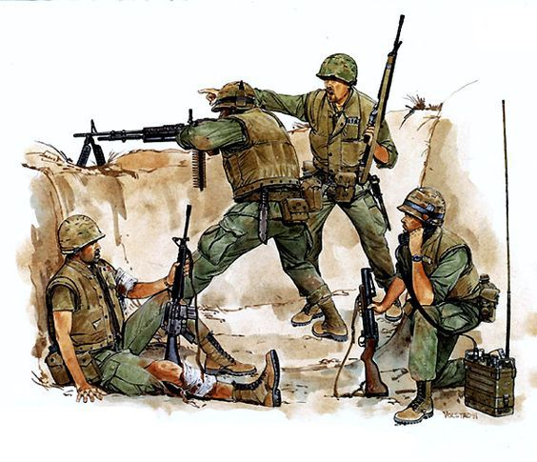
106. Marines fire from trench line by militar.org.au
`
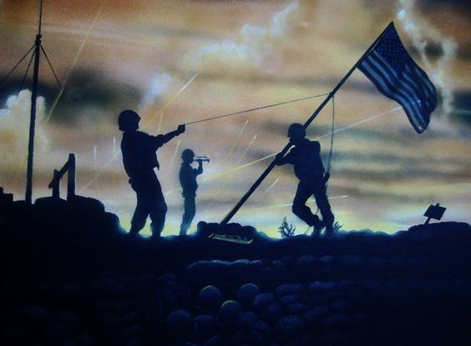
107. Raising the flag on Hill 881 in Vietnam
`
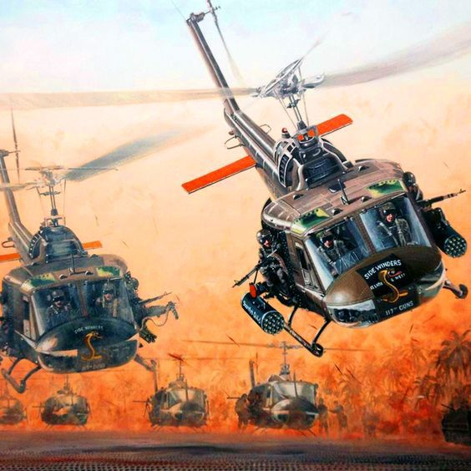
108. Sidewinders gunships – 117th Assault Helicopter Company – Joe Kline
`
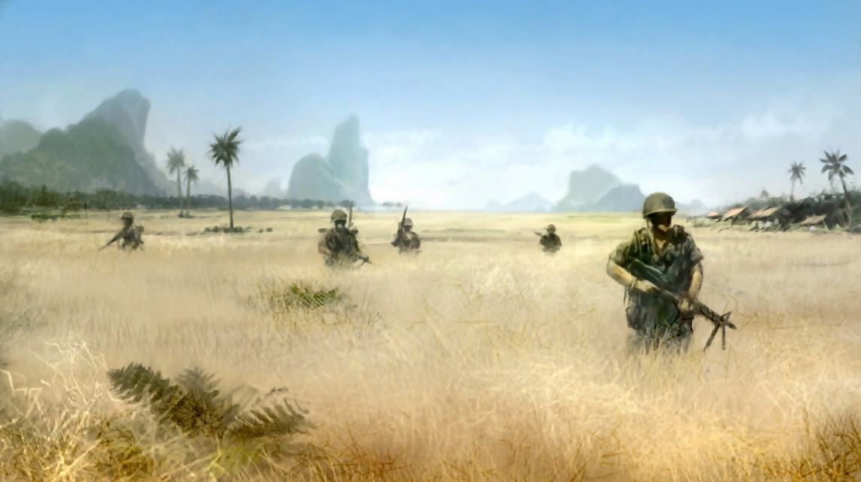
109. Patrol through old rice paddies
`
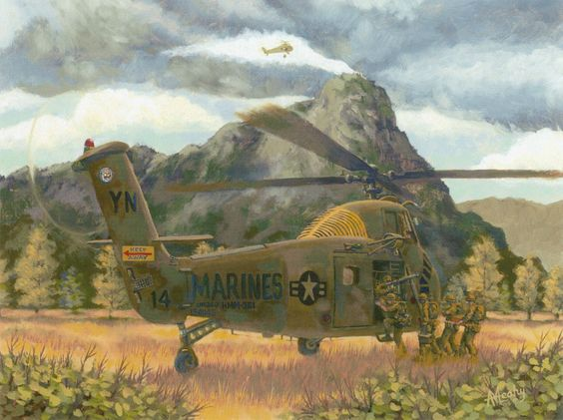
110. Marines picked up from mission by A. Meary
`
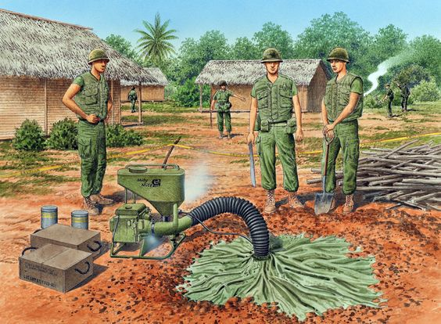
111. Filling uncovered tunnel complex with CS gas
`
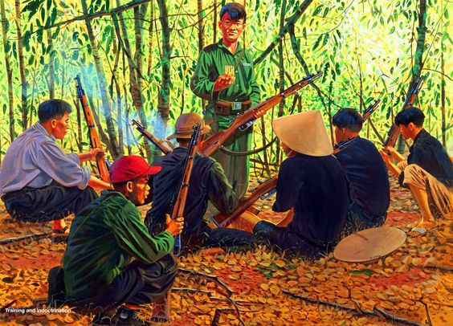
112. Training and indoctrination of Vietcong fighters
`
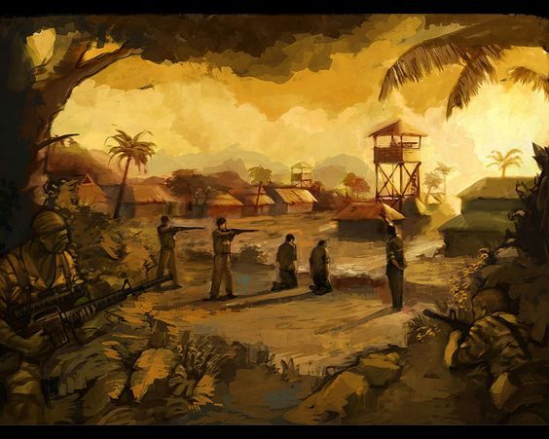
113. U.S. Commando attack on NVA POW Camp
`
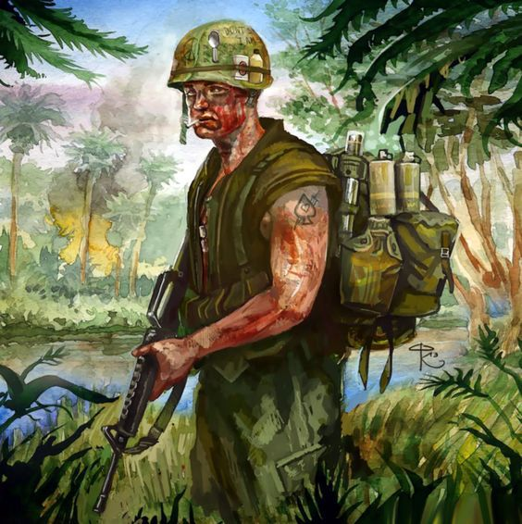114. Typical “Grunt” on patrol
`
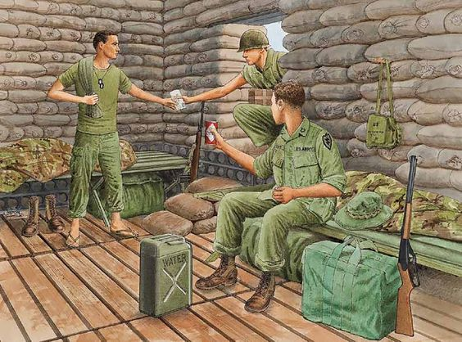115. 25th Infantry firebase “Hootch”
`
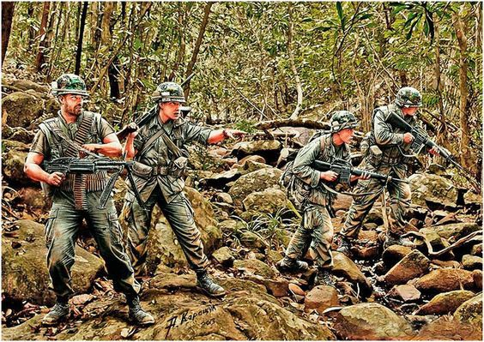
116. Squad checking out bunker on the side of a hill from warwall.ru
`
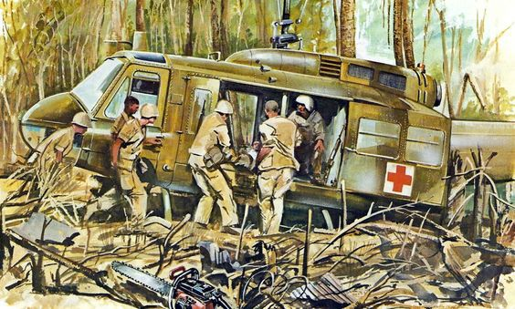117. Dustoff arriving in hastily cut landing zone
`
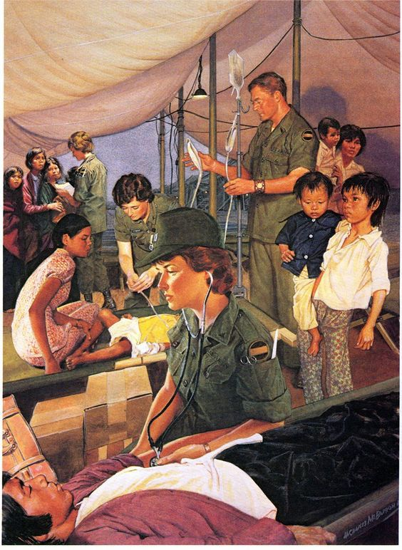
118. Field hospital for villagers
`
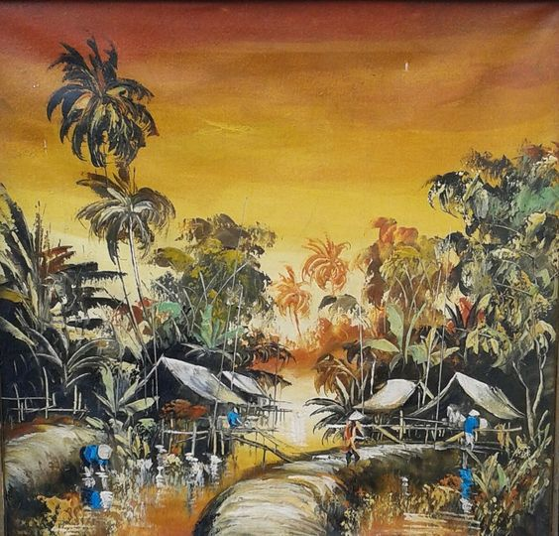
119. Village along one of the rivers in the Mekong Delta
`
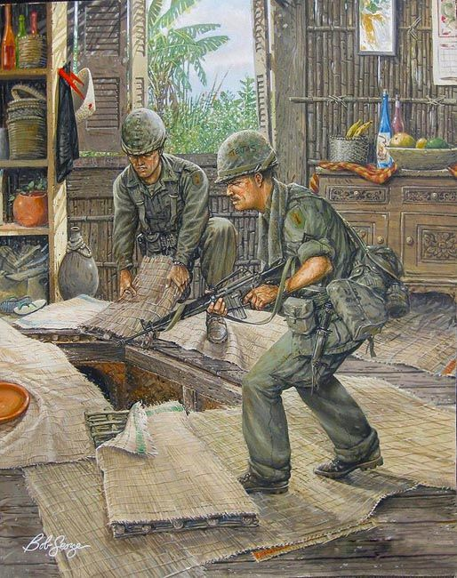
120. Uncovering tunnel in village hut by Bob George
`
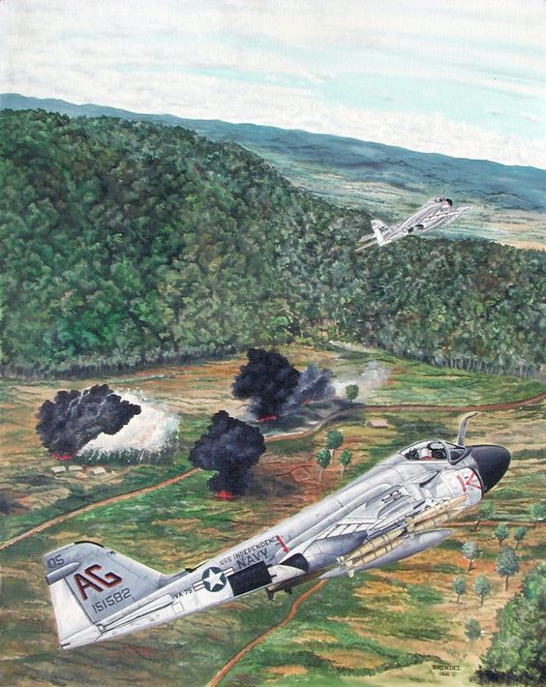121. A-6A on first combat missions, Vietnam, 1965 algrancapitan.org`

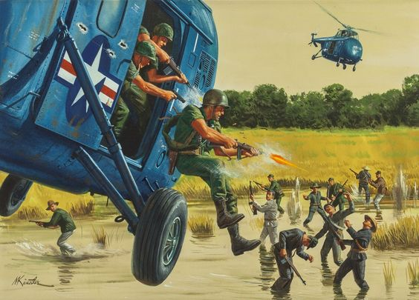
122. One Man Army They Call ‘The Cong Buster’ Mort Künstler Source Heritage Auctions
`
123. VC preparing an ambush site
`
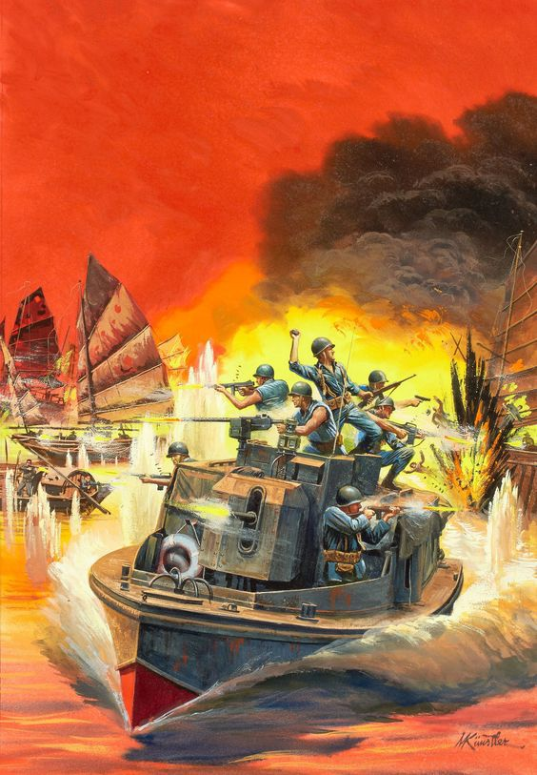
124. Navy PBR attacking VC Sampans by M. Kunstler
`
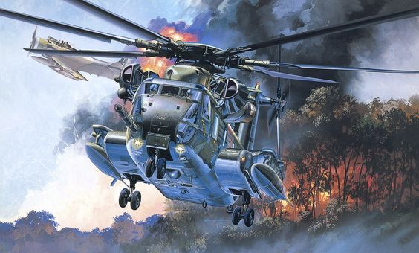
125. HH-53C Super Jolly Green Giant after pilot recovery 1zoom.me
`
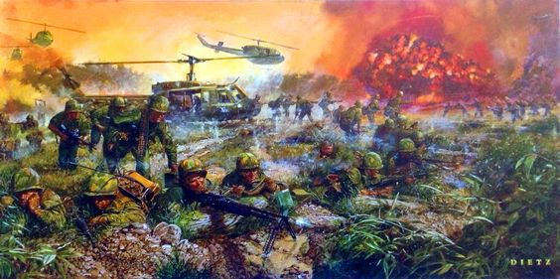
126. ‘We Live to Honor Them’ Battle of the La Drang Valley- by Dietz
`
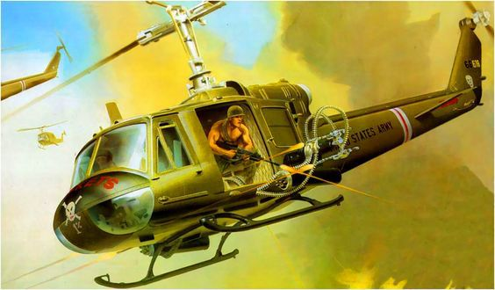
127. Bell UH-1B Gunship in Vietnam from elgrancapitan.org
`
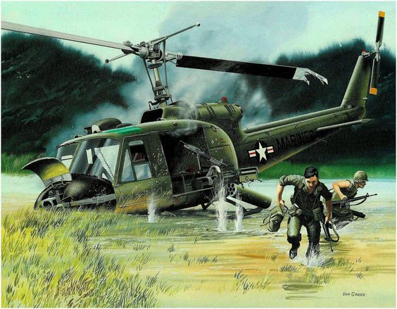
128. A downed Bell UH-1 Iroquois ‘Huey’ in Vietnam by Bud Gaynor
`
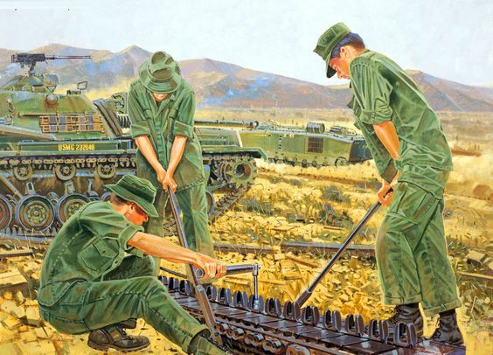
129. Daily life – tank track repair militar.org.ua
`
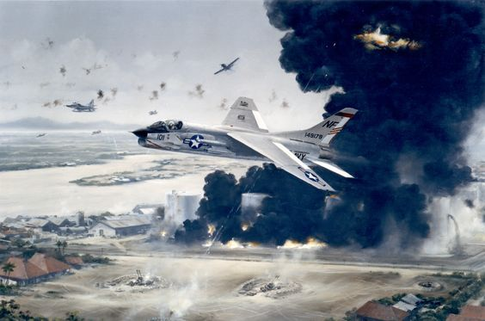
130. James Stockdale’s plane on the day he was shot down
`
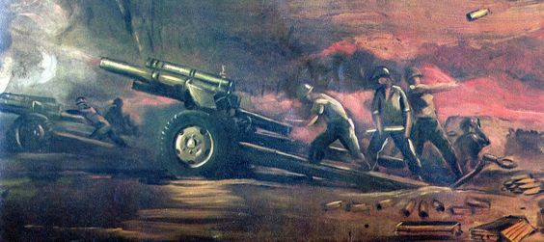
131. NVA artillery
`
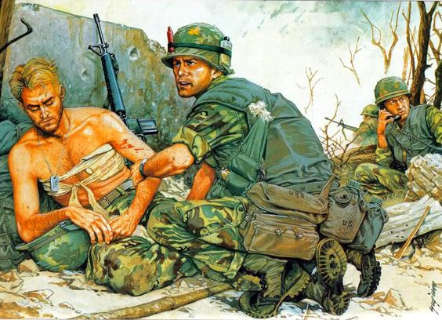
132. The Cost, Operation Dewey Canyon photo by militar.org.ua
`
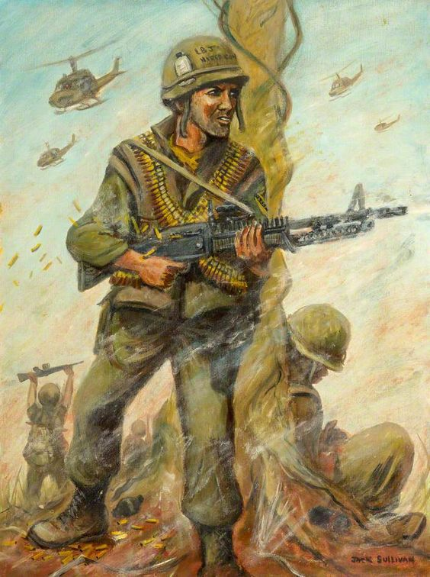133. 1st Cav Airmobile – Jack Sullivan`
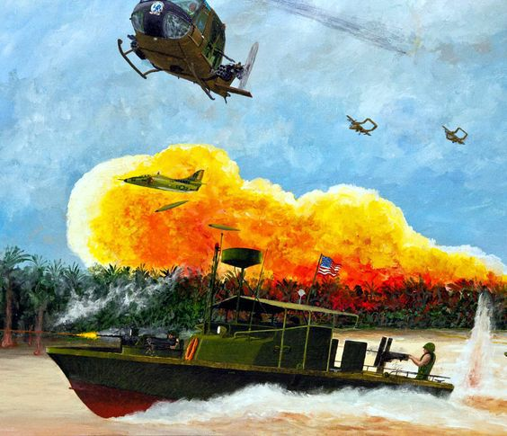
134. U.S. forces in the Delta
`
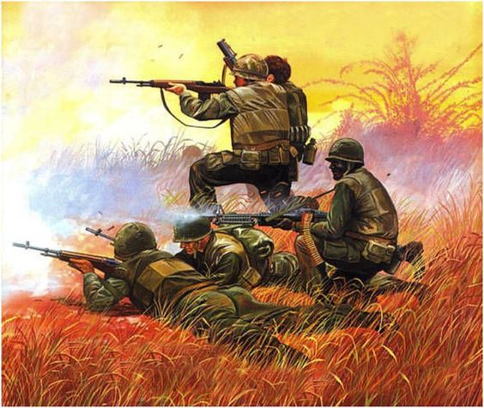
135. U.S. Marines in action
`
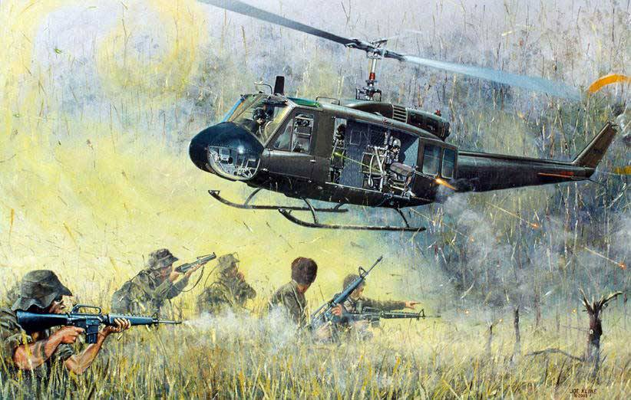
136. God’s lunatics by Joe Kline
`
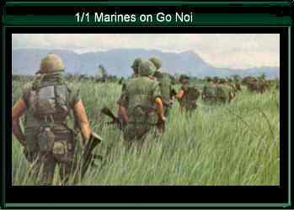
137. Marines patrolling on Go Noi Island
`
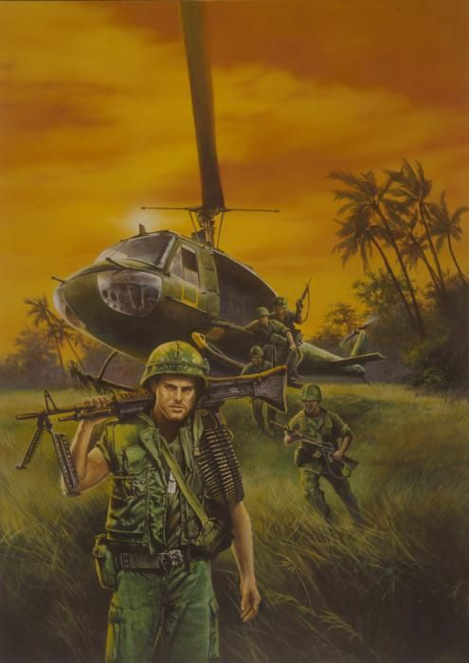
138. Grunts offloading to patrol the area. Print by fineartamerica.com
`
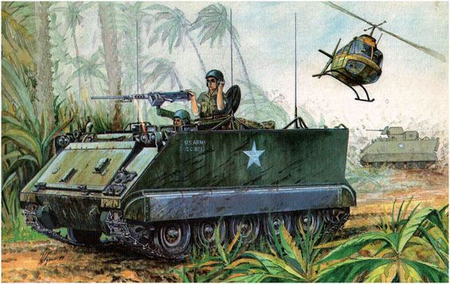
139. 11th Armored Cav on patrol
`
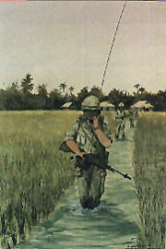
140. Humping through the Chu Lai rice paddies by Eric Nevatie
`
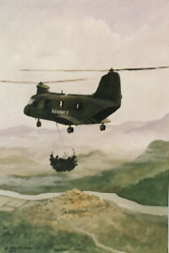
141. Sea Knight flying supplies to Marines at DMZ by Eric Nevatie
`
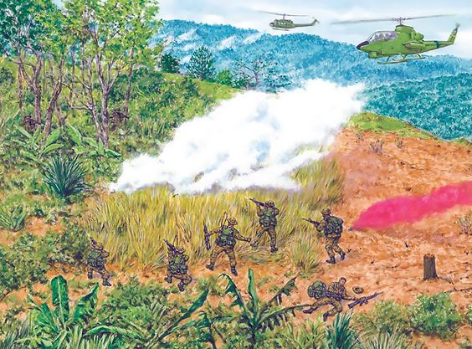
142. An extraction under pressure, that is, engaged by a closely pursuing enemy force, was among the most dangerous actions LRPs encountered”
`
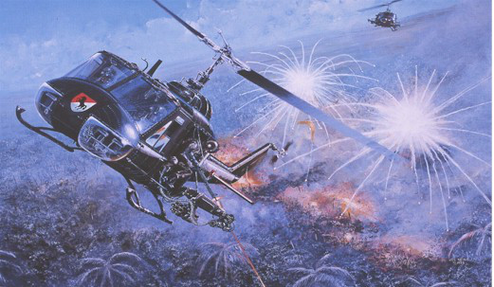
143. “Have Guns, Will Travel” Air Cav Troop, Vietnam. Two UH-1C Huey gunships hammering North Vietnamese positions inside Cambodia in 1970.
Print by Joe Kline
`
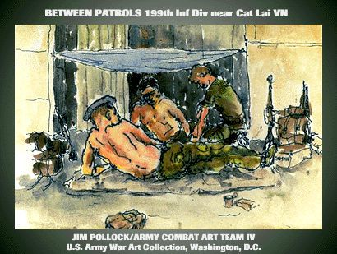
144. Stand down
`
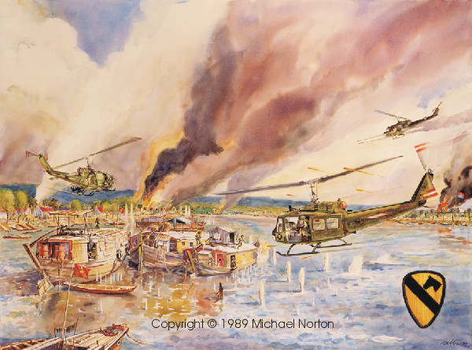
145. 1st Cav attack on Sampans by Michael Norton
`
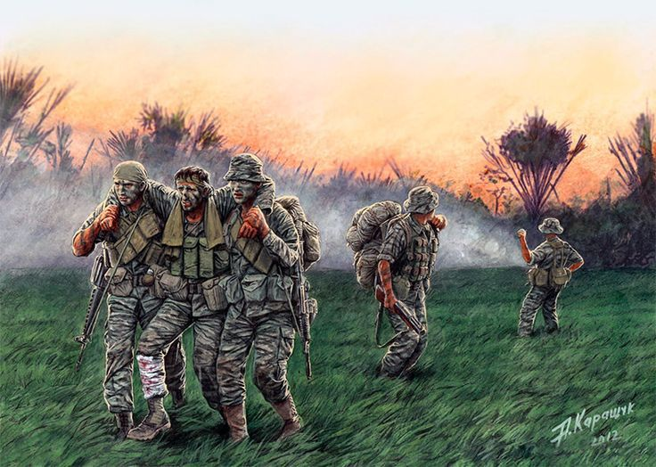
146. SOG patrol evading enemy troops by P. Kapawyk
`
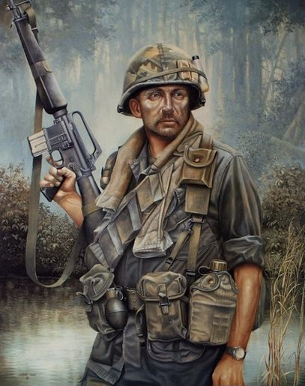
147. Just another day in the jungle
`
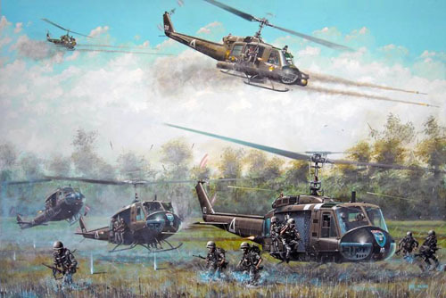
148. God’s own Lunatics by Joe Kline
`
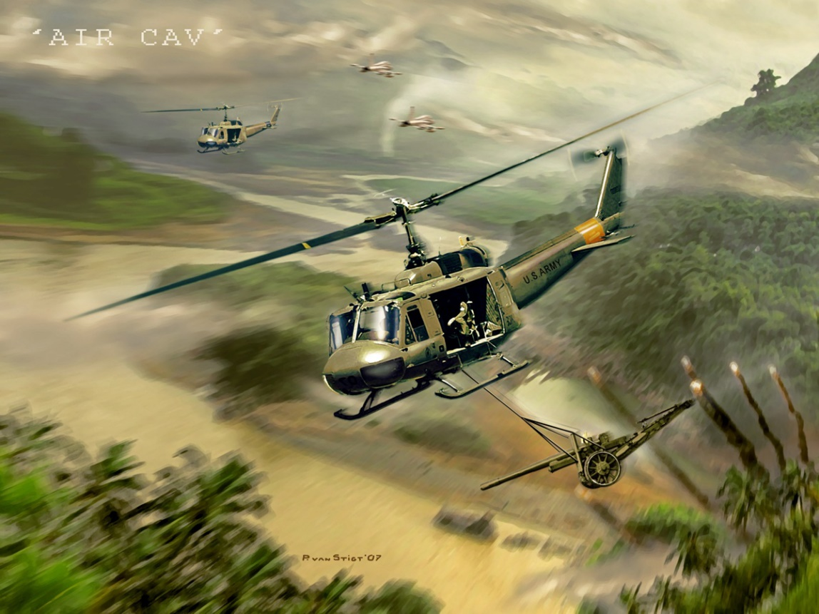
149. Huey slinging 105mm artillery cannon by Ryan Grist
`
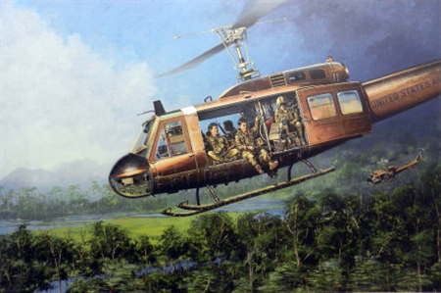
150. Driving the kids to school by Joe Kline
`
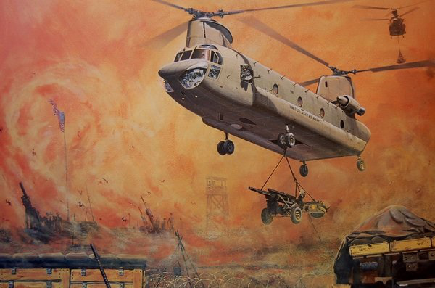
151. Iron Dance by Joe Kline
`
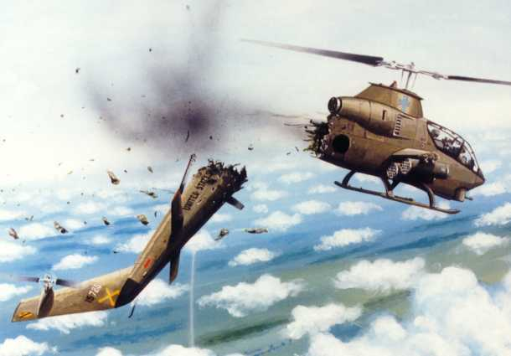
152. Cobra knocked out of the sky by Joe Kline
`
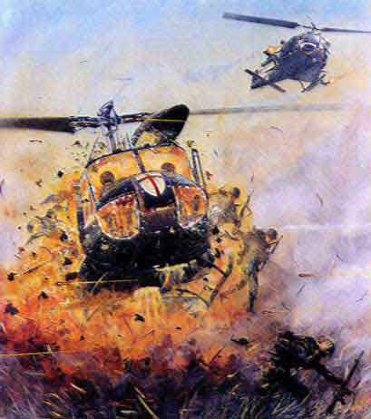
153. Crusader Huey exploding upon landing in LZ by Joe Kline
`
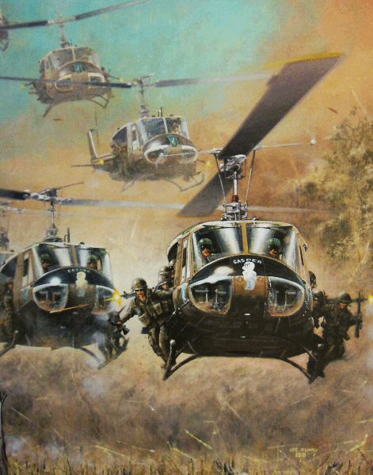
154. Casper bringing in the troops by Joe Kline Aviation Platoon H & H Co. – 173d Airborne Brigade
`
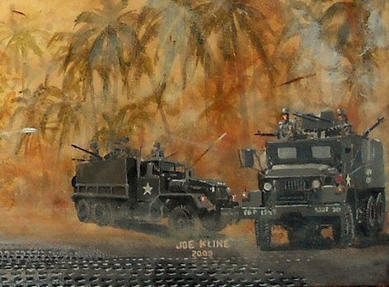
155. Gun trucks traveling the roads by Joe Kline
`
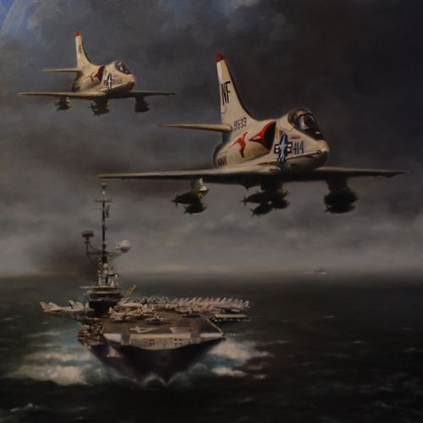
156. Robert D. Fiacco, “Oriskany Rendezvous” : A-4C Skyhawks from VA-94, assigned to USS Hancock, fly past the USS Oriskany (CVA-34) prior to striking targets in North Vietnam in 1967.
`
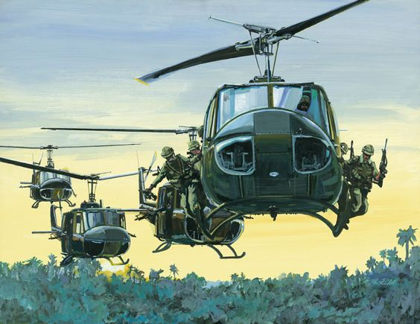
157. Gaggle of Huey’s bringing in the troops by David Layton
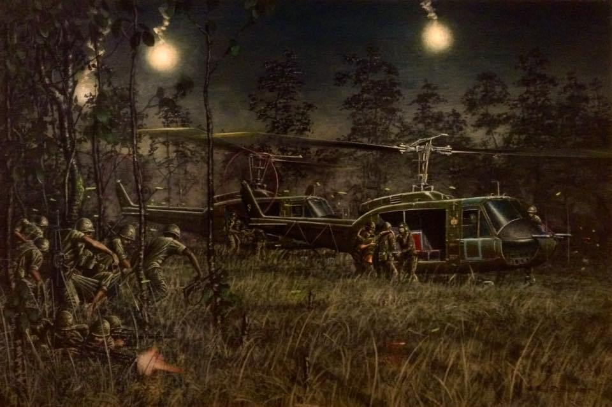
158. Tribute to LZ Albany 11/17/65 by Paul Tuttle
`
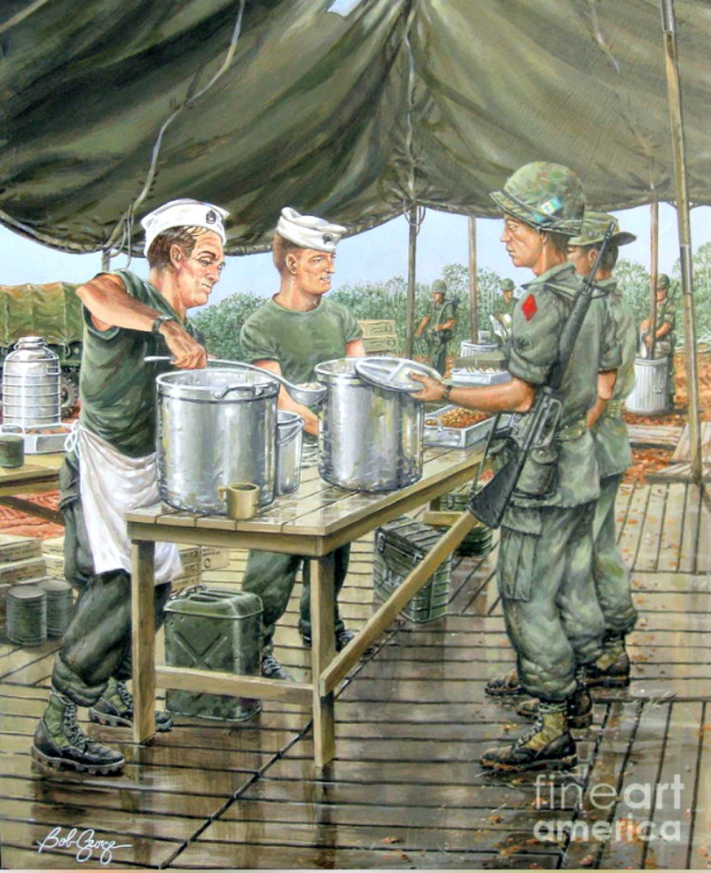
159. Serving Chow on the DMZ by Bob George
`
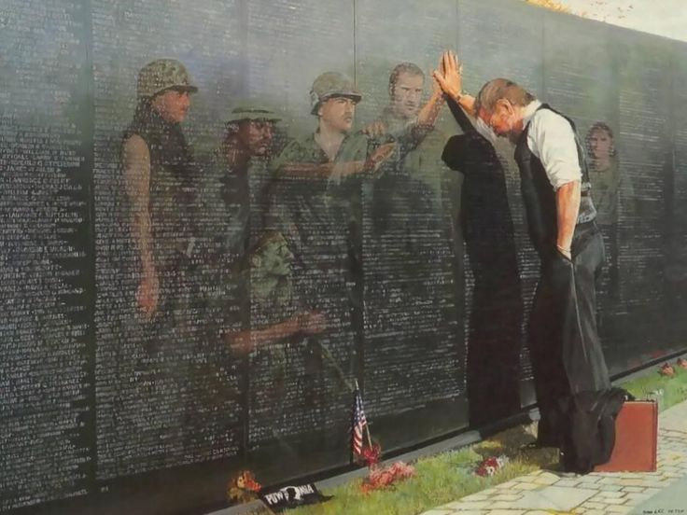
160. Vietnam Reflections by Lee Teeter
`
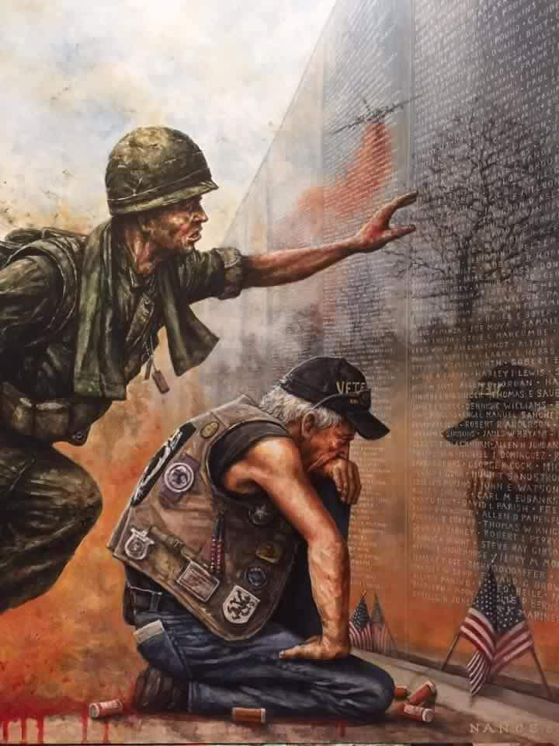
161. The price of freedom
`
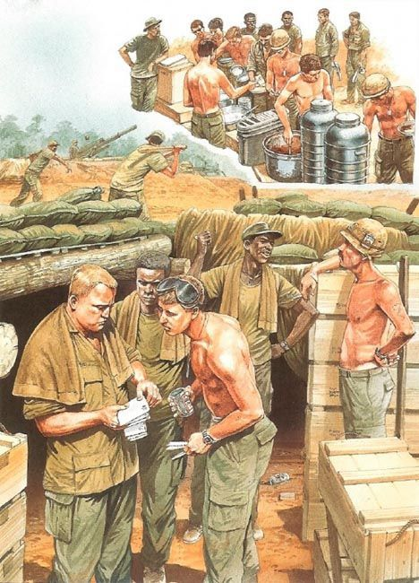
162. Life on a firebase
`
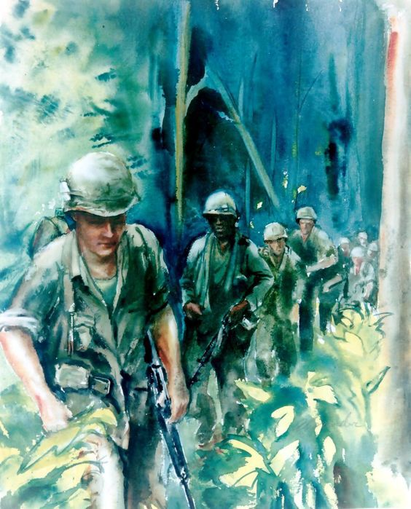
163. Coming out of the jungle
`
Joe Kline put this video together of many of his artwork prints (some you’ve already seen) – make sure you turn up the sound.

Thank you for taking the time to view this article! Don’t miss out on the many other stories, pictures and videos available to you on this website (see below).
If you enjoyed this article and want to learn more about the Vietnam War – subscribe to this blog and get each new post delivered to your email or feed reader. Meanwhile, you can link to my special pages, most recent articles and those most popular listed to the right of each article. If you’d rather sample every post, then click on the Cherries title at the top of this page to be redirected to the blog’s main page. There, you can scroll down through all the published titles, listed chronologically – the most recent is first.
I’ve also included a poll to help identify my website audience – before leaving, can you please click HERE and choose the one item best describing you. Thank you in advance!

Advertisements
Rate this:

i

7 Votes
Share this:
Facebook
Twitter
Email
Pinterest
Pocket
LinkedIn
Google
Tumblr
Reddit
Print

Like this:
Like Loading...
artwork and printsbook sitesbooks warcherry soldiercombatCombat Infantrydigital booksfirefightsGruntsjungle warfareMilitarynovelsThe vietnam warThe Vietnam war storyVeteranVietnam blog pagesVietnam bookVietnam conflictVietnam GenerationVietnam HeroesVietnam veteranwar bookswar storyWars and Conflicts

