At War's End, U.S. Ship Rescued South Vietnam's Navy
September 1, 20105:45 PM ET
Heard on All Things Considered
Joseph Shapiro
Sandra Bartlett
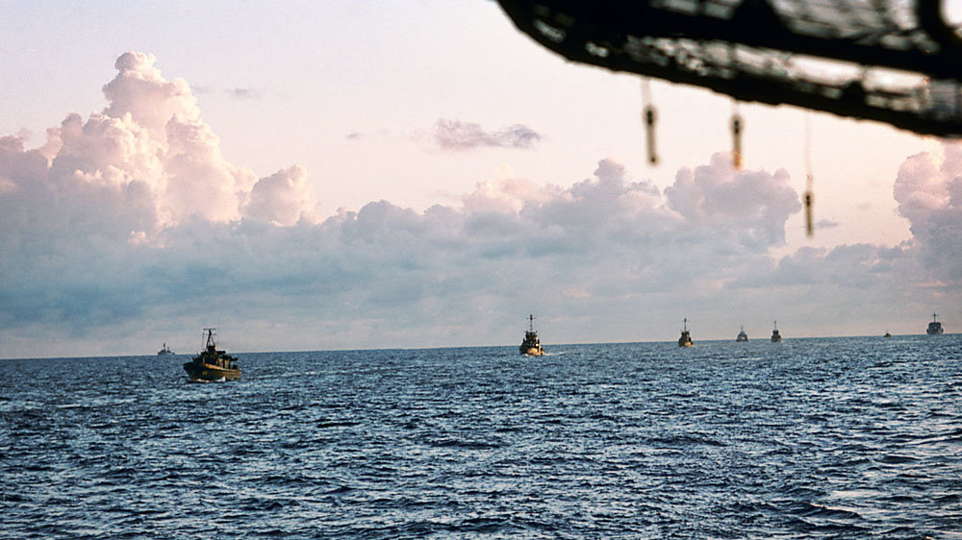
Enlarge this image
The South Vietnamese fleet follows the USS Kirk to Subic Bay in the Philippines. The Kirk's final mission at the end of the Vietnam War was to bring the remnants of the South's navy to safety in the Philippines.
The South Vietnamese fleet follows the USS Kirk to Subic Bay in the Philippines. The Kirk's final mission at the end of the Vietnam War was to bring the remnants of the South's navy to safety in the Philippines.
Hugh Doyle
On April 30, 1975, North Vietnamese troops entered the deserted streets of Saigon. Tanks crashed through the gates of the presidential palace and soldiers hoisted the yellow and red flag of the Viet Cong.
Just hours before, the last Americans had been evacuated, rescued and flown on Marine helicopters to U.S. Navy aircraft carriers waiting off the coast.
The Vietnam War was officially over. Now those Navy ships were steaming away from Vietnam.
There was one exception. That night, the captain of a small destroyer escort, the USS Kirk, got a mysterious order to head back to Vietnam.
South Vietnamese Navy: 'We Forgot 'Em'
Paul Jacobs, the captain, received the directive from Adm. Donald Whitmire, commander of the evacuation mission — Operation Frequent Wind. He was aboard the USS Blue Ridge, the lead ship of the Navy's 7th Fleet.
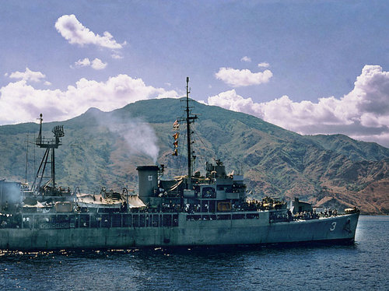
USS Kirk DE-3
The Kirk reached Con Son Island, off the southern coast of Vietnam, on May 1, 1975. There, it was met by 30 South Vietnamese navy ships and dozens of fishing boats and cargo ships — and as many as 30,000 Vietnamese refugees.

The Kirk reached Con Son Island, off the southern coast of Vietnam, on May 1, 1975. There, it was met by 30 South Vietnamese navy ships and dozens of fishing boats and cargo ships — and as many as 30,000 Vietnamese refugees.
Jacobs recalls Whitmire's surprise message: "He says, 'We're going to have to send you back to rescue the Vietnamese navy. We forgot 'em. And if we don't get them or any part of them, they're all probably going to be killed.'"
The Kirk was being sent to an island off the Vietnamese mainland — by itself. And there was one more odd thing, the admiral told Jacobs: He'd be taking orders from a civilian.
Richard Armitage came aboard the Kirk late at night, wearing a borrowed sport coat. Years later, Armitage would become second in command to Colin Powell in the Bush administration's State Department. But on that last day of April 1975, he was on a special assignment from the secretary of defense. He'd just turned 30 that week.
Armitage recalls coming aboard the ship and quickly being escorted to the officer's mess where he met with Jacobs and Commodore Donald Roane, commander of the flotilla of Navy destroyers.
"Commodore Roane said something like, 'Young man, I'm not used to having strange civilians come aboard my ship in the middle of the night and give me orders,' " Armitage recalls. "I said, 'I am equally unaccustomed, sir, to coming aboard strange ships in the middle of the night and giving you orders. But steam to Con Son.' And so they did."
Secret Plan To Rescue More Than Just Ships
The Kirk and its crew of about 260 officers and men were ordered to Con Son Island, about 50 miles off the coast of South Vietnam and not yet occupied by the North Vietnamese. Con Son was the site of a notorious prison. Now, its harbors were the hiding place for the remnants of the South Vietnamese navy.
Armitage had come up with the plan for them to gather there.
Armitage, a graduate of Annapolis, had been a Navy intelligence officer, assigned to Vietnamese units. He gained respect for the South Vietnamese as he worked alongside them and became fluent in the language. Then he resigned his commission and left the Navy in protest when the Nixon administration signed the Paris peace accords. That 1973 agreement between all warring parties in Vietnam ended direct U.S. military involvement in the war. Armitage felt the U.S. had sold out the South Vietnamese.
But as it became clear that the South Vietnam government was about to fall, a Pentagon official asked Armitage to fly back to Vietnam with a dangerous mission. His assignment: to remove or destroy naval vessels and technology so they wouldn't fall into the hands of the Communists.
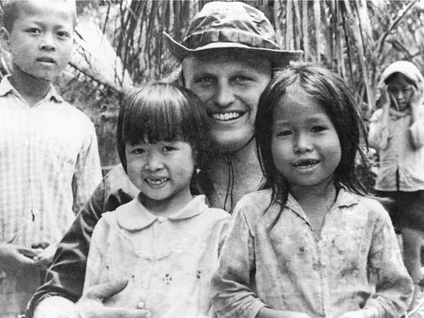
Enlarge this image
In 1975, Richard Armitage was a 30-year-old civilian charged with a dangerous mission: to remove or destroy South Vietnamese naval vessels and technology so they wouldn't fall into the hands of the Communists. Later, Armitage would serve as deputy secretary of state from 2001 to 2005, under Secretary of State Colin Powell in the administration of George W. Bush. Courtesy Richard

In 1975, Richard Armitage was a 30-year-old civilian charged with a dangerous mission: to remove or destroy South Vietnamese naval vessels and technology so they wouldn't fall into the hands of the Communists. Later, Armitage would serve as deputy secretary of state from 2001 to 2005, under Secretary of State Colin Powell in the administration of George W. Bush.
Courtesy Richard Armitage
A few weeks before Saigon fell, Armitage had shown up at the office of an old friend, Capt. Kiem Do, deputy chief of staff for the South Vietnamese navy. Together, they came up with the secret plan to rescue the Vietnamese ships when — as was becoming clear would happen — the South Vietnamese government surrendered.
Do remembers warning Armitage that they'd be saving more than ships.
"I told him, I said, 'Well, our crew would not leave Saigon without their family, so therefore there will be a lot of people,' " Do recalls.
He says Armitage remained silent. "He didn't say yes; didn't say no. So I just take it as an acknowledgement," Do says.
Armitage didn't tell his bosses at the Pentagon there would be refugees on those ships. He feared the American authorities wouldn't want them.
Neither Do nor Armitage, though, could predict how many refugees would turn up in Con Son.
Chaos At Con Son Island
The Kirk steamed through the night to Con Son and reached the island just as the sun came up on May 1. There were 30 South Vietnamese navy ships, and dozens of fishing boats and cargo ships. All of them were packed with refugees, desperate to get out of Vietnam.
The ships "were crammed full of people," says Kent Chipman, who in 1975 was a 21-year-old machinist's mate in the ship's engine room and today works at a water purification plant in Texas. "I couldn't see below deck, but above deck the people were just as tight as you could get, side by side."
There was no exact count of how many people were on those ships. Some historical records say there were 20,000 people. Other records suggest it was as many as 30,000. Jan Herman, a historian with the U.S. Navy Medical Department, who is documenting the story of the Kirk, uses the higher number.

The Kirk sent its engineers to some of the boats to get them started.
"They were rusty, ugly, beat up," says Chipman. "Some of them wouldn't even get under way; they were towing each other. And some of them were actually taking on water and we took our guys over and got the ones under way that would run."
One cargo ship was so heavy it was sinking. People below deck were bailing out the water with their shoes.
Stephen Burwinkel, the Kirk's medic — in the Navy known as a hospital corpsman — boarded that ship to check on the sick and injured. He saw a Vietnamese army lieutenant helping passengers leave the sinking ship, crossing to another ship, over a narrow wooden plank. As people pushed to get off the sinking ship, one man knocked a woman who stopped in front of him. She fell off the plank and into the ocean.
The woman was quickly rescued. But Burwinkel worried that the others on the ship would panic. He says the lieutenant acted quickly.
"This Vietnamese lieutenant did not hesitate, he went right up the back of that guy, took his gun out and shot him in the head, killed him, kicked him over the side. Stopped all the trouble right then and there," Burwinkel recalls. The shooting was shocking, he says, but it very likely prevented a riot.
Leading The Way Toward The Philippines
After fixing what could be fixed on the seaworthy vessels and transferring people from the ships that would be left behind, the Kirk led the flotilla of naval ships, fishing boats and cargo ships toward the Philippines.
The USS Cook, another destroyer escort, like the Kirk, helped out as the ships were leaving Con Son. The Cook's crew provided rice, and its corpsman helped Burwinkel and his assistant from the Kirk attend to the sick and injured, too.
As the flotilla headed out to sea, on the way to the Philippines, other Navy ships came in and out of the escort, according to Herman. Among those other ships were the USS Mobile, USS Tuscaloosa, USS Barbour County, USS Deliver and USS Abnaki.
But it's clear from the daily logs from the Kirk and the other ships that the crew of the Kirk took the lead.
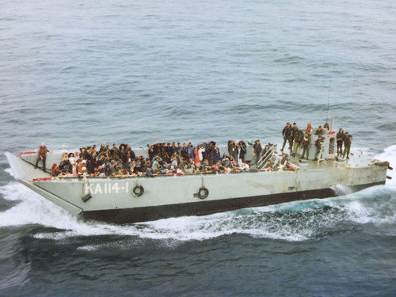
A boat brings Vietnamese refugees to the Kirk near Con Son Island. The U.S. ship undertook one of the greatest humanitarian missions in the history of the U.S. military

A boat brings Vietnamese refugees to the Kirk near Con Son Island. The U.S. ship undertook one of the greatest humanitarian missions in the history of the U.S. military.
"For me, the Kirk was ideal," says Armitage, who moved from the Kirk to the Vietnamese navy's flagship. "It could communicate with the rest of the U.S. fleet. They would go with us across to the Philippines and would be able to rescue any of the folks who might be in harm's way. Some had been wounded. Some were pregnant. All were sick after a while. And we needed a way to take care of those folks."
The Kirk's sailors kept busy providing food, water and medicine to people on the South Vietnamese ships.
Burwinkel spent his time moving from ship to ship treating the sick and injured. With thousands of people — many of them babies and children — he had to work almost nonstop.
"When they gave me the meritorious service medal over all this, I quite frankly referred to it as my 'no-sleep' medal," says Burwinkel, who made a career in the Navy and is now retired and living in Pensacola, Fla. "I would go out there and do my thing and at dark we would come back to the Kirk and try to get a little bit to eat and make some rounds — gather my wits about me, resupply myself and get ready for the next day."
'Last Sovereign Territory Of The Republic Of Vietnam'
Of the some 30,000 refugees on vessels escorted by the Kirk over six days, only three died.
But as the flotilla approached the Philippines, the Kirk's captain got some bad news. The presence of South Vietnamese vessels in a Philippine port would present the government in Manila with a diplomatic predicament.

Finding The Kirk's Story
The USS Kirk carried out one of the most significant humanitarian missions in U.S. military history. Yet the story went untold for 35 years. Correspondent Joseph Shapiro and producer Sandra Bartlett of NPR's Investigative Unit interviewed more than 20 American and Vietnamese eyewitnesses and participants in the events of late April and early May 1975. They studied hundreds of documents, photographs and other records, many never made public before — including cassette tapes recorded at the time by the ship's chief engineer.
Shapiro first learned of the Kirk from Jan Herman, historian of the U.S. Navy Medical Department, who says the Kirk's heroics got lost because, as the Vietnam War ended, Americans were bitterly divided over the war's course and cost. There was little interest in celebrating a mission that saved the lives of 20,000 to 30,000 refugees. Herman is working on a book documenting the story and a film documentary, which was shown when the Kirk crew met for a reunion in Springfield, Va., in July.
"The Philippine government wasn't going to allow us in, period, because these ships belonged to the North Vietnamese now and they didn't want to offend the new country," Jacobs, the captain, recalls.
The government of Philippine President Ferdinand Marcos was one of the first to recognize the Communist rulers now in control of a single Vietnam, and Jacobs was told the ships should go back.
Armitage and his South Vietnamese friend, Capt. Do, came up with a solution that Marcos had to accept.
Do recalls the plan: "We will raise the American flag and lower the Vietnamese flag as a sign of transfer [of] the ship back to the United States, because during the war those ships are given to the Vietnamese government as a loan, if you want, from the United States, to fight the Communists. Now the war is over, we turn them back to the United States."
There was a frantic search to find 30 American flags. Two officers from the Kirk were sent aboard each Vietnamese ship to take command after a formal flag ceremony.
Rick Sautter was one of the Kirk officers who took command of a Vietnamese ship.
"That was the last vestige of South Vietnam. And when those flags came down and the American flags went up, that was it. Because a Navy ship is sovereign territory and so that was the last sovereign territory of the Republic of Vietnam," he says.
"Thousands and thousands of people on the boats start to sing the [South Vietnamese] national anthem. When they lower the flag, they cry, cry, cry," Do remembers.
'High Point Of My Career'
On May 7, the ships flying American flags were allowed into Subic Bay For the refugees, it was just the beginning of their long journey, which took them to Guam and then resettlement in the United States.
For the sailors of the Kirk, ending the Vietnam War by rescuing 20,000 to 30,000 people was very satisfying.
"This was the high point of my career and I'm very proud of what we did, what we accomplished, how we did it," Jacobs says. "I felt like we handled it truly professionally and that was kind of a dark time."
Armitage says he "envied" the officers and men of the USS Kirk. The ship had not seen combat on its tour to Vietnam. But it ended with the rescue of tens of thousands of refugees, one of the greatest humanitarian missions in the history of the U.S. military.
Says Armitage: "They weren't burdened with the former misadventure of Vietnam."

