ALAMO CHAPTER 1836
MILITARY ORDER OF THE PRUPLE HEART
MISSION REACH VETERANS MONUMENT FUNDRAISING PROGRAM
AUGUST 2019
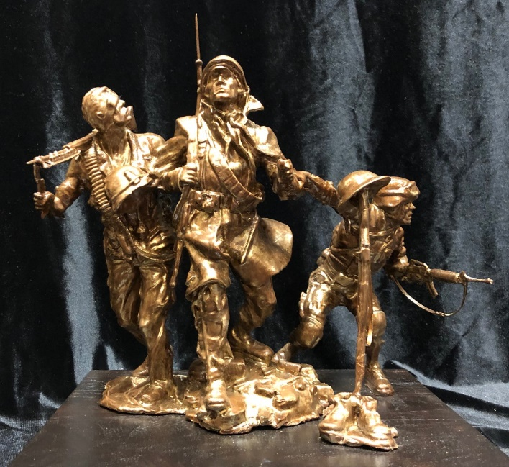
In 2018 Bexar County Commissioners Court approved a wonderful place for the placement of a veteran’s monument on the banks of the San Antonio River across the River from the beautiful and historic Mission Concepcion. This section of the River is called “Mission Reach” because it connects the five original Spanish missions: Mission San Juan Capistrano, Mission Espada, Mission San Jose, Mission Concepcion and the Alamo.
The monument that was proposed and accepted by the Commissioners is a 13’ bronze statue and pedestal designed by noted sculpture Michael Boyett. This statue was first proposed by Michael at the 2014 Department of Texas Military Order of the Purple Heart Annual Convention and approved at the Convention. After delay in finding a location the monument was once again approved at the 2018 Annual Department Convention and $5,000 was dedicated to its construction.
We have the wonderful location but now must raise funds for casting and erection of the statue. We ask that Chapter 1836 veterans take the lead on this effort and are hereby establishing an awards program to encourage donations to this project.
Platinum Donation $1,000.00
Gold Donation $500.00
Silver Donation $100.00
Bronze Donation $50.00

Donations and pledges will be announced at all regular chapter meetings and a current chart of donors will be displayed at the meetings and posted on the chapter web site. Pledges may be made with a payment spread over next two years.
Donations may be made to the Chapter Finance Officer, Dale Prescott, (361) 550-7460,
dt-prescott@hotmail.com
Mission Reach Veterans Monument Fund – Chapter 1836

Yours in Patriotism,
Tony Roman, Commander, Alamo Chapter 1836 &
Chair, Mission Reach Texas Veterans Monument Committee

