**Mobile Riverine Force and 9th Infantry Division Face Book page . Below is some of the info sent by and Comments made by the MRFA Member.**

**DESCRIPTION Note From Bob Doc Pries Group Admin**

**Welcome to the Facebook Group of the Mobile Riverine Force and 9th Infantry Division Vietnam. This group is dedicated to all Army and Navy men who served with pride and distinction in a place called the Mekong Delta. Be it on water or land, they all served their country. Whether they were on a Monitor or making a helo assault, setting an ambush on a lonely, quiet, dark night, walking through waist deep water in a rice paddy, riding a tango boat up a narrow canal, or at anchor in the middle of a brown-water river for long hot hours. Places like Dong Tam, Tay Ninh, Snoopy's Nose, the Cross Roads, Ambush Alley, My Tho, Rach Kien, Plain of Reeds, Parrot's Beak, Tan An, Nha Be or Ben Tre and names like Colleton, Washtenaw, Windham, Benewah, Westchester, Satyr, Askari, PBR, and Swiftboat are names and places we'll never forget.  
  
This group is to preserve a living memory of all those who served in the Mobile Riverine and 9th Infantry Division Vietnam.  
  
Politics and religion are the fastest way to start an argument and cause hard feelings and absolutely have no place on this page.  
  
I expect members to treat each other with dignity and respect. If anyone can not do this, I respect your personal choice but be advised I will be more than happy to escort you from the group.  
  
We hope you enjoy the group.  
  
In Brotherhood,  
  
Doc Pries - Group Admin**



U Minh Forest

No Longer a VC Sanctuary

U MINH FOREST**, Vietnam— During the** Vietnam War**, the impenetrable "**forest **of darkness" in the far south seemed to be the most menacing ...**

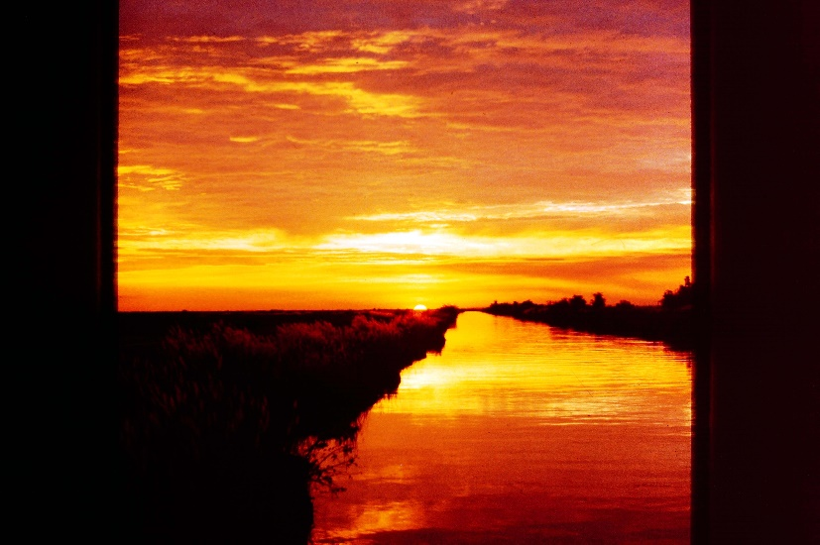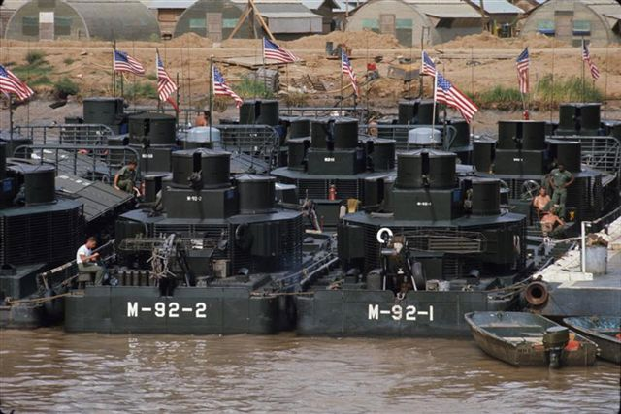

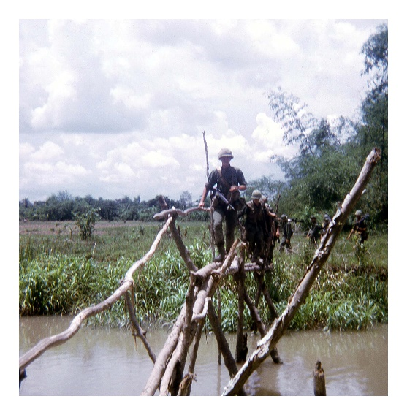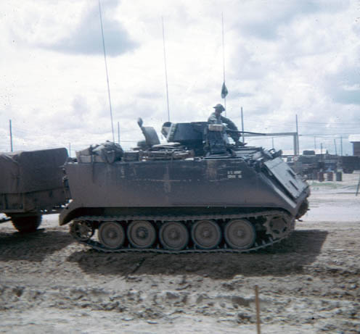

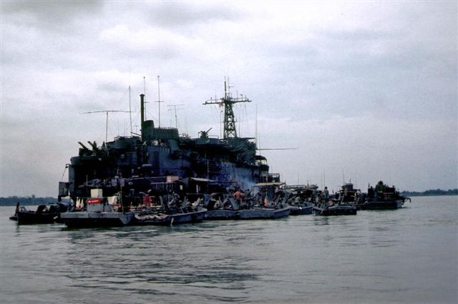 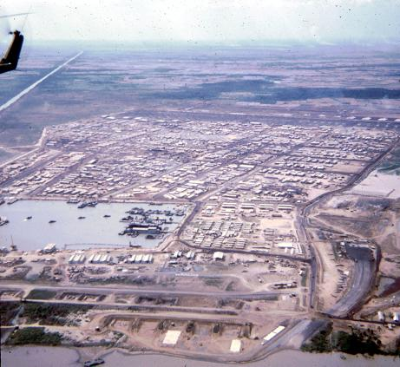   - Description: USFlag.thin

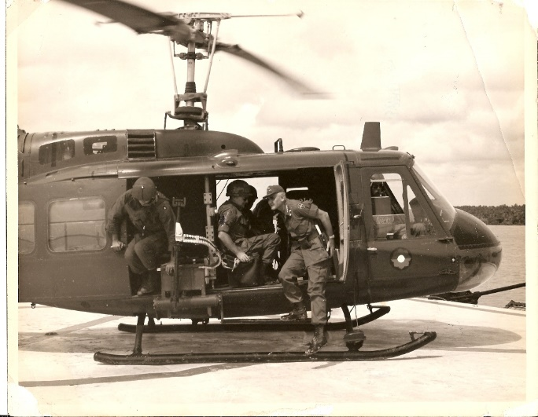 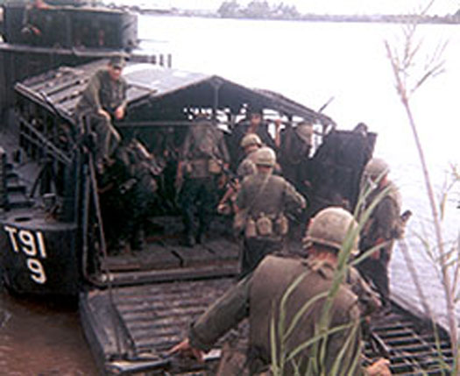

Where have all the VC gone? This was the question Allied commanders in the Mekong Delta were asking themselves in late spring and early summer this year (1968).

Three answers immediately came into mind. First enemy forces encircling Saigon were drawing replacements and reinforcements from as far away as Vinh Long Province. Next: the enemy was still rebuilding after a disastrous Tet which saw the Mobile Riverine Force (MRF) pulverize VC units from My Tho to Can Tho, and accordingly, was deliberately avoiding contact. Finally: it is now rice planting season, and since everyone needs food to survive during the coming year, peasants and guerrillas are working side by side in the rice paddies.

Finally in late July, MRF tacticians and IV Corps planners mapped out a bold plan which would thrust almost 3,000 allied soldiers into an area where no Allied and a few Vietnamese soldiers had ever dared venture before, the wide stretch of marshland zigzagging southwest of Can Tho to the notorious, legendary U Minh Forest.

For centuries a safe heaven for pirates, smugglers, bandits, and recently the Viet Cong. The U Minh Forest failed to capture room on front pages until spring of 1968. At that time the giant maze which had resisted every human destructive force up to and including the French, succumbed to a three month long blaze which left almost two-thirds of the forest defoliated. Still the U Minh Forest remained a sanctuary and training center for the enemy.

On July 30, 1968 Naval Assault Flotilla One unloaded second brigade Soldiers into the area. Less than half an hour after they disembarked one U.S. Commander discovered a cache featuring assorted enemy firearms, medical supplies, and documents “… you name it and it was there,” said one infantry platoon leader. It got so bad that the men didn’t want to find any more because it meant they had to carry it back to the boats,”

And that was the way it was for the entire 10 day operation, contact with enemy was frequent. One enemy cache after another. One large body count after another, and incredibly, not one U.S. soldier was killed.

For the first time in MRF history, the 2nd Brigade command post went ashore. From the CP and his command and control helicopter, Colonel Robert Archer personally coordinated the efforts of his own two infantry battalions and five artillery batteries with the 5th Vietnamese Marines and supporting ARVN artillery.

Major Donald Morrelli, River Raider operation officer, in a masterful understatement, explained: “Once again the 9th Division’s 2nd Brigade River Assault Flotilla One have demonstrated their unique long range strike capability,” And demonstrate they did – in a territory where the local population had never seen a C-ration can.

“To give you an idea of how positive the local Vietnamese officials were that this area was 100 per cent VC.” Said Morelli, “We had a huge specified strike zone. In other words, the provincial government gave our artillery prior clearance to fire on an unusually large sector of land. Though we still needed U. S. clearance, hours were saved.”

In the eyes of the world, 10 rockets landing in Saigon are more important than 10 U Minh Forest Operations. But in the Mekong Delta, both allied and enemy commanders possess renewed awareness that no VC stronghold can be considered forever secure. The U Minh Forest’s greatest importance may prove to be psychological as is it decisively showed the enemy that their time was running out, that as soon as the threat to Saigon was diminished sufficiently to permit more U.S. troops to move south, the days of the Viet Cong infrastructure, safe for decades was over…. By 1LT Howe McCarty.

From a 1968 issue of “Octofoil” … A 9th Infantry Division Publication

**Some Comments on the above Article that was posted on our Facebook page  Thanks to all who commented.. The article was posted in the fall of 1968 as you can see by the comments the Navy and Army were still in contact with the V C  into 1970 Albert**

* [**Charles Davis**](https://nam05.safelinks.protection.outlook.com/?url=https%3A%2F%2Fwww.facebook.com%2Fcharles.davis.12576%3Fcomment_id%3DY29tbWVudDozNDA3NjIzNzE5MjUzNDEwXzM0MDc2Mjg2NzU5MTk1ODE%253D&data=02%7C01%7C%7C9aa9276735f5424008fb08d7d3fcfb74%7C84df9e7fe9f640afb435aaaaaaaaaaaa%7C1%7C0%7C637210955938344384&sdata=6rAEVY6X4hhEfHFsmaAnHRay0uslJTOOcbgyx25wr%2BE%3D&reserved=0) River Squadron 15 especially division 152 spent most of our tour in the forest. It was not a joy ride for the scenic beauty it.

[**Jim Day**](https://nam05.safelinks.protection.outlook.com/?url=https%3A%2F%2Fwww.facebook.com%2Fjim.day.980%3Fcomment_id%3DY29tbWVudDozNDA3NjIzNzE5MjUzNDEwXzM0MDc2NTQyNzI1ODM2ODg%253D&data=02%7C01%7C%7C9aa9276735f5424008fb08d7d3fcfb74%7C84df9e7fe9f640afb435aaaaaaaaaaaa%7C1%7C0%7C637210955938354378&sdata=wMu582iL4b2eozJy7JwjrGFQ8%2BOOMVE1WPiGu0vLHHU%3D&reserved=0) C Co, 3/60th Infantry was initially inserted by chopper. They prepped the LZ with

[**Henry Archer Jr**](https://nam05.safelinks.protection.outlook.com/?url=https%3A%2F%2Fwww.facebook.com%2Fhenry.j.archer%3Fcomment_id%3DY29tbWVudDozNDA3NjIzNzE5MjUzNDEwXzM0MDc2NTc3ODI1ODMzMzc%253D&data=02%7C01%7C%7C9aa9276735f5424008fb08d7d3fcfb74%7C84df9e7fe9f640afb435aaaaaaaaaaaa%7C1%7C0%7C637210955938354378&sdata=zT1n3UTzD563o2v1DkE3KRFj0Z6xAHz1wogMeaFfcCc%3D&reserved=0) Been there. Song Ong Doc, 1970. RIV RON 13, RivDiv 131, ASPB-1.

[**Rhett Perry**](https://nam05.safelinks.protection.outlook.com/?url=https%3A%2F%2Fwww.facebook.com%2Frhett.perry.359%3Fcomment_id%3DY29tbWVudDozNDA3NjIzNzE5MjUzNDEwXzM0MDc2NjcxNzkyNDkwNjQ%253D&data=02%7C01%7C%7C9aa9276735f5424008fb08d7d3fcfb74%7C84df9e7fe9f640afb435aaaaaaaaaaaa%7C1%7C0%7C637210955938364376&sdata=TGDRkgMpuU0Ctc4YCQWE%2Fyaq53itS5JQyx87%2B4rROX8%3D&reserved=0)[](https://nam05.safelinks.protection.outlook.com/?url=https%3A%2F%2Fwww.facebook.com%2Fgroups%2F195572170458597%2Fbadge_member_list%2F%3Fbadge_type%3DNEW_MEMBER&data=02%7C01%7C%7C9aa9276735f5424008fb08d7d3fcfb74%7C84df9e7fe9f640afb435aaaaaaaaaaaa%7C1%7C0%7C637210955938374369&sdata=CPaF74SzSC%2FB6%2BO6JHqHNqL1IVJIFsHY5NUoJk55mjs%3D&reserved=0) All in this piece is not accurate. We did take casualties including men in my unit. Secondly, prior to Tet, those of us on the ground knew something was amiss.

[**Pat Kelly**](https://nam05.safelinks.protection.outlook.com/?url=https%3A%2F%2Fwww.facebook.com%2Fpat.kelly.716970%3Fcomment_id%3DY29tbWVudDozNDA3NjIzNzE5MjUzNDEwXzM0MDc2NzMwNzI1ODE4MDg%253D&data=02%7C01%7C%7C9aa9276735f5424008fb08d7d3fcfb74%7C84df9e7fe9f640afb435aaaaaaaaaaaa%7C1%7C0%7C637210955938384366&sdata=uHFZcFu4ordV%2BbOZ1XDuV9YNSWtOHmtTmgJcZG1TDcs%3D&reserved=0)[](https://nam05.safelinks.protection.outlook.com/?url=https%3A%2F%2Fwww.facebook.com%2Fgroups%2F195572170458597%2Fbadge_member_list%2F%3Fbadge_type%3DNEW_MEMBER&data=02%7C01%7C%7C9aa9276735f5424008fb08d7d3fcfb74%7C84df9e7fe9f640afb435aaaaaaaaaaaa%7C1%7C0%7C637210955938394358&sdata=cBoFOjbpcklpOWZBW5wVDg7nQjcQ11in4dweICCbJ50%3D&reserved=0) RIVRON 15 found them just before mid-night, December 31, 1968.

[**Pat Kelly**](https://nam05.safelinks.protection.outlook.com/?url=https%3A%2F%2Fwww.facebook.com%2Fpat.kelly.716970%3Fcomment_id%3DY29tbWVudDozNDA3NjIzNzE5MjUzNDEwXzM0MDc2NzQyMjI1ODE2OTM%253D&data=02%7C01%7C%7C9aa9276735f5424008fb08d7d3fcfb74%7C84df9e7fe9f640afb435aaaaaaaaaaaa%7C1%7C0%7C637210955938404356&sdata=4FTped75xn20dzyXj8J2mjzyk9U%2Bv44%2FnZDzcxbakj8%3D&reserved=0)[](https://nam05.safelinks.protection.outlook.com/?url=https%3A%2F%2Fwww.facebook.com%2Fgroups%2F195572170458597%2Fbadge_member_list%2F%3Fbadge_type%3DNEW_MEMBER&data=02%7C01%7C%7C9aa9276735f5424008fb08d7d3fcfb74%7C84df9e7fe9f640afb435aaaaaaaaaaaa%7C1%7C0%7C637210955938414350&sdata=kIoLXkxfpU%2FApssRg76ViiQsmm4VVgkuMgOC%2Bb6sLvE%3D&reserved=0) Longest sustained water borne ambush of the Vietnam War.

[**Mike Howard**](https://nam05.safelinks.protection.outlook.com/?url=https%3A%2F%2Fwww.facebook.com%2Fmike.howard.75248795%3Fcomment_id%3DY29tbWVudDozNDA3NjIzNzE5MjUzNDEwXzM0MDc3MTA5MzU5MTEzNTU%253D&data=02%7C01%7C%7C9aa9276735f5424008fb08d7d3fcfb74%7C84df9e7fe9f640afb435aaaaaaaaaaaa%7C1%7C0%7C637210955938424347&sdata=o6YXRFSvsQSmta8ZYkv4xucMMtn5fhIj0KDEYIfxrAE%3D&reserved=0) a busy time for us on the barge mounted artillery --Gunned 59er

[**Pat Kelly**](https://nam05.safelinks.protection.outlook.com/?url=https%3A%2F%2Fwww.facebook.com%2Fpat.kelly.716970%3Fcomment_id%3DY29tbWVudDozNDA3NjIzNzE5MjUzNDEwXzM0MDc3Mjc4MjU5MDk2NjY%253D&data=02%7C01%7C%7C9aa9276735f5424008fb08d7d3fcfb74%7C84df9e7fe9f640afb435aaaaaaaaaaaa%7C1%7C0%7C637210955938434342&sdata=%2FvyGPkcEA0m0xNzr1RUW8lVuiJfD2pZY36eLQ%2FJdgjQ%3D&reserved=0)[](https://nam05.safelinks.protection.outlook.com/?url=https%3A%2F%2Fwww.facebook.com%2Fgroups%2F195572170458597%2Fbadge_member_list%2F%3Fbadge_type%3DNEW_MEMBER&data=02%7C01%7C%7C9aa9276735f5424008fb08d7d3fcfb74%7C84df9e7fe9f640afb435aaaaaaaaaaaa%7C1%7C0%7C637210955938444341&sdata=G6gwtvSOkAE2rhd%2FqCwsM2r7Q3teSo0IxrDQMl5D%2FWo%3D&reserved=0) Couple of days later, we had 3 WIA on Z-152-1, couple days after that, LT Tobloski (sp?) got his Silver Star medal. Saw it all. Never saw a boat climb a bank like that.

[**John Patrick Descoteaux**](https://nam05.safelinks.protection.outlook.com/?url=https%3A%2F%2Fwww.facebook.com%2Fdescoteaux1%3Fcomment_id%3DY29tbWVudDozNDA3NjIzNzE5MjUzNDEwXzM0MDc3NDAxOTI1NzUwOTY%253D&data=02%7C01%7C%7C9aa9276735f5424008fb08d7d3fcfb74%7C84df9e7fe9f640afb435aaaaaaaaaaaa%7C1%7C0%7C637210955938454335&sdata=mElhRyWCGsLv0C%2BWYXKwho4pChoaWZEB9ZWckF%2BPvj8%3D&reserved=0) I went in with an aid boat carrying RVN Marines. We lost three, I believe. I gave aid best I could to one and turned to another just to look over my shoulder and see the first in his death throes. If I had a bottle of IV Sodium, maybe he would have made it. It was the Stuff to make life long nightmares!

[**John Mcdonough**](https://nam05.safelinks.protection.outlook.com/?url=https%3A%2F%2Fwww.facebook.com%2Fyooperjohn%3Fcomment_id%3DY29tbWVudDozNDA3NjIzNzE5MjUzNDEwXzM0MDc3NTMzMjI1NzM3ODM%253D&data=02%7C01%7C%7C9aa9276735f5424008fb08d7d3fcfb74%7C84df9e7fe9f640afb435aaaaaaaaaaaa%7C1%7C0%7C637210955938464329&sdata=FqoeEUgwgIz%2B9snAbJx4Bbt87cBEsC496Ih76FsBxjE%3D&reserved=0) My last 30 days in country were spent tdy to that area, since i would not extend in country to get out of the army 6 months early. I was safer in the infantry on patrol anywhere but there. i dont rember the name on the small mountain that we were assigned to but they were so dug in nothing could be done to get them out. They had 100 years to dig into that hill.

[**Robert Hoelle**](https://nam05.safelinks.protection.outlook.com/?url=https%3A%2F%2Fwww.facebook.com%2Frobert.hoelle.12%3Fcomment_id%3DY29tbWVudDozNDA3NjIzNzE5MjUzNDEwXzM0MDc3NzIyNTkyMzg1NTY%253D&data=02%7C01%7C%7C9aa9276735f5424008fb08d7d3fcfb74%7C84df9e7fe9f640afb435aaaaaaaaaaaa%7C1%7C0%7C637210955938474323&sdata=X%2FbpqLqXOHkC%2FoJMWYxec66AtWSZIbgcExcnVOLPOUY%3D&reserved=0) The U Minh was my first op in 68, and my first enemy contact with B 4/47. I also remember our convey being ambushed on the way back when we left the U Minh.

[**David Russell**](https://nam05.safelinks.protection.outlook.com/?url=https%3A%2F%2Fwww.facebook.com%2Fdavid.russell.779205%3Fcomment_id%3DY29tbWVudDozNDA3NjIzNzE5MjUzNDEwXzM0MDc3NzI1MTU5MDUxOTc%253D&data=02%7C01%7C%7C9aa9276735f5424008fb08d7d3fcfb74%7C84df9e7fe9f640afb435aaaaaaaaaaaa%7C1%7C0%7C637210955938474323&sdata=D1FlAGbSnQdnXaej2bxRkjMmzvtizEck2jnV%2BUfDE8o%3D&reserved=0) one cache of weapons was so large my tango had a full well deck as did two other tangos that were also full to overflowing...

[1](https://nam05.safelinks.protection.outlook.com/?url=https%3A%2F%2Fwww.facebook.com%2Fufi%2Freaction%2Fprofile%2Fbrowser%2F%3Fft_ent_identifier%3DZmVlZGJhY2s6MzQwNzYyMzcxOTI1MzQxMF8zNDA3NzcyNTE1OTA1MTk3%26av%3D100006613033508&data=02%7C01%7C%7C9aa9276735f5424008fb08d7d3fcfb74%7C84df9e7fe9f640afb435aaaaaaaaaaaa%7C1%7C0%7C637210955938484319&sdata=rM2S1w0bZsAtxviNKabPGAGVs877AyXYc0oFcUvk8JI%3D&reserved=0)[**Roger Rose**](https://nam05.safelinks.protection.outlook.com/?url=https%3A%2F%2Fwww.facebook.com%2Fprofile.php%3Fid%3D100009485680436%26comment_id%3DY29tbWVudDozNDA3NjIzNzE5MjUzNDEwXzM0MDc4NTg0MTI1NjMyNzQ%253D&data=02%7C01%7C%7C9aa9276735f5424008fb08d7d3fcfb74%7C84df9e7fe9f640afb435aaaaaaaaaaaa%7C1%7C0%7C637210955938494314&sdata=KrWT01eIPCbEM%2B4pzuXjY%2FdKbhhCPdul1sROPJtaJU0%3D&reserved=0) We lost Tango 4 in our division down there in the fall of 69. I was on Tango 3 at the time.Was there 2 different times for a period of about 6 months.Not a nice place to be.

[**Frank Springer**](https://nam05.safelinks.protection.outlook.com/?url=https%3A%2F%2Fwww.facebook.com%2Ffrank.springer.37%3Fcomment_id%3DY29tbWVudDozNDA3NjIzNzE5MjUzNDEwXzM0MDc4ODgxMjU4OTM2MzY%253D&data=02%7C01%7C%7C9aa9276735f5424008fb08d7d3fcfb74%7C84df9e7fe9f640afb435aaaaaaaaaaaa%7C1%7C0%7C637210955938504308&sdata=7EpyvY5bkKQSgnWaspLP0XKOih45Ql8cVBZgD0sjcyI%3D&reserved=0) Made some of the first trips in there when I was chopped to 91. I was wounded there Nov 68.

[**Denny Frank**](https://nam05.safelinks.protection.outlook.com/?url=https%3A%2F%2Fwww.facebook.com%2Fprofile.php%3Fid%3D100030739933090%26comment_id%3DY29tbWVudDozNDA3NjIzNzE5MjUzNDEwXzM0MDc5NDEzMzkyMjE2NDg%253D&data=02%7C01%7C%7C9aa9276735f5424008fb08d7d3fcfb74%7C84df9e7fe9f640afb435aaaaaaaaaaaa%7C1%7C0%7C637210955938514305&sdata=2DTfeaArqjX0qsJYkDoVIvV0eTWn%2FFpDhFO3epZ1ujw%3D&reserved=0) My first operation in Vietnam...landed in a u shape ambush, brought in many air strikes and finally connected with rest of the company about nine hours later,

[2](https://nam05.safelinks.protection.outlook.com/?url=https%3A%2F%2Fwww.facebook.com%2Fufi%2Freaction%2Fprofile%2Fbrowser%2F%3Fft_ent_identifier%3DZmVlZGJhY2s6MzQwNzYyMzcxOTI1MzQxMF8zNDA3OTQxMzM5MjIxNjQ4%26av%3D100006613033508&data=02%7C01%7C%7C9aa9276735f5424008fb08d7d3fcfb74%7C84df9e7fe9f640afb435aaaaaaaaaaaa%7C1%7C0%7C637210955938524300&sdata=WizFozSvk2KnlHuSTmD2AINHVVENwZaWk%2FBBrM5jMko%3D&reserved=0)[**Joe Palardis**](https://nam05.safelinks.protection.outlook.com/?url=https%3A%2F%2Fwww.facebook.com%2Fprofile.php%3Fid%3D100004419048544%26comment_id%3DY29tbWVudDozNDA3NjIzNzE5MjUzNDEwXzM0MDc5NDk1NjkyMjA4MjU%253D&data=02%7C01%7C%7C9aa9276735f5424008fb08d7d3fcfb74%7C84df9e7fe9f640afb435aaaaaaaaaaaa%7C1%7C0%7C637210955938534298&sdata=rU%2FjioJLVso4nMrEZmLvh%2BBDSe%2FkbiwujqSjXjkH2nA%3D&reserved=0) You got it Scott !

[**Mark Vandling**](https://nam05.safelinks.protection.outlook.com/?url=https%3A%2F%2Fwww.facebook.com%2Fmark.vandling%3Fcomment_id%3DY29tbWVudDozNDA3NjIzNzE5MjUzNDEwXzM0MDgzNTMyNTkxODA0NTY%253D&data=02%7C01%7C%7C9aa9276735f5424008fb08d7d3fcfb74%7C84df9e7fe9f640afb435aaaaaaaaaaaa%7C1%7C0%7C637210955938544290&sdata=SazBzFtMJHIvlYjk5hF4J%2F%2FizAHg%2BkgM996vtPiUKG8%3D&reserved=0) 132 had boats there in early 70.. we worked from Sea Float.. that U Mingh was a nasty AO. Worse than the Vingh Te canal if that's possible

[**Clyde Wilson**](https://nam05.safelinks.protection.outlook.com/?url=https%3A%2F%2Fwww.facebook.com%2Fclyde.wilson.54%3Fcomment_id%3DY29tbWVudDozNDA3NjIzNzE5MjUzNDEwXzM0MDg2NjYwOTI0ODI1MDY%253D&data=02%7C01%7C%7C9aa9276735f5424008fb08d7d3fcfb74%7C84df9e7fe9f640afb435aaaaaaaaaaaa%7C1%7C0%7C637210955938554284&sdata=SDfYv7jNY0aSV%2BBTtWhLTB1zDkIhgVjKsI8pzRJ29cI%3D&reserved=0) Nice read. I got to Nam in August of 68. M-152-1.

[**Tim Graham**](https://nam05.safelinks.protection.outlook.com/?url=https%3A%2F%2Fwww.facebook.com%2Ftim.graham.54966%3Fcomment_id%3DY29tbWVudDozNDA3NjIzNzE5MjUzNDEwXzM0MTMwNzg3NzUzNzQ1NzE%253D&data=02%7C01%7C%7C9aa9276735f5424008fb08d7d3fcfb74%7C84df9e7fe9f640afb435aaaaaaaaaaaa%7C1%7C0%7C637210955938564282&sdata=hZlMQS6Bi8zoLbl09wMoI5DYbZrkGSg0LPnUKZjC4QM%3D&reserved=0) Was aboard T-111-10 , I'll always remember the U Minh !

Top of Form

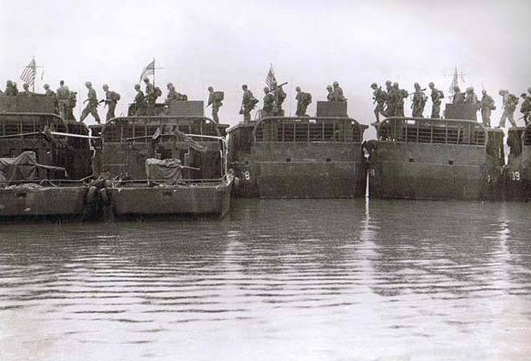

[**Charles Zies**](https://www.facebook.com/charles.zies?fref=gs&__tn__=%2CdC-R-R&eid=ARAdo8jy-1W5mWAbdHkzEq5mqU4ZLBqX92lGGychou3q1faV9q5M3wYShjCqIk3R63qxmIu2e9l5N4-y&hc_ref=ARQpiCE-0FziSYgM-n0DY7Oh4Oy8KIjkEEqFNbaRhV3pqWn3_fG80ZNLg908fJupqK0&dti=195572170458597&hc_location=group)

[Yesterday at 9:40 AM](https://www.facebook.com/groups/195572170458597/permalink/3424637474218701/)

APRIL 1, 1967 – WILEY WOUNDED 1

We had been patrolling in the Rung Sat. The Rung Sat was a swamp area which was used to filter supplies and men into the Mekong Delta. We were supposed to destroy everything in the area. Anything or anyone in this area was considered the enemy.

We were walking one day and we heard, “Get down!” All of a sudden this water buffalo started running up the middle of the column. It was snapping off trees with his horns. Every one of us started diving out of the way. When the buffalo got to the end of the column the machine gunner killed it.

We found storehouses of rice, a base camp with bunkers and printing presses. They were telling the people to defect. We found little jails above the ground for prisoners and animals. Everything was to be killed or destroyed.

We were walking in this swamp area one day. You would walk, look around. Walk, look around. The mud would cause your bones to be pulled out of joint. Sometimes the water would be knee deep. Sometimes the mud would be like quicksand. You would sink down in it and someone would have to pull or dig you out.

We were at the end of a patrol and an out-point man was tired. Our squad leader Ken Wiley took his place. The leaders were not supposed to be at the front. They were to direct from behind. Our squad leaders and Officer did their fair share of risk taking. Ken replaced Dones at point. He had only been walking a little while when we heard a loud explosion. Black billowy smoke went up in the air. That usually meant a Chinese grenade. Ken Wiley was screaming at the top of his voice.

Lieutenant Heller crawled over where he was. They called up the medic. Ken had tripped a grenade right by his leg. Lieutenant Hezller called me up to comfort Wiley while the medic worked on him. I told him he would get to go home and be with his wife. I tried to say words of comfort but he was in terrible pain. I looked down at his leg and it looked like a perforated sieve. I told the medic he was bleeding a lot. I looked up and Lieutenant Heller was looking at me with the meanest look. I’m thinking why is he mad at me? Then I remembered. I had broken one of the cardinal rules of First Aid. He was in tremendous pain, bleeding a lot and I could have killed him by causing him to go into shock. We started cutting down trees for a landing zone. All we had was a dull machete. The copter came in and we had to lift the wounded up into the helicopter. I remember Wiley’s leg dangling without support. We never saw him again. We waited several months to hear how he turned out. Several years later we found out he survived numerous surgeries, numerous bouts of infection. He kept on going. Every day is still filled with pain. He mountain climbs, kayaks and enjoys the out-of- doors. He wrote a paper called “Not on My Mother – in – Laws Birthday” about his experience. Ken Wiley's wood carving of SP4 Charlie Zies

Yesterday I was reminded of the fact that I have too much lead in my ass. The shrapnel in my hips keep them from being able to get any sort of MRI image of my hips. Same thing happened with my left leg 20 years ago. That time they actually thought the MRI was broken even though I told them about all of the shrapnel in my legs. Life is so much fun.

KEN WILEY’S EXPLANATION OF APRIL 1ST

From my prospective, the pilot did not even have an inch of clearance to settle into. The tips of the rotor blades were constantly hitting the tops of the trees as he settled in to pick me up. Then there were so many stumps and it was so tight he stopped in a hover five feet off of the ground. Then, thanks to some really strong arms, they hoisted me into the copter. I started to breathe normally again as he got clear of the trees as we headed to Vung Tao.

The effort that everyone put forth to getting me out of there was monumental and I really do not understand how everyone was able to clear so many trees in such a short time. I truly thank everyone from the bottom of my heart for helping save my life. Every one of you did as much as even the doctors did to make me whole again or close to it.

Thanks for all of the kind words about me on this day I just wish everyone could have made it back. Wow, that was 49 years ago. I don't think any of us look day older. ϑ

For those that know about my bike accident, I ended up with a broken rib, a good concussion and a lot of contusions and missing skin. I was only in the ER for about 3 hours and sent on my merry way to deal with a total state of confused with a scrambled brain. They were wonderfull

Top of Form

[53Gary Grahn, David Graves and 51 others](https://www.facebook.com/ufi/reaction/profile/browser/?ft_ent_identifier=ZmVlZGJhY2s6MzQyNDYzNzQ3NDIxODcwMQ%3D%3D&av=100006613033508)

[14 Comments](https://www.facebook.com/groups/195572170458597/permalink/3424637474218701/)

[**Gregory L. Brenner**](https://www.facebook.com/gregory.l.brenner?comment_id=Y29tbWVudDozNDI0NjM3NDc0MjE4NzAxXzM0MjQ2OTM1OTc1NDY0MjI%3D) I was on A-91-5 one day (probably that day you mentioned first) when we heard a burst of machine gun fire in an otherwise quite time. I got on the radio to find out what was going on and somebody came back and said “one of the Army units had to kill a water buffalo.” I remember thinking how that would scare the crap out of a man to see a water buffalo charging!

[4](https://www.facebook.com/ufi/reaction/profile/browser/?ft_ent_identifier=ZmVlZGJhY2s6MzQyNDYzNzQ3NDIxODcwMV8zNDI0NjkzNTk3NTQ2NDIy&av=100006613033508)[**Wayne King**](https://www.facebook.com/wayne.king.37669?comment_id=Y29tbWVudDozNDI0NjM3NDc0MjE4NzAxXzM0MjQ3ODM1MzQyMDQwOTU%3D) Old Reliable 3rd 60th Charlie Company ‘68 ‘69.... bless you Brother .

[2](https://www.facebook.com/ufi/reaction/profile/browser/?ft_ent_identifier=ZmVlZGJhY2s6MzQyNDYzNzQ3NDIxODcwMV8zNDI0NzgzNTM0MjA0MDk1&av=100006613033508)[**CA Pantino**](https://www.facebook.com/ca.pantino?comment_id=Y29tbWVudDozNDI0NjM3NDc0MjE4NzAxXzM0MjQ5NzIwODA4NTE5MDc%3D) 9ID Cco 3/60 4plt Mekong Delta 66/67 WIA👨‍🦽  
Brother , Thank God we made it.  
Take care of yourself. 🌹🤝

[**CA Pantino**](https://www.facebook.com/ca.pantino?comment_id=Y29tbWVudDozNDI0NjM3NDc0MjE4NzAxXzM0MjQ5ODU2Mjc1MTcyMTk%3D) Glad you made it.  
I have been told a number of times,  
No MRI. Last year in civilian health care, they told me since 50+ years had past, there was enough scar tissue and it wouldn’t be a problem. I got it in writing to protect my dear wife. Had the MRI,no problem. I’m sure this must vary from person to person. Best wishes, Brother. …[See More](https://www.facebook.com/groups/195572170458597/permalink/3424637474218701/)

[**Kenneth Zimmerman**](https://www.facebook.com/kenneth.zimmerman.7?comment_id=Y29tbWVudDozNDI0NjM3NDc0MjE4NzAxXzM0MjQ5OTUyNjQxODI5MjI%3D) I was in the 9 5/60 and A 3/47 in 1967 Dong Tam

[**Delano Poppelreiter**](https://www.facebook.com/delano.poppelreiter?comment_id=Y29tbWVudDozNDI0NjM3NDc0MjE4NzAxXzM0MjUwMzY5NDc1MTIwODc%3D) Thanks for the stories. We will never forget....💓

[**David Todd**](https://www.facebook.com/david.todd.9659?comment_id=Y29tbWVudDozNDI0NjM3NDc0MjE4NzAxXzM0MjUwNzYwMTQxNzQ4NDc%3D) There are many of us who understand what you are talking about... I always said 40 days and 40 nights in the Rung Sat. What a shit hole..

[**Steven Pitkin**](https://www.facebook.com/steven.pitkin.16?comment_id=Y29tbWVudDozNDI0NjM3NDc0MjE4NzAxXzM0MjU0ODIzMDA4MDA4ODU%3D) I remember that we were never to stare at water buffalo bc they chewed on marijuana leaves and got paranoid and then charge you. This happened once as one got real violent with our platoon and someone used a LAW which cut the buffalo in half, stopping the 2 others with it. Papasan was pretty upset with this as would any farmer if you blew up his John Deer, so we paid 145 P to the farmer.

[**Robert W Bush**](https://www.facebook.com/robert.bush.92102?comment_id=Y29tbWVudDozNDI0NjM3NDc0MjE4NzAxXzM0MjU2NDEyNDA3ODQ5OTE%3D) B 3/47, I recall an incident when we had just gotten off the LCMs and was moving to our objectives when there was the sound of machine gun fire. I had the RTO with me and he said that our A company had been attacked by a water buffalo and it gouged s…[See More](https://www.facebook.com/groups/195572170458597/permalink/3424637474218701/)

[**Greg Eastman**](https://www.facebook.com/greg.eastman.5?comment_id=Y29tbWVudDozNDI0NjM3NDc0MjE4NzAxXzM0MjU2Njk3ODc0NDg4MDM%3D) We carried ropes in our 9th Avn Huey to help pull you guys out of the mud before the tide came in

* [**William Frede**](https://www.facebook.com/william.frede.7?comment_id=Y29tbWVudDozNDI0NjM3NDc0MjE4NzAxXzM0MjYyNTE5MDA3MjM5MjU%3D) We took the 9th to the Rung Sat shortly after our boats arrived in-country.

Bill Wolters commenting on the Corona Virus Hello all: Staying at home and "sheltering in place" gives me time to think. I remember being in Vietnam and on patrol for days at a time. Slogging through the jungle, walking through mud and God only knows what else. Fording rivers and streams which were draining what? Containing what? Walking through rice paddies fertilized with what? Sleeping in the mud, made up of what? Drinking out of canteens which were still wet from being doused with the latest stream water. Eating out of C-ration cans that had been exposed to all the same mud and water. Not showering or changing clothes for days at a time. Never washing my hands in the field, unless it was in the same rivers and streams. Now it's wash your hands every five minutes or you'll catch the virus. Who are the people who made up these rules? They sure as hell don't have an infantry background. Scared of the virus We're all probably immune to the virus anyway, with what we were exposed to and the way we used to live. Wolters

Top of Form

[**William Frede**](https://www.facebook.com/william.frede.7?comment_id=Y29tbWVudDozNDI1NTE3MTA3NDY0MDcxXzM0MjYyNTAzMjczOTA3NDk%3D) AO exposure, hell we swam in those AO infested waters. Ate Malaria pills on a daily basis.

Bottom of Form

[**David Graves**](https://www.facebook.com/david.graves.712?comment_id=Y29tbWVudDozNDI0NjM3NDc0MjE4NzAxXzM0MjYwNDYzMTQwNzc4MTc%3D) Such a wonderful place

[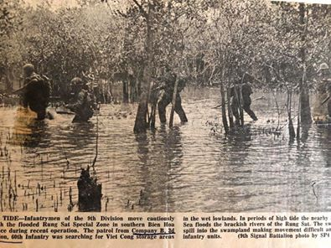](https://www.facebook.com/photo.php?fbid=10222230803303074&set=p.10222230803303074&type=3)

[**William Frede**](https://www.facebook.com/william.frede.7?comment_id=Y29tbWVudDozNDI0NjM3NDc0MjE4NzAxXzM0MjYyNTE5MDA3MjM5MjU%3D) We took the 9th to the Rung Sat shortly after our boats arrived in-country.

Bottom of Form