MRFA Articles of Interest

Links of interest

www.armytimes.com

www.navytimes.com

www.,Military.com

www.airgotce.com

Stars and Stripes
www.stripes.com

Hi Mike. Albert and Don:

I came across this resource today: https://www.archives.gov/research/military/logbooks/navy-online

It has the daily deck logs for each of the ships in our little fleet. There is one log book for each month. There is an entry every four hours about the location and status of the ship. Underway info includes course and speed. Other info included are incidents involving malfunctions, injuries, the status of missing crew members, the results of disciplinary actions, flight operations, refueling and re-supply and embarkation/debarkation of the army.

I read the Colleton logs and was surprised that my memory of our first month in Vung Tau in May 1967 was totally wrong. I could have sworn that we were tied up to a dock there, but the logs indicate that we were anchored out the whole time before heading up to Dong Tam. Interesting, to say the least.

Anyway, I thought you would want this for the history page.

Thanks for your work.

Tom Scott, FTG2
USS COLLETON APB-36 1966-1968
I noticed not all the ships that served with or supported the MRF are not listed. but this link can help you find your ships logs. Thanks to Tom Scott for providing this information . Tom is very knowledgeable and well versed on the Brown Water Navy and Army units that served with the MRF/ Albert

The Entire Vietnam War Casualty Profiles
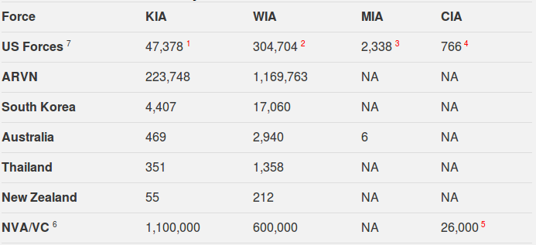
Legend:
KIA = Killed in Action
WIA = Wounded in Action
MIA = Missing in Action
CIA = Captured in Action
Notes:
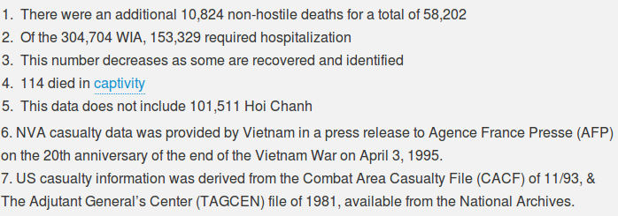

MRF Summary Report - February 1967
MOBILE RIVERINE FORCE SUMMARY
ComRivFlotOne / ComRivSuppron - Seven
Command History
February 1967
On the 1st of February 1967, ComRivFlotOne/ComSuppRon-Seven, Captain Wade C. Wells, USN, 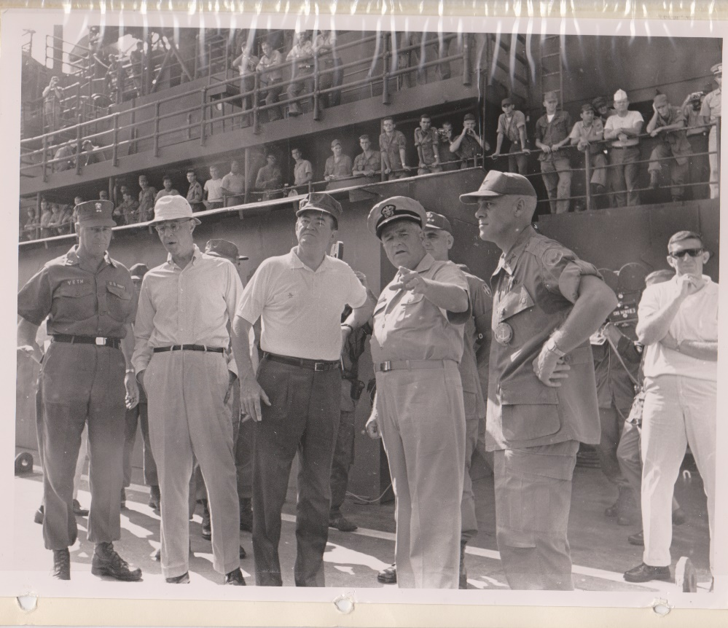
L-R Adm Veth-AMB Buntner-V P Humphrey- Captain Wells. Col David 2nd Bde
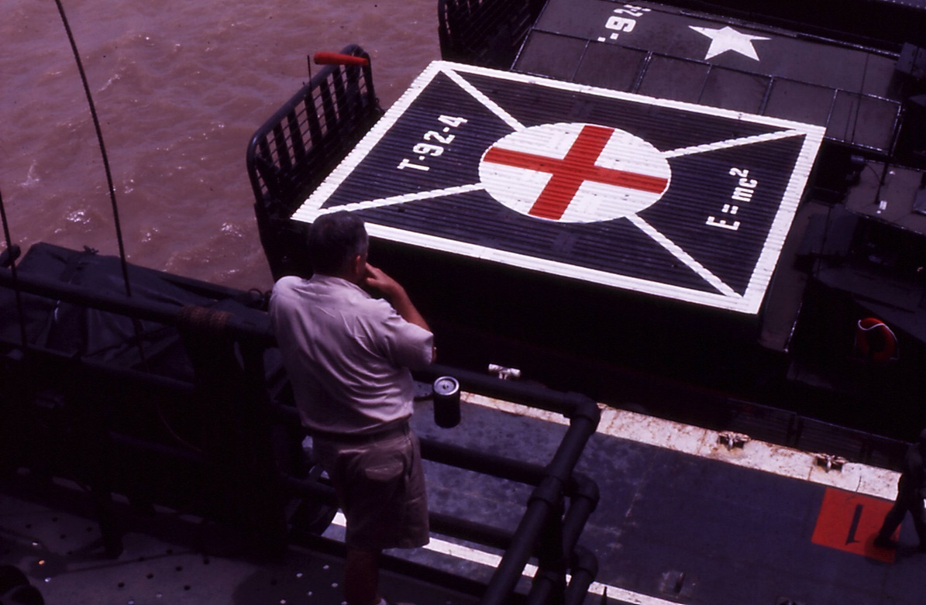
Commodore Wade Wells checking out 1st helo pads done by the USS Askari ARL-30

and the major portion of his staff were at the Naval Amphibious Base Coronado preparing for their deployment to Vietnam. The advanced echelon of the command divided between the USS Whitfield County. LST 1169, 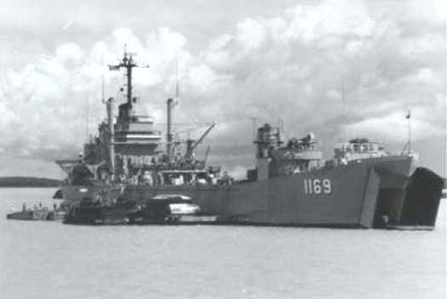
and the Headquarters for Commander Naval Forces Vietnam, Saigon. Under the leadership of Chief Staff
Officer Captain Edwin P. Smith Jr. USN, this advanced group of ten officers and 15 enlisted men was preparing for the arrival of the staff of River assault Flotilla One and was overseeing the training of River Assault Squadron Nine 4 Officers and 9 enlisted men. And River Assault Division Ninety-One 2 officers and 135 enlisted. Both of which were embarked on the Whitfield County. Serving as temporary support ship, Whitfield County was anchored in Vung Tau Harbor, one mile from Vung Tau.
Elements of River Assault Squadron Nine (RAS-9) and River Assault Division Ninety- One (RAD-91) continued training with the 9th Infantry Division's 3rd Brigade, using boats borrowed from the Vietnamese Navy (VNN) RAS-9 and RAD-91 were exercising with the Army in LCM operations. This training followed a four-day cycle set up by ComRivFlot One personnel.
Day 1. Movement to the ship, lectures by ship and flotilla personnel.
Day 2. Wet net training and beaching and gunnery exercises.
Day 3. Day and night exercises with several insertions and extractions at selected areas in the RSSZ.
Day 4. Another exercise in the RSSZ with insertion and extraction, at various operation areas, and a return to the support ship. By February 5, five such cycles had been completed. Other elements of the squadron and division were undergoing training as observers aboard VN RAG boats at Can Tho and My Tho.
During the TET holidays from 9-12 February training operations were secured and the time was used for boat maintenance and repairs. On the 12th of February, RAS 9 and RivDiv-91 began working with the 3rd/47th 2nd Brigade 9th Infantry Division. In the first four-day cycle "A" and "B" Company participated. On February 16, 1967, "C" and "E" Companies were scheduled to start the same four-day cycle That "A" and "B" Companies had just completed. Increased enemy activity in the Long Tau channel of the RSSZ caused a change. ComNavForV on 16 February 1967, ordered RAS-9 and RAD-91 to support two companies of the 3rd Battalion in the Rung Sat Special Zone (RSSZ). This message marked the end of training and the beginning of combat operations for River Assault Flotilla One…. At 0800 hours, units of RAD-91 landed "A" and "B" companies of the 3rd/47th in the RSSZ, thus began Operation River Raider One, the First U.S. Riverine Assault operation since the Civil War. Also on the 16th of February, the arrival of the USS Askari (ARL-30)
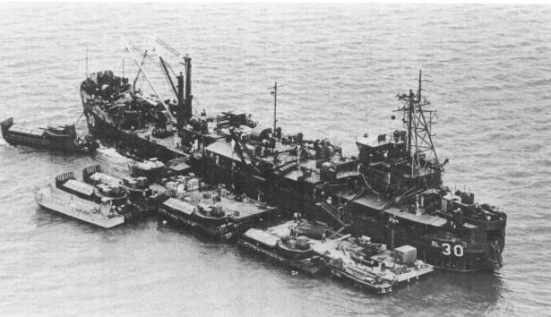
gave Commander River Assault Squadron SEVEN, a repair capability. The following morning at 0800, Army and Navy personnel gathered at the Command Post in the RSSZ for a brief on the already-commenced operation. On the 18th of February, a Joint Tactical Operation Center (JTOC) was established on the Whitfield County. Search and destroy and ambush attempts by the Army failed to produce and significant contact with the enemy. However, positive evidence of his recent presence was ascertained.
On the 23rd of February, the staff of ComRivFlot One arrived in Danang and was transferred to Vung Tau on the 25th. The USS Henrico (APA-45) stood in Vong Tau Harbor on the 24th of February to relieve the Whitfield County as interim support ship for ComRivFlot One.
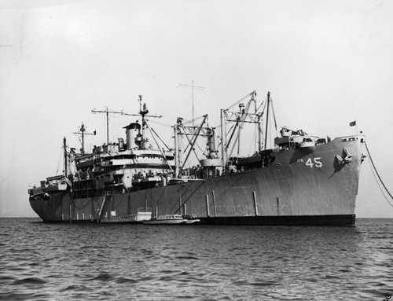
Captain Wells arrived in Saigon on the 27th of February after participating in briefing at CinPacFlt Headquarters. RAD-92 arrived in Saigon on the 28th and was shuttled to Vung Tau and USS Henrico during the day. At 0801 (local time) on 28 February Riverine Assault Force (TF-117) was activated under the command of Captain Wells. Units assigned to TF-117 were River Assault Flotilla One / River Support Squadron Seven Staff / River Assault Squadron Nine Staff, River Assault Division Ninety-One and Ninety-Two and the USS Askari (ARL-30). Captain Wells flew to Vung Tau on the 28th and broke his pennant at 1010 (local Time) in USS Henrico.
Significant among February 1967 activities for ComRivFlot One was (1) the change of operational status on the 16th, (2) the arrival of ComRivFlot One on the 27th and, (3) the activation of TF-117 on 28 February 1967.

Oct 8 1968

U.S. Navy and South Vietnamese Forces Launch Operation Sealords

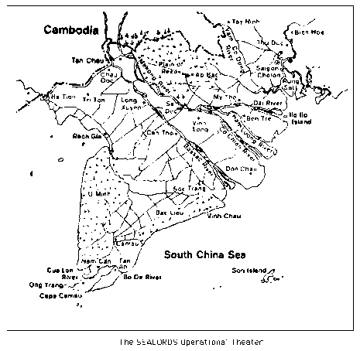
Operation Sealords (SEALORDS is an acronym for Southeast Asia Lake, Ocean, River, and Delta Strategy) was a military operation that took place during the Vietnam War.
Conceived by Elmo R. Zumwalt, Jr., it was a joint operation between U.S. and South Vietnamese forces. Sealords launched on October 8, 1968, and was intended to disrupt North Vietnamese supply lines in and around the Mekong Delta. As a two-year operation, by 1971 all aspects of Sealords had been turned over to the South Vietnam Navy.
As U.S. forces prepared the South Vietnamese military to assume complete responsibility for the war, they also worked to keep pressure on the enemy. In fact, from 1968 to 1971, the allies exploited the Communists' staggering battlefield losses during the Tet attacks by pushing the enemy's large main force units out to the border areas, extending the government's presence into Viet Cong strongholds, and consolidating control over population centers.
The Navy in particular spearheaded a drive in the Mekong Delta to isolate and destroy the weakened Communist forces. The Sealords program was a determined effort by U.S. Navy, South Vietnamese Navy, and allied ground forces to cut enemy supply lines from Cambodia and disrupt operations at his base areas deep in the delta. It was developed by Vice Admiral Elmo R. Zumwalt, Jr., appointed COMNAVFORV (= Commander US Naval Forces Vietnam) in September 1968.
When Admiral Zumwalt launched Sealords in October 1968 with the blessing of the new COMUSMACV (Commander of US Military Assistance Command Vietnam), General Creighton Abrams, Allied naval forces in South Vietnam were at peak strength. The U.S. Navy's Coastal Surveillance Force operated 81 Swift boats, 24 Coast Guard WPBs, and 39 other vessels. The River Patrol Force deployed 258 patrol and minesweeping boats; the 3,700-man Riverine Assault Force counted 184 monitors, transports, and other armored craft; and Helicopter Attack Squadron Light (HAL) 3 flew 25 armed helicopters. This air component was soon augmented by the 15 fixed-wing OV-10 Bronco aircraft of Attack Squadron Light (VAL) 4, activated in April 1969. The lethal Bronco flown by the "Black Ponies" of VAL-4 carried 8 to 16 5- inch Zuni rockets, 19 2.75-inch rockets, 4 M-60 machine guns, and a 20-millimeter cannon. In addition, five SEAL platoons supported operations in the delta.
Complementing the American naval contingent were the Vietnamese Navy's 655 ships, assault craft, patrol boats, and other vessels. To focus the allied effort on the Sealords campaign, COMNAVFORV appointed his deputy, Rear Admiral William Hiram House, USN the operational commander, or "First Sealord," of the newly activated Task Force 194. Although continuing to function, the Game Warden, Market Time, and Riverine Assault Force operations were scaled down and their personnel and material resources increasingly devoted to Sealords. Task Force 115 PCFs mounted lightning raids into enemy-held coastal waterways and took over patrol responsibility for the delta's larger rivers. This freed the PBRs for operations along the previously uncontested smaller rivers and canals. These intrusions into former Viet Cong bastions were possible only with the on-call support of naval aircraft and the heavily armed riverine assault craft.
In the first phase of the Sealords campaign allied forces established patrol "barriers," often using electronic sensor devices, along the waterways paralleling the Cambodian border. In early November 1968, PBRs and riverine assault craft opened two canals between the Gulf of Siam at Rach Gia and the Bassac River at Long Xuyen. South Vietnamese paramilitary ground troops helped naval patrol units secure the transportation routes in this operational area, soon named Search Turn. Later in the month, Swift boats, PBRs, riverine assault craft, and Vietnamese naval vessels penetrated the Giang Thanh-Vinh Te canal system and established patrols along the waterway from Ha Tien on the gulf to Chau Doc on the upper Bassac. As a symbol of the Vietnamese contribution to the combined effort, the allied command changed the name of this operation from Foul Deck to Tran Hung Dao I. Then in December U.S. naval forces pushed up the Vam Co Dong and Vam Co Tay Rivers west of Saigon, against heavy enemy opposition, to cut infiltration routes from the "Parrot's Beak" area of Cambodia. The Giant Slingshot operation, so named for the configuration of the two rivers, severely hampered Communist resupply in the region near the capital and in the Plain of Reeds. Completing the first phase of the Sealords program, in January 1969 PBRs, assault support patrol boats (ASPB), and other river craft established patrol sectors along canals westward from the Vam Co Tay to the Mekong River in Operation Barrier Reef. Thus, by early 1969 a patrolled waterway interdiction barrier extended almost uninterrupted from Tay Ninh northwest of Saigon to the Gulf of Siam.
Source: Wikipedia Added by: Rob Brent
Operation Sealords was a military operation that took place during the Vietnam War. Conceived by Elmo R. Zumwalt, Jr., it was a joint operation between U.S. and South Vietnamese forces. Sealords launched on October 8, 1968, and was intended to disrupt North Vietnamese supply lines in and around the Mekong Delta. As a two-year operation, by 1971 all aspects of Sealords had been turned over to the South Vietnam Navy.

