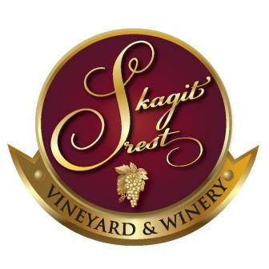
The ‘Crest Club’ Wine Club

Skagit Crest Vineyard & Winery is happy to offer membership into the ‘Crest Club’. By becoming a member, you will receive a 10% discount on all wines purchased, a 15 % discount if purchasing two or more cases at a time, tasting fees waived, first access to new releases, and have opportunities to attend members only special events. There is no fee to join – we only ask that you commit to the purchase of a case of wine per year; minimally 4 bottles each in January, April and September. You may choose to pick up your wines at the tasting room, our Sedro Woolley winery, or shipped to you. If you choose to ship the wine, an adult age 21 or older needs to sign when the Fed Ex package is delivered.

(Please print)
Sign Up Date ____/____/____
Name ______________________________________________________________________
Mailing Address ___________________________ City ___________________________ State ____ Zip _______
Home Phone ___________________________________ Cell Phone ____________________________
Email _______________________________________________________________________
Shipping Address (if different than mailing address) (Adult signature required)
__________________________________________ City ________________________ State ____ Zip_________

Signature ________________________________________________________

If mailing application, please mail to: 22230 Cully Rd., Sedro Woolley, WA 98284

