

_____________________________________________________________________________________

Solid Modeling in Computer Graphics

by Vidhi Verma & Rashmi Baghel

BCA, Ambedkar Institute of technologies



*ABSTRACT*

The Research paper contains a brief introduction about solid modeling. How solid modeling is developed and how it is derived and it solves the drawbacks of the wireframe and surface modeling. This research paper contains the past present and future of solid modeling and 3D designing.

I. INTRODUCTION

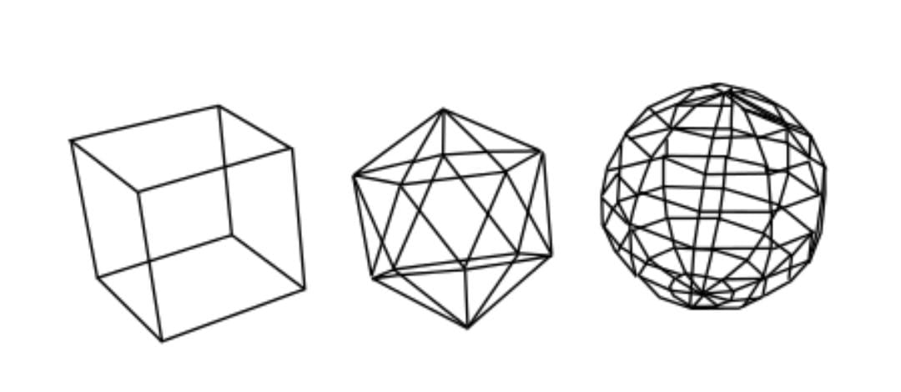As we know that before solid modeling, we have two more methods, which are wireframe modeling and surface modeling ..... these both are not properly efficient for modeling as wireframe works on wire or we can say borders first and mainly and surface modeling works on surfaces but none of them works on the solid shape itself.... so , by combining both wireframe and surface modeling's advantages and features, we generated solid modeling ... solid modeling works on solid shapes and 3d shapes more efficiently and with more perfection.... it works on vertices, edges , and faces and properly connect them for a complete viewpoint ..... also, it consists of geometric and topological data like shape , size , Connecticut nodes, etc... ..

Solid modeling was rootly created for the verification and designing of machines and mechanical assembly... but because of its efficiency and efficient outputs ... it has evolved in other industries and became popular throughout the industries.

Industries like video games, interior designing, media and 3d printings, etc . Uses 3d modeling or solid modeling .... so after this, we can simply say that solid modeling is not just for engineers nowadays....... everyday new solid modeling techniques and updates are coming, and each one has increased efficiency and easy usage methods....so, yes, the solid modeling is just at its beginning .... the future will be wide and open for it.

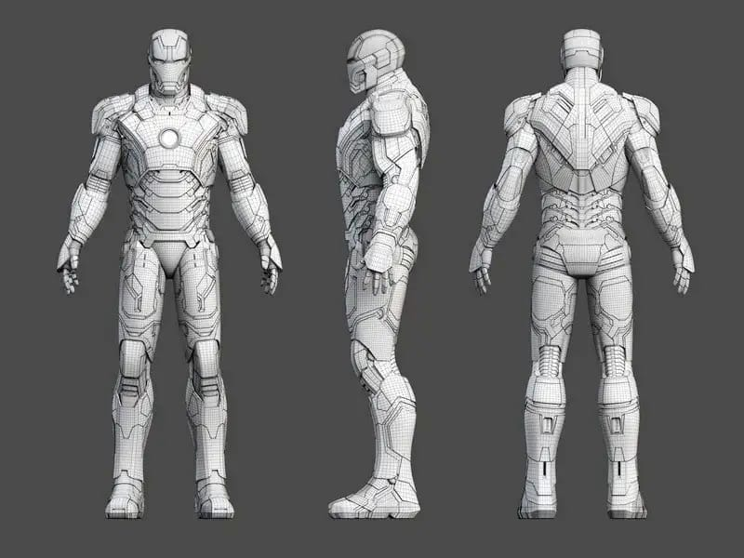

II. HISTORY and FUTURE.

The historical development of solid modelers has to be seen in context of the whole history of CAD, the key milestones being the development of the research system BUILD followed by its commercial spin-off Romulus which went on to influence the development of Parasolid, ACIS and Solid Modeling Solutions. One of the first CAD developers in the Commonwealth of Independent States (CIS), ASCON began internal development of its own solid modeler in the 1990s.[9] In November 2012, the mathematical division of ASCON became a separate company, and was named C3D Labs. It was assigned the task of developing the C3D geometric modeling kernel as a standalone product – the only commercial 3D modeling kernel from Russia.[10] Other contributions came from Mäntylä, with his GWB and from the GPM project which contributed, among other things, hybrid modeling techniques at the beginning of the 1980s. This is also when the Programming Language of Solid Modeling PLaSM was conceived at the University of Rome. **PLaSM (Programming Language of Solid Modeling)** is an open-source scripting language for solid modeling, a discipline that constitutes the foundation of computer-aided design and CAD systems. In contrast to other CAD programs, PLaSM emphasizes scripting rather than interactive GUI work. Users can create arbitrarily complex designs using a wide range of simple 2D and 3D objects, advanced curves and curved surfaces, Boolean operations, and elementary as well as advanced geometric transformations. CAD was introduced in 1960 but it was costly and for windows only. But in 2001 Free CAD was introduced which was an open source and was free of cost. Free CAD was also available in linux and ubuntu. The current version of **UNITY** that is UNITY 2022.1.3 (released on May-31-2022) is the latest update in solid modeling and designing field. This updated version holds tech stream and is compatible for several platforms. UNITY 2022.1.3 is the most user friendly and most convenient software which is available on linux/windows/centOS.

The future is full of solid modeling as it is one of the field where everyone likes to be in and which can be use in every field as we discussed above.

III. CONCLUSION

As we know that before solid modeling, we have two more methods, which are wireframe modeling and surface modeling ..... these both are not properly efficient for modeling as wireframe works on wire or we can say borders first and mainly and surface modeling works on surfaces but none of them works on the solid shape itself.... so , by combining both wireframe and surface modeling's advantages and features, we generated solid modeling ... solid modeling works on solid shapes and 3d shapes more efficiently and with more perfection.... it works on vertices, edges, and faces and properly connect them for a complete viewpoint ..... also, it consists of geometric and topological data like shape, size , Connecticut nodes, etc.....

REFERENCES

[1] SARITA VERMA MAM’S NOTES.

[2] https://www.sciencedirect.com/topics/engineering/solid-modeling

[3] Ching L. Teo, Cornelia Fermuller, Yiannis Alimonies; Proceedings of the IEEE International Conference on Computer Vision (ICCV), 2015, pp. 1644-1652.

[4] G. Ferin , Carsten Witt, History of solid modeling 605, 2022, Pages 21-41, ISSN 0304-3975

[5] Foley, Van Dam, Finer, Hughes, Computer Graphics Principles & Practice of FREECAD , 2001, Pearson