Runway Cafe Appetizer Buffet

Entree List (Pick 3)

Turkey and Cream Cheese Roll-ups
Angus Cheeseburger Sliders
Mini Sandwiches (pesto chicken salad,
ham and cheese, and pimento cheese)
Swedish Meatballs
Chicken Tenders
Stuffed Mushrooms

Side List (Pick 3)

Bruschetta
Tri-Colored Pasta Salad
Vegetable Tray
Chips and Salsa
Fresh Fruit (seasonal)
Potato Salad
Dinner Rolls
Black Bean and Corn Salad

Dessert

Brownies and chocolate chip cookies

Beverages

Iced Tea or lemonade and water
Attendees | Price
Parties containing 50 people or fewer | Reduced menu and pre-order required
Parties of 50-100 people | $14.99 per person
Parties of more than 100 people | $13.99 per person
Parties of more than 150 people | $12.99 per person

Runway Cafe Casual Buffet

Entree List (Pick 3)

Angus Beef Cheeseburgers
Spicy Black Bean and Corn Burgers
(with or without cheese)
Hot Dogs
BBQ Pulled Pork
Corn Dogs
Chicken Tenders

Side List (Pick 3)

Mashed Potatoes
Green Beans
Tri-Colored Pasta Salad
Garden Salad
Baked Beans
Potato Chips
Attendees | Price
Parties containing 50 people or fewer | Reduced menu and pre-order required
Parties of 50-100 people | $14.99 per person
Parties of more than 100 people | $13.99 per person
Parties of more than 150 people | $12.99 per person

Dinner Rolls

Dessert

Brownies and Chocolate Chip Cookies

Beverages

Iced Tea or lemonade and water

Catering Packages

Trays

20 pc Chicken Finger $35.00

20 pc Assorted Half Sandwiches $80.00

20 pc Assorted Half Wraps $80.00

20 pc 1/4lb Sliders $60.00

Lays Potato Chips (20 servings) $15.00

Fresh Fruit (15-20 servings) $35.00

Raw Veggies(15-20 servings) $30.00

Tea (2 Gallons) $8.00

Lemonade (2 Gallons) $8.00

We can price out specific amounts based on the needs of your event. Inquire about any quantities differing from the above listed.

Our restaurant can customize any menu for your party. Contact us and we will work to meet your party’s needs, the phone number is (864-991-8488) and email is runwaycafegmu@gmail.com.

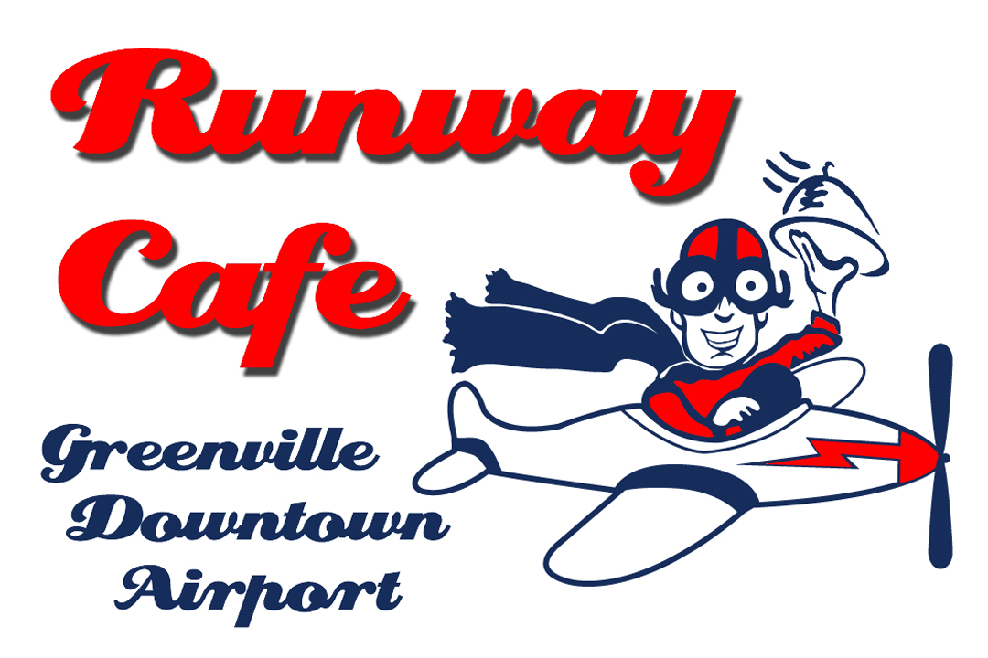

This is a brief breakdown of our various party pricing for our 3000 square foot hangar. There are more details, restrictions, and policies on our website runwaycafegmu.com and on handouts available at the cafe. The hangar makes an ideal space for wedding receptions, rehearsals, reunions, birthdays, work parties, themed parties, and much more. Give us a call at (864) 991-8488 or an email at runwaycafegmu@gmail.com to inquire about available dates, times, and details. Stop by anytime we are open to check out the hangar and see why we are quickly becoming Greenville's favorite party venue!

Hangar Rental Only

$600 for 100 people and up to 5 hours
$300 for an additional 100 people
$150 for each additional hour (past 5 hours)
$50 per non operating hour of the cafe
$75 Setup/Cleanup charge for 100 people

$125 Setup/Cleanup charge for over 100

For parties of less than 100 people that desire an hourly rate, the rental is $250 for the first hour, and $125 each added hour.

Runway Cafe Kid's Hangar Party

-Maximum of 50 people

Little Aviators PartyPackage :

Use of tables and chairs

Private use of space for up to 3 hours b

Setup and use of inflatable bounce house

Food and drink for 15 kids

Children’s Food (served with potato chips)

Landing Gear: Mini Corn Dogs

Blue Angels: Chicken Nuggets

Aviator: Grilled Cheese

The Zeppelin: Small Cheeseburger

The B52: Plain Hot Dog

Includes lemonade and water

Pricing

$300 (hangar rental up to 3 hours

and food and drink for 15 kids)

$50 Setup and cleaning charge

Prices do not include 8% taxes

Kids Hangar Rental Only

$200 for three hours,

$50 Setup and cleaning charge

Large firehouse themed bounce house: $50

Popcorn Machine : $30

A deposit of $150 is required to reserve a date. 100% refunded if cancelled before 30 days prior to event

General Information

Food is served buffet style. Children aged 4 – 10 are half price, children under 3 are free. Price includes plates, flatware, napkins, table setting, available tables and chairs, and room rental. Additional charges will be applied if the party is longer than the allotted time or occurs during non-operating hours. Party is allowed 1.5 hours previous to the reservation for setup. Parking attendants and security personnel can be provided for an additional charge, and are required for parties over 100 people. Portable restrooms are recommended (at the party’s expense) for parties over 100 people. Minimum guaranteed attendance must be received two weeks prior to the event. If attendance is less than the guaranteed number, the client will be charged for the guaranteed number. If attendance is greater, the client will be charged for the actual number. An $150 deposit is required to secure your reservation. The deposit is refundable if a cancellation is made within 30 days prior to the event. The Runway Cafe must provide all alcoholic beverages unless previously arranged with us. There is a $50 bar set up fee for parties requiring a bar. There is a $75 cleaning fee applied to all parties of less than 100 people, parties of 100 or more people are charged $125.

Restrictions:.
No loud music before 8pm
No glitter, balloons or confetti
No food preperation on site
Ask for alcohol restrictions

