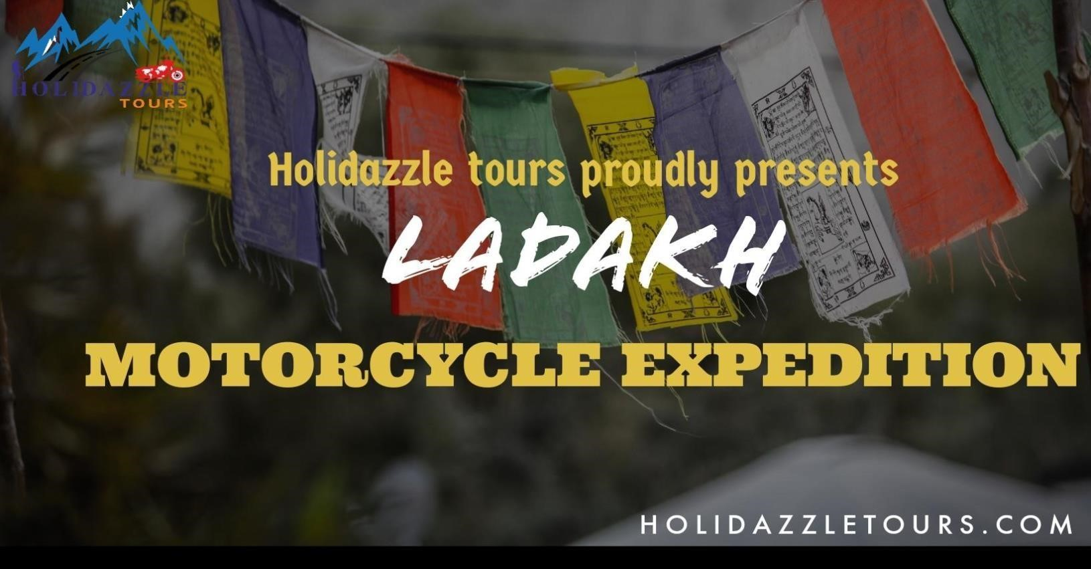
HOLIDAZZLE TOURS
10-12,Nethaji Road,Madurai-625001 | 9994144441 | toursholidazzle@gmail.com www.holidazzletours.com

AUGUST 12 2023’

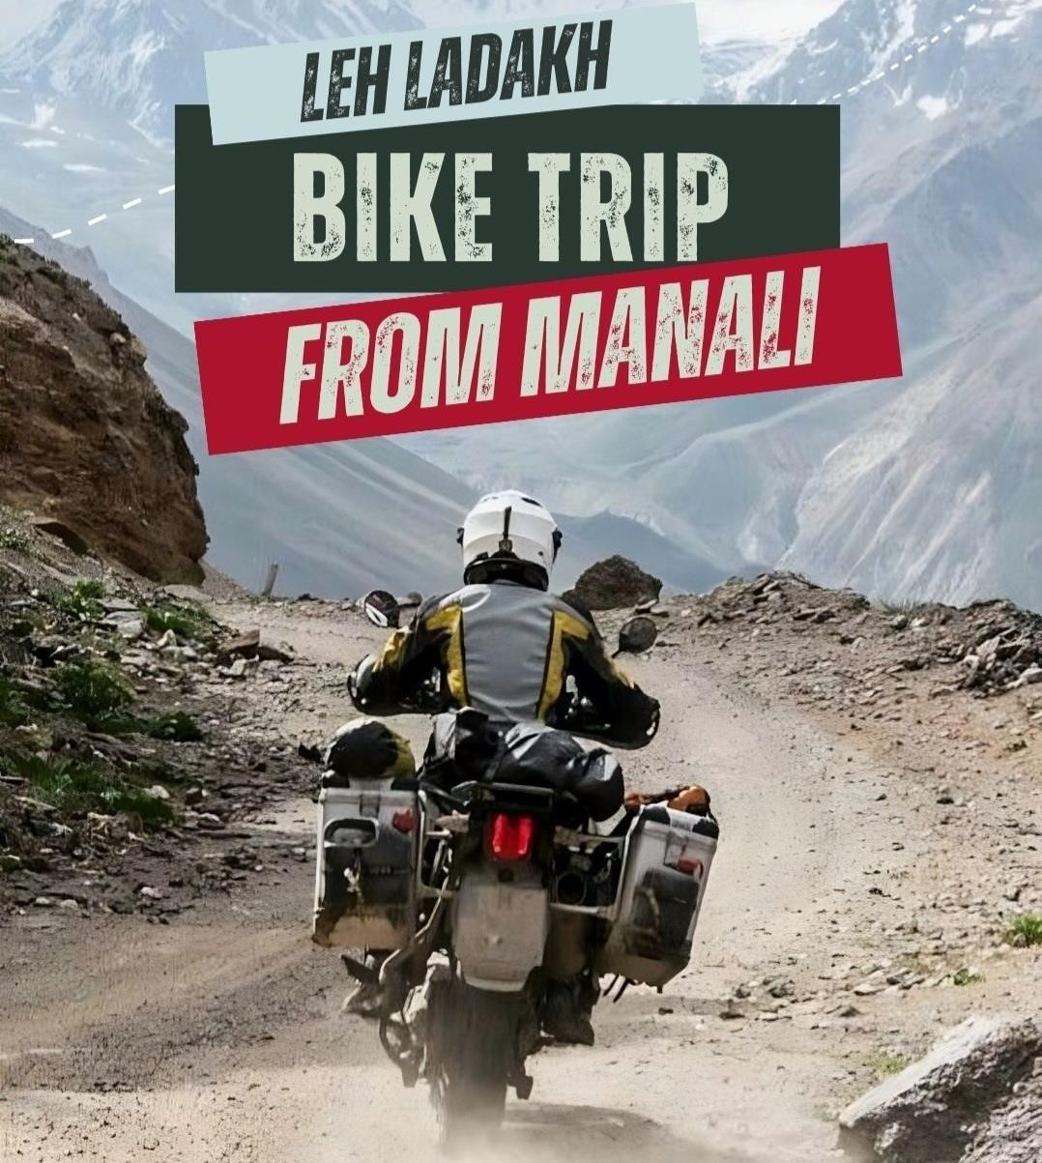
Jammu, Kashmir, and Ladakh cover the majority of the Northern Himalayan area, which has a terrain and moonscape unlike any other. It’s largely a wind-driven voyage across some of the most beautiful and challenging regions of the planet, filled with adventure, wildlife, and culture. Leh — Ladakh is a place rich with natural beauty as well as soul-stirring experiences. These are experiences that will allow you to connect with yourself, and the magnificent sights will be something you will remember for the rest of your life. Prepare for an exciting journey now that you’ve stocked up on everything you’ll need. When it comes to the fascinating Leh Ladakh trip, the old adage “there’s beauty everywhere, all you have to do is look around” is absolutely true. A vacation to Leh Ladakh in India is all about the feeling of snowcapped mountains, rough scenery, towering peaks, hazardous roads, and screaming motorcycle engines. In a nutshell, embarking on a Ladakh bike tour is all about positive feelings and a rider’s unwavering attitude.

Ladakh’s highest passes and twisting roads attract passionate riders. With the well-planned Leh Ladakh Bike Tour, which may lead oneself to bask in the bliss of the mountains. The meticulously created tour package, allows bikers to be the most trusted companion on an exciting adventure. Ladakh bike tour will cherish with memories of lifetime by providing with the ultimate adventure. The cruise will go all the way through rocky terrain, blue waters, top tourist destinations, tranquil monasteries, and more, in addition to providing with a once-inalifetime ride. The path leading to Ladakh is the same one followed by caravans on their way to the Silk Route centuries ago. If that wasn’t impressive enough, the region’s roadways are only open four months of the year, with the remaining eight
months buried in snow.
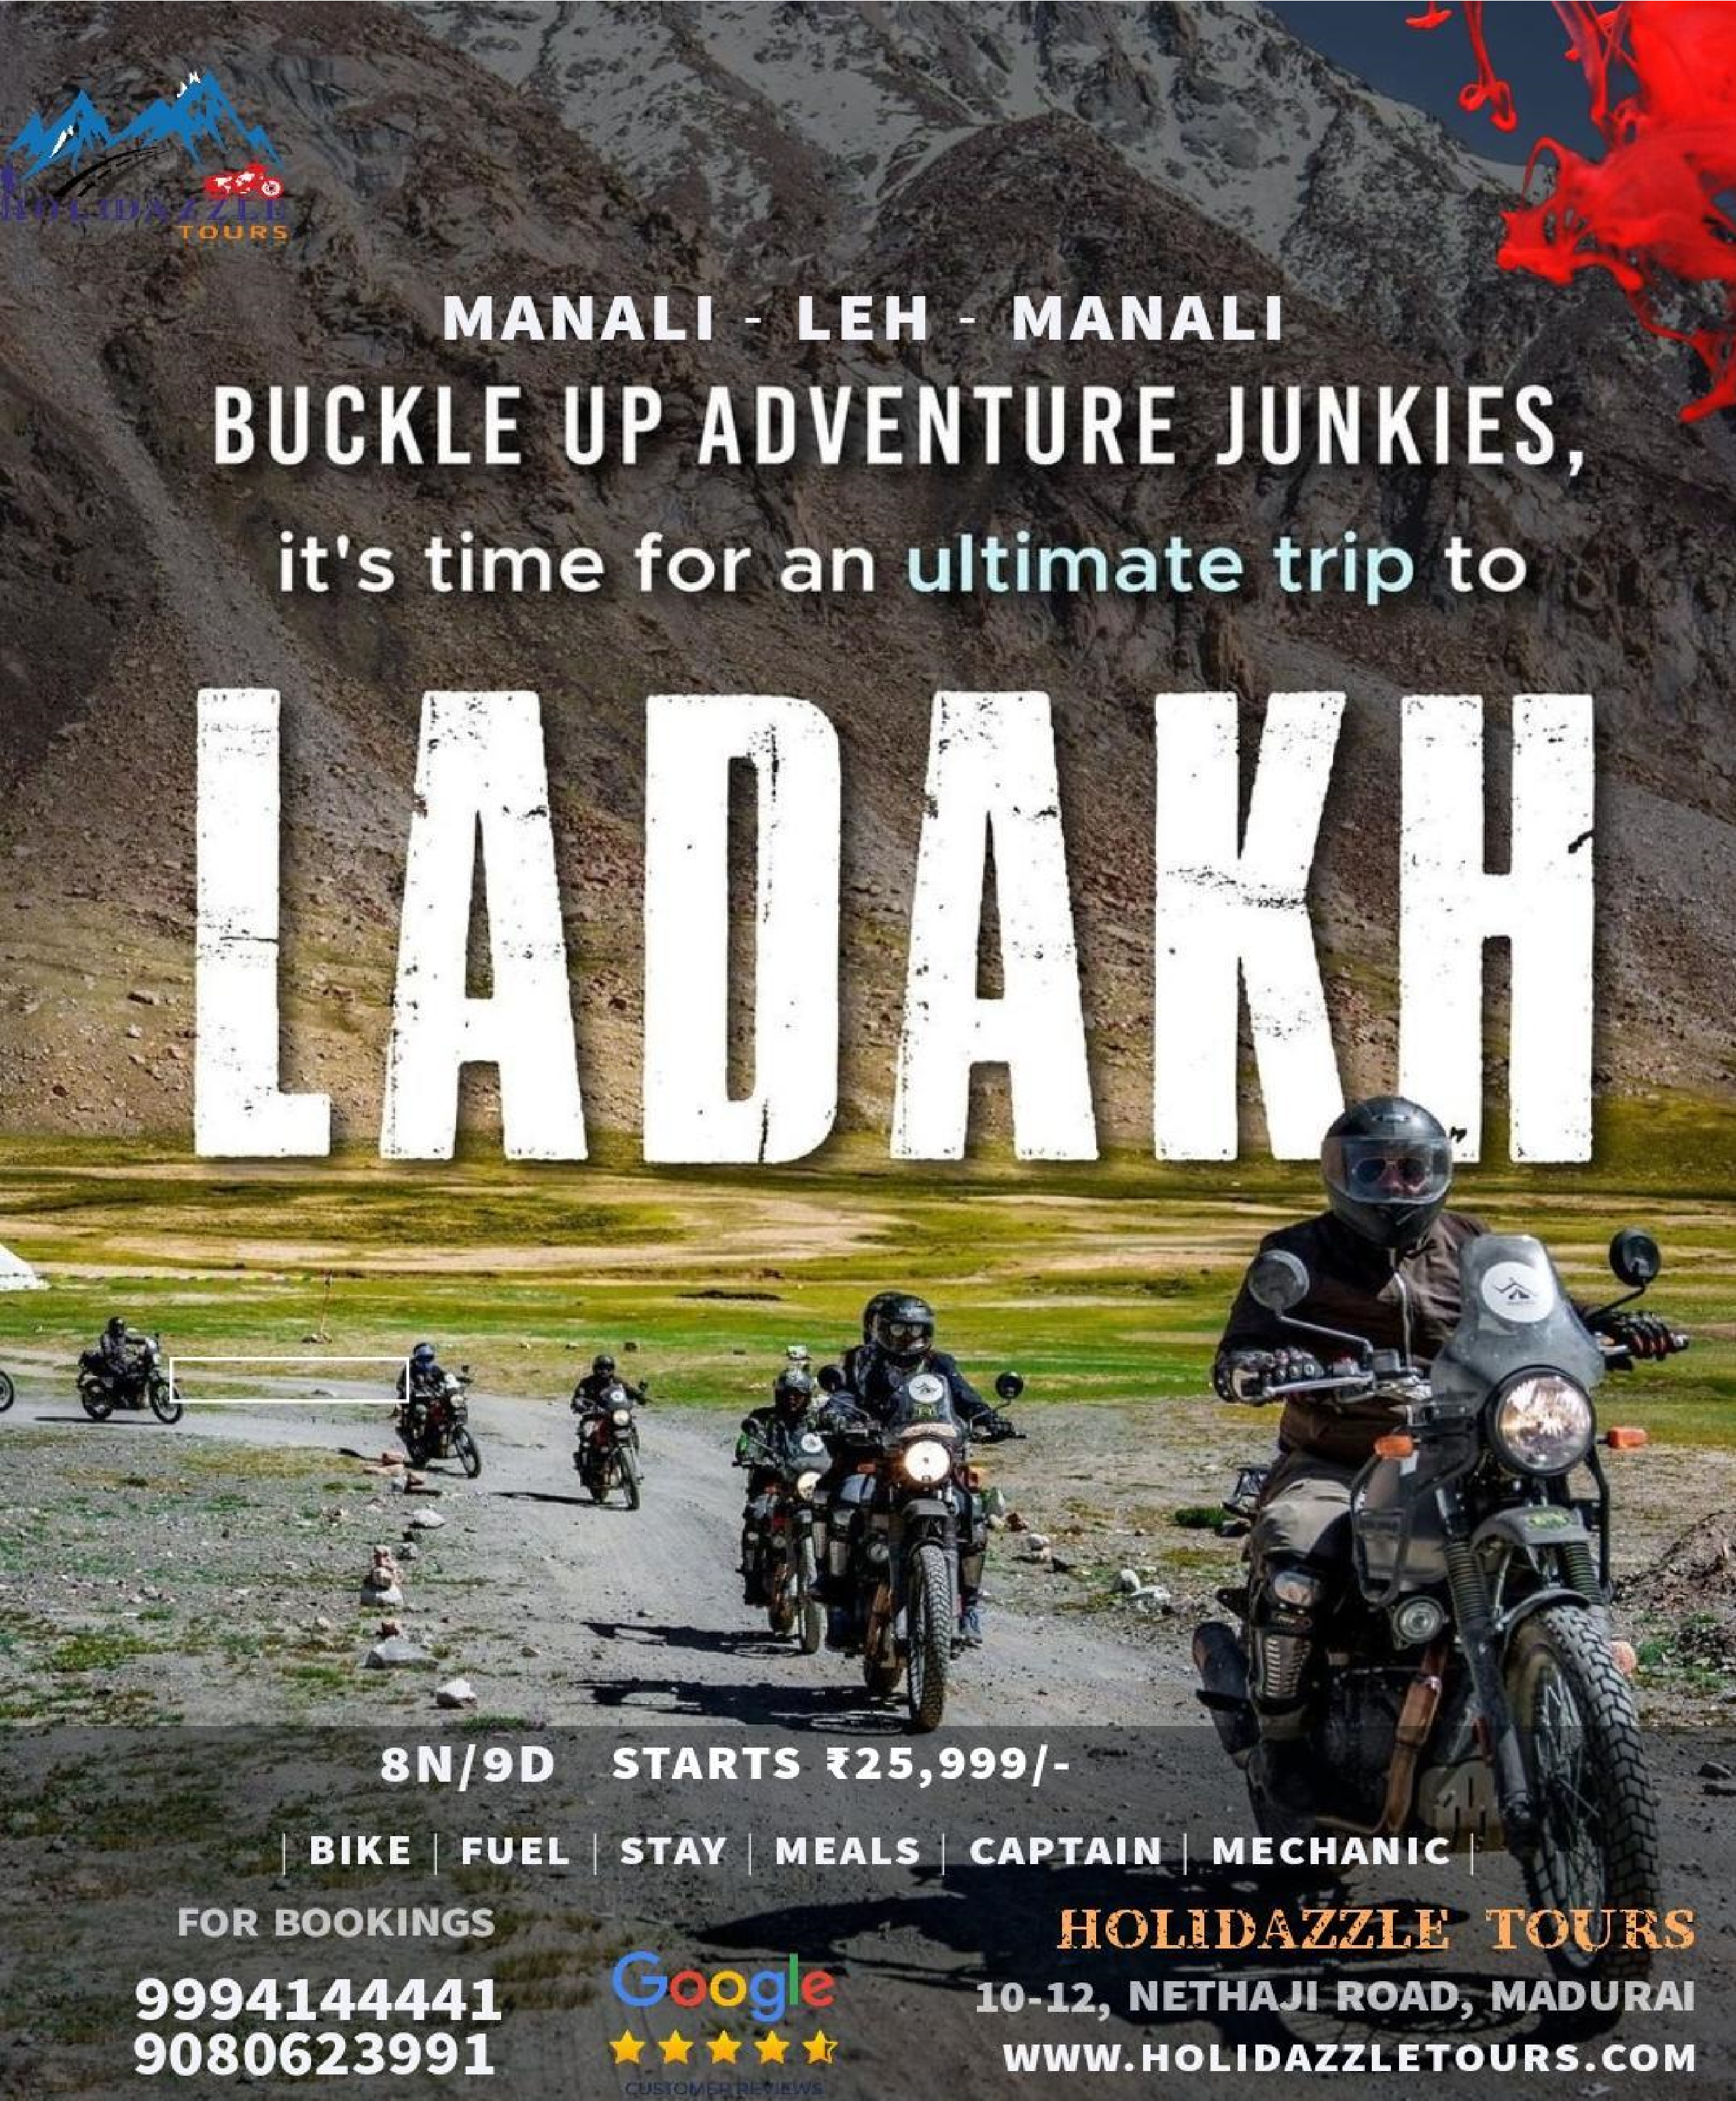

COST OF THE PACKAGE
DOUBLE RIDER – 26,999 /-
SINGLE RIDER – 32,999 /-

Ride your bikes to the top of the world through the world’s highest motorable passes with the spectacular beauty of snowcapped mountains. Admired for its unparalleled scenic views, pristine icy lakes, and swirling roads, Ladakh is becoming the most Instagrammable place in India and is on everyone’s bucket list. It offers you a stay amidst the beautIful valley of mountains and a starlit sky in the night. The unique thing about the Ladakh terrain is that it has mountains, forests, deserts, lakes, rivers, waterfalls in one beautiful and dynamic geography.
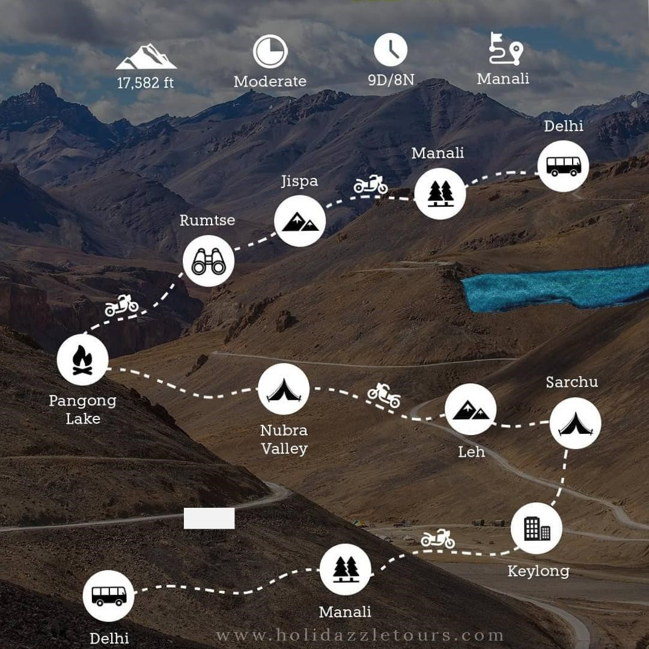

Route: Delhi - Manali – Rohtang La – Jispa – Baralacha La – Sarchu – Gata loops – Nakila – Lachulung La – Pang – Moore plains – Pangong Tso – Nubra – Khardung La – Leh – Sarchu – Manali - Delhi
Duration: 9 Days & 8 Nights
Start point: DELHI
Endpoint: DELHI
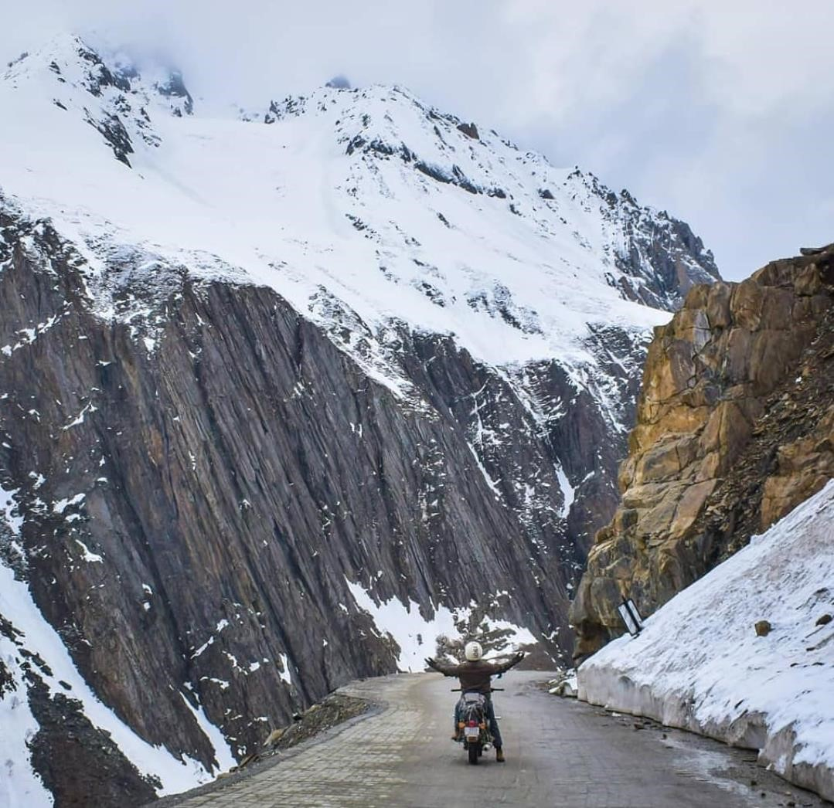

QUICK INFORMATION

- Tour Location: LADAKH MANALI

- Starting Location: DELHI

- Tour Duration: 8N/9D

- Adventure Type: Bike Trips

- Ending Location: DELHI

Manali leh highway route

Manali – Marhi – Rohtang Pass
Rohtang Pass – Gramphu – Kokhsar
Kokhsar- Sissu – Tandi
Tandi – Keylong
Keylong – Jispa
Jispa – Darcha
Darcha – Sumdo – Patsio – Zingzingbar – Baralacha La – Bharatpur – Sarchu
Sarchu – Gata Loops – Nakeela La – Lachulung La – Pang
Pang – More Plains – Tanglang La – Gya – Upshi
Upshi – Karu – Leh
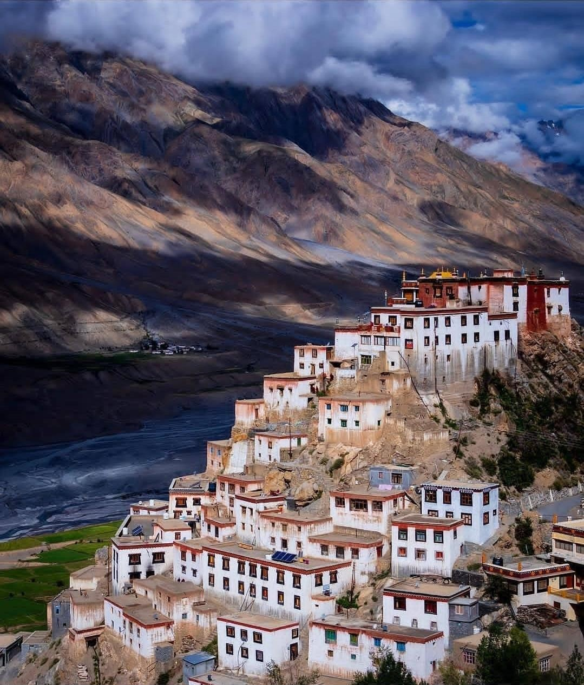

SHORT ITINERARY
Day 1 – DELHI TO MANALI ( 535 KMS )
Day 2 – MANALI ARRIVAL
Day 3 – MANALI TO JISPA ( 140 KMS )
Day 4 – JISPA TO LEH ( 320 KMS )
Day 5 – BORDERS OF LEH
Day 6 – LEH TO NUBRA VALLEY (170 KMS)
Day 7 – NUBRA VALLEY TO PANGONG (170 KMS)
Day 8 – PANGONG TO LEH ( 160 KMS )
Day 9 – PANGONG TO SARCHU (220 KMS)
Day 10 – SARCHU TO MANALI ( 225 KMS )
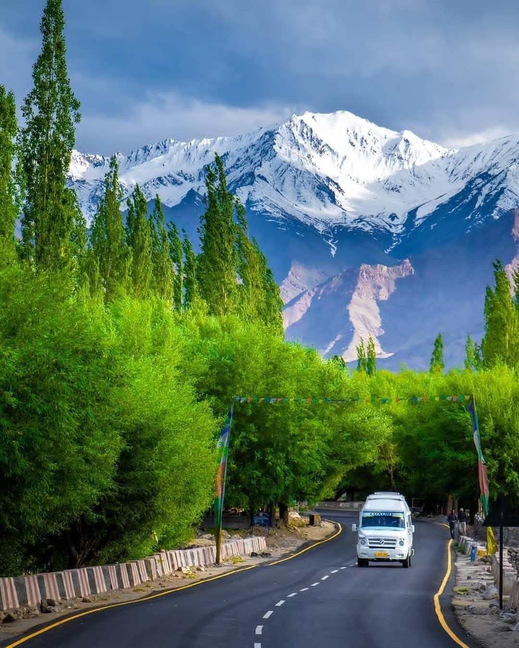

BRIEF ITINERARY

Day 1: Departure from Delhi

On this day, you will be on the way from Delhi to Manali via Volvo. Take in the nature’s beauty along the way as you prepare for a thrilling and adventurous time ahead.

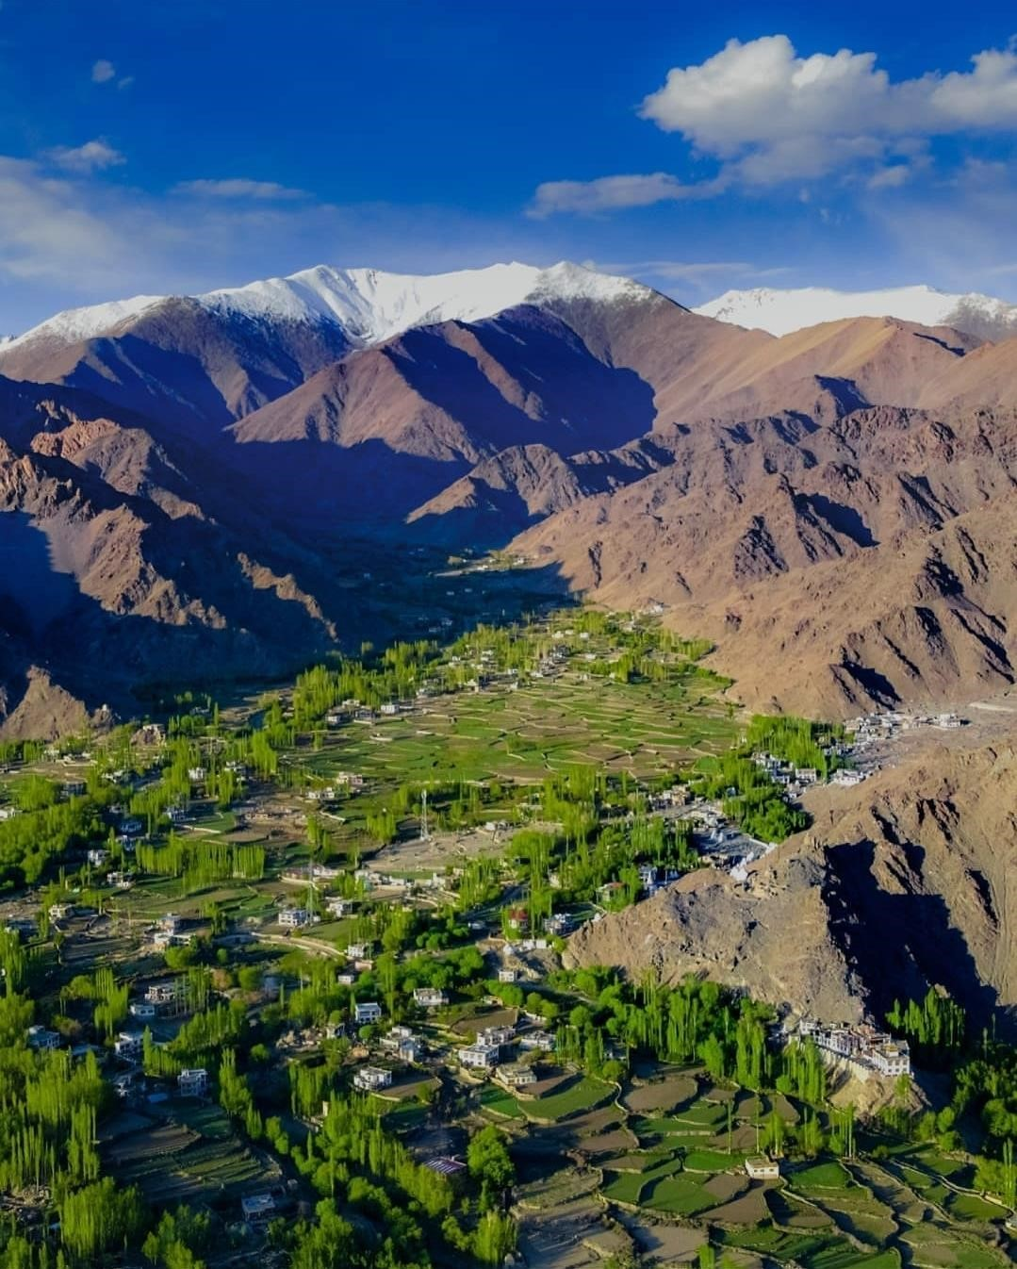

Day 2: Arrival at Manali

On this day, You’ll arrive at Manali in morning. We will check into our hotel and relax today to allow our bodies to acclimate. Manali Local Sightseeing is a great way to see the sights in the area. You may also spend some time by visiting the local markets and shopping. You will be briefed about overview of the ride, including the itinerary, bike allocation, and so on. Afternoon at leisure Overnight stay at a hotel with dinner to explore and enjoy.

Day 3: Manali to Jispa

The adventure begins in Manali and continues to Jispa over the Rohtang
Pass, passing through peaceful Lahaul Valley villages like as Khoksar,
Sissu, Gondla, and Tandi, as well as the confluence of the Chandra and Bhaga Rivers. The route passes through unique landscapes of rocky mountains and mud, making it ideal for photographers. A lovely bike ride will be provided by the magnificent lush green valley and hairpin curve. We will enter the Lahaul valley after crossing our first pass, and our ride will continue beside the Chandra river until late afternoon, when we will arrive in Jispa. We’ll make a campfire and camp out here for the night. Staying in Jispa is also recommended since your body will begin to acclimate.

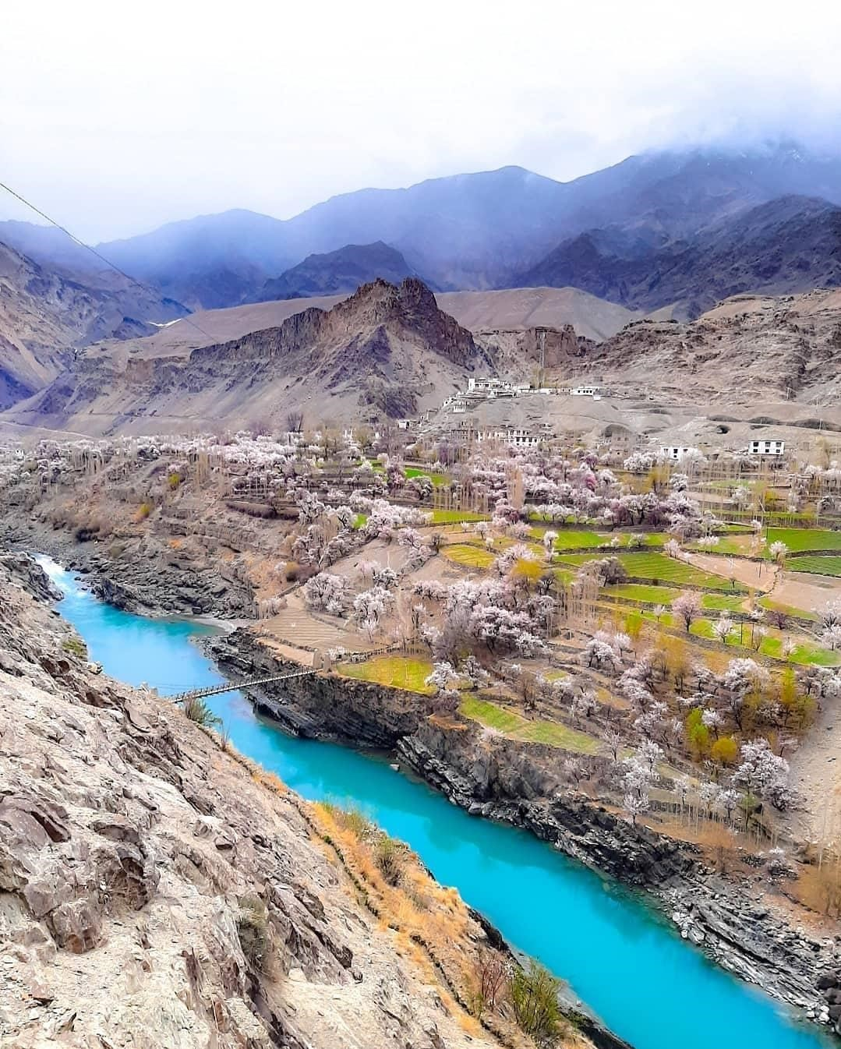

Day 4: Jispa - Sarchu to Leh

Begin your journey very early. We’ll hit the road as soon as the sun shines. We will pass through many magnificent views that have never been seen before. Zing zing bar, suraj tal, baralacha la-16040 ft, and killing sarai will be crossed. Baralacha la is a high mountain pass in the zanskar range that is generally covered in snow all year. We shall arrive at sarchu in the early evening (4300m). Sarchu is a large plateau with a stunning, martian-like environment. Cliffs with needle-like structures that resemble sand castles are attempting to reach the sky.
. The Gata loops’ 21 hairpin curves continue to rise towards the Nakila and Lachungla Passes. We’ll stop for lunch and refreshment in the afternoon at Pang. We will also see 50 kilometres of flatlands before going to Tanglang La Pass, the world’s second highest motorable road pass. Prepare to take some stunning photos, as the scenery resembles a football field created by God for Yetis. We shall arrive at Leh in the evening. After a long day, we need a good rest.

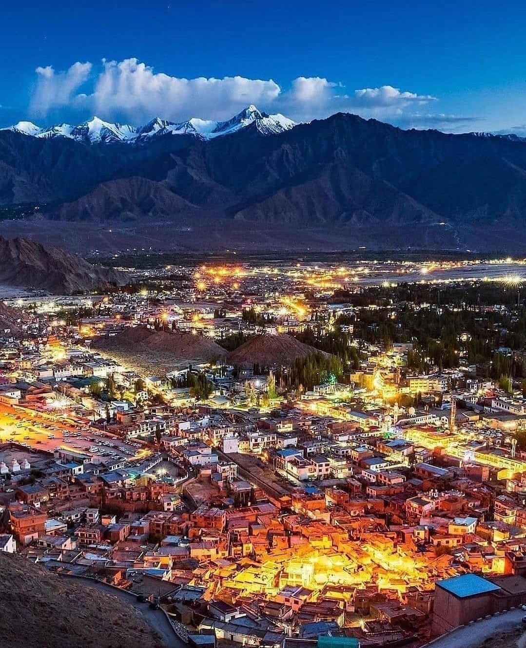

Day 5 : Exploring Borders of Leh

Spend a day in Leh resting and exploring the surrounding areas. The ancient Lamayuru Monastery is a place to admire and find calm. Take the time to pause and be surprised by the mesmerising vistas of Lamayuru, commonly known as the ‘Moonland’ Hills. We’ll go to Shanti Stupa and the surrounding monasteries. Shanti Stup’s architecture and beauty are indescribable. Shanti Stupa’s elevation allows us to see the entire landscape of Leh Ladakh. You may spend the evening exploring Leh’s gleaming bazaar. You can stay in any hotel in Leh tonight, depending on your needs.
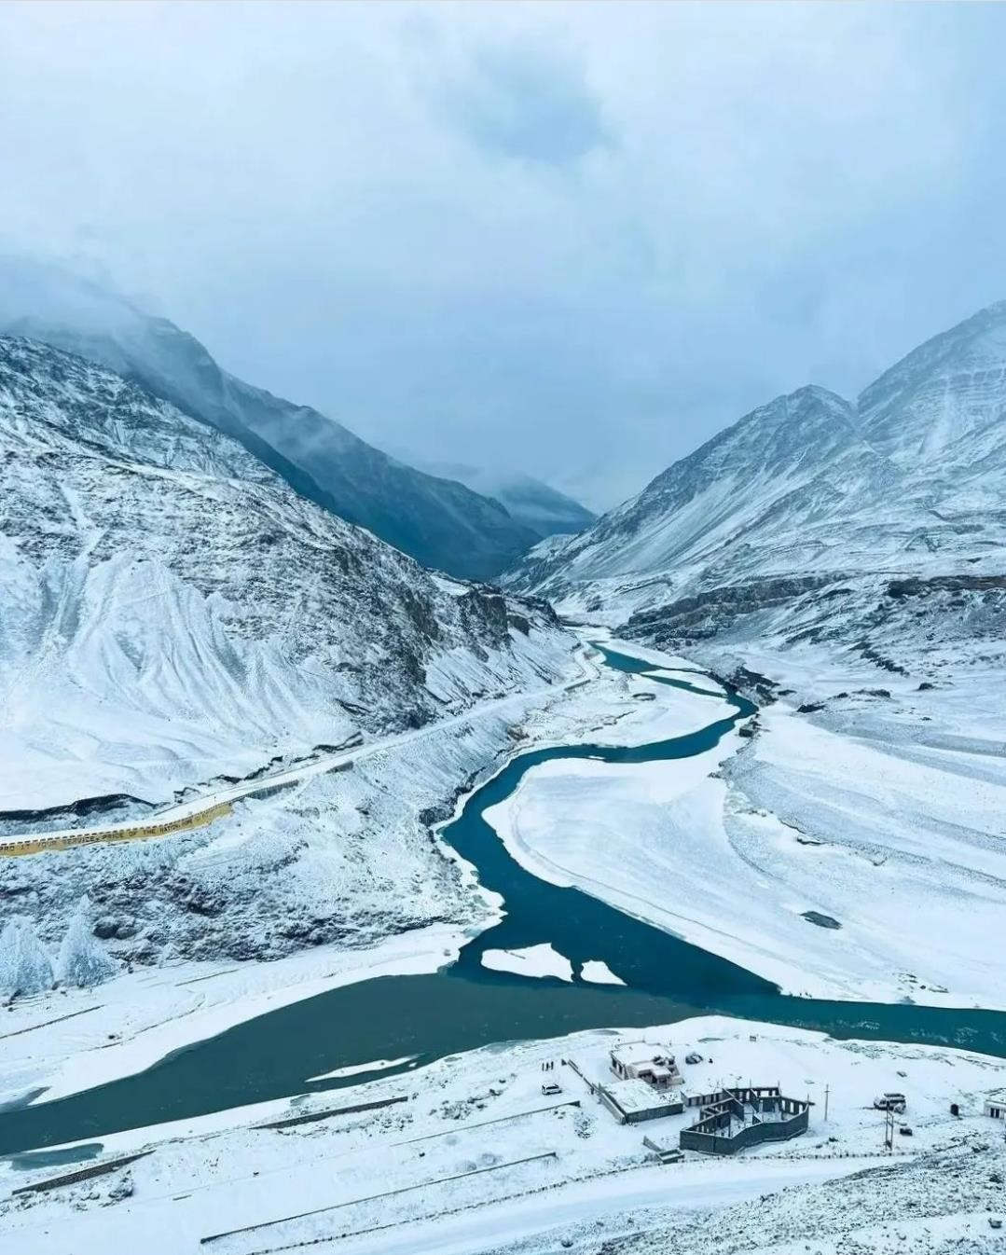

Day 6 : Leh to Nubra Valley via Khardung-La Pass | A
Drive to the World’s Highest Motorable Road (18000 ft.)

After breakfast in the hotel, prepare yourself for the ultimate adventure
The journey from Leh to Nubra falls on a very scenic route

Known as the gateway to the Shyok and Nubra valleys, the Khardung-La pass is the world’s highest all-season motorable road
As you descend from Khardung-la, experience the white sand dunes in
Nubra and enjoy a ride of the double-humped camel, exclusively found in Ladakh
Later enjoy camping under the sky full of stars
Overnight stay at the campsite in Nubra Valley.

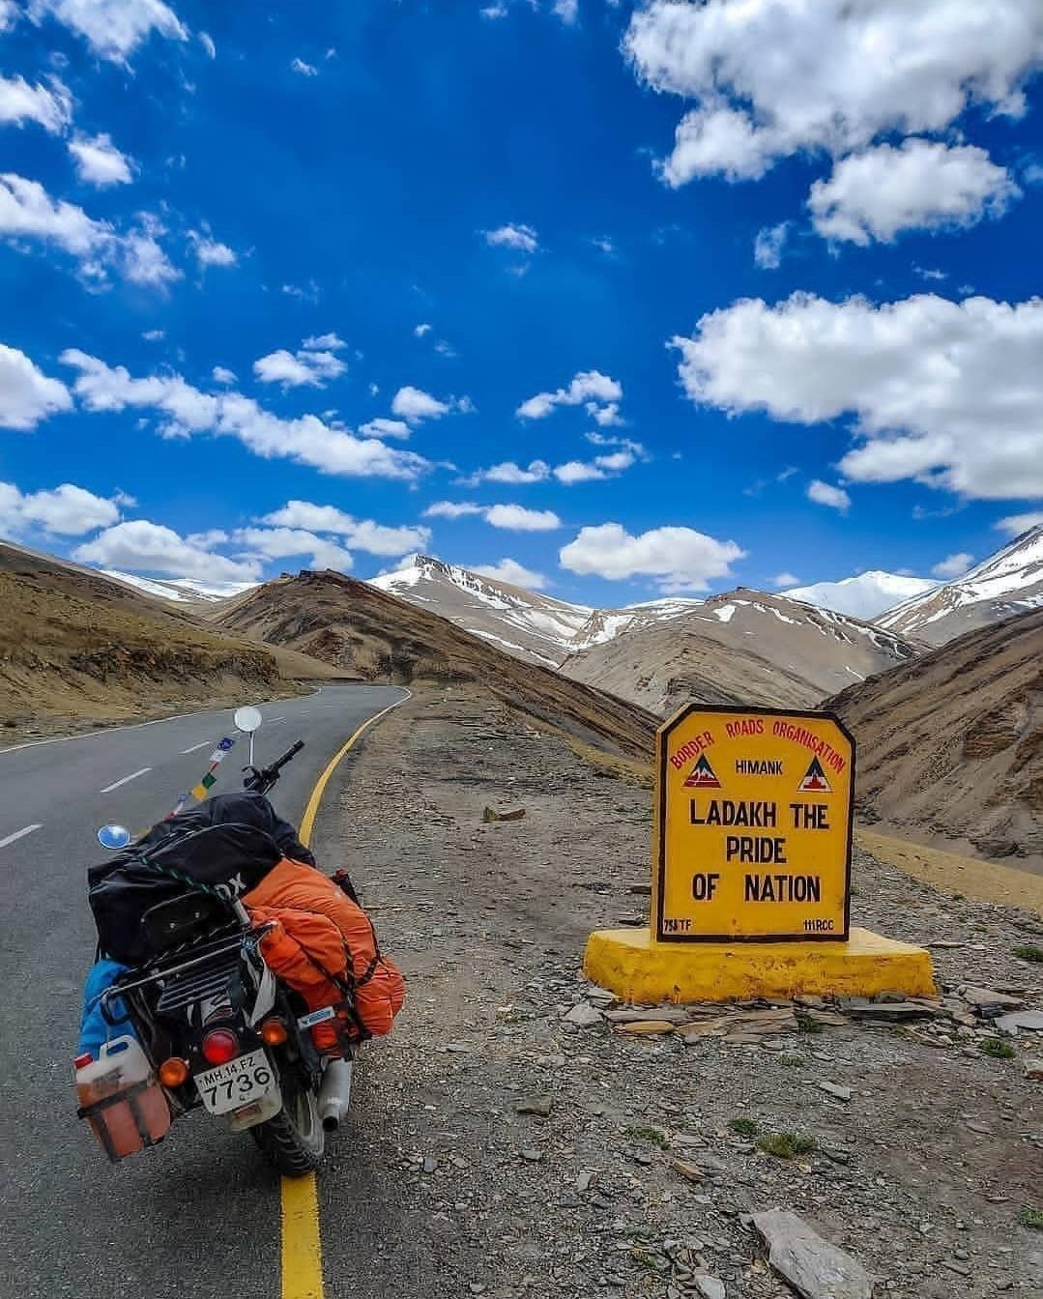

Day 7 : Nubra Valley to Pangong Lake | Relive the Bollywood Moments

In the morning after breakfast, ride to Pangong Lake on the Indo-China border
The lake is a major attraction of the region and is amongst the highest altitude saline water lakes in the world and changes colors from shades of blue to green to red
Enjoy the scenic beauty with the view of the shyok river on one side and the mountains on another side
Featured in movies like 3-idiots and Jab Tak Hai Jaan, enjoy the place in Bollywood style and take a picture with the famous 3-idiots scooter.
Overnight stay at a campsite near Pangong Lake/Tangste.
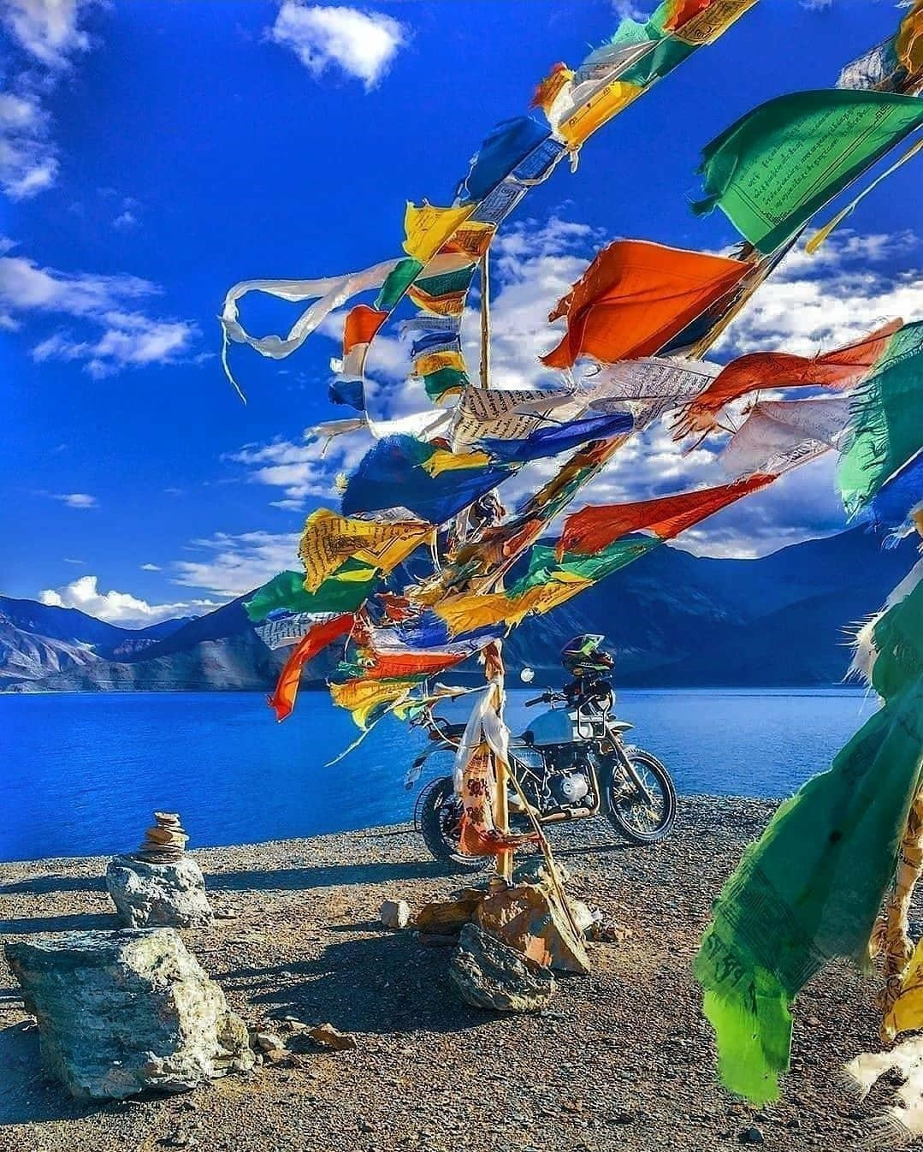

Day 8 : Pangong Lake to Leh | Via Chang La Pass

Wake up in the morning to the beautiful Pangong Lake view
The journey from Pangong Lake back to Leh takes you via Chang La, a mountain pass situated at an altitude of 17,590 feet (5360 meters).
Visit, known to be the largest Tibetan monastery in Ladakh, visit Thiksey monastery housing several stupas, statues, and other Buddhist artifacts in its 12 story structure
Reach Leh and enjoy a delicious dinner at the hotel Overnight stay at a hotel in Leh.

Day 9 : Leh to Jispa

The journey today will be the longest, since we will be riding for 8 to 10 hours. We’ll stop for lunch in Pang before continuing on our way to Manali. Riding in lengthy lines back to back with friends is a unique experience, especially in this type of setting. We will arrive in Jispa in the evening and will be able to enjoy our adventure with a bonfire and music.

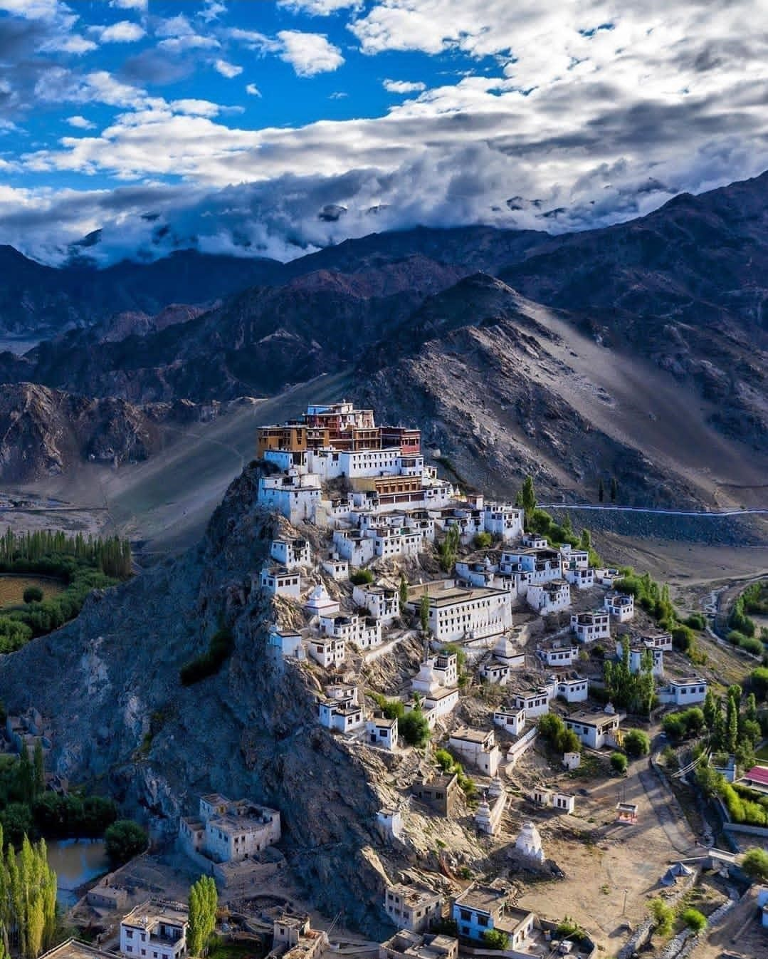

Day 10 : Jispa to Manali

It’s now time to cycle back to where we started after the dawn today. On the way, we’ll stop at Sissu Lake, where there’s also a large waterfall known as Palam Dhara.
Following that, we’ll have lunch in Koksar. We will arrive at Manali in the late afternoon. Set out on a journey to Manali, taking in the breathtaking scenery along the way. Stay at Manali for the night.

Day 11 : Manali to Delhi.

This is when the thrilling adventure comes to an end. Leave from Manali and go to Delhi, then return to your respective areas with stories full with thrills and experiences.

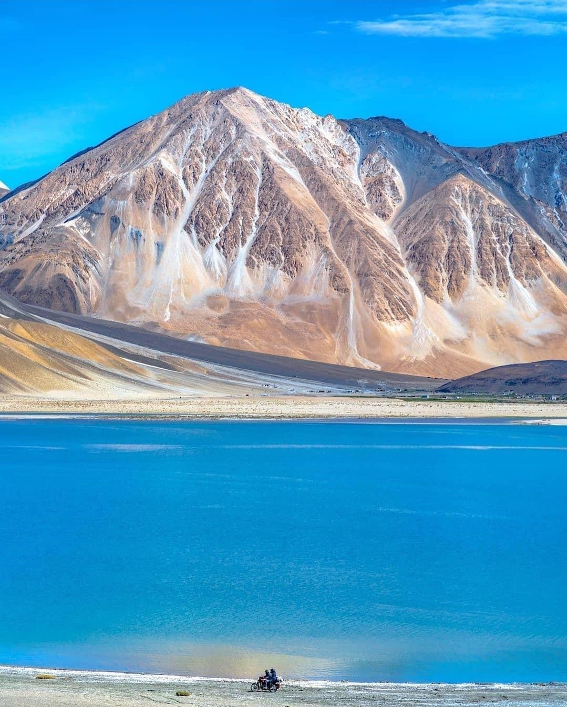

Passes Covered

Baralacha (15,910 ft) – NakeeLa Pass (15,547 ft) – Lachung La
(16,600 ft) – Tanglang La (17,480 ft) – Khardung La (17,982 ft)
– Chang La (17,688 ft)

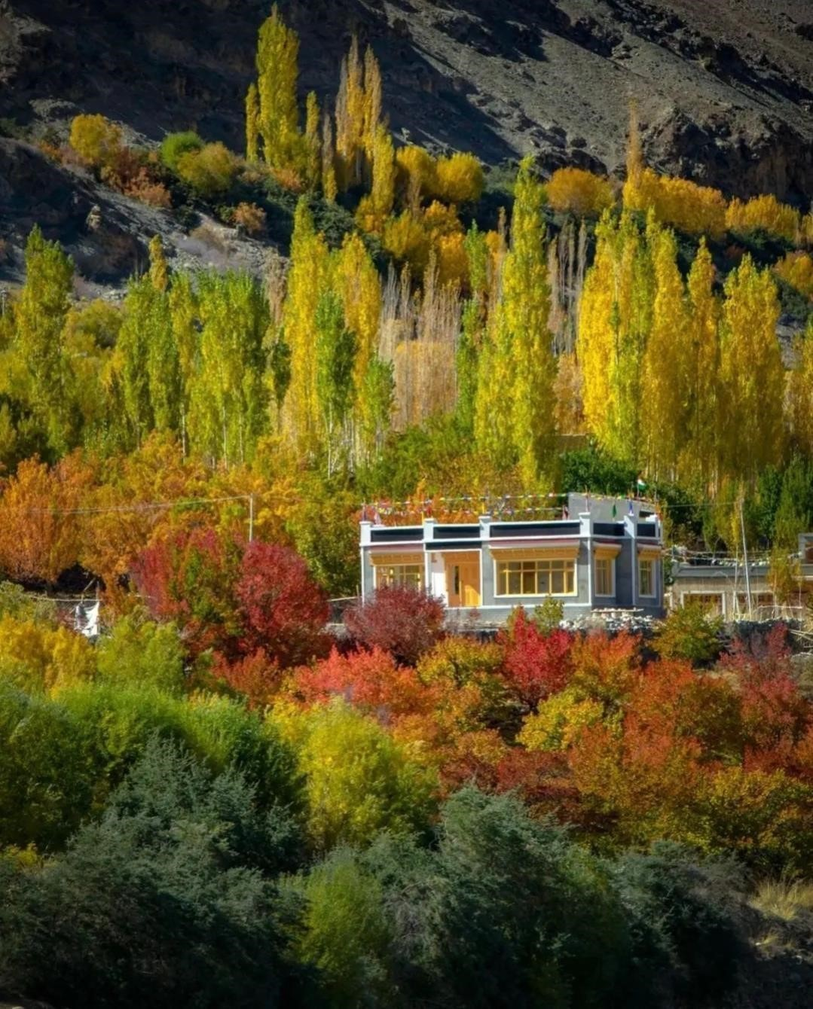

INCLUSIONS
- Accommodation on triple sharing basis
- All transfers
- Volvo Tickets from Delhi to Manali & Manali to Delhi.
- Royal Enfield 350 CC, Royal Enfield 500 CC, Royal Enfield
Himalayan 411 CC
- Fuel
- Bike Marshal / Tour Captain.
- Mechanic
- Breakfast & Dinner
- Inner line Permits
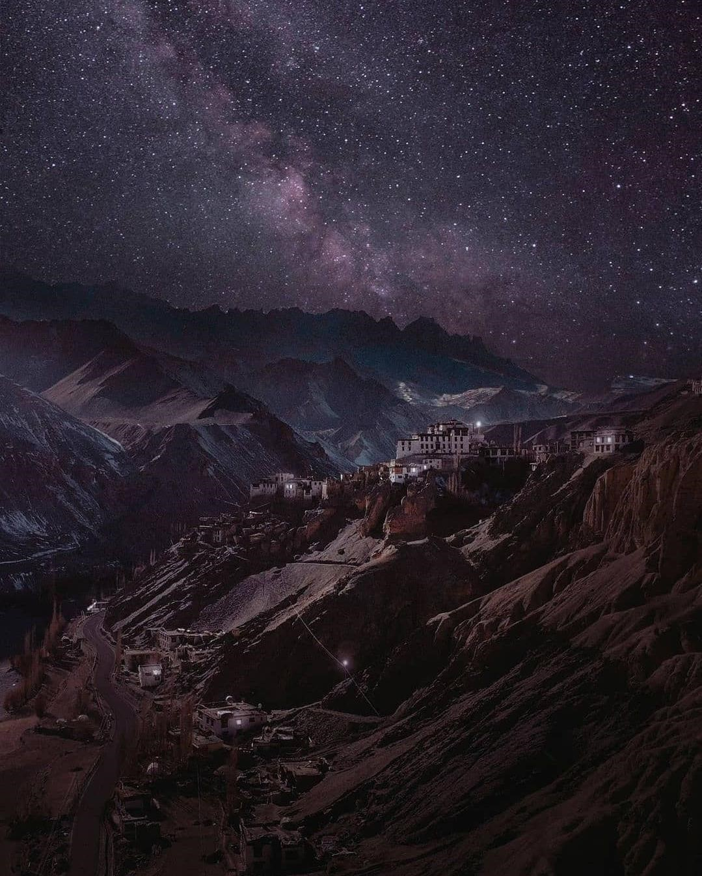

PACKAGE EXCLUSIONS
- Meals which are not mentioned

- Any personal expenses like laundry, telephone bills, tips, etc

- Any kind of Biking gears (such as Elbow Guard, Knee Guard, Riders Jacket, etc.)

- Any cost arising due to natural calamities like land slides, roadblocks, etc. to be borne by the client directly on the spot.

- BIKE Damages cost.

- Any other item which is not specified under cost inclusion

- Any entrance fee to the monastery and monuments Travel Insurance

- Cost escalation due to change in itinerary Natural reason of unforeseen conditions like Landslides, Road Blockage, Bad Weather, Social or Political Unrest, Strikes, sudden shut down of any govt. office etc

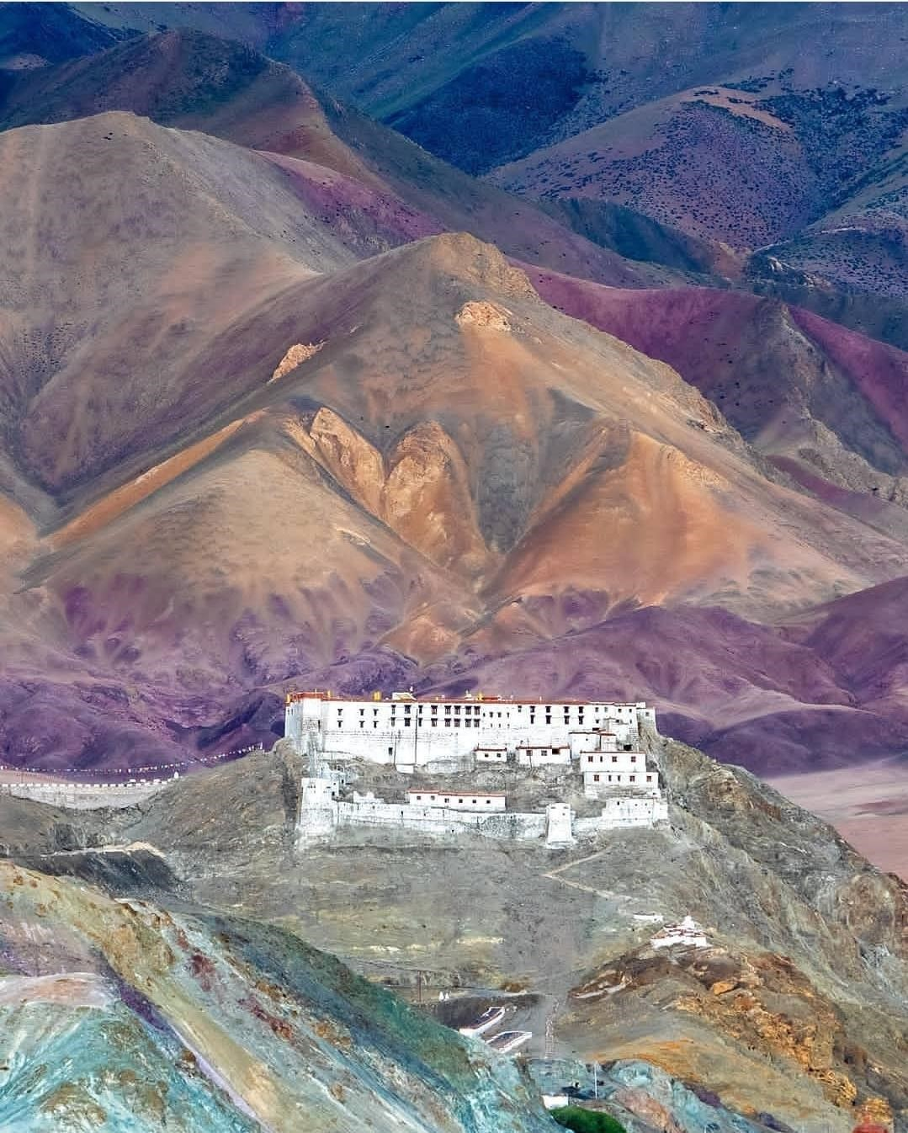

KNOW BEFORE YOU GO FOR LADAKH BIKE
TRIP :-

- Don't forget to bring your Driving License.
- Valid Identity Proof for being an Indian citizen & 2 or 3 passport-size color photographs of both the rider & the pillion.
- Carry some woolen & warm clothes with you like sweaters, jackets, high boots, etc. to protect your body from catching a
cold.
- Persons having Heart problems & Back related issues are not recommended to participate in this Trip.
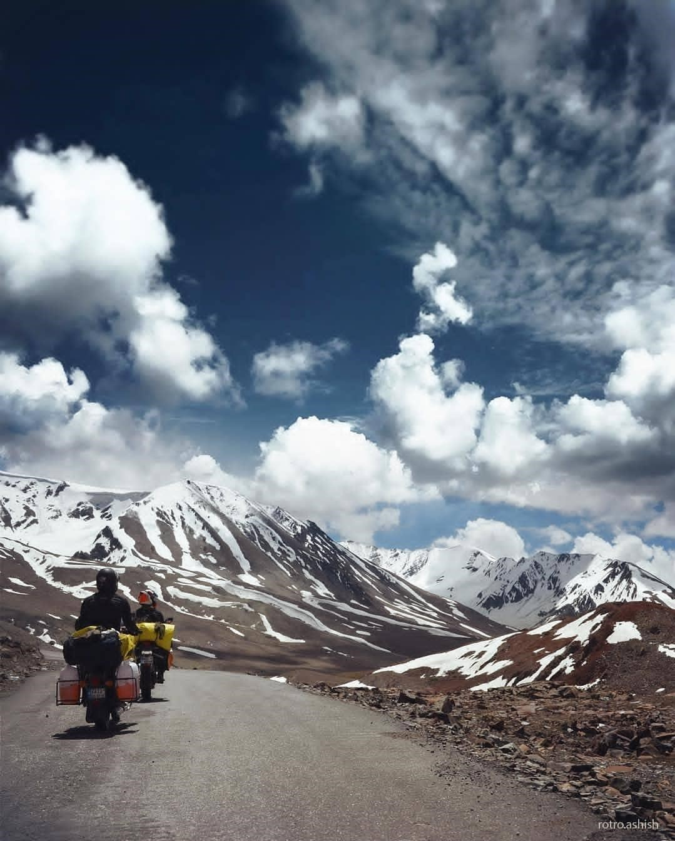
●

Consumption of alcohol before or at the time riding bikes is not

HOW TO PREPARE FOR LADAKH BIKE TRIP

- Full Face Helmet with clear Visor: Get a good quality full face helmet for the ride to protect you from the cold winds while riding.
- Riding Gloves: Gloves is necessary for the ride, as after a while you might feel cold, and if not it gives a good grip and protect your hands in case you fall down.
- Elbow and Knee Guard: If you are not comfortable wearing a riding jacket and riding pants, the least you can do is wear elbow and knee guards.
- Riding Shoes: Make sure you wear riding shoes, and if not then gumboots with thermal socks will serve the purpose.
- Sunscreen Lotion: UV rays at high altitude keeps getting harsh which is quite damaging to the skin. Carry a plus SPF 30, as you don’t want a bad tan.
- Water Bottle: It is necessary to drink 4-5 litres of water at high altitude to avoid dehydration. As it will later might result to AMS (Altitude Mountain Sickness) symptoms like nausea, vomiting, headache and burning of eyes. So keep your body hydrated at all times.
- Clothing: Always dress like an onion (dress in layers) at highaltitude, it is better than a thick woollen. Carry at least 2-3 spare shirts, with 1 pair of riding pants, and 1 pair of jeans.
- Cap: Carry a cap to keep yourself protected from the harsh winds while riding. It will protect your forehead, ears and even neck.
- Driving license: This goes without saying,
- carry your DL at all times as it required to show at certain checkpoint

High-Altitude Sickness

High altitude sickness (also known as Acute Mountain Sickness or AMS) is a direct result of exposure to a lower percentage of oxygen at high altitudes. As altitude increases, the level of Oxygen present in the air starts to get lower. In order to accommodate for low oxygen per breath, our body increases the breathing rate and this is the reason why we start to huff and puff so easily in mountains.

The process of a human body getting accustomed to low oxygen and adapting to the new environment is called acclimatization. When there is ample time for this process and our body is not undergoing stress, there will not be any symptoms at all.

However, as it happens in the case of a trip to Ladakh, the gain in altitude continues to happen over a period of 3-4 days and at a faster rate than our bodies can adapt to. This is what leads to acute mountain sickness on Manali to Leh route or in Ladakh.

The common symptoms of altitude sickness are different for everyone. But for most people, they are mostly the same as a high fever. Your temperature will shoot up, you will have a headache, body ache, won’t feel like eating anything, and would just want to lie down and rest.

Places that you are most likely to suffer from AMS are between Sarchu and Tanglang La Pass. This is why a night stay at either Sarchu or Pang is never recommended. If you are traveling with your family, it is best to break the journey at either Keylong or Jispa and then go straight to Leh from there.

LEH MANALI HIGHWAY PLACES & THEIR ALTITUDE

Manali – 1950 Mtrs
Marhi – 3300 Mtrs
Rohtang Pass – 3980 Mtrs
Gramphu – 3200 Mtrs
Khokhsar – 3140 Mtrs
Sissu – 3170 Mtrs
Tandi – 2573 Mtrs
Keylong – 3080 Mtrs
Jispa – 3320 Mtrs
Darcha – 3360 Mtrs
Deepak Tal – 3810 Mtrs
Patseo – 3811 Mtrs
Zingzing Bar – 4270 Mtrs
Suraj Tal – 4883 Mtrs
Baralacha La – 4890 Mtrs
Bharatpur – 4600 Mtrs
Sarchu – 4290 Mtrs
Gata Loops – 4190 Mtrs
Nakee La – 4740 Mtrs
Lachalung La – 5079 Mtrs
Pang – 4600 Mtrs
Moore Plains – 4730 Mtrs
Debring – 4835 Mtrs
Tanglang La – 5328 Mtrs
Rumste – 4260 Mtrs
Upshi – 3480 Mtrs
Leh – 3500 Mtrs
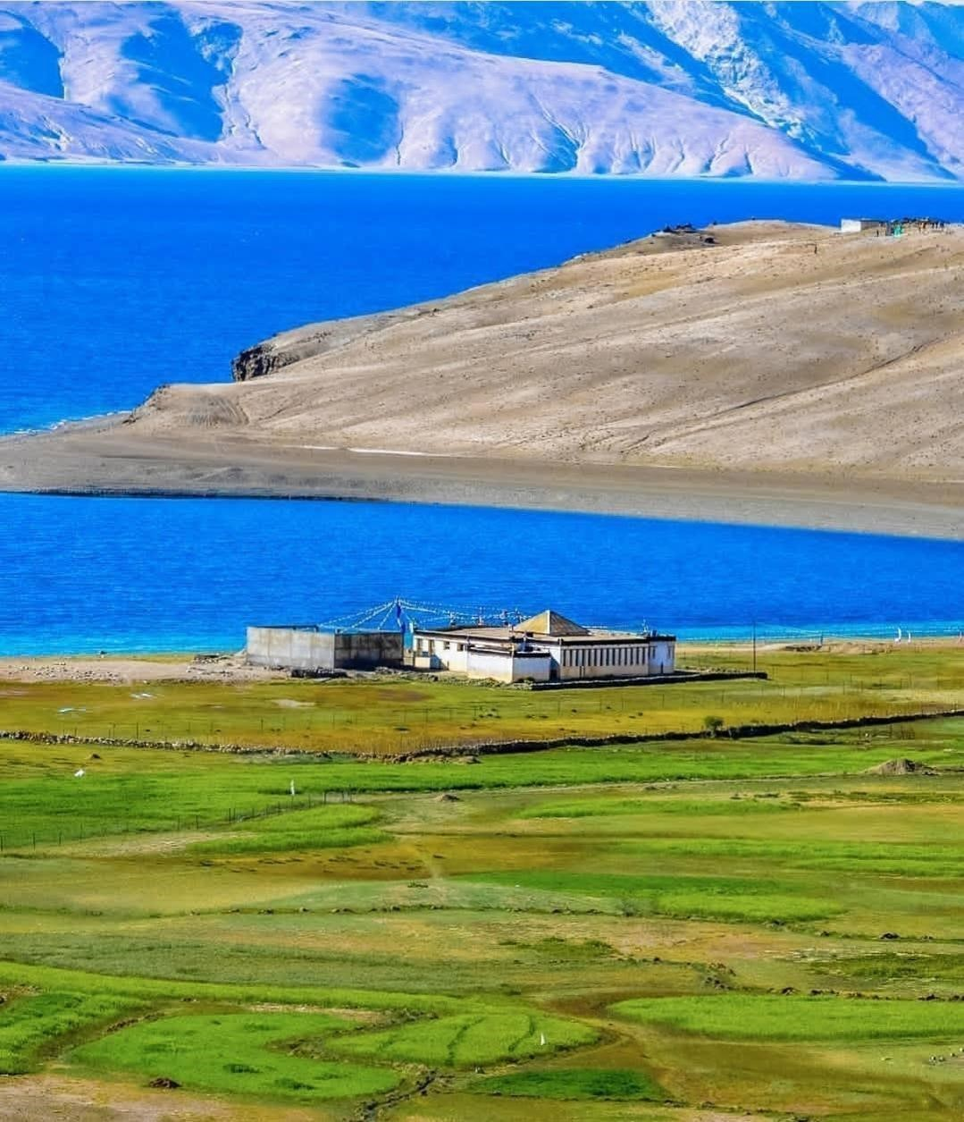

ASSUMPTION OF RISKS
You understand and accept that your proposed tour may expose you to inherent dangers including but not limited to Covid, physical exertion, equipment failure, or the activity itself. You acknowledge that alterations to the schedule itinerary or activity may be made as necessitated by weather, group size, road transport, road closures, illness, lock downs or other factors, you agree to accept the decisions of the tour leader or
representative, and you accept that neither we nor the providers of services can be held responsible for expenses or
inconvenience incurred as a consequence. You acknowledge that the enjoyment of your tour or holiday is derived in part from travel beyond the safety risks of life at work or at home, and you accept and assume all the risks involved.
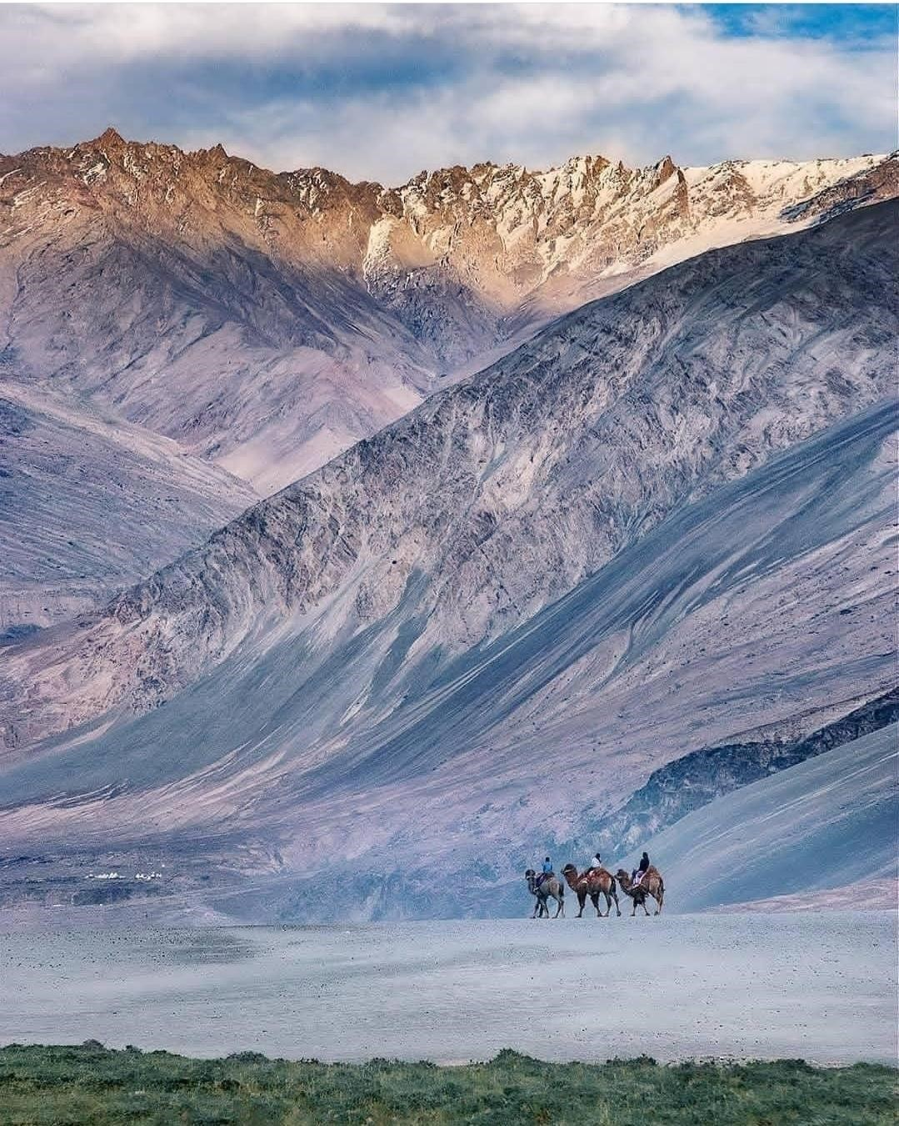

■ CANCELLATION POLICY

You or any member of your party may cancel their travel arrangements at any time. Written notification or an email. The cancellation charges applicable are as per the published cancellation policy below:

Cancellations between 15 days to 30 days before start date,
Full refund is applicable.

Cancellations between 10 days before start date, 50% of
tour cost would be charged as retention

Cancellations made within 5 days of start date, 100% tour cost shall be charged as retention.

PAYMENT TERMS AND CONDITIONS

- 75 PERCENTAGE OF THE PAYMENT TO BE DONE AT
THE TIME OF BOOKINGS.

- REMAINING 25 PERCENTAGE OF PAYMENT TO BE
DONE BEFORE DEPARTURE.

ACCOUNT INFORMATIONS

■ Kotak Mahindra bank
HOLIDAZZLE TOURS

SYED YUNUS
Account number -4845214622
IFSC Code - KKBK0000811
( UPI) 9994144441@kotak
Gpay-9994144441
Phone Pe -9994144441

■ INDIAN BANK
HOLIDAZZLE TOURS SYED
YUNUS
Account number -6142298057 IFSC code:IDIB000P053 MADURAI, K. Pudur branch.
Thanking you and assuring you of our best services
and care at all the times. With kind regards,
HOLIDAZZLE TOURS
Greetings From Syed Yunus, HOLIDAZZLE TOURS.
Reservations - Whats app and Mob -9994144441
Business Whats app – 9994558005


Website - www.holidazzletours.com Mail - toursholidazzle@gmail.com

