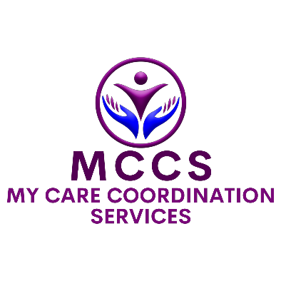

FEEDBACK AND
COMPLAINTS FORM

Use this form to give feedback, make a compliment, raise a concern, or make a complaint about My Care Coordination Services (MCCS). You can ask a worker, family member, representative, advocate or interpreter to help you complete it. You can also make a complaint anonymously. Making a complaint will not affect your supports.
How to give this form to MCCS: give it to any MCCS worker, ask a worker to record it for you, email feedback@mycarecoordination.com.au, or phone 0458 810 182. MCCS will help you use another communication method if needed.
If someone is in immediate danger, call 000. If a person with disability could be harmed soon but it is not an emergency, contact the NDIS Quality and Safeguards Commission on 1800 035 544 as soon as possible.

WHAT WOULD YOU LIKE TO TELL US?
☐ Feedback / suggestion | ☐ Compliment
☐ Complaint / concern | ☐ Request for follow-up
☐ Report of poor quality or unsafe support | ☐ Other: ________________________________

WHO IS MAKING THIS REPORT?
☐ Participant | ☐ Family member / carer
☐ Guardian / nominee / authorised  representative | ☐ Advocate
☐ Worker / contractor | ☐ Service provider / stakeholder
☐ Staff member recording this on behalf of a  participant | ☐ Other: ________________________________
Person / participant details
Participant name, if relevant
Person completing this form
Relationship to participant
Do you have authority or consent to act for the participant? | ☐ Yes ☐ No ☐ Not applicable  ☐ Participant has asked for support to complete this form

CAN WE CONTACT YOU?
You do not have to give your name or contact details. If you stay anonymous, MCCS may not be able to contact you for more information or tell you the outcome.

☐ Yes, please contact me | ☐ No, I do not want contact
☐ I want to remain anonymous | ☐ Contact my representative / advocate instead
Optional contact details
Best contact name
Phone
Email
Postal address, if needed
Best time / way to contact you

COMMUNICATION AND SUPPORT NEEDS
☐ I need an interpreter | ☐ I need information in Easy Read or plain English
☐ I need help from an advocate | ☐ I need support from a trusted person
☐ I prefer phone | ☐ I prefer email
☐ I prefer SMS/text | ☐ Other: ________________________________

WHAT HAPPENED, OR WHAT WOULD YOU LIKE TO TELL US?
Basic details
Date of event / issue
Time, if known
Where did it happen?
Who was involved? Include worker names if known.

IMPACT, SAFETY, AND URGENCY
☐ No immediate safety concern | ☐ Participant feels unsafe or distressed
☐ Possible abuse, neglect, violence,  exploitation or discrimination | ☐ Possible privacy breach
☐ Possible medication, mealtime,  transport or community-access concern | ☐ Possible NDIS reportable incident
☐ Police / emergency services have been  contacted | ☐ Other urgent concern: ________________________________
Immediate action / safeguarding
What support is needed now?
Has this been reported to anyone else? | ☐ No ☐ Yes - who/when: ________________________________________________

WHAT OUTCOME WOULD YOU LIKE?
☐ Acknowledgement / apology | ☐ Explanation or answers
☐ Action to fix the issue | ☐ Change to supports or roster
☐ Staff training or follow-up | ☐ Review of a policy or process
☐ Help to contact an external complaints body | ☐ Other: ________________________________

YOUR RIGHTS AND EXTERNAL COMPLAINT OPTIONS
- You have the right to make a complaint, give feedback, or withdraw a complaint at any time.
- You have the right to be treated respectfully and not be disadvantaged because you made a complaint.
- MCCS will acknowledge complaints within 2 working days where contact details are provided.
- MCCS aims to provide a response within 28 days from acknowledgement. If more time is needed, MCCS will provide an update and expected response date.
- You can use an advocate, representative, interpreter, family member or trusted person to help you.
- You can complain directly to the NDIS Quality and Safeguards Commission at any time: 1800 035 544 or www.ndiscommission.gov.au.
- In Western Australia, you may also contact HaDSCO for health, disability or mental health service complaints: (08) 6551 7600 or www.hadsco.wa.gov.au.

PRIVACY NOTICE AND DECLARATION
MCCS collects the information on this form to receive, assess, respond to, record and review feedback and complaints. Information will be handled under the Privacy and Confidentiality Policy and Procedure. MCCS will only share information where needed to manage the matter, where required by law, or where not sharing information may place someone’s safety, health or wellbeing at risk.

☐ I understand how this information will be used
☐ I consent to MCCS contacting me about this matter
☐ I consent to MCCS contacting the participant / representative named above, where relevant
☐ I do not consent to contact except where required for safety, legal or safeguarding reasons
Declaration
Signature / name
Date

