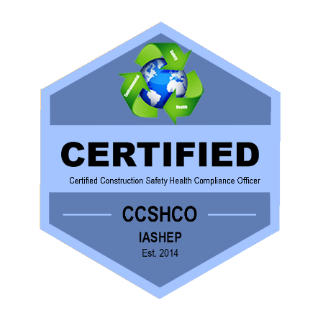

**Certified Construction Safety Health Compliance Officer (CCSHCO)   
  
Course Duration: 40 Hours**

**Course Credential: (CCSHCO)   
Course Fees: $1295.00**

**CERTIFIED CONSTRUCTION SAFETY HEALTH COMPLIANCE OFFICER (CCSHCO) **  
  
IASHEP Certified Construction Safety Health Compliance Officers (CCSHCO) are

experienced, well-trained construction safety and industrial hygienists professionals whose goal is to assure compliance with OSHA, ANSHI, NFPA, and other regulatory or advisory requirementsand help employers and workers reduce on-the-job hazards and prevent injuries, illnesses, and deaths in the workplace.   
  
Certified Construction Safety Health Compliance Officers (CCSHCO) protect the well-being of the public and the environment by ensuring that safety, health and is some cases the environmental regulations workplace standards are met. These professionals often work for the corporations, federal, state or local government and might spend work hours in locations as varied as mines or factories.

A Certified Construction Safety Health Compliance Officers (CCSHCO) plans, organizes, coordinates, and implements comprehensive safety and loss control/prevention programs and activities for the employer, implements program goals and objectives; evaluates safety training requirements; inspects facilities and equipment for compliance with mandated safety regulations; performs a variety of administrative tasks in support of assigned area of responsibility; and exercises fairly independent judgment and decision making in the course of duties performed.

**This course covers the following:**

* How to perform as a Certified Construction Safety Health Compliance Officer (CCSHCO)
* How to plan, conduct, audit and manage safety and health training that changes the way your management and employees work
* How to save money by developing your own safety, health and environmental programs
* How to avoid civil and criminal liability for accidents/injuries
* How to interpret and manage the application of OSHA, NIOSH, ANSI, NFPA, NEC, DOT, EPA and other regulatory or advisory regulations
* How to analyze and document workplace hazards
* How to manage and conduct workplace safety, health and environmental inspections /audits
* How to investigate, analyze and document workplace accidents
* How to develop, implement, and manage your own safety, health and environmental programs
* How to create and manage a successful safety culture
* How to manage hazardous materials

## **Course Prerequisites: Certified Safety Health Officer (CSHCO)requirements and qualifications**

* Three (3) years of demonstrated experience as a Construction Safety & Health professional or similar role such as but not limited to a construction manager, supervisor, lead, union leader, union safety representative where at least 25% of your work responsibilities covered working in this field.
* Excellent knowledge of legislations and procedures
* Excellent knowledge of potentially hazardous materials or practices
* Three (3) years of experience in producing reports in construction related safety & health issues
* Experience with writing policies or writing job specific Job Safety Analysis (JSA) or Job Task Analysis (JTA) or work procedures where employee safety and health was part of the procedures
* Familiarity with conducting data analysis and reporting statistics
* Documented GED / Apprentice Certificate Completion / On-The-Job / Skills Training / or AA / BSc / BA in safety management or similar field
* Certificate in occupational health and safety from OSHA or an Authorized OSHA Training Institute Education Center (OTIEC), NEBOSH, National Safety Institute or similar training organizations. Note: Training certificates from the National Association of Safety Professionals (NASP) or the International Association of Safety Professionals (IASP) will not be accepted.
* Pass a four (4) hour - Two Hundred & Fifty (250) question, proctored examination and pass at an 80%. You are allowed three attempts to pass this examination. Should you not pass this examination after three attempts, you may retake this course for fifty (50) percent of the listed price and try again.