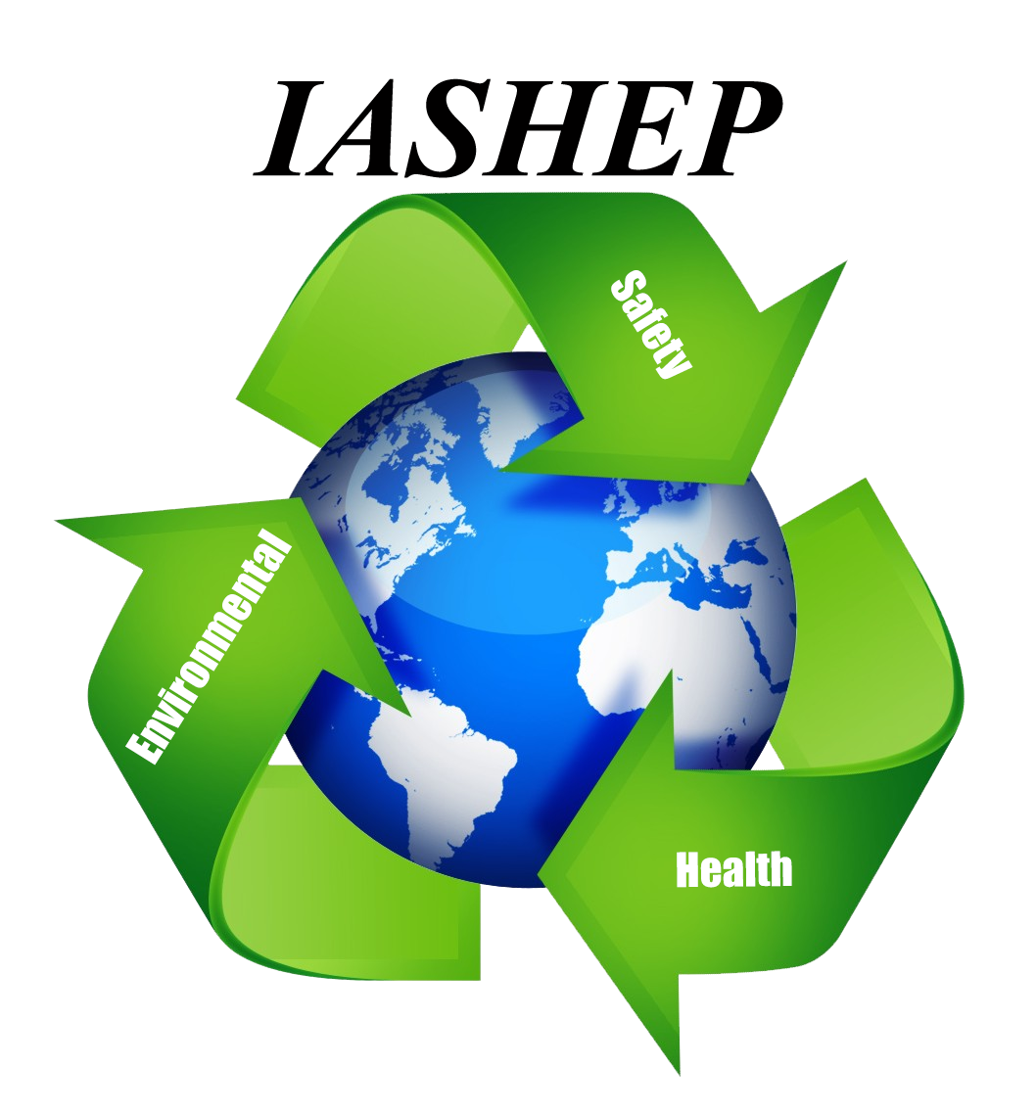
Certified Master Environmental, Health & Safety Administrator (CMSHEA)
Course Credential: CMSHEA

Course duration: 60 hours

Continuing Education Credits (CEU’s) 4.5
Course Fees: $2995.00
Our Certified Master Environmental, Health and Safety Administrator (CMSHEA) Certification Course will:
The IASHEP Certification "Master Environmental, Health and Safety Administrator course will teach the student the foundational statutory and regulatory origins of environmental health and safety compliance management and learn how to effectively and efficiently streamline resources to integrate safety and health regulations across sectors and industries.
This program prepares students to:
Develop and demonstrate a higher awareness of environmental ethics including the responsible exercise of individual judgment and civic responsibility and honesty in dealing with environmental issues
- Understand the importance and application of the science of ecology and its impact on the cultural and social creation of humans and earth's physical and biological system
- Clearly articulate the roles of legislatures, rule-making bodies, and regulatory enforcement agencies in environmental protection and management
- Display critical thinking processes: analyze, understand, and evaluate environmental issues in organizations including educating the public and instituting collaborative decision-making on issues involving the levels of acceptable risks and degree, intensity, and acceptability of environmental protection
Critical instruction is given on health and safety statutes and regulations, management of worker health and safety issues, environmental management and reporting systems, and business and finance strategy.
This course also covers the following elements
- Introduction To OSHA Regulations
- Introduction to EPA Regulations
- Introduction to Industrial Hygiene
- Introduction to Hazardous Materials
- Introduction to Machine Guarding and Machine Guarding Techniques
- Introduction to Respiratory Protection
- Principles of Ergonomics
- Introduction to Permit Required Confined and Non-Permit Confined Spaces
- Excavation, Trenching & Shoring
- Electrical Standards (High and Low Voltage)
- Introduction To Personal Protective Equipment (eyes, face, body, and other types of personal protective equipment.
- Introduction To Fall Protection and Fall Prevention Systems
- Introduction To Safety Standards for Ladders, Aerial Lifts and Scaffolds
- Introduction To Cranes (both mobile, gantry, truck and overhead), Forklifts and Material Handling Equipment
- Introduction to Laboratory Safety
- Introduction to Environmental laws and Regulations

Course Objectives:
The Master Environmental, Health and Safety Administrator certification consists of 17 topical subjects. Each of these topics is also a certification course or courses that stand alone.

Testing:
Students completing the course must take a proctored final exam. A score of 80% on the final exam is necessary to receive your personalized certificate of completion. The student gets three (3) attempts to pass the course.

