24th Annual PumpkinFest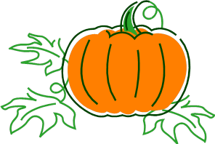 Saturday September 19th
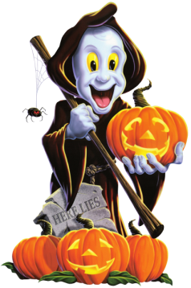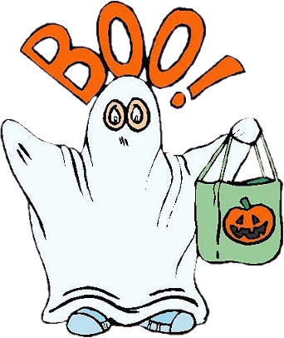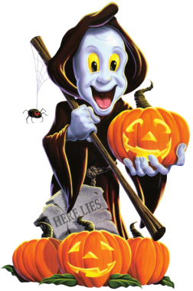
Don’t miss the 14th Annual

LIGHTED PARADE

Saturday September 19th at 8:00 p.m.
Starts on the corner of Michigan St. and M-25.
Light up yourself, your bike, your car, or a float.
Bring your kids and use that costume more than once! Guarantee to have a good time.
YOU WON’T WANT TO MISS IT!!!!

