Green Tea and Walnuts: The Diet, Blood Sugar, and Brain Health Connection

*By*[*Rae Bennett*](https://www.bluezones.com/author/raebennett/)From [Blue Zones](https://www.bluezones.com/2025/05/green-tea-and-walnuts-the-diet-blood-sugar-and-brain-health-connection/?mc_cid=871ceba2f3&mc_eid=b063d3005e) May 2025

The recent study titled “[Glycemic control contributes to the neuroprotective effects of Mediterranean and green-Mediterranean diets on brain age](https://doi.org/10.1016/j.ajcnut.2024.09.013)” provides compelling evidence linking dietary interventions to brain health. Conducted as part of the DIRECT PLUS trial, the research examined how Mediterranean (MED) and green-Mediterranean (green-MED) diets rich in polyphenols and low in red meat can slow age-related brain atrophy and promote glycemic control.

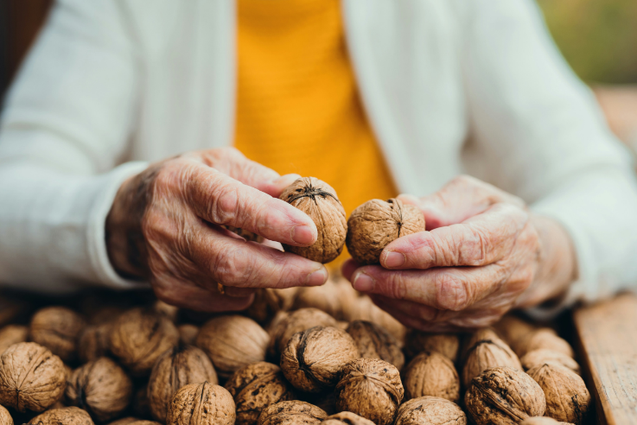

Study Overview

The trial involved 294 participants aged 30 or older with abdominal obesity or dyslipidemia, primarily men (88%) with an average age of 51. **Participants were randomly assigned to one of three groups for 18 months:**

1. Healthy dietary guidelines (HDG): Active control group following general health recommendations.
2. Traditional MED diet: Calorie-restricted, low in simple carbohydrates, emphasizing vegetables, fish, poultry, and walnuts.
3. Green-MED diet: Further enriched with polyphenol-rich foods such as green tea (3 – 4 cups daily) and Mankai duckweed shakes (500 mL daily).

All participants received free gym memberships and attended group sessions on nutrition and physical activity. Brain structure changes were assessed through MRI scans, and metabolic markers like fasting glucose, insulin, and hemoglobin A1c (HbA1c) were measured.

Key Findings

The study highlighted that both MED diets significantly slowed age-related hippocampal atrophy, a biomarker for [brain aging and cognitive decline](https://www.healthline.com/). Notably, the green-MED diet exhibited superior results, reducing hippocampal shrinkage by approximately 50% compared to the HDG group. This translates to a younger “brain age” compared to chronological age, as measured by the hippocampal occupancy (HOC) score.



Glycemic Control, Blood Circulation, and Brain Health

Improved glycemic control emerged as a pivotal factor in reducing brain aging. Participants with lower fasting glucose and HbA1c levels, markers of blood sugar regulation, experienced greater neuroprotective effects, independent of weight loss. [Better glycemic control](https://www.psypost.org/) was also associated with improved blood circulation, which helps deliver oxygen and nutrients to the brain while reducing oxidative stress and inflammation. This enhanced circulation likely contributes to healthier brain tissue and reduced atrophy.

Improvement in diabetes status was associated with greater HOC deviation changes than either no change in diabetes status (0.010; 95% CI: 0.002, 0.019) or with an unfavorable change (0.012; 95% CI: 0.002, 0.023).

Those adhering to the green-MED diet demonstrated the most pronounced improvements in glycemic markers, brain aging metrics, and inflammation reduction. Higher consumption of green tea and Mankai shakes was associated with these benefits, suggesting the role of polyphenols in crossing the blood-brain barrier, reducing inflammation, and promoting cellular repair in memory-critical regions like the hippocampus. Participants who improved their diabetes status also exhibited less brain tissue loss, reinforcing the importance of blood sugar management in cognitive preservation.

Higher consumption of green tea and Mankai shakes was associated with these benefits, suggesting the role of polyphenols in crossing the blood-brain barrier, reducing inflammation, and promoting cellular repair in memory-critical regions…



Mechanisms of Action

**Polyphenols, abundant in the green-MED diet, may enhance brain health by:**

* Reducing oxidative stress and inflammation.
* Supporting neurogenesis, particularly in the hippocampus.
* Improving gut health, which influences the [gut-brain axis](https://www.bluezones.com/2022/08/10-foods-to-boost-your-gut-immune-axis/) and overall cognitive function.
* Enhancing blood circulation, which ensures the brain receives vital nutrients and oxygen.

Key polyphenol-rich components included [walnuts](https://www.bluezones.com/2017/07/why-nuts-are-nutritional-powerhouse/), [olive oil](https://www.bluezones.com/recipes/food-guidelines/), [green tea](https://www.bluezones.com/2019/10/what-happens-when-you-drink-tea-every-day/), and [Mankai](https://www.vegetariantimes.com/health-nutrition/what-is-mankai/" \t "_blank). These foods support blood sugar stability and provide antioxidants that may protect against age-related neurodegeneration.

Implications and Recommendations

The findings underscore the potential of dietary interventions, particularly polyphenol-rich diets, in mitigating age-related brain changes. Adopting a green-MED diet could be a practical, low-risk strategy for preserving brain health and reducing dementia risk. **Key dietary recommendations include:**

* Incorporating green tea (3 – 4 cups daily).
* Consuming Mankai shakes multiple times weekly.
* Increasing intake of walnuts, olive oil, leafy greens, and berries.



[Adopting a green-MED diet could be a practical, low-risk strategy for preserving brain health and reducing dementia risk.](https://twitter.com/intent/tweet?url=https%3A%2F%2Fwww.bluezones.com%2F2025%2F05%2Fgreen-tea-and-walnuts-the-diet-blood-sugar-and-brain-health-connection%2F&text=Adopting%20a%20green-MED%20diet%20could%20be%20a%20practical%2C%20low-risk%20strategy%20for%20preserving%20brain%20health%20and%20reducing%20dementia%20risk.&via=bluezones&related=bluezones)

While the results are promising, limitations include the predominantly male participant group and the absence of cognitive performance assessments. Further research is needed to explore these effects across diverse populations and assess long-term cognitive outcomes.



Conclusion

This study highlights the neuroprotective potential of MED and green-MED diets through improved glycemic control, enhanced blood circulation, and polyphenol intake. By adopting such dietary habits early in life, individuals may reduce brain aging and preserve cognitive health, offering a valuable strategy for addressing age-related neurodegeneration.

**By Rae Bennett**