The CMATCH Mentor’s Guide

Successful Efforts to Enable Tobacco Product Users to Quit

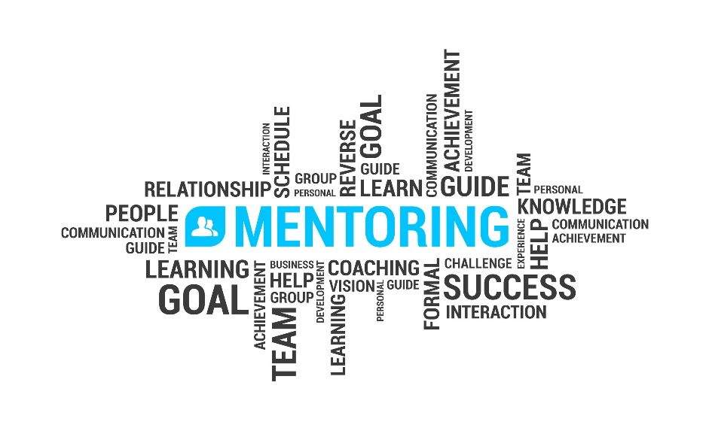

FrameWork Health, Inc.
Timberville, Va.
2021, 2023

Welcome to the Role of Mentor. . .
To begin and to better understand this neighborly responsibility, review the vision and mission of the CMATCH Support System.

Overview of the CMATCH Support System
FrameWork Health, Inc., a 501 c (3) foundation corporation, is organized to provide programs and services of health promotion and disease and injury prevention of a regional and national scale. Wellness "packages" aimed at reduction of heart disease, cancer, and diabetes are offered to industry, communities, and healthcare organizations with particular interest in nicotine addiction recovery, nutritional management, general health improvement for adults. Programs and services of FrameWork Health are health education and mentoring, telephone coaching, and community organization.
It is our intention to Restore the Image of God in the Portrait of Man by:
- Expressing love and concern for fellow humans struggling with addiction to tobacco and alcohol and with control of optimum weight.
- Individualizing by assessment and intervention the needs of individuals seeking our assistance in behavior change.
- Offering a spiritual dimension to decision-making and life change practice that we believe is capable of effecting optimum health and quality of life.
- Implementing an outcome-based wholistic health promotion intervention utilizing audio/visual, telecommunication, and internet technology.
- To operate a reliable and valid model of intervention worthy of replicability anywhere in the world.
The name FrameWork Health alludes to the FRAMES Model of Motivational Interviewing developed by Samet, Rollnick, & Barnes (F=Feedback, R=Reframe, A=Advise, M=Menu of options, E=Empathy, S=Self-efficacy). We have modified FRAME to the rubric of:
F = Freedom from addictive/deleterious behavior
R = Restoration of health through quality living
A = Appreciation for personal strengths, creative power of God,
Divine intervention through human sources
M = Meaningful life purpose
E = Experience of helping relationships
PHILOSOPHY
Health is a gift and a privilege emanating from the grace of our Creator. We are stewards of our health, which therefore requires that we learn how to preserve it, conserve its assets, and improve it against the influences of an imperfect world. FrameWork Health, Inc. believes that God's desire for His created children is to reflect His image through lifestyle and express His love through service. The power lies in God's interest in His human family and His ability to strengthen their resolve in efforts of change, in their attitude and thinking, and in their alteration of behavior.
Maintaining health requires knowledge about health-preserving strategies that include components of the physical, emotional, cognitive, and spiritual realms. All individuals are subject to biopsychosocial and environmental stress and may display various symptoms which they will evaluate or ignore. Certain lifestyle practices are employed in response to human stress experience that are either life-promoting or deleterious. These practices may be overeating, overworking, indolence, and substance abuse (alcohol, drugs, tobacco), etc. Individuals make irrational decisions or become subject to indecision and require assistance toward health according to their interest, motivation, and determinism.
For that reason, FrameWork Health, Inc. is formed to facilitate the restoration of health in individuals through the production and presentation of education programming and the conduct of motivation services that employ wholistic life-changing principles for assisting individuals to reach their maximum potential and experience quality of life. Emphasis is placed on learning how to make critical judgments about one's lifestyle behavior and how to realize positive change through a system of caring social support.
VISION
Individuals seeking information and assistance in lifestyle adjustment will achieve skills and employ tools of strategy that will effectively improve their health. As a result of successfully-changed lives through the model of FrameWork Health’s CMATCH, other groups and communities will seek to replicate it, thus widening the influence and efficacy of this approach to health promotion.
AIM
It is the intention of FrameWork Health to facilitate restoration and maintenance of health by:
- Expressing love and concern for fellow humans struggling with addiction to tobacco, achievement and control of optimum weight, reduction of stress, and general healthy lifestyle challenges.
- Individualizing by assessment and intervention the needs of individuals seeking our assistance in behavior change.
- Offering an optional spiritual dimension to decision-making and life change practice that we believe is capable of effecting optimum health and quality of life.
- Implementing an outcome-based whole person health promotion intervention utilizing audio/visual, telecommunication, and internet technology.
- Operating a reliable and valid model of intervention worthy of replicability anywhere in the world.

______________________
Social Support
The concept of social relationship in which a social network serves as a key psychosocial protective, or “buffeting,” factor that reduces an individual’s vulnerability to the effects of stress on the mental, physical, and social health. Identified social support sources are generally kin or known to the individual or family and may share common experience with them. Seldom do people include health professionals in their list of social support network. They are seen as power figures. Health professionals and others can alter that perception and foster a reciprocal relationship with participants in the following ways:
- Effective communication
  - Solicitous, reaching
  - Patient, kind, sensitive, caring
  - Knowledgeable
  - Facilitating
- Collaborative function
  - Build partnership
  - Advise
  - Seek a level of mutuality
  - Availability
  - Foster teamwork with participant, primary provider, and CMATCH team
- Best interest
  - Effectively employing the motivational strategies of the CMATCH program

DEFINING MENTORING
To be a Mentor is to successfully pass through the stage of a relationship acquaintance > friend > to one who has the other’s best interest at heart with a willingness of commitment of care, support, and encouragement toward the achievement of their God-given potential. Here is an acronym that describes mentoring attributes to expand this definition:
- Mindful attention—Giving thoughtful and sympathetic professional attention
- Encouragement—Giving positive encouragement to the one who is struggling
- Nurture growth while focusing on the positive aspects of the experience
- Teach the new healthy lifestyle strategies with joy, reflecting personal experience
- Observe and orient the mentee compassionately
- Recognize and respect accomplishments and efforts regularly

EFFECTIVE COMMUNICATION: In Mentoring
Four patterns of communication between individuals have been identified which have an impact on the response obtained and the quality of the relationship between the communicators:
Small talk Chatty conversation, relaxed, friendship-forming
Control talk Light Control: Natural in conduct; directing, advising, cautioning,
praising, instructing, giving expectations, stating concerns
Heavy Control: Used when the primary goal is getting one’s own way through use of harsh or aggressive conversational tone.
Search talk Exploring or gathering information without accusing. Just getting the facts without being judgmental. In other words, initially in building a relationship with your Mentee, inquire of him/her “Why is it important to you to change your health behavior?” Then listen to the nature of the response and look for items for goal-setting in future talk.
Straight talk Speaking to the behavior, rather than attacking one’s self-esteem. Does not use blame or sarcasm. Effective in problem solving, sharing, handling tensions, expressing feelings, discussing anticipated change, asking forgiveness.
Active Listening Skills Here are five activities that enhance listening:
* Observe for and acknowledge non-verbal signals indicating the learner's desire to respond or to ask a question. (In the case of telephone communication, one can observe for audible, non-verbal sounds, tone of voice, etc.)
* Focus on what the learner says through thoughtful and apt response.
* Maintain non-verbal attentiveness through eye contact and body positioning angled toward the learner.
* Avoid interrupting.
* Evaluate learner questions and responses only after they are complete. Ask for elaboration if unsure.
Through the use of active listening, the stage is set for effective questioning. Seven techniques to support this process are listed below. The nurse-teacher role is to fill in knowledge gaps and facilitate practical problem solving.

Three Techniques for Effective Questioning
1. Ask open ended questions that foster flexible dialogue, rather than asking questions requiring a "yes" or "no" response.
2. Avoid using either-or scenarios. This implies there are only 2 options to choose from and does not empower the learner to take an active role in learning and problem solving. Discuss and mutually evaluate multiple options instead while reflecting on and drawing from the personal reasons the Mentee has for changing behavior.
3. Respond to the underlying emotional needs of the learner as applicable to the learning situation. If a learner is worried about behavior of children or workplace stress, then if may be difficult to focus on the helping interview.

IDEAL CHARACTERISTICS OF A MENTOR
- Trustworthiness
- Persisting interest
- Future-oriented
- Visionary – the bigger picture
- Unselfish/Unbiased
- Empowering
- Gracious
- Greater-purpose Thinker

Smokefree.gov offers guidelines and suggestions for aiding someone trying to overcome the addiction to nicotine and the habitual actions acquired:

Know Your Relationship Style
The way you deal with tobacco product use can have an effect on a person who is trying to quit. It helps to become aware of your relationship style. Your style affects their habit, their quitting, their health, and yours. Ask yourself these questions:
- Do you mind that they smoke/vape/chew around you?
- Do you argue about tobacco product use?
- Do you avoid talking about it?
Understanding your relationship style can help you understand what both of you may have to change to better deal with their nicotine use and quitting. For example, you may need to:
- Recognize your friend or family member’s small successes when quitting.
- Avoid criticizing them if they slip and have a cigarette/vape/chew.

Interaction Techniques
The basic approach to interactions in motivational interviewing is captured by the acronym OARS: (1) Open-ended questions, (2) Affirmations, (3) Reflective listening and (4) Summaries. The acronym is a nice image. It gives us power to move, yet it is not a powerboat. We don't zip from one place to another, yet with sustained effort OARS can take us a long way.

Start the Conversation with an Open-ended Question
An open-ended question allows the client to create the impetus for forward movement. Although close-ended questions have their place - indeed are necessary and quite valuable at times - the open-ended question creates a forward momentum that we wish to use in helping the client explore change. For example, "So what makes you feel that it might be time for a change?"
It can be hard to get someone to talk about quitting smoking. To get a conversation started, look for an opening. Respond positively when someone says:
- "I'm thinking about quitting smoking."
- "My doctor told me that I should quit smoking."
- “I’m pregnant. I should probably quit nicotine chewies.”
- “My wife is pregnant. I should probably quit smoking for her.”
- "My kids are asking me about my cigarettes. I should probably quit smoking for them."
Affirmations are Statements of Recognition about the Peron’s strengths.
Affirmations can be wonderful rapport builders. For clients suffering from addictions, affirmations can be a rare commodity. However, they must be congruent and genuine. If the client thinks you are insincere, then rapport can be damaged rather than built. Let them know you think it's great they're considering quitting and that you're ready to help. If you're an ex-smoker, you can draw from your own experience of quitting. Let them know how much better you feel now that you're smokefree. You might say:
- "I'm so proud of you for trying to quit smoking. I'll help with whatever you need to make it happen."
- "Quitting tobacco will be hard, but I know you can do it. Have you set a quit date?"
- "You're not in this alone. Even if it gets tough, I'll be here for you."
- "Quitting smoking is the best thing I ever did! Let me know if you need any tips."

Create an Opening
If someone doesn’t give you an opening, create one. Ask them whether they’ve thought about quitting. Or you could try a different approach. You might say:
- "I heard on the news that taxes on cigarettes might go up soon. Sounds expensive. What do you think?"
- "I saw a commercial last night that showed an ex-smoker who lost teeth from gum disease caused by chewing tobacco. I didn't know that could happen. Did you?"

Ask Questions
Asking open-ended questions can help you understand what a tobacco product user who is quitting is going through. For instance, you might ask:
- "What made you want to start smoking?"
- "What things make you crave a cigarette?"
- "What made you decide to quit smoking?"
- "What things have been stressing you out lately?"
- "What could I do to help make quitting easier for you?"
Reflective listening is the key to this work.
Quitting nicotine use is about them—not you. Face them and look them in the eyes. Listen to what they have to say not what you are about to say. You will focus on their change talk and provide less attention to non-change talk. If you ask a question, be quiet and give them time to answer. Resist the urge to insert your own comments. Observe the unsaid communication and pay attention to nonverbal cues. Attempt to mentally enter their world.

Don't Lecture
Lectures, nagging, and scolding won't help your friend or family member quit. It might just put you on their bad side, and they may not come to you for help when they really need it.
Here are some things to avoid when you’re trying to help someone quit:
- Nagging them about why their addictive habit is bad.
- Counting the number of cigarettes they smoked.
- Asking them if they vaped today.
- Arguing with them about being irritable when they're going through withdrawal.
- Giving them a hard time if they have a bigger appetite from withdrawal.
- Getting upset if they slip and smoke a cigarette or vape.

Be Patient and Positive
Nicotine withdrawal can start as soon as 20 minutes after the use of a tobacco product. It generally peaks at about Day 3 of abstinence, and the physical dependence can last for up to four weeks. The psychological cravings can last much longer, however. Smokers in particular report cravings well past six months after quitting. Common nicotine withdrawal symptoms include irritability, anxiety, restlessness, difficulty concentrating, sleep disturbance, depressed mood, bad mood, increased appetite, and weight gain. (Centers for Disease Control and Prevention. (2020b). Smoking and tobacco use fast facts. https://www.cdc.gov/tobacco/data_statistics/fact_sheets/fast_facts/index.htm)
Supporting someone who is trying to quit nicotine use can be frustrating and exhausting. Focus on staying upbeat. Don’t give up on them. Your support is important.
The withdrawal that can come from quitting may make a person moody and irritable.
Avoid:
- Taking their moods personally.
- Telling them it was easier to put up with their moods when they were smoking.
- Suggesting it would be easier for them to just go back to using nicotine.
The cravings a person might face can be hard to deal with. Don't let them lose confidence in quitting. Check in on them and let them know you support them. You might say:
- "I can tell this is hard on you, but I'm proud of you for sticking with it. Let's do something fun to celebrate how far you've come!"
- "It sounds like you're having a rough day. How about I take care of dinner tonight/watch the kids/mow the lawn, so you can have some time for yourself? You deserve it."
Expectations to Quitting
- Enjoying a sense of VICTORY!
- Increased sense of self-esteem
- Improved health, more and sustainable energy
- Feeling of well-being
- Pleasant body fragrance
- Better-tasting food and pleasant breath

Don't Be Too Hard on Them if They Slip
Your friend or family member may slip at some point and smoke a cigarette. They'll probably feel guilty, so getting angry with them will not help. Instead, you could:
- Tell them you know they can still quit and remind them of all the progress they have made.
- Help them figure out what triggered the craving that led to the slip.
- Help them come up with a plan for dealing with the craving if it happens again.
- Ask if there is anything else you can do to help.
- Refer them back to the Taking Control program to remind them of strategies
Here are some ways you could respond to a slip:
- "Slips happen. Don't beat yourself up over it! Like anything tough, you learn as you go. Use this moment as a time to restart and get back on track."
- "So, you slipped. Quitting isn't easy and many people need several tries before they quit for good. Your Friend Jesus knows about this and cares; and I'm here for you."
- "Let's talk about what's triggering you to smoke. That will help you stay on track this time. Just don't smoke that next cigarette!"


MENTOR’S COMMUNICATION JOURNAL for CMATCH
Mentor’s Name _________________________ Mentee’s Name ________________________________
DATE | TOPIC (Progress, Concern, etc.) | COMMENT

