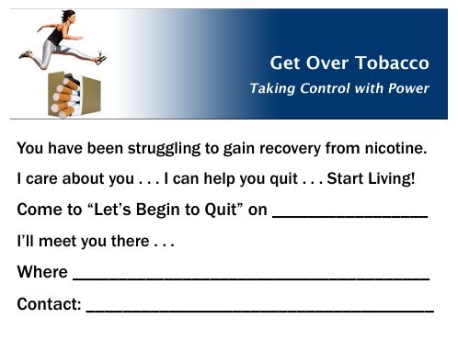

**Are You Dependent on Nicotine?**

**Have you been thinking about quitting tobacco use?**

**Learn how to quit with friendly support and proven strategies.**

**You can’t afford not to** . . . **“Let’s Begin to Quit”**

**Come to a Workshop at** -- **1700 Lyndhurst Rd, Waynesboro, VA**

**The 7th Day Adventist Church Fellowship Hall, (lower level)**

**When:** __________________ **I’ll meet you there!**

**Contact:** ______________________ **Phone:** _____________________  
_________________





**Are You Dependent on Nicotine?**

**Have you been thinking about quitting tobacco use?**

**Learn how to quit with friendly support and proven strategies.**

**You can’t afford not to** . . . **“Let’s Begin to Quit”**

**Come to a Workshop at** -- **1700 Lyndhurst Rd, Waynesboro, VA**

**The 7th Day Adventist Church Fellowship Hall, (lower level)**

**When:** __________________ **I’ll meet you there!**

**Contact:** ______________________ **Phone:** _____________________  
_________________







**Dear Friend,**

**You have been struggling to gain recovery from nicotine.**

**I care about you . . . I can help you quit . . . Start Living!**

**Come to a Workshop at -- 1700 Lyndhurst Rd, Waynesboro**

**The 7th Day Adventist Church Fellowship Hall, (lower level)**

**When:** __________________ **I’ll meet you there!**

**Contact:** ______________________ **Phone:** __________________