Vacation Bible School
7/27/2020 – 7/31/2020
Links will be posted each day!

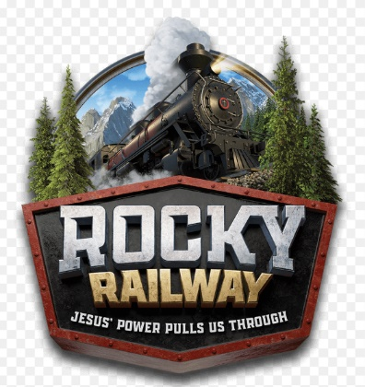

3434 Hempstead Turnpike
Levittown, NY 11756
(516) 731 – 7387

MATERIALS

Arts & Crafts | Snack
Monday:  - Paper lunch bag  - Cotton balls  - Goat sheet (worksheet will be posted online)  - Glue  Tuesday:  - 2 paper plates  - Brown construction paper in a circle shape  - Feathers  - Glue  - Scissors  - Small googly eyes  - Yellow paper  Wednesday:  - Index card  - Pipe cleaners  - Tape  - White construction paper in a circle  - Medium googly eyes  - Crayons  - Yarn  Thursday:  - Red and white paper straws  - 2 brass bands  - Brown construction paper  - Red circles  - Yellow construction paper  - White cardstock  Friday:  - Black pom poms  - Large googly eyes  - Brown construction paper  - Tape or stapler  - Pencil | Monday:  “Chew, chew track.” Jesus’ power helps us do hard things!  Ingredients:  1. 2 pieces of licorice  2. A couple granola bars  Directions:  1. Place the granola bars in a line, pretend they are super heavy like a real 300lb piece of wood  2. Then place the licorice across the top to make it look like a real railroad track. Sometimes we have to do hard things first and lay a solid foundation to get on the right track.  Philippians 4:13 “For I can do everything through Christ, who gives me strength!”  Tuesday:  “Bagel Tunnel.” Jesus’ power gives us hope.  Ingredients:  1. Favorite type of bagel, cut in half  2. Your favorite bagel spread, butter, cream cheese, or jam  Directions:  1. Line up your bagels to look like a tunnel. You may be able to get down and look through the tunnel to see the light at the end. The light at the end of the tunnel is a sign of hope, that the train will come out safely.  Psalm 31:24 “So be strong and courageous, all you who put your hope in the Lord!”  Wednesday:  “Coal Crunch.” Jesus’ Power helps us be bold.  Ingredients:  1. A couple Oreo cookies  2. A couple marshmallows  3. Dark icing  4. Plastic bag  Continued on next page  Directions:  1. Place Oreos in bag and crush  2. Rip apart marshmallows and put in bag with Oreo pieces  3. Squish Oreo and marshmallows  4. Remove from bag and shape into a ball to look like a piece of coal  5. Take your dark icing and cover any light white parts. There you have a piece of coal that gives the train POWER. But Jesus gives us the most power.  Isaiah 40:29 “He gives power to the weak and strength to the powerless.”  Thursday:  “Crunchy Crossbuck.” Jesus’ power lets us live forever!  Ingredients:  1. Twisted pretzels, or pretzel bread  2. Icing, any type  Directions:  1. Squeeze icing in the middle of one pretzel  2. Make an “X” with the two pieces  3. Rotate your “X” or crossbuck, to look like a cross.  Romans 8:11 “The Spirit is God, who raised Jesus from the dead, lives in you.”  Friday:  “Good Friend Fruit Pizza.” Jesus’ power helps us be good friends.  Ingredients:  1. A few graham crackers  2. Whip cream in any form  3. Fresh fruit prepared with your grown-up  Directions:  1. Work together to construct a “fruit pizza” working together is a good way to show friendship and love.  John 15:12 “Love each other in the same way I have loved you”

