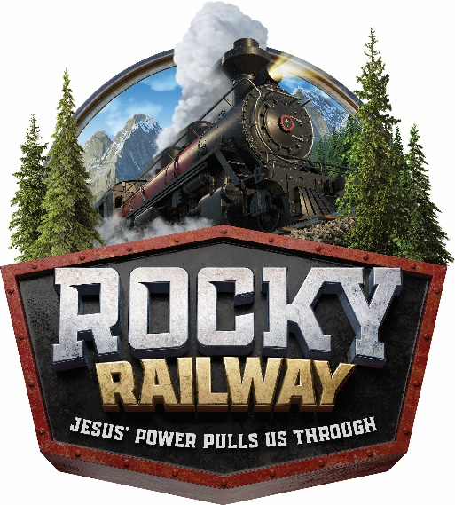
Good Shepherd
Lutheran Church
Vacation Bible School
July 27th – July 31st, 2020
9 am to 12 noon

Summer is just around the corner and here at Good Shepherd we’re planning another exciting VBS adventure! Are you looking for a safe, friendly, fun environment for your kids? Then sign up today for “Rocky Railway- Jesus’ power pulls us through” This fun-filled Vacation Bible School is for everyone between the ages of 3 years old to 11 years old. The adventure begins 7/27 and continues till 7/31 from 9 am to 12 noon.
Be a part of this exciting adventurous “Rocky Railway- Jesus’ power pulls us through” Vacation Bible School! Kids learn Jesus is the one who lights our way and gives us hope for each new day. His love illuminates when the path is dark. Vacation Bible School encourages kids to follow Jesus where ever he will lead them! At “Rocky Railway- Jesus’ power pulls us through” kids will hear stories about Jesus, make cool crafts, learn catchy songs, play zany games, dance to cool videos, eat yummy snacks and make lots of new friends!
Registration is going on NOW! Attached is a registration form for your child(ren) as well as their friends. All children are welcome to enjoy this fun filled week. They do not have to be members of Good Shepherd.
Please fill out a separate form for each child. Cost is $25 per child. Allergy friendly environment.
Please make check payable to: GOOD SHEPHERD LUTHERAN CHURCH and mail to 3434 Hempstead Turnpike Levittown NY 11756

“Rocky Railway- Jesus’ power pulls us through”
Good Shepherd Vacation Bible School 2020

Students name: _____________________________________ AGE_______GRADE ENTERING______________
Any known allergies or medical concerns: ______________________________________________________
Does the student attend church? Which Church? _________________________________________________
Parents Name______________________________________________________________________________
Address:__________________________________________________________________________________
Email: ___________________________________ Phone #: ________________________________________
Siblings names/ages _______________________________________________________________________
Emergency contact: _______________________________ Phone #: ________________________________

Please Register me for Free Sunday school: Yes / No

