Windows 10 and 11 Remote Assistance Instructions

From the search bar type: msra . The msra app should display. Click on it or hit the Enter key

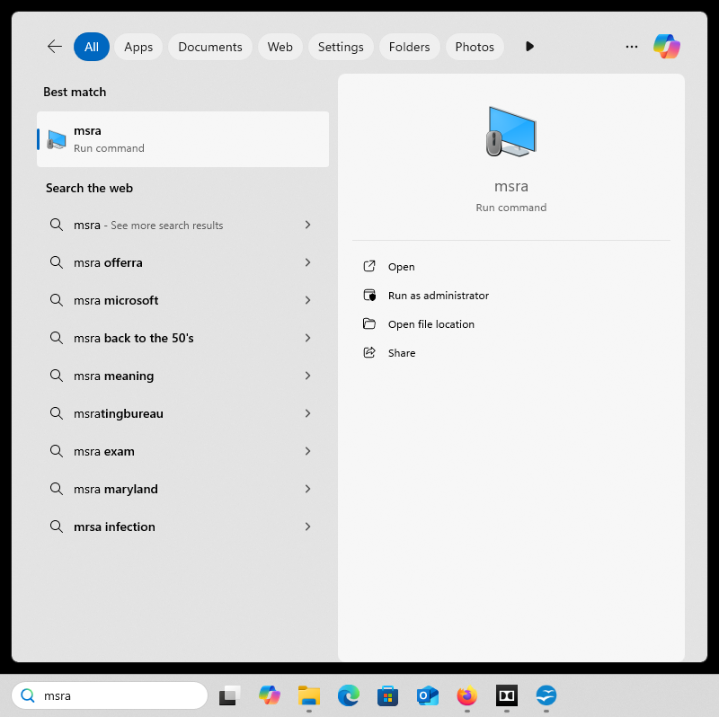

When the app loads, select “Invite someone you trust to help you”.

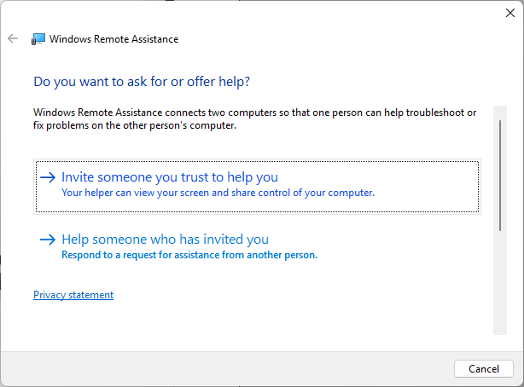

Next select “Save this invitation as a file”.

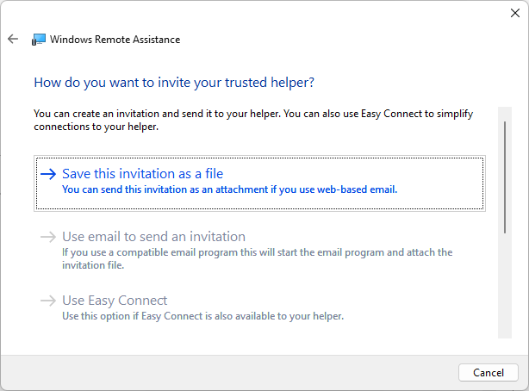

Save the invitation file to your desktop by selecting “Desktop” in the left column then click “Save”

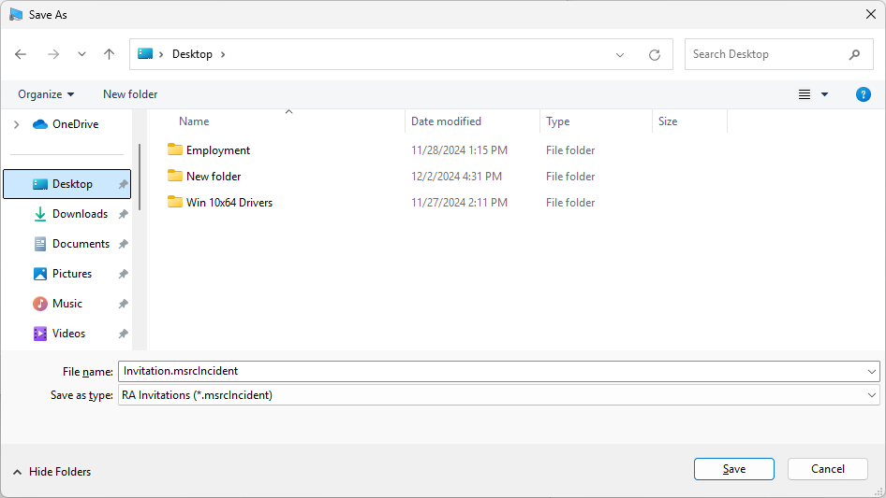

It should look similar on your computer

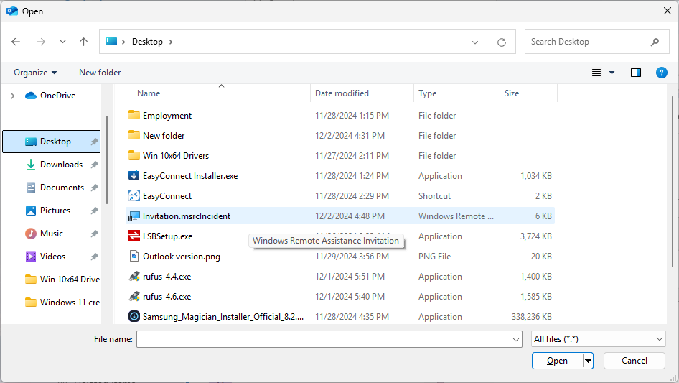

After the file is saved, the top of your screen should have the required password in order for the remote session to take place. Highlight the password and right-click to copy or use **Ctrl C** on the keyboard to copy.

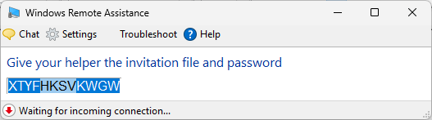

Next, open you're email program and compose a new message. In the body of the email paste the password for the remote session you have copied.

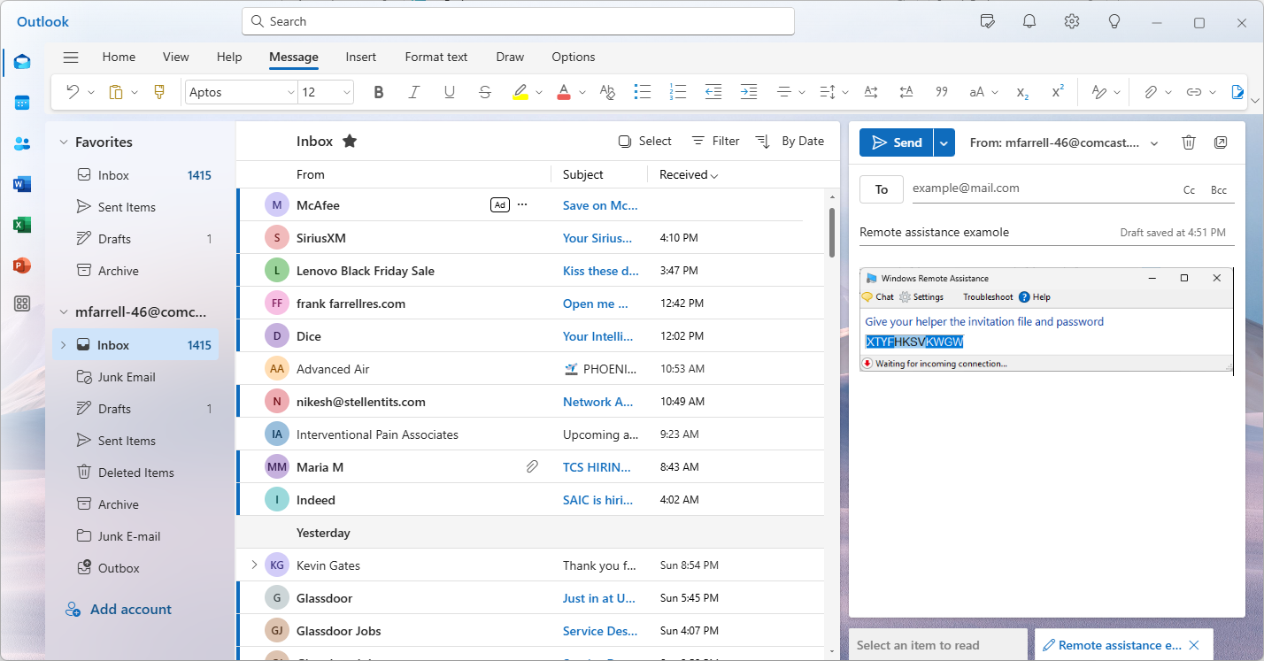

Next, attach the invitation file you saved to the desktop. Your email program may differ.

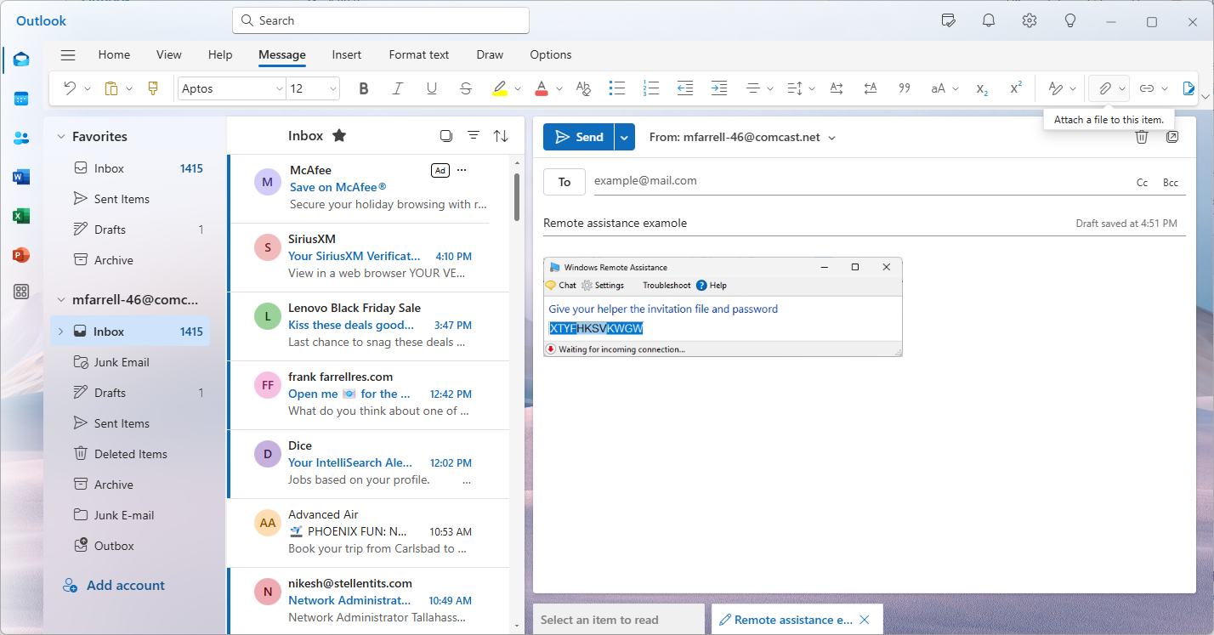

Browse to the “Desktop” and select the invitation file as seen below then click “Open”.

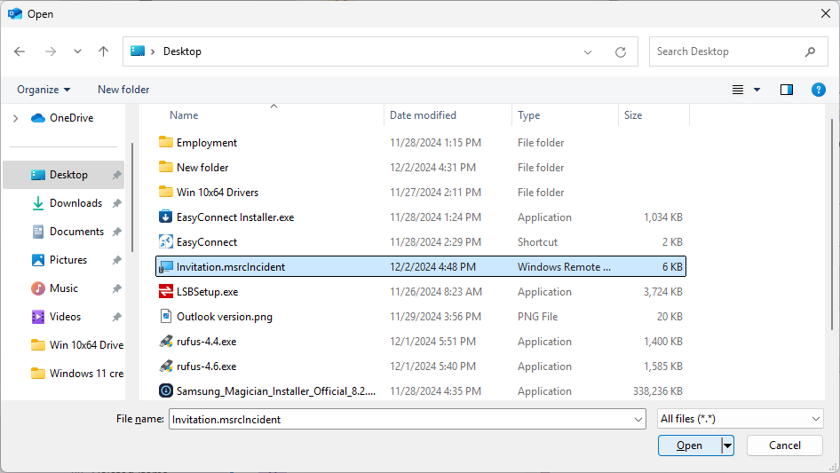

The email should look similar to the one below showing the password pasted into the body and the invitation file attached. Send the email to: **contact@MidAtlanticIT.tech**

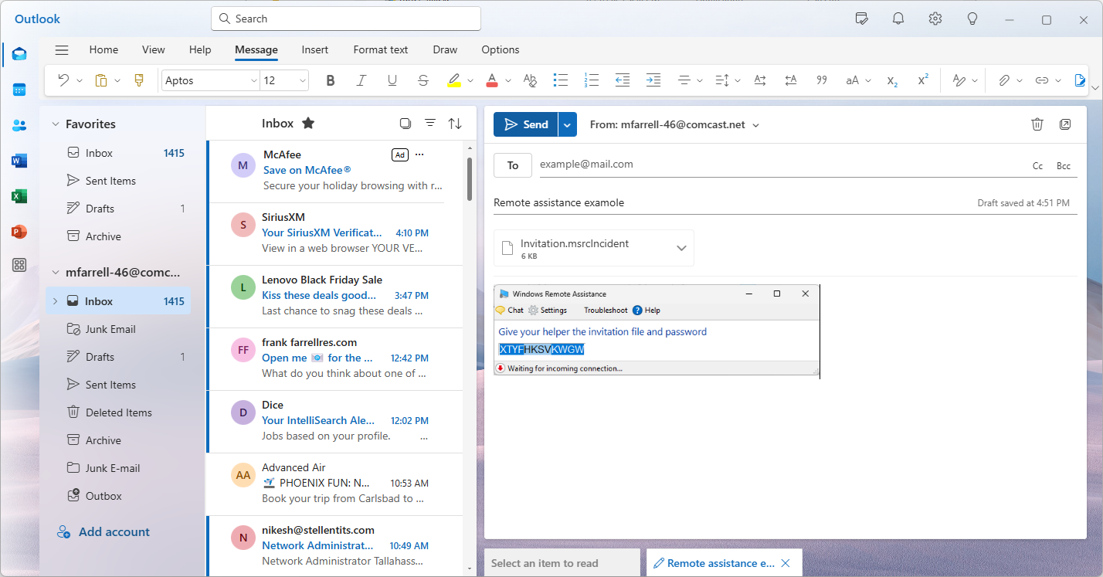

Note: Remember that each time the msra tool is used or the computer is restarted, the invitation file and passcode’s change. Therefore this process must be performed again from start to finish.