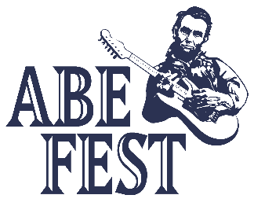
2022 Abe Fest Food Vendor Form

We are pleased to invite you to participate in this year’s Abe Fest being held Friday, July 8th (6:00 pm - 10:30 pm) and Saturday, July 9th (6:00 pm - 10:30 pm). Please review and complete this form and all other required documents and submit with payment to Abe Fest.

REGISTRATION INFORMATION

Vendor Name: _________________________ Head Cook: _____________________________

Website: __________________________ Facebook Page: ______________________________

Address: _______________________________________ Phone:________________________

Cell: ___________________________ Email: ________________________________________

BOOTH SPACE
All participants are guaranteed a 12’ x 12’ space with a $200 entry fee. No additional fees apply. Please note, additional 12” x 12” space is $50 per space.

______ I will need a 12’ x 12’ space _____ I will need the following size ____________

Electric Needs? ______________________ Water Needs? ________________________

PAYMENT & INFORMATION CHECKLIST

_____ $200 Entry Fee / _____ Extra Space Fee / _____ Menu Form

_____ Copy of General Liability Insurance

TOTAL AMOUNT ENCLOSED: $ ________________ (Check payable to Abe Fest)

WAIVER of LIABILITY
In consideration of your acceptance of this entry form, I the undersigned, intending to be legally bound, do hereby for myself, my heirs, executors and administrators, waive and release any and all rights and claims for damages I may have against Abe Fest, BOS Center and the City of Springfield and their offices, directors, trustees, employees, insurers, agents, successors and assigns from any and all injuries suffered by me in connection with this event. I further grant permission to Abe Fest, Inc. and/or agents unauthorized by them to use any photographs, videotapes or any other record of this event for any legitimate purpose. No registration fee refunds.

Signature: _______________________________________ Date: _____________________

Mail to: Rick Lamb Cell: 217-871-8718
204 8th St Email: info@abefestillinois.com
Lincoln, Illinois 62656

Menu Form

Please indicate your menu choices and prices below. Vendors may not sell bottled water, soda or alcoholic beverages as Abe Fest will be selling those items.

Menu Item #1: _________________________________________ Cost: $ _________

Menu Item #2: _________________________________________ Cost: $ _________

Menu Item #3: _________________________________________ Cost: $ _________

Menu Item #4: _________________________________________ Cost: $ _________

Menu Item #5: _________________________________________ Cost: $ _________

Menu Item #6: _________________________________________ Cost: $ _________

YOU ARE RESPONSIBLE FOR CONTACTING THE COUNTY AND CITY FOR ALL NECESSARY PERMITS AND FORMS.

Sangamon County Health Department: Alan 217-535-3145
City of Springfield: Crystal 217-789-2255

