“Accelerating Western Balkans University Modernisation by Introducing Virtual Technologies”
VTech@WBUni

WP1 - Deliverable D3.1

QUALITY ASSURANCE PLAN

Project duration: 15/11/2019 - 15/11/2022
Due date of deliverable: 30/03/2020
Actual submission date: 30/06/2020
Dissemination Level: Consortium (Confidential, only for members of the consortium)
Version | Date | Change History | Author | Organisation
01 | 25/05/2020 | Document drafted | Lejla Abazi Bexheti, Arbana Kadriu | SEEU
02 | 10/06/2020 | First revision/comments | Ornela Vladi | UET
03 | 12/06/2020 | Second revision | Lejla Abazi Bexheti, Arbana Kadriu | SEEU
04 | 18/06/2020 | Third revision | Albana Halili, Kseanela Sotirofski | UAMD
05 | 30/06/2020 | Final version | Lejla Abazi Bexheti,Arbana Kadriu | SEEU

Table of Contents

Introduction 3
Project background 3
Distribution List 4
Quality Monitoring Plan 5
Achievement Measuring 5
Potential risks 7

Introduction
Quality assurance monitoring and periodic assessment of progress towards project goals is one of the integral objectives of this project. Data collection will be provided during the project development, qualifying the project management to maintain the project’s quality.
The Quality assurance team in conjunction with the key partners will work to determine the data relevant to demonstrate impact of the project. We will use several methods to obtain and record data in the project. Regular reports will be provided by the QA team. The reports will include plot explaining achievements, challenges and analysis of how project activities provided to changes in specific milestones.
In this document we have defined the Indicators of Achievement (IOA), to measure awaited outcomes, as well as potential risks, together with the corresponding mitigation measures.

Project background
At Digital Assembly held on June 2018, the European Commission has launched the Digital Agenda for the Western Balkans (WB), calling for capacity building on ICT, for building digital society, aiming training for a new generation of researchers and engineers that will promote interdisciplinary collaboration across Europe. The key to unlock the economic potential of Western Balkans countries is considered investment in quality of education, teaching, learning and innovation, especially in the area of ICT.
Possessing specific ICT skills have effect on economic competitiveness, especially at small countries such as WB countries (Albania, FYROM, Kosovo), with high unemployment rate, whereas one of the solutions to survive is active participation in lifelong learning process (European Commission, 2011), by upgrading current competences and obtaining new competences, needed in the local, regional, European and global labor market.
The forecast for Virtual Technologies Market is 52% growth rate for the next five years. Virtual Technologies are considered as one of tools to transform and modernize the Higher Education. Students today are already familiar with various technologies, which is why computerized tools and apps make sense in a classroom setting. In WB countries the rate of possession of smart phones and other smart equipment’s is comparable with the rate presented for European countries. Therefore, consortium thinks a Strategy should exist and capacities should be developed and upgraded to take advantage of the opportunities offered by incorporating emerging digital technologies in university culture.

Distribution List
This Quality Assurance Plan will be circulated to the all Project Partners.
The Quality Assurance Plan is prepared by SEEU. All below listed partners need to revise and update the Quality Assurance and Risk Mitigation Plan.
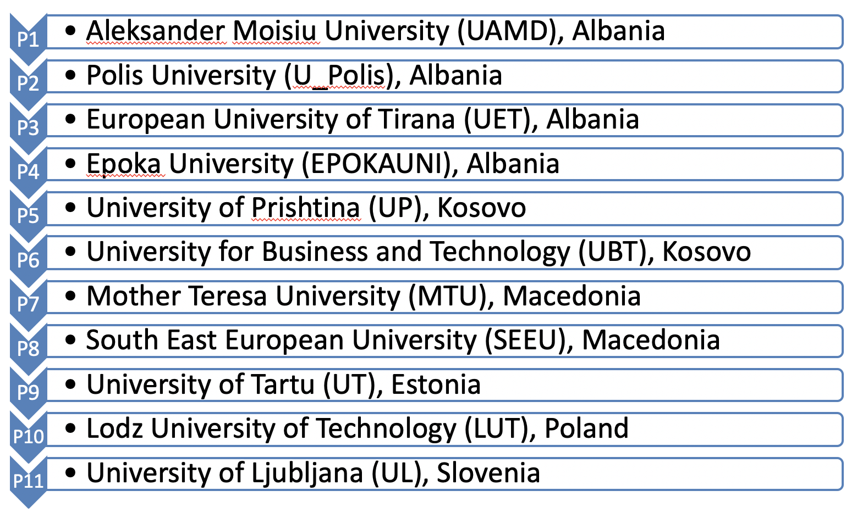
Project Quality Committee (PQC)
The PQC is composed by each of the Institutions (partners) coordinators of each Working Package (WP).
List of members of the Project Quality Committee is as follows:
- UAMD, Albania: Kseanela Sotirofski, nelasotiri@yahoo.com
- U_Polis, Albania: Manjola Hoxha
- UET, Albania: Ketrina Cabiri, ketrina.cabiri@uet.edu.al
- EPOKAUNI, Albania: Julian Hoxha
- UP, Kosova: Enver Hamiti
- UBT, Kosova: Besnik Qehaja
- MTU, North Macedonia: Diturije Ismaili
- SEEU, North Macedonia: Arbana Kadriu, a.kadriu@seeu.edu.mk
- UT, Estonia: Ryan Eric Hamer
- LUT, Poland: Dorota Kaminśka
- UL, Slovenia: Klemen Pečnik
The Project Quality Committee will prepare every 6 months overall project Quality reports based on quality reports prepared by each WP leader. Possible weaknesses will be identified through these reports, allowing the QC to detect possible deviations and to adopt the necessary measures to correct them.
A PQC meeting will be held before the elaboration of each report. These meetings will be done virtually or on face every 6 months (June 2020, December 2020, June 2021, November 2021, May 2022, October 2022) coordinated by the WP leader for Quality assurance.

Quality Monitoring Plan
The PQC will use as main source for its reports two tools to be specifically developed: Quality Reporting Table (Timeline of achievement indicators) and delivered reporting documents.
Every activity will have a separate sheet, which will be filled out by the responsible institution of the activity/sub-activity, providing information as start and end date, outcomes/outputs, indicators, or source of verification. For each indicator the final target should be defined by the responsible institution for the work package.
The overall life cycle for each task is divided on several milestones. One milestone covers a period of approximately 4-5 months. For each milestone the coordinators should fulfill the data for the achieved indicators. Indicators are defined as metric values (marked with yellow in the table), based on the indicators defined in the project application. If in a certain milestone timeframe there is no foreseen activity for some indicator, that field should be marked with NA (No Activity).
For each task, a folder on the Project shared folder (Dropbox/Quality) is created. The entity responsible for the activity will be asked to upload to this folder all the complementary documentation that supports the Outcomes/Outputs, especially those related to the Source of Verification.
The Timeline worksheet will be shared, and it will be accessible to all the partners.

Achievement Measuring
Awaited outcomes will be measured in terms of the effectiveness of their achievement, based on the reported data provided on the worksheet. We will use Indicators of Achievement (IOA), which is a list of tools to measure the achievement for each defined objective. After the completion of each activity, the IOA for every objective will be measured, giving in this way a QA monitoring approach. Indicators of achievement are defined for each particular objective.
Objective 1: Capacity building of academic staff to incorporate Virtual Technologies in teaching
Indicators of achievement:
- Number of trained academic staff for each university (first round)
- Number of trained academic staff from the trainers
- Number of trained administrative staff
- Survey on preparation satisfaction after each training
- Published reports/paper
Objective 2: Develop teaching methodologies availing of technology and/or ICT tools
Indicators of achievement:
- Review of prepared course materials
- Review of prepared user guidelines
- Surveys concerning course exercises and their evaluation
- Surveys concerning user experience evaluation
- Number of delivered courses (as defined for every university)
Objective 3: Equip students with competencies to use/access tools, software and platforms
Indicators of achievement:
- Surveys concerning student satisfaction on gained competencies
- Evaluation on gained student competencies using different tests and projects from the field
Objective 4: Increase interaction between teachers and students
Indicators of achievement:
- Surveys/interviews concerning student satisfaction
- Interviews with teachers to understand their perception of interaction
Objective 5: Increase the level of understanding and reduce the grasping time and the effort that students need to learn information by using 3D concepts instead of 2D ones
Indicators of achievement:
- Tests formulated by experts that can assess level learned information by using 3D concepts compare when using 2D ones
- Tests formulated by experts that can measure timing to learn information by using 3D concepts compare when using 2D ones
Objective 6: Offer a better delivery of basic knowledge even for complex issues, higher learning efficiency and better learning experience by AR/VR techniques.
Indicators of achievement:
- Comparing gained knowledge of courses that employ AR/VR technologies vs traditional courses (the same test for two groups)
- Impact assessment and evaluation from students

Objective 7: Establish Virtual Technology HUB for developing teaching materials for basic learning courses and serve as a HUB for other HEIs
Indicators of achievement:
- Number of established laboratories per university as indicated in the project
- Number of equipment per laboratory as indicated in the project
Objective 8: Foster cooperation between academy and industry by organizing open days, joint product developments, thesis supervision etc.
Indicators of achievement:
- Number of open days, joint product developments, thesis supervision etc.
- Number of participants on these joint events
- Surveys concerning participant satisfaction on these joint events
- Videos and others materials from these joint events
- Number of total online views of the streamed event
Objective 9: Develop capacities for future joint research and innovative ideas with the support of Virtual Technologies.
Indicators of achievement:
- Number of joint courses
- Published joint research papers
- Application on new similar projects

Potential risks
There are potential risks that might occur during project implementation and after its completion. We list the identified as potential risks and describe the measures we would undertake in order to mitigate the anticipated risks, together with the expected risk level.
Risk 1: Partnership risks: Misunderstanding between partners leads to a slowdown of activities
Mitigation measures: Project partners have signed a detailed agreement that regulates relations, while previous contacts have resulted in established cooperation
Risk level: low
Risk 2: Management risks: Lack of human resources, project delays
Mitigation measures: Project partners have defined project staff with many years of project experience; well defined milestones and deadlines for the project activities; continuous consultation between partners, assuring that deadlines are met and delays are not encountered.
Risk level: low
Risk 3: Technological risks: Not enough prepared laboratories for delivering the courses with new technologies
Mitigation measures: Project partners have defined project cost regarding the needed equipment
Risk level: low
Risk 4: Academic staff risks: Not well trained staff for course delivering
Mitigation measures: Project partners have defined all training activities which should ensure that the necessary number of trained academics is accomplished
Risk level: low
Risk estimation and monitoring will be accomplished on quarterly gaps, aiming the objectives fulfilment and quality satisfaction.

