Accelerating Western Balkans University Modernization by Incorporating Virtual Technologies
(VTech@WBUni)

WP2.6 - Deliverable D2.6.2

TEACHER TRAINING REGARDING USER INTERFACE DESIGN, USER EXPERIENCE AND VR SICKNESS

Project duration: 15/11/2019 - 15/11/2022
Due date of deliverable: 15/07/2020
Actual submission date: DD/02/2021
Dissemination Level: Consortium (Confidential, only for members of the consortium)
Version | Date | Change History | Author | Organisation
01 | 10/01/2021 | Document drafted | Matevz Pogacnik | UL
02 | 15/01/2021 | First edition | …………….. | ……..
03 | DD/MM/2021 | First revision | ………………. | ………
04 | DD/MM/2020 | Second revision | ……………. | ……….

Table of Contents

1. Introduction 3
2. 1st training on User experience guidelines in VR and AR 3
3. 2nd training on User experience guidelines in VR and AR 6
4. 3rd training on VR evaluations and VR sickness 9
5. Conclusion 9

Introduction
The scope of the Work package 2.6, are usability aspects of VR solutions and lectures, which will be developed in the scope of this project. The goal of the WP is to provide best user experience in educational content consumption, which requires consideration of usability and user experience guidelines. The emphasis of this document are reports on Teacher trainings regarding user interface design, user experience and VR sickness.
Several trainings on user experience guidelines, user experience in VR and VR sickness have taken place in the scope of the project, described in this document. The trainings were foreseen to be done on site, but due to the pandemic they had to be done online.

Institution | Location | Date
University of Ljubljana | Online Zoom | 1st of April 2021
University of Ljubljana | Online Zoom | 8th of April 2021
University of Ljubljana | Online Zoom | June 2021
The structure of this document is as follows: Each training is described in a section, sorted by date of training execution.

1st training on User experience guidelines in VR and AR
The teacher training in Ljubljana took place online over Zoom platform on 1st of April. The training agenda was sent to partners a week before training and was acknowledged by the participating partners. The teaching staff, which attended the training came from the following institutions:
- University of Tartu (UT)
- Lodz University of Technology (LUT)
- European University or Tirana (UET)
- University of Prishtina (UP)
- South East European University (SEEU)
- Aleksander Moisiu University (UAMD)
- Polis University (U_Polis)
- Epoka University (EPOKA)
- University for Business and Technology (UBT)
- Mother Teresa University (MTU)
There were more than 50 participants from the above institutions attending the training and workshop.
The training was done at the premises of the University of Ljubljana, where a temporary studio was setup for this purpose, with the possibility to show the lectures, speakers, demonstrations, mobile phone screen captures, etc.
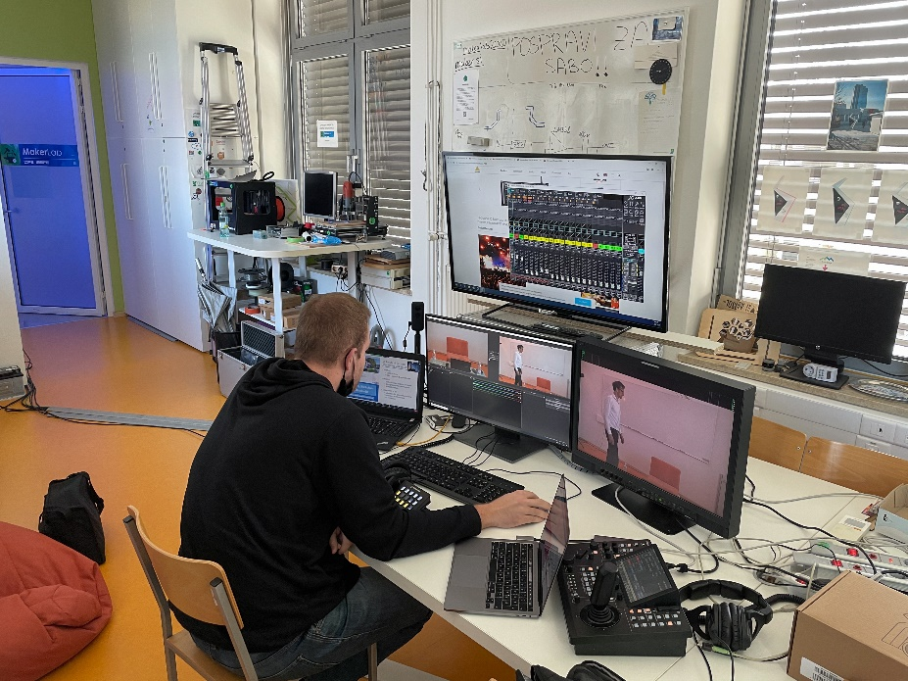
Figure 1: Temporary studio for broadcasting/streaming of the workshop over ZOOM
The training session started with the welcome speech of the rector of University of Ljubljana, who greeted the participants, followed by the presentation of the Faculty of Electrical Engineering and two laboratories (LMMFE and LTFE) by the chairman of the Laboratory of Telecommunications prof. dr. Andrej Kos.
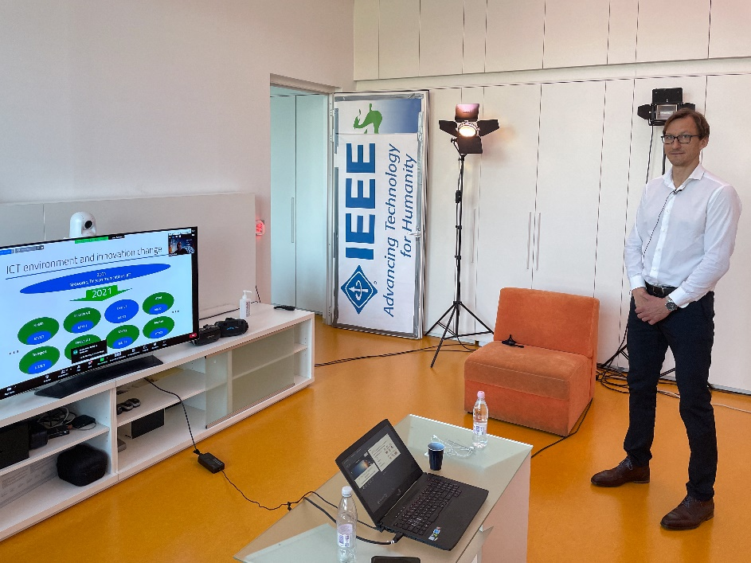
Figure 2: Lecturer dr. M. Pogačnik during the presentation of dr. A. Kos
The first part of the training was composed of presentations prepared by dr. Jože Guna, dr. Matevž Pogačnik and Klemen Pečnik from the Laboratory of multimedia. This part consisted of lectures regarding user experience guidelines on how to design a VR user interface, taking into account ergonomics, field of view, human perception and vision as well as movement in VR space, etc. Some emphasis was given to aspects of VR sickness, which will be discussed and presented in more details in one of the coming workshops.
Additionally, some guidelines were given on AR user interface guidelines as AR technology may also benefit the teaching process and learning in selected cases and courses. These guidelines took into account some specifics related to interactions and user interfaces in AR as these are heavily dependent on the environment, lighting conditions etc.
The second part of training consisted of lectures on production and consumption of 360-degree video, which is one of the approaches to teaching using VR technologies. This technology is especially suitable for presentation of live demonstrations or presentation of topics, where students (lesson attendants) cannot participate in person due to security, health or other reasons such as remoteness of the location, etc. Best professional and consumer 360-degree cameras were presented as well as aspects and limitations of Head mounted displays (a.k.a. HMDs or VR goggles), which influence the perceived quality of VR content. The theoretical limitations of video and HMDs’ resolution related to human vision was discussed as well as the consequential technical aspects - such as huge bit rates and adaptive streaming of 360-degree videos, for example.
The third part of the training consisted of practical demonstration related to VR (360-degree) video. The first demonstration included a “How to stream live 360-video”. In this scope a camera-to-smart phone setup was presented, with all the settings explained in combination with YouTube Studio settings for best quality and lowest streaming latency. The participants could follow the 360 video live stream on the preprepared URL. Using this a short tour of UL studio setup was given as an example of teaching using VR technology.
The second demonstration included presentation of the influence of 360-degree video quality (resolution, bitrate) to perceptual quality, considering a limited field of view and quality of the display (HMD, mobile or PC). A number of high-quality YouTube videos (8K) were used for this purpose, with different resolutions.
The training was concluded after a fruitful discussion and a Q&A session. The training was recorded and is available to participants for later viewing.

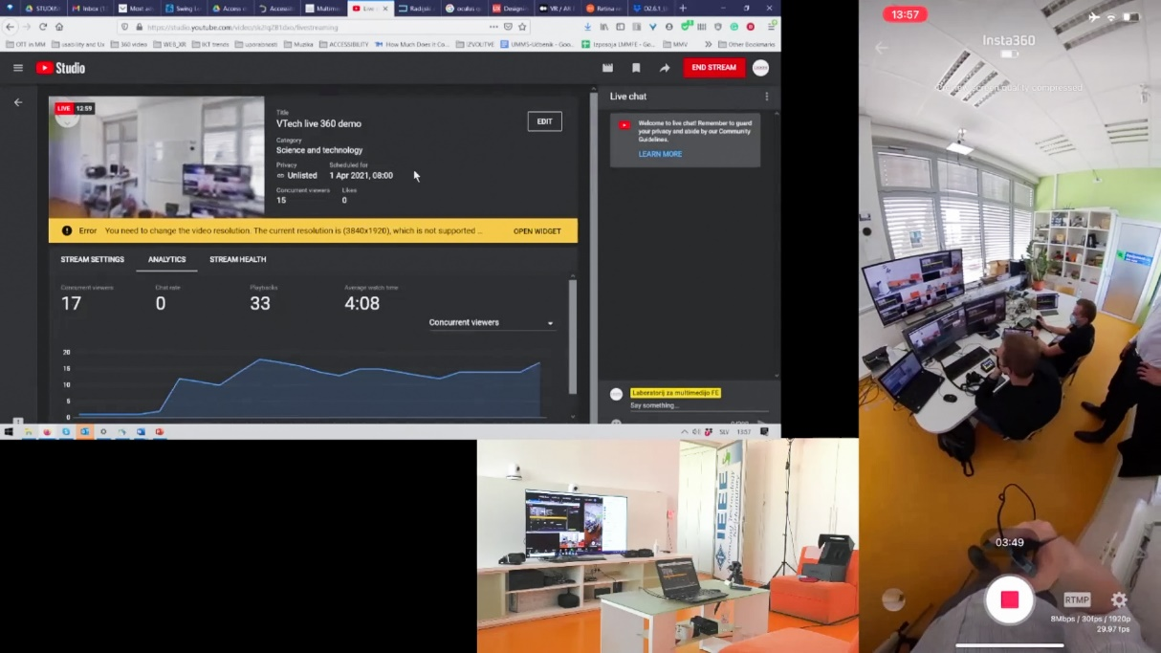
Figure 3: A demonstration of 360-degree LIVE streaming over YouTube
The training session again started with the welcome speech of the rector of University of Ljubljana, who greeted the participants, followed by the presentation of the Faculty of electrical engineering and two laboratories (LMMFE and LTFE) by the chairman of the Laboratory of telecommunications prof. dr. Andrej Kos.

2nd training on User experience guidelines in VR and AR
The second training on VR and ASR guidelines for user experience in Ljubljana took place online over Zoom platform on 1st of April. The participants were this time some of the teaching staff that could not attend the first meeting and students. The training agenda was similar to the 1st training, with some differences in the demonstrations in the end of the training session. The teaching staff and students, which attended the training came from the following institutions:
- European University or Tirana (UET)
- University of Prishtina (UP)
- South East European University (SEEU)
- Aleksander Moisiu University (UAMD)
- Polis University (U_Polis)
- Epoka University (EPOKA)
- University for Business and Technology (UBT)
- Mother Teresa University (MTU)
There were more than 70 participants from the above institutions attending the training and workshop.

The training was again done at the premises of the University of Ljubljana, where another temporary studio was setup for this purpose, with the possibility to show the lectures, speakers, demonstrations, mobile phone screen captures, etc.
The structure of the training was the same as the one during the first training, with the first part consisting of lectures regarding user experience guidelines on how to design a VR user interface, taking into account ergonomics, field of view, human perception and vision, movement in VR space and VR sickness, etc. This was later followed by a session on user experience guidelines in AR applications.
The second part again consisted of lectures on production and consumption of 360-degree video, its specifics, benefits and (technical) drawbacks.
The third part of the training again consisted of practical demonstration related to VR (360-degree) video, starting with a “How to stream live 360-video” over YouTube using YouTube Studio and its settings. This was followed by a demonstration, which included presentation of the influence of 360-degree video quality (resolution, bitrate) to perceptual quality, considering a limited field of view and quality of the display (HMD, mobile or PC). This time a virtual presentation of the Faculty of electrical engineering was used to demonstrate different quality settings, with specially prepared transcoded material, which was recorded for the purpose of UL FE promotion. Finally, the virtual tour of UL FE was used as an example of good practice VR content for promotional purposes.
The training was concluded with a long and fruitful discussion and a Q&A session. The training was recorded and is available to participants for later viewing.
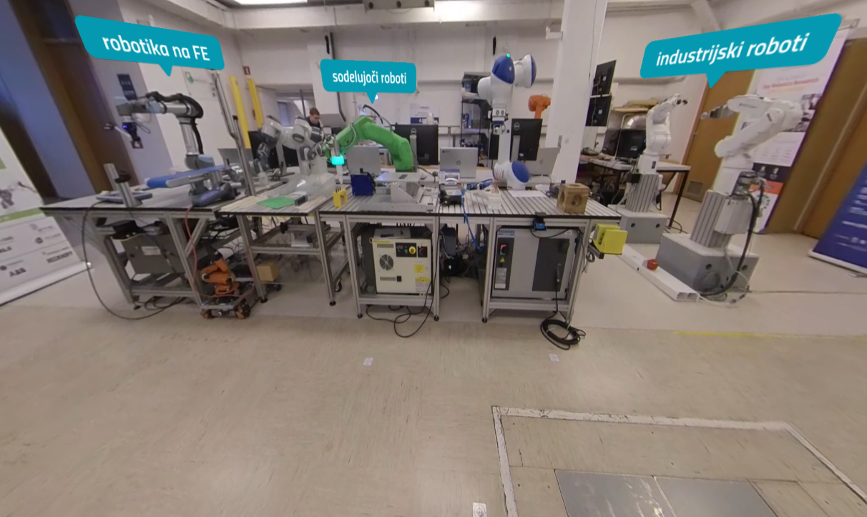
Figure 4: A virtual presentation of UL FE.

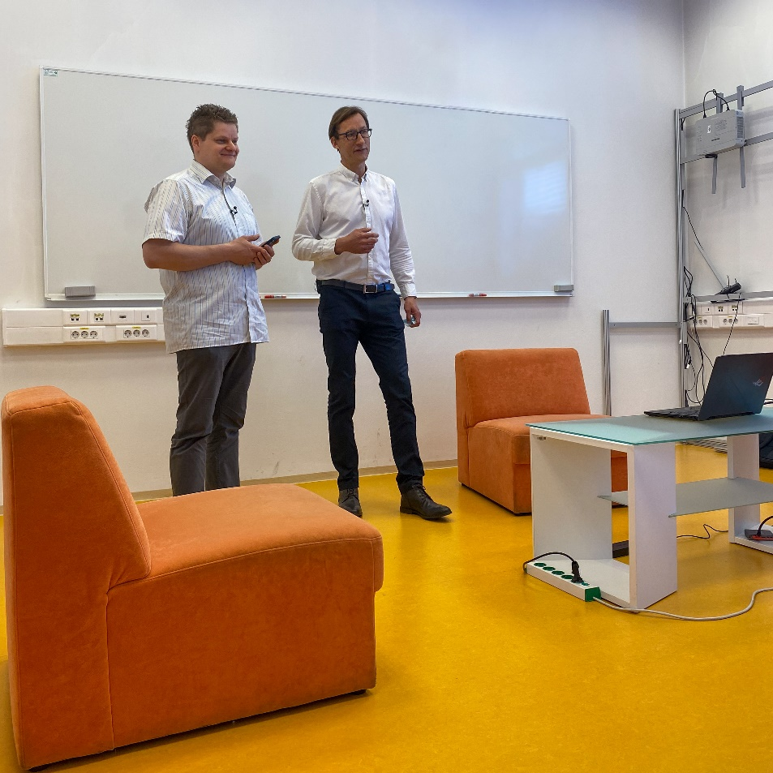
Figure 5: dr. M. Pogačnik and K. Pečnik answering the questions of the participants.

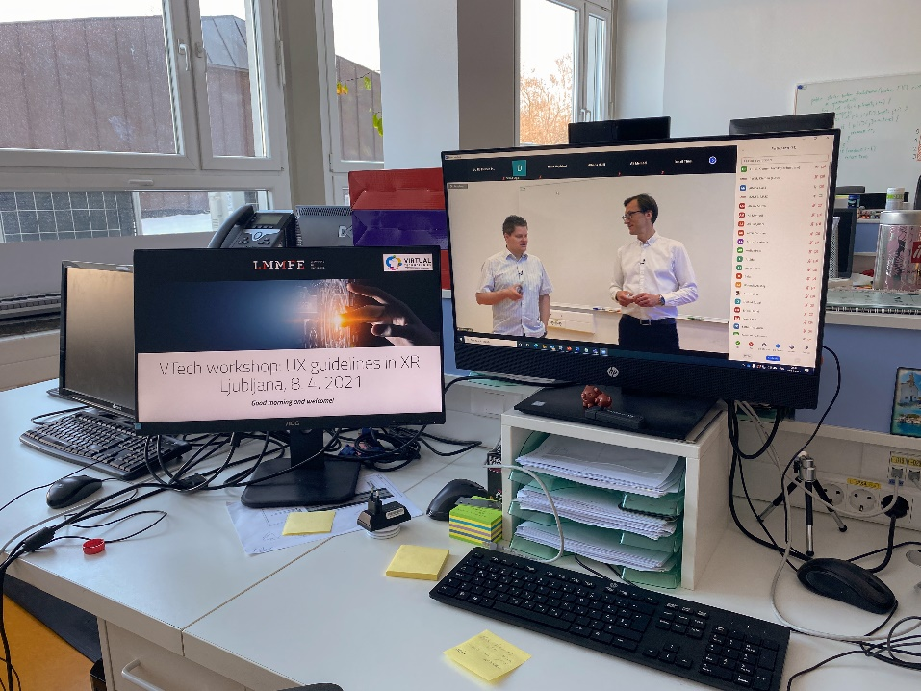
Figure 6: A control view of the training session

3rd training on VR evaluations and VR sickness

Conclusion
This document is presenting the reports on trainings that have taken place in the scope of WP2.6 in the domain of user experience, related to VR content. The goal of the document is to provide guidelines for creation of educational VR content in the scope of the Erasmus+ VTech project.

