**Accelerating Western Balkans University Modernization by Incorporating Virtual Technologies**

**VTech@WBUni**

**WP1 - Deliverable D1.3**

REGIONAL RESULTS/FINDINGS ON THE USE OF VIRTUAL TECHNOLOGIES IN TEACHING METHODOLOGIES IN ALBANIA

**Project duration:** 15/11/2019 **-** 15/11/2022

**Due date of deliverable:** 26/02/2021

**Actual submission date:** 26/02/2021

**Dissemination Level: Consortium** (Confidential, only for members of the consortium)

|  |  |  |  |  |
| --- | --- | --- | --- | --- |
| **Version** | **Date** | **Change History** | **Author** | **Organisation** |
| 01 | 10/01/2021 | Document drafted | Albana Halili | UAMD |
| 02 | 01/02/2021 | First edition | Valerio Perna | U_POLIS |
| 03 | 15/02/2021 | First revision | Valerio Perna | U_POLIS |
| 04 | 19/02/2021 | Second revision | Flora Krasniqi | U_POLIS |

Table of Contents

1. Introduction 3

2. Objectives, methodology and scope of the survey 3

3. Sample (questionnaire) design 4

4. Results 5

1.1. Results of TEACHERS/RESEARCHERS’ questionnaires 5

1.2. Results of student questionnaires 11

5. Conclusion 18

# Introduction

Project The education system needs new technologies in order to stay relevant in the ever-changing world and be effective at realizing its mission. Virtual & Augmented Reality is the next logical step in the evolution of the Education System. Augmented and Virtual Reality education apps can make the process of explaining complicated concepts less challenging by adding an interactive audio-visual factor. A lot of educational technology companies are using virtual reality to bring true to life experiences to the classroom, while highlighting the technology’s ability to inspire and grab the attention of the students.

While virtual reality offers the simulation of an entirely computer-generated perceptive experience, augmented reality is the integration of digital information with the user’s environment. The popularity of AR is rising because it brings elements of the virtual world into the real world, thus enhancing the things we see, hear, and feel. Following this trend and capturing this opportunity came into life VTECH project, which is an Erasmus+ Capacity Building in Higher Education project led by the Aleksander Moisiu University, Albania. The consortium has 11 partners out of which 6 are HEIs from Albania, Kosovo and the Republic of North Macedonia, and 5 partners HEIs from program countries namely Estonia, Poland, Slovenia.

VTECH projects general aim is to introduce for the first time at Western Balkan universities the concept of Virtual Technologies as a tool for accelerating university modernization, while contributing to developing knowledge-driven society.

In this regard it has planned to follow step by step the entrance and implementation of such technologies in WB universities, but before that as e preliminary phase under the preparation package of it was planned to make a survey to analyze the overall situation on educational institutions. Firstly, it was planned to make it within the partner institutions but in order to make a clear panorama of the overall situation, educational institutions outside the consortium are included also.

# Objectives, methodology and scope of the survey

The main objective of the survey was to better understand the general technological advancement in the Albanian education system by gathering valuable insight from both students and academic staff. Its purpose was to make clear view of the situation by identifying the current technological knowledge level and implicitly to understand the readiness of Albanian universities to advance more by entering into learning process the latest advancement in technology.

The methodology used is direct questioning to gather primary data. There were about 13 questions on it, and it can be considered as semi-structural survey because it had both closed and open-end questions. One of the project tasks was to prepare a questionnaire to gather inputs for a detailed gap analysis at country level. To have an overall picture and for the use of VR in the Balkans, the same questionnaire was used for Albania, Kosovo and North Macedonia. Specifically, the focus of this report is to analyze and interpret the results collected regarding Albanian case.

# Sample (questionnaire) design

Due to the fact that partners within the consortium mostly have somehow common profiles in the sense that the programs they offer are somehow similar and being so automatically is implied that technological necessities are common, it was decided later on to include on the educational institutions outside the consortium. Doing so, it is thought that the sample will be more representative in some different aspects: in the sense that the respondent number will be increased considerable; the profile of the participants will be diversified; and the country situation will be more accurately reflected.

There were prepared two different questionnaires:

1. Academic staff / researcher questionnaire
2. Students questionnaire

In Albania, there are 11 universities included on the survey from which 4 are partner institution of the consortium and 7 are other public and private universities operating in the country.

The list of universities included on the survey is made up by those institutions:

1. Aleksander Moisiu University
2. Epoka University
3. Polis University
4. European University of Tirana
5. Polytechnical University
6. Marin Barleti University
7. University “Our Lady of good Council”
8. Agricultural University of Tirana
9. University of Tirana
10. Luarasi University
11. Beder University College

There is a total of 375 staff members and 641 students participating on the survey and it was conducted during two different time periods: surveys on the consortium are conducted during the time period between April, 2020 and September, 2020 while the survey filled on other universities are conducted during the time period October, 2020 and January, 2021.

# Results

Following subtitles are given the detailed results for both categories: teachers and students.

* 1. Results of TEACHERS/RESEARCHERS’ questionnaires

Before starting the analysis of each question constructed with the aim to identify and collect information it is worth to make a general presentation of the composition of the responding staff members of Albanian universities. As it can be seen from the graphical representation the survey is filled by staff members from 11 universities: Aleksander Moisiu University, Epoka University, Polis University, European University of Tirana, Polytechnical University, Marin Barleti University, University “Our Lady of good Council”, Agricultural University of Tirana, University of Tirana, Luarasi University and Beder University College.

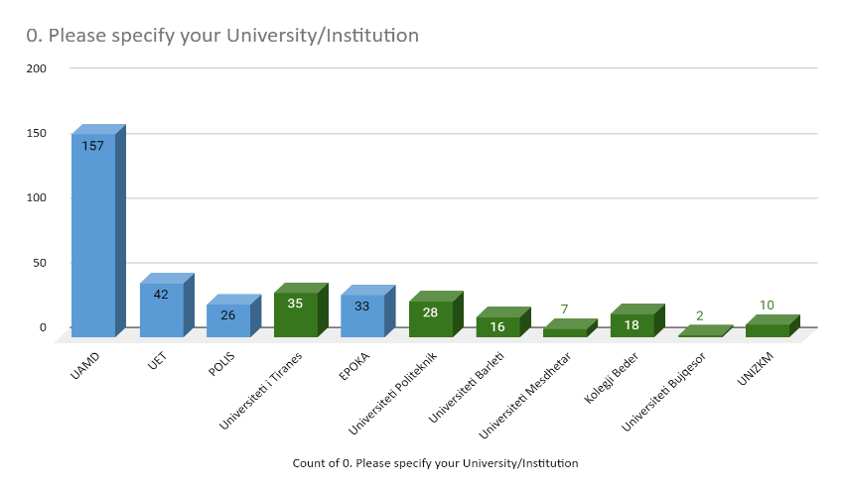

There is a total number of 375 staff members who have participated on the survey among which 259 belong to partner universities in the consortium and 116 from other universities in Albania where the survey was distributed. If we refer to the figure, the once with blue color are respondents from partner institutions and the once with green color are from other universities.

Innitially, staff member are asked regarding their experience in teaching, so that latter on can be used for further analysis to see which staff category better adopt to technological changes.

Majority of the respondents from consortium belong to 4 and 5 teaching years groups with 14.4% percentage each, which is somehow an indicator that the teaching staff is relatively new and more willing to contribute and adopt technological innovation. Somehow the same is situation on other universities but in this case there is a majority of teacher who have more than 10 years teaching experience ***(Question1****).*

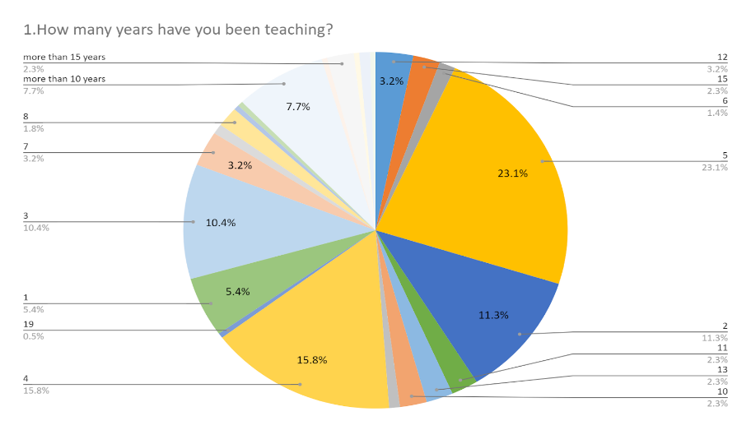

The aim of the second question is to proximate the actual level of knowledge the academic staff in albania has regarding virtual/digital technologies. We can for sure say that the academic staff on the albanian universities has considerable knowledge regarding virtual/digital technologies because only a small minority has declared that has no knowledge on them (7%).

Majority of albanian academic staff have a technological knowledge on virtual/digital technologies above average, ranging from level 3 to level 5 and promisingly 13.5% of them have full knowledge on them. It is promising because it is a ready staff which can support the implementation of them since in the early phases, and at the same time can help the other to adopt ***(Question2****).*

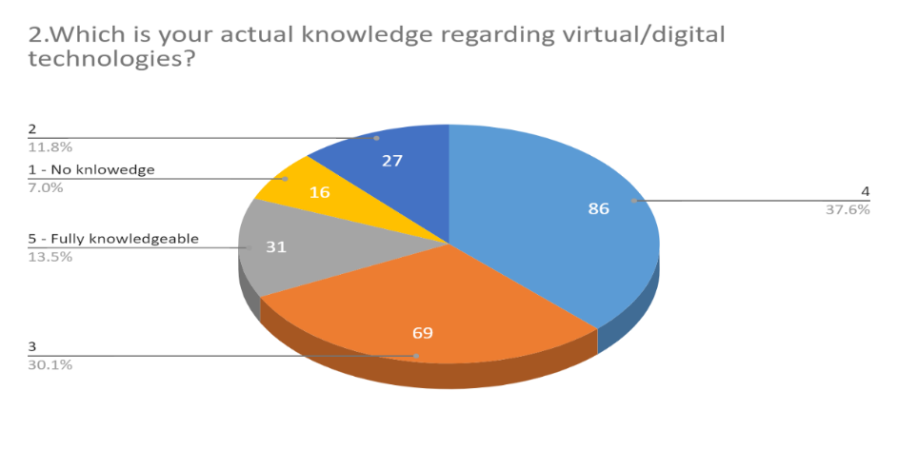

When we try to analyse if they have tested to use virtural reality or augmented reality in order to supplement current classroom teaching, or differently said how they have so far put in practice the technological knowledge they aquire, we see that the result is slitely different. Only 7.6% do so on daily basis, but what is hopefull is that 36.6% (14.3%%+ 22.3%) make such practices above the avareage (level 3 and level 4). The main point here remains the considerable high group of teacher who never use them in their daily teaching practices (41%) ***(Question 3).***

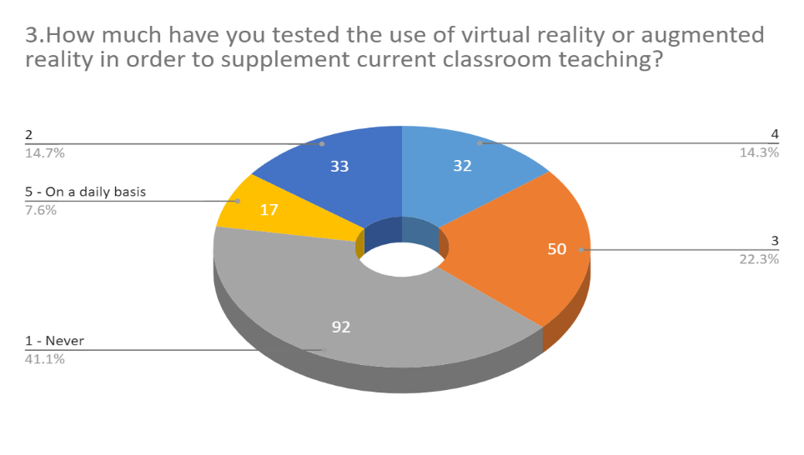

Question 4 aims to trackle the real impact such technologies have on learning process. Based on the results of this specific question we can see that almost in every field of education there is an impact of virtual technology. Staff members in albanian universities value the rate of impact of virtual technologies as strong or very strong. Only a small minory of them do not consider to have a high impact on their fields. In here we see that 33.9% of them thinks that it has very high impact and that 34.4% are shown more moderate saying that it has high impact on their field of education ***(Question4).***

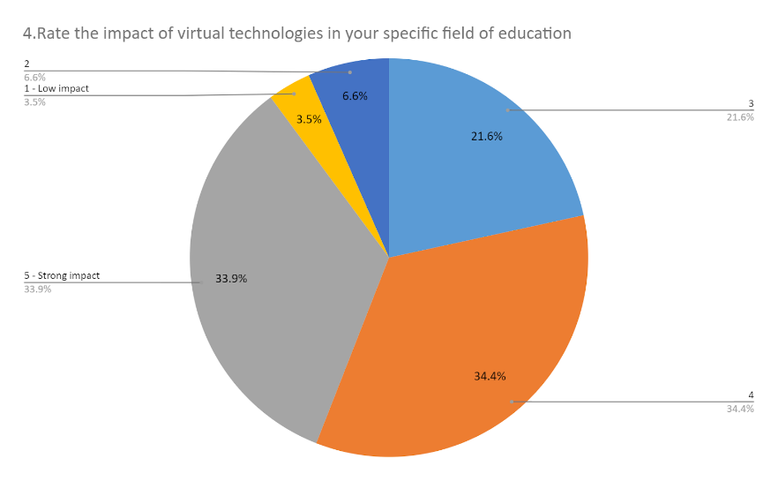

Any technological development has its main field of application. VR/AR technologies also have their context of application and in order to properly implement it within this question we tried to identify teacher’s fields of expertise. There is a very heterogeneous group of teachers who have filled the survey. The main fields of their occupation include Architecture, Design, Mathematics, Computer Sciences and all its programs, Economics and all its subfields, Statistics, Law, Multimedia, etc. There are many academicians coming from Computer Science field and its related programs, but also from other sciences like mathematics ***(Question 5).***

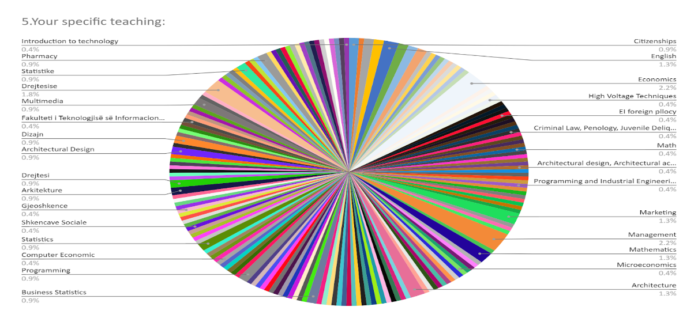

From question 6 results that most of respondents state that it will take at least some years to adopt this new technology in education. The positive result in here is that only a minority of 7.6% thinks that it will happen within 10 years. The most optimistic part of them thinks that it will happen in a short period of time, ranging from within a few months to 3 years. Due to the fact that thte survey was addresed to them, maybe some of them have persived the idea that it is done on e concrete project in the near future. Because if we cross check the answers sometimes there are diverging results on them and we try to make sense of what they intteted with specific answer ***(Question 6).***

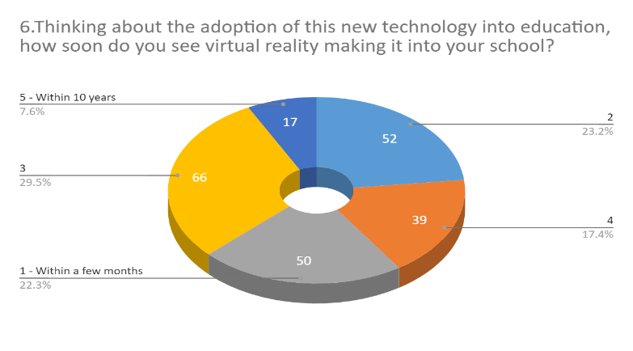

What is actual infrastructure on the institutions? We can see that a considerable group of them says that there is available technology in their institutions, but of course there is much to do in this regard. There is a high percentage saying that their university currently is fully equipped with hardware, but based on the previous question we can explain this result from the point of view that: since almost half of them belong to social sciences their actual technological needs is fulfilled with the current technological hardware in their institutions ***(Question 7).***

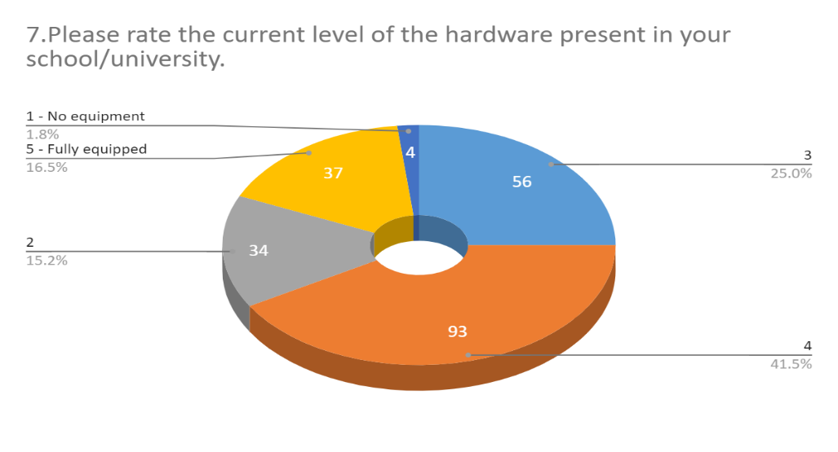

Based on the answers given to this question it is moslty seen that, most of the academic staff mention specific digital technologies which are related to their specific courses or their fields of expertise. Only 1% of them declare that they have augmented reality on their premises ***(Question 8).***

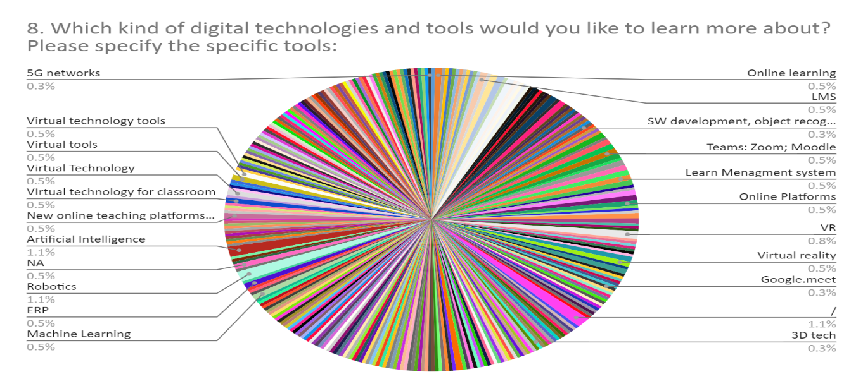

Academic staff of the albanian universities is well prepared for integration of new digital technology in their classrooms. Only very few of them are not confident to this technological development. 30.4% of them are fully confident about the readiness to use them and 36.3% are confident eough to support them ***(Question9).***

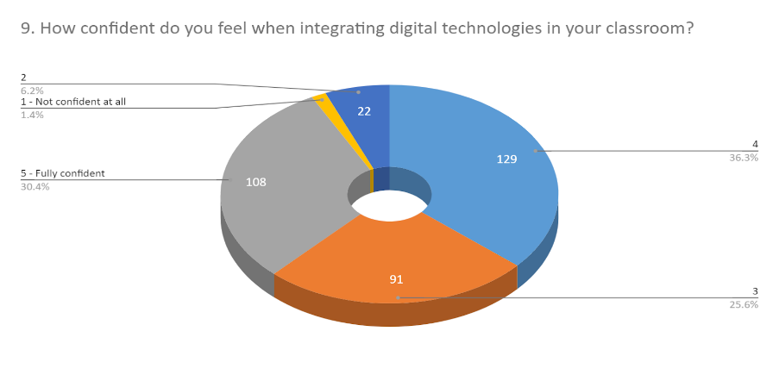

In most of the cases they use the university laboratories on the frequencies, often and sometimes. 15.5% of them who use it on daily bases, but here are also among them who do not see it necessarily to use them that often, 16.6% of them do never use them. 24.2% use the laboratories often which can be interpreted that their course is not fully based on such infrastructure but it’s a combination of a hybrid type of lesson ***(Question 10).***

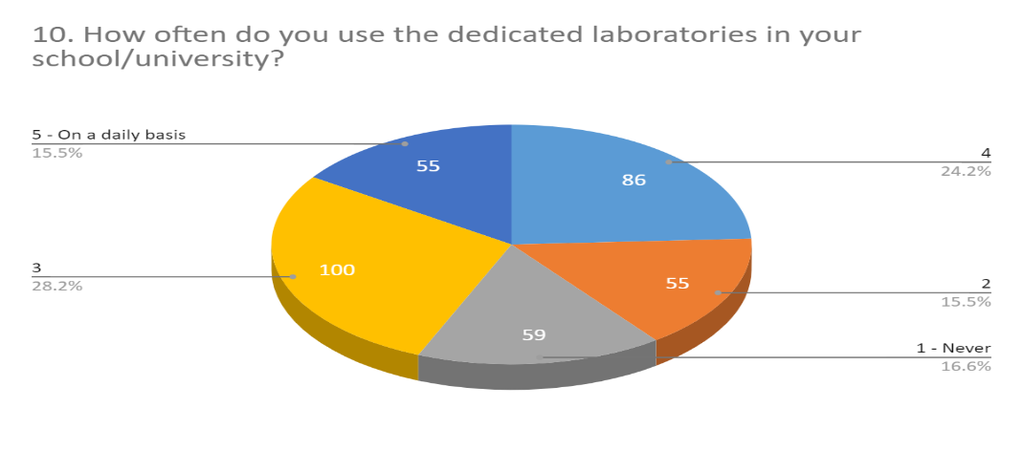

***Question 11*** have been with open end to gather some options and idea regarding which type of technologies staff members would like to implement in their institution. The main suggestions are: a complete digitalization of the available literature; creating video practicum for more accessible intercommunication with students; 3D printing technologies; 5G; a fully integrated smart mix technology; AI in research.

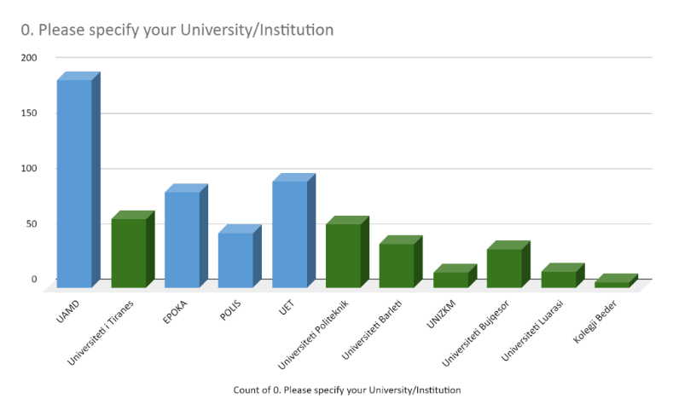

***Question 12***also has been with open and to have some examples academic staff will find useful VR technologies and the main answers are; product promotion; time frequency representation of signal; Fourier analysis; using CAD software; HRM; 3D videos; simulating different manufacturing process.

* 1. Results of student questionnaires

It is a total of 641 students who have been responding the survey with the aim to see actual level of entrance of virtual reality in Albanian education system, of which 433 are student coming from the institutions part of the consortium and 208 from students coming from institutions outside the consortium.

As it can be seen from the graphical representation the survey is filled by student members from 11 universities: Aleksander Moisiu University, Epoka University, Polis University, European University of Tirana, Polytechnical University, Marin Barleti University, University “Our Lady of good Council”, Agricultural University of Tirana, University of Tirana, Luarasi University and Beder University College. So, quantitatively there are 4 public and 7 private institutions included in the survey which is a very representative result to have further comparative analysis of the situation accordingly and off course the sample is very representative in quantitative terms also.

Question 1 oriented to students is a lickered scale question with five degree level ranging from “1-Very Low” to “5-Very High” done with aim to identify the actual level of knowledge the albanian students have on virtual/digital technologies. The result in over all can be considered postive but there are slite differences between respondets belonging to the consotrium with those out side the consortium.

The main result coming from insitutions in the consortium is an actual level of virtual technologies at level 4 which means that students have a high level of it, while the majority of students outside the consortium have declared that their actual level of digital knowledge is at level 1 which is translated on a very low level of knowledge.

The overall situation, in the consotrium majority of students belog to the group average and upper level, while the opposite is true for the respondent out of the consotrium where majority of them belong to the group average and lower level of digital knowledge.

Beyond the diverging result, it makes sense somehow if we take into consideration the profile of the programs those insitutions have, and universities in the consortium are selected on purpose to have the program appropriate for the aim of the project ***(Question 1).***

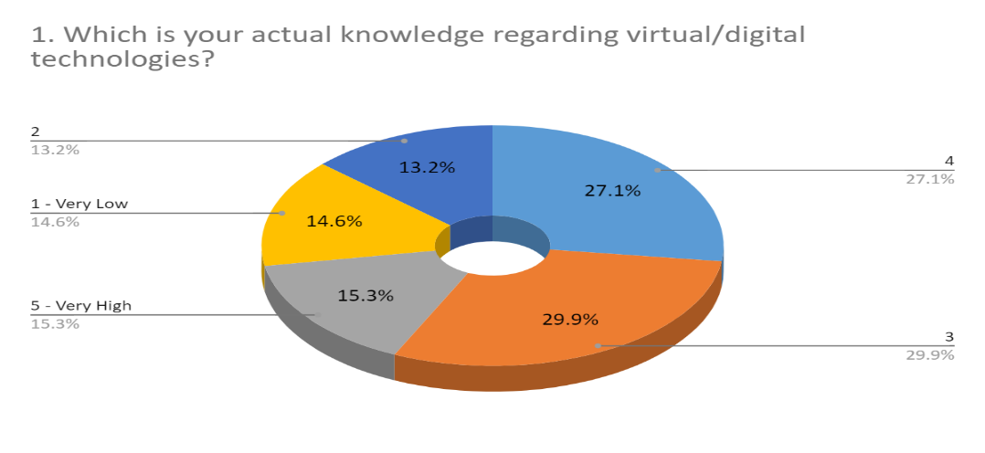

Again this is a lickered scale question with five degree level ranging from “1-Very Low” to “5-Very High” done with aim to see if students have been introduced before with VR/AI technologies. 49% of the students in the consortium says that they have never been introduced before with such technologies while the result outside the consortium goes to the level of 87.5% ***(Question 2).***

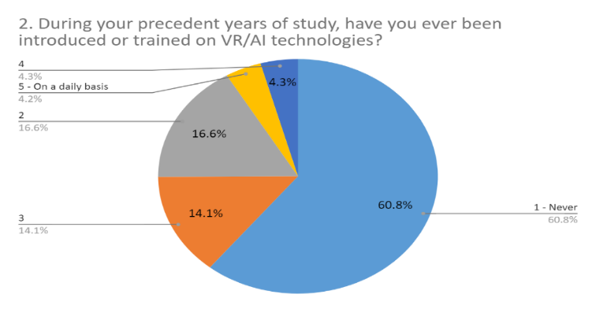

It is obvious that digital learning is part of learning process of the students in Albania. In this regard we see that contradictory student outside the consortium have declare that they use digital learning activities mainly on daily basis and very often. There is an equal share of students in consortium among all defined measurement level. If we relate to the answers on the previous question maybe we can explain this with the fact that they may be using different technologies which are more appropriate to the program of the profile they are enrolled in ***(Question 3).***

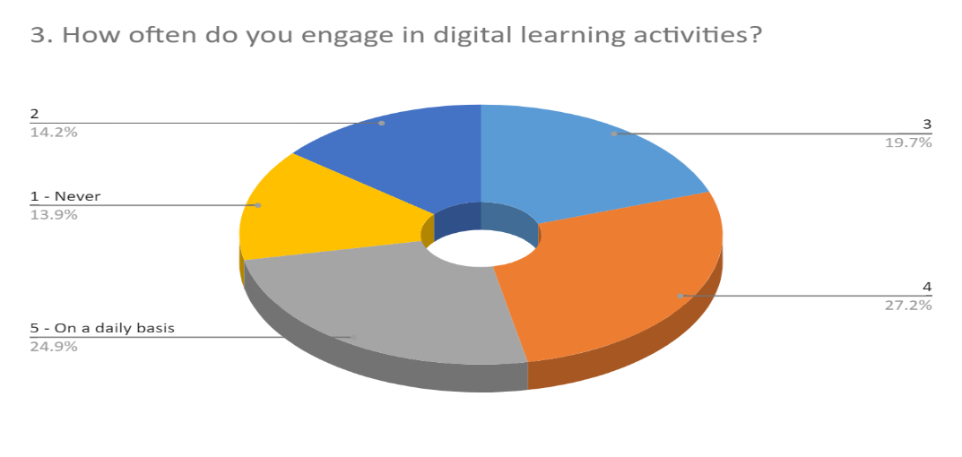There is a very wide range of digital learning activities on which student have declared they are engaged in. For both groups of respondents, the main digital learning activity they are engaged are the online classes. Only a very few of them have declared that are engaged on trainings, workshops, programming and those involved in their work premises ***(Question 4).***

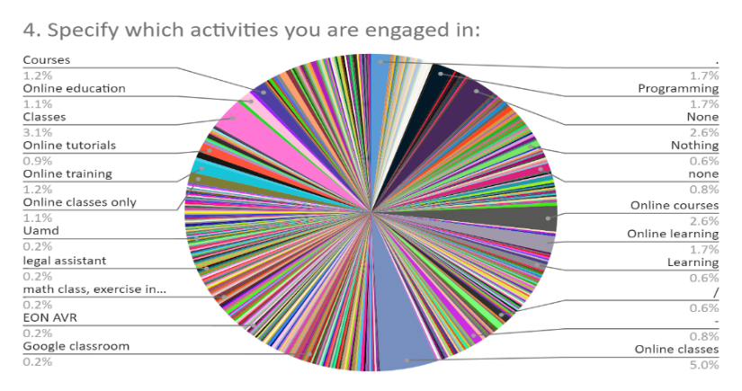

For all of them virtual technologies have a high impact in their field of education. For only a low minority of them made up of 10% the technological impact is low. The majority of students from both groups consider the impact that virtual technologies have on their field as high or very high, while there are students who state that those technologies have lower impact on their field of education ***(Question 5).***

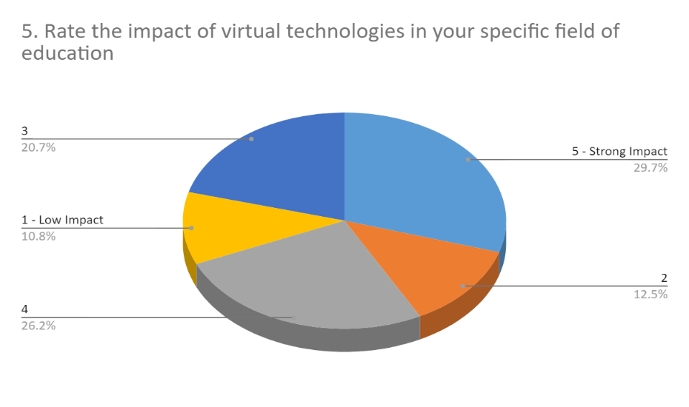

In the consortium there is a higher level of homogeniety of their fields and as we can see their areas of studies are consentrated only on 7 field. Interestingly, majority of them come from fields of study which have actual needs for digital technologies, considering also the fact that technology nowdays is an integrated part of every field and every profession. There is a high percentage of them coming from Computer Science field and its programs like computer enginiering, programming, electronics, IT, telecomunication. But the rest also coming from for example architecture or urban planning can not do without updating at a moderate technological level.

Regarding the group of students belonging the universities out of the consortium we see that there is a very wide spread of field related this with the profile of their institutions and the field of studies they offer ***(Question 6).***

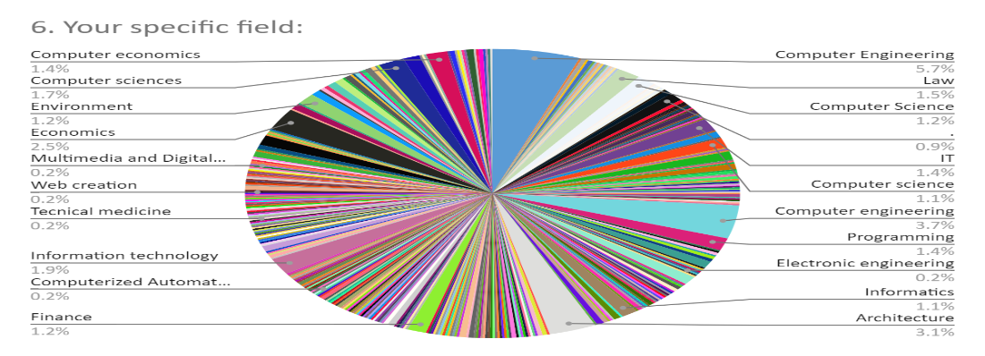

Question 7 was about the information regarding these technologies shared at schools between students and professors. When we refer to the results in consortium, there is somehow an equal share of satisfied and unsatisfied students, while the level of unsatisfied students outside the consortium is higher. Only of minority of them are satisfied in this regard. The spread of results in Albanian institutions in such range shows that there is not a uniform institutional use of technologies on learning process. This result can be interpreted also as an initiative of specific professor to include on their teaching process any available technology possibly ***(Question 7).***

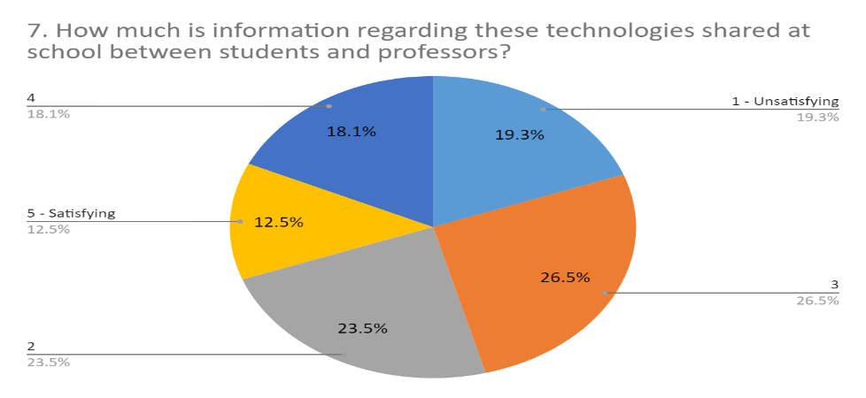

Majority of them declare that they would implement such technologies in their learning proces which once again shows that there is an actual need for them. Differently from the daily use of them, almost 27% automatically state that they would implement it on a daily basis and 30% would implement it very often.What is intersting here also is the fact that the student from the consourcium are more willing to implent such technologies in their lreaning process while the once outside are somehow more skeptich about them. Maybe we can relate such result with the level of knowledge and information they have about them and also with the profile of the study field they come from ***(Question 8).***

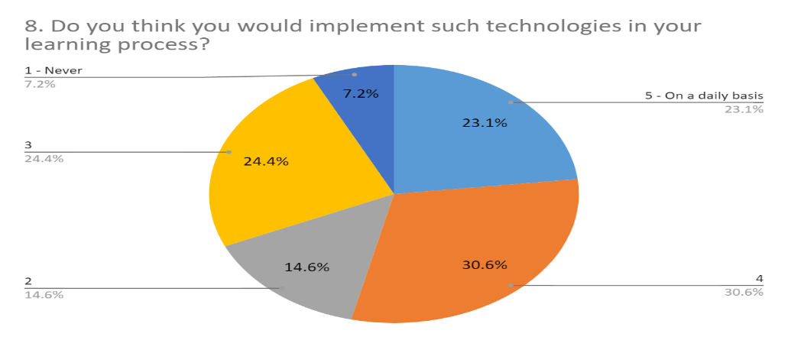

We all agree that this is the generation of technology and in the same line 50% of the students respond that they use digital technology on daily basis. Only a small minority of 5.7% said that they do not use technology on their free time. The same result comes also from student enrolled on other universities, which is an insight that Albanian students have tracked the technological advances and that they are willing to update in even more complex ones ***(Question 9).***

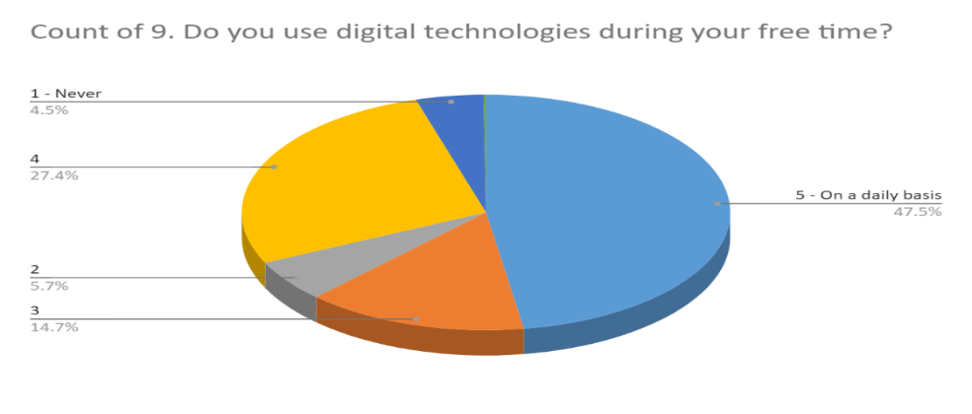

Disappointedly almost all of them have declared that the kind of technology they mostly use are smartphones and all the social networks very popular now days. Only very few of them have at least mentioned the use of computer, online courses and google classrooms ***(Question 10).***

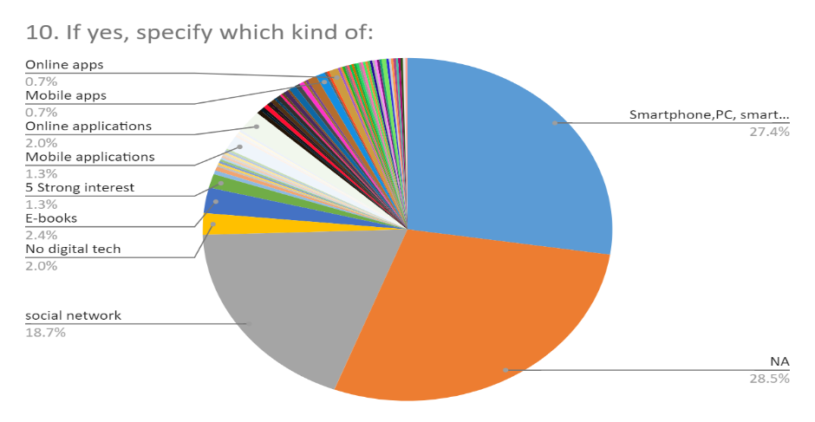

Actual interest in receiving specific training on digital technologies and tools is relatively high. Almost 85% of them have an interest above average and what is very promising is that 40% of them show a very strong interest. What is interesing in here is the fact that the once who have a moderate level of knowledge are more willing to advance on them and the once who do not possess such knowledge do not show interest to learn. To find a reason behind this we have to make a cross analysis, maybe this is related to the importance and actual need they have for such technologies on their field of study and in the learning process ***(Question 11).***

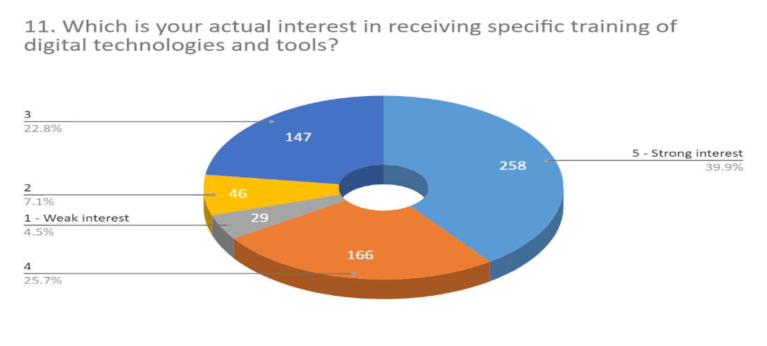

In this regard, it is a very high percentage who never use laboratories in their school/universities, and at the same time a high percentage who use them very rarely. We have to explore for the reason behind this: first of all, we have to clarify what kind of laboratories are there in the university premises, because in most of the cases they refer to dedicated laboratories, the computer labs found in there; secondly the main purposes for which they use the computer labs are to do any assignment or to improve it in any case ***(Question 12).***

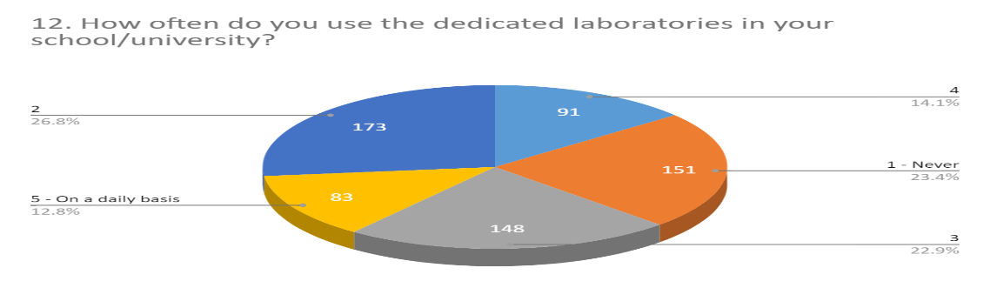

# Conclusion

Higher Educational Institutions in Albania are giving maximum affords to pursue continuous progress in the teaching and learning process. Technological integration and experience-based learning in a moderate level stands at the core of their objectives.

There is much potential from both sides, students and staff, for bringing the curriculum to life used virtuality. Virtual and augmented reality technologies are at the frontier of development right now and once it meets the demand side also, very promising results will be achieved in the near future.

Off course that there is an actual need for advancement but technological literacy in Albanian universities is very high and the potential to increase also is at maximum. Both, students and staff show enthusiasm and willingness to participate on trainings and activities which can further develop their knowledge.

In this regard, institutions must take care to offer innovative practices and to continuously monitor their effectiveness. We strongly believe that such implementation will further foster individual initiatives and will improve the education system. Based on the result we identified that there are all specific elements need, the only thing to do is to combine them and to make an even better functioning cluster.