Accelerating Western Balkans University Modernization by Incorporating Virtual Technologies

VTech@WBUni

WP1 - Deliverable D1.3

REGIONAL RESULTS/FINDINGS ON THE USE OF VIRTUAL TECHNOLOGIES IN TEACHING METHODOLOGIES IN KOSOVO

Project duration: 15/11/2019 - 15/11/2022
Due date of deliverable: 15/07/2020
Actual submission date: 02/03/2021
Dissemination Level: Consortium (Confidential, only for members of the consortium)
Version | Date | Change History | Author | Organisation
00 | 10/01/2021 | Document drafted | Albana Halili | UAMD
01 | 28/01/2021 | First edition | FECE Team | FECE - UP
02 | 31/01/2021 | First revision | FECE Team | FECE - UP
03 | 06/02/2021 | Second revision | FECE Team | FECE - UP

Table of Contents
1. Introduction 3
2. Objectives, methodology and scope of the survey 4
3. Sample (questionnaire) design 6
4. Results 7
4.1. Results of teachers’ questionnaires 7
4.2. Results of student questionnaires 11
5. Conclusion 16

Introduction
Possessing specific ICT skills have effect on economic competitiveness, especially at small countries such as WB countries (Albania, FYROM, Kosovo), with high unemployment rate, whereas one of the solutions to survive is active participation in lifelong learning process (European Commission, 2011), by upgrading current competences and obtaining new competences, needed in the local, regional, European and global labour market.
Virtual Technologies are considered as one of tools to transform and modernize the Higher Education. Students today are already familiar with various technologies, which is why computerized tools and apps make sense in a classroom setting. In WB countries the rate of possession of smart phones and other smart equipment’s is comparable with the rate presented for European countries.
The project general aim is to introduce for the first time at Western Balkan universities the concept of virtual technologies as a tool for accelerating university modernisation, while contributing on developing knowledge-driven society.
By incorporating Virtual Technologies in academic culture of universities we aim to increase the quality and level of efficiency in teaching and knowledge retention through interactive learning methods, thus contributing on skills enhancement and further building of digital society at WB countries.
In the mid and long term, the project will enhance effectiveness of the higher education system in knowledge retention and application. The project direct beneficiaries are universities, schools, teachers, students, regional industries and businesses.
Some of the specific objectives of the project are:
- Capacity building of academic staff to incorporate Virtual Technologies in teaching
- Develop teaching methodologies availing of technology and/or ICT tools
- Increase the level of understanding and reduce the grasping time and the effort that students need to learn information by using 3D concepts instead of 2D ones
- Offer a better delivery of basic knowledge even for complex issues, higher learning efficiency and better learning experience by AR/VR techniques.
The project brings together 11 partners with University “Aleksander Moisiu” of Durres as lead partner.
- Aleksandër Moisiu University of Durrës
- European University of Tirana
- Polis University
- Epoka University
- University of Prishtina
- University for Business and Technology
- South East European University
- Mother Teresa University
- University of Ljubljana
- University of Tartu
- Lodz University of Technology
This Report is prepared as an activity and deliverable within Vtech Erasmus + project.
The compilation of Report is based on student and teaching staf evaluations collected from 1289 student and 275 teachers responses in respective questionnaires.
The European Commission support for the production of this publication does not constitute an endorsement of the contents which reflects the views only of the authors and project consortium, and the Commission cannot be held responsible for any use which may be made of the information contained therein.

Objectives, methodology and scope of the survey
The objective of the survey is to measure the level of implemetation of interactive learining methods, with the focus on VR/AR Technologies, within the study program in universities in Kosovo. The survey also aims to enhance the skills for further building the digital society in Kosovo.
The survey collects data for gaining information reagarding the reserachers’ (teachers) knowledge about virtual/digital technologies including the use and impact of virtual technologies in relevant study fields. In addition, this survey also gather information regarding the frequency of laboratories usage in specific universities. There is also a field where the survey participant can give their suggestion about the type of virtual tecnhologies that they desire to be implemented in the respective classes.
The students’ knowledge about vritual/digital technologies is also evaluated through this survey. The students gave their feedback about the level of the implementation of virtual technologies into their specific stufy field. They also evaluated the impact of the these technologies in their specific field of study. Furthermore students gave their suggestions about the kind of technologies that they want to be implemented in their faculties.
The information gained through this survey represents the level of virtual technologies knowledge in Universities and Private Higher Education Institutions in Kosovo. The data collected is consistent in both education sectors.
The survey is conducted from Asoc. Dr. Sabrije Osmanaj, Prof. Ass. Dr. Hana Maloku and Ass.MSc. Jeta Dobruna, professors in Faculty of Electrical and Computer Engineering (FECE) and was electronically delivered to researchers and students during November, December of 2020 and January of 2021.

Sample (questionnaire) design
Based on the purpose of the VTECH project and the respective objectives, the following data was obtained from relevant universities, for the purpose of updating the sampling framework, regarding the:
- Number of teachers
- Number of students
- Study fields
- Digital devices
- Virtual technologies
- Excisting laboratories
The survey scope consists of teachers and students. Based on this information the relevant samples are formulated, for techers and professors. Afterwards, the samples are delivered in University of Prishtina, University of Peja, University of Gjakova, Univeristy of Prizren and two bigest Private Higher Education Instutions: AAB and UBT.
The purpose of this survey is to provide information about the knowledge and frequency of usage of digital/virtual technologies from teachers/researchers and students. Relevant data was collected and processed based on selected samples. Based on the surevey results, the recommendations will be dervied regarding the need for trainings for different types of virtual technilogies.
The data is gathered electronically, through online survey, under supervision of the above mentioned team, selected from VTECH project coordinators.

Results
The survey data are collected through two questionnaires and the results are presented below:

Results of teachers’ questionnaires
Teachers’ questionnaires consits of eleven questions and graphs for each question are presneted below:

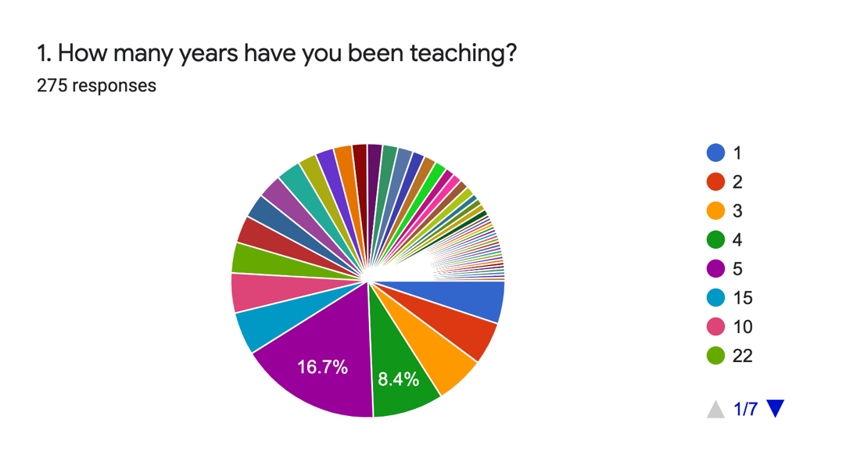
This question consists data regarding the teachers’ experience in teaching. It should be noted that, the survey participant were teachers with different teaching experience.
The above graph presents the percentage of participants in terms of their teaching experience. 41.1% of the respondents have up to five years experience in teaching, while the others have more than five years experience in teaching.
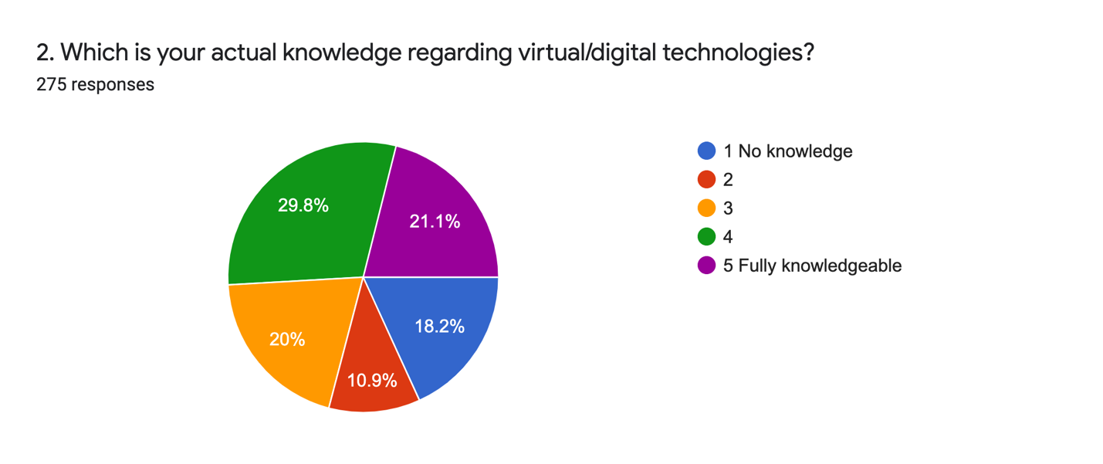
The second question reflects the knowledge of teachers regarding the vritual technologies. As presented in the graph above, teachers are not very familiar with virtual technologies. 18.2% have no knowledge for these technology, while 21.2% stated that are fully knowledgeable about virtual technologies.
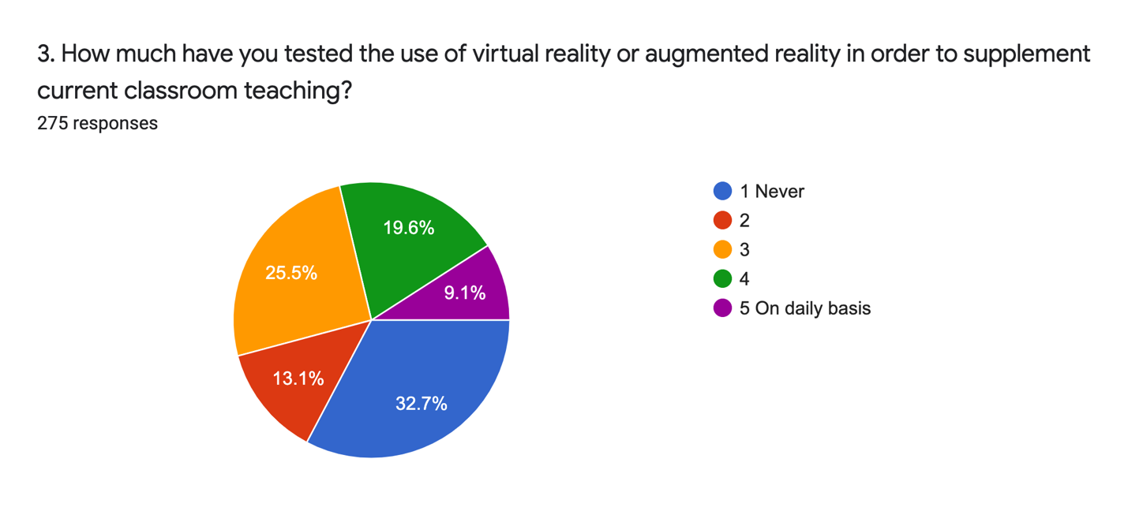
The third question provide information about the frequency of usage of virtual reality into the teaching process. From the presented graph we can see that there is a low level of implementation of virtual reality in the different teaching courses.
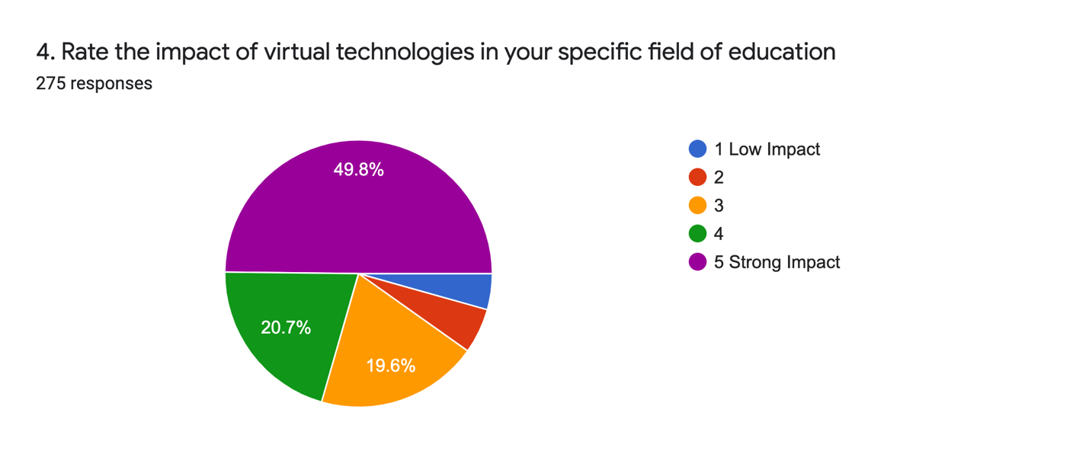
This question evaluates the impact of virtual technologies in the relevant fields of education. Half of the participants evaluated that these technologies has strong impact in their specific field. Some of the participants’ teaching fields were: engineering, computer scinece, mathematics, environmental science, civil law, tourism, management etc.
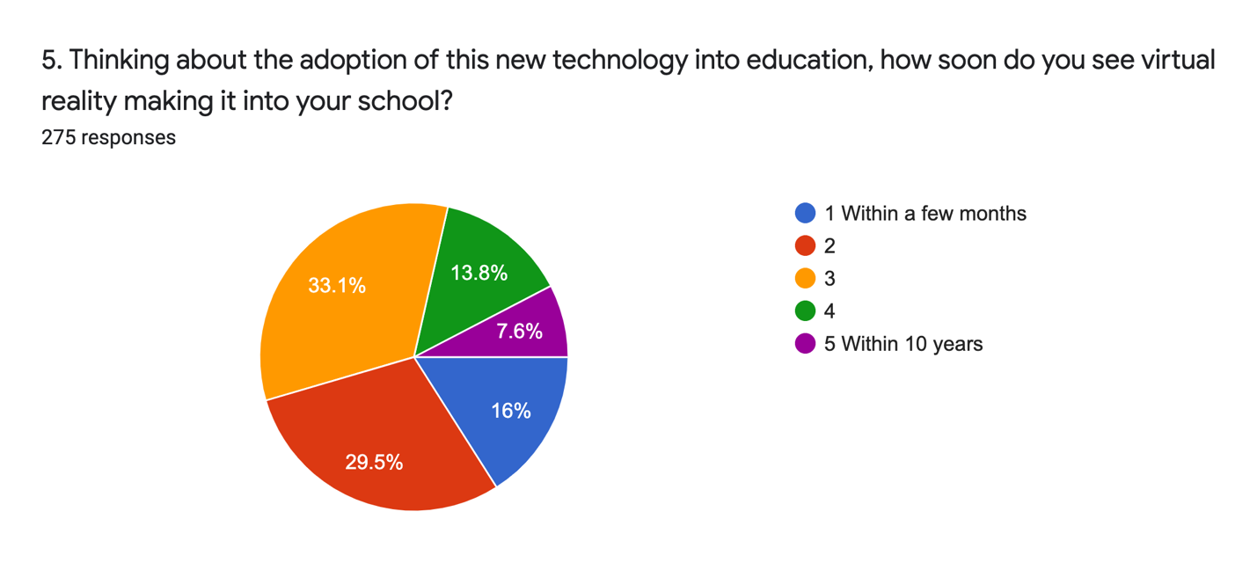
The fifth question reflects the teachers’ opinion about the speed of the implementation of virtual technologies into the teaching process. From the graph we can see that the teachers evaluated that the implementation of these technologies will take a couple of years.
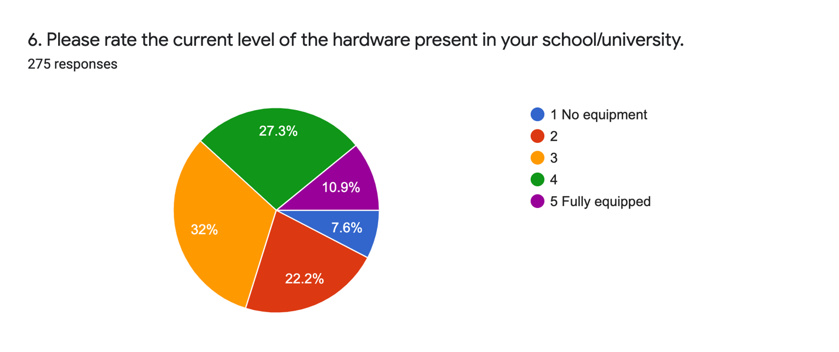
In the sixth question participant gave their feedback about the level of hardware present in their univeristy. They indicated that there is not enough hardware in their schools, as it is shown in the graph.
- Which kind of digital technologies and tools would you like to learn more about?
In the seventh question the participant express their interes for the kinds of digital technologies that they want to learn. Most of the teachers stated that they are very interested to have a VR laboratory in their universities.
Some of the mentioned technologies were: VR technologies, IoT technologies, Artificial Intellegence technologies etc.
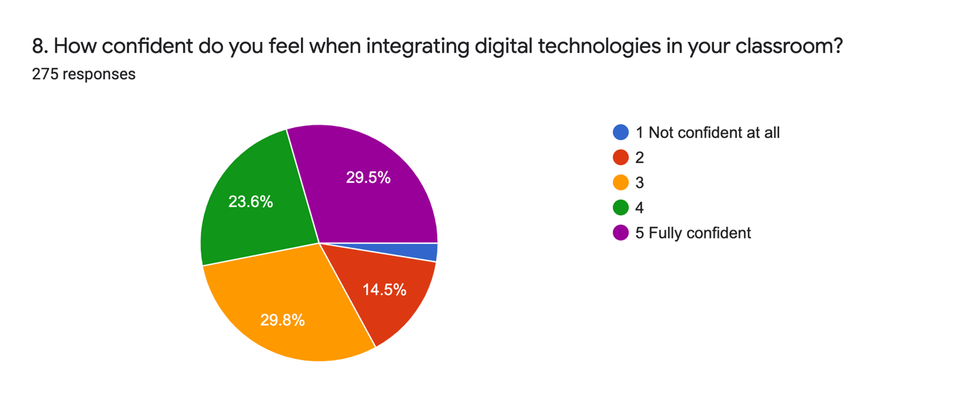
The eighth question evaluates the level of teachers’ confidence while implementing the virtual technologies into their classes. From the graph we can see that participants are not very confident in the implementation of these tecnologies in the teachning process, without trainings.
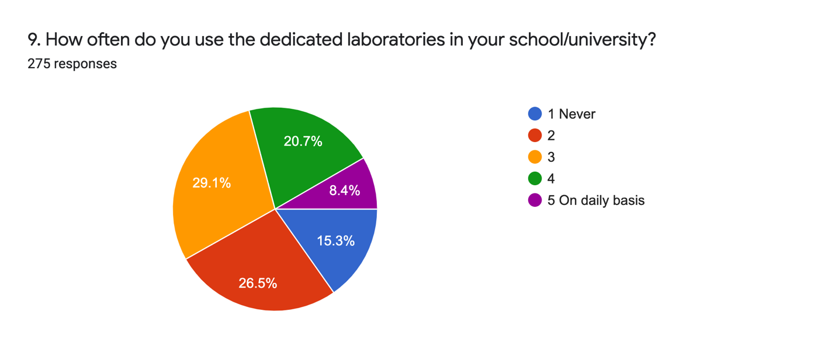
The frequency usage of the dedicated laboratories in relevant universities is stated in the ninth question. From the graph above we can conclude that laboratories are not use very often from the teachers in their teaching process.
- Add any suggestion regarding which kind of technologies you would like to be implemented in your school and how.
In the tenth question teachers gave their suggestions for the technologies that they would like to implemnt in their school. Some of the suggested technologies were: VR technologies, networking technologies, LabVIEW Toolkit, simulations tools, math programs etc.
- Give some example on where, during your daily work, you would find the implementation of VR technologies useful (classes, topics, lab work, etc.).
Some of the examples where implementation of VR technologies is useful are given in the eleventh questions. Most of the participants in the survey stated that implementation of virtual technologies in teaching process, into different classes, would be very useful.

Results of student questionnaires
Student questionnaires consits of ten questions and graphs for each question are presneted below:
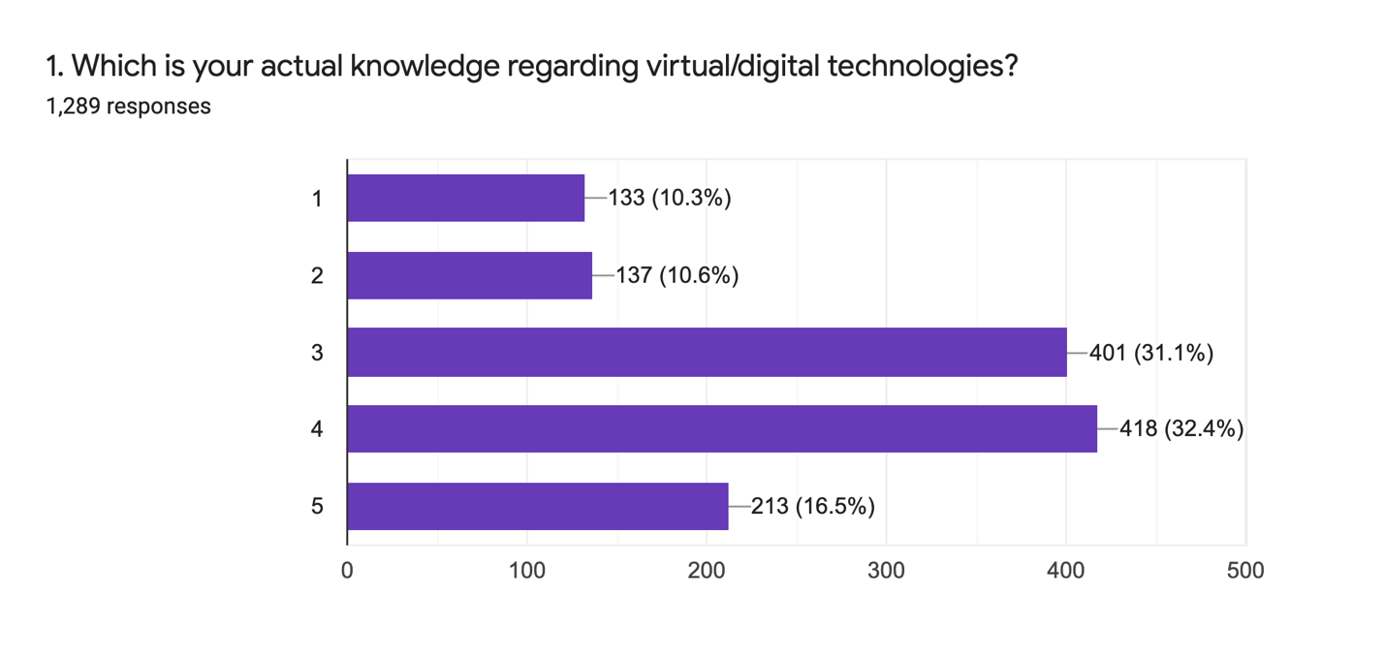
The first question of this questionnaire reflects the knowledge of students regarding the vritual technologies. As presented in the graph above, students are not very familiar with virtual technologies.
16.5% of students stated that are fully knowledgeable with virtual technologies, while 10.3% said that have no knowledge regarding virtual technologies.
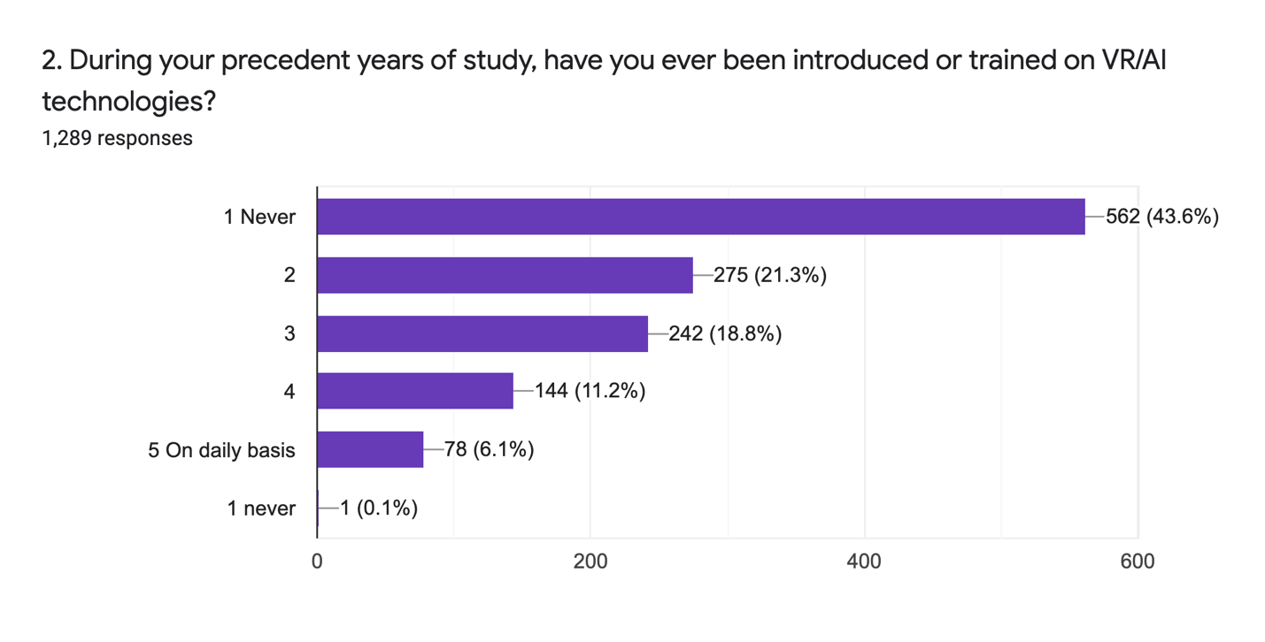
The second question indicates the students’ experience regarding the virtual technologies. From the graph we can conclude that 43.6% of students have never received any training about virtual technologies, while only 6.1% of students stated that they have been introduced on virtual technologies.
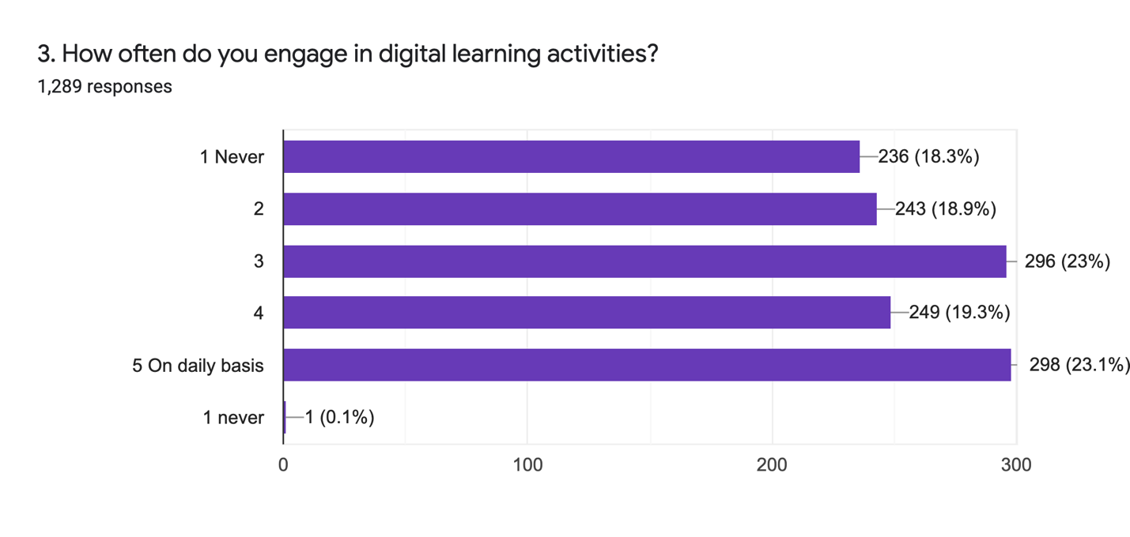
The third question expresses the frequency of engagement of students in digital learning activities. 18.3 % of students claimed that they have never been engaged in these activities, while 23.1% stated that they are engaged in digital learning in daily basis (reflecting the online learning due to the pandemic situation).
Some of the activities that students mentioned were: online learning, programming, coding etc.
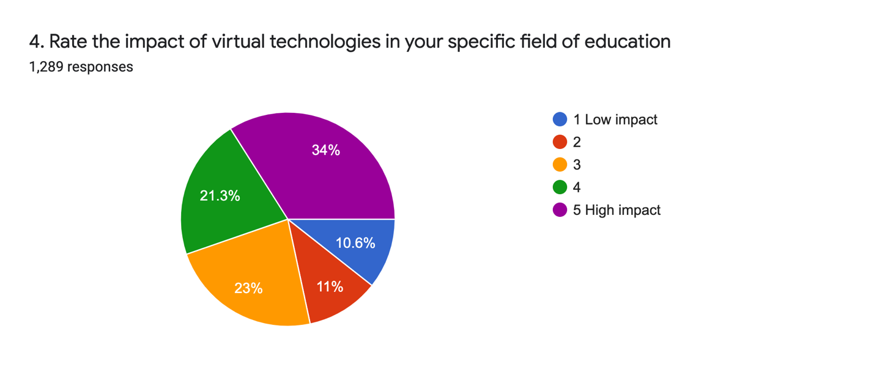
This question rates the impact of virtual technologies in specific study fields.
Most of the students think that virtual technology has significant impact in their study field. Only 10.6% stated that virtual technologies have low impact in their learning process.
Some of the study fields that survey participant (students) are engaged in are:
Engineering, computer science, medicine, English language, preschool education, Albanian language, nursing etc.

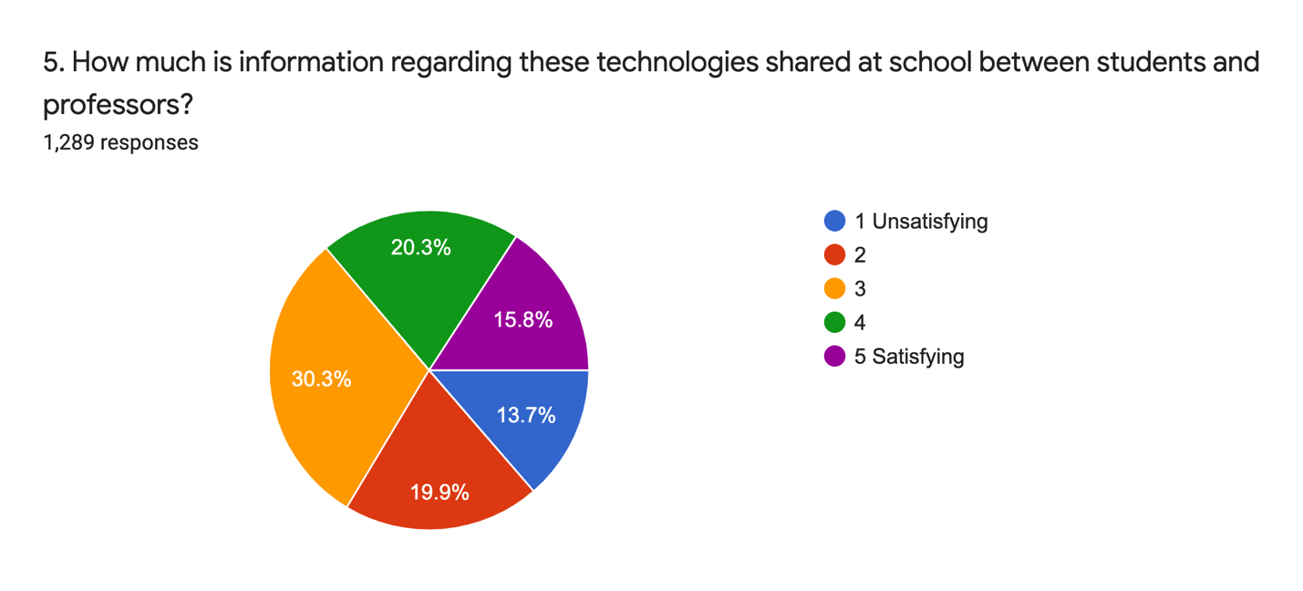
The fifth question evaluates the level of sharing information between professors and students, regarding virtual technologies. As we can see from the graph, there is not a satisfying level regarding this activity. Only 15.8% of students stated that the level of information sharing, regarding virtual technologies, is satisfying.
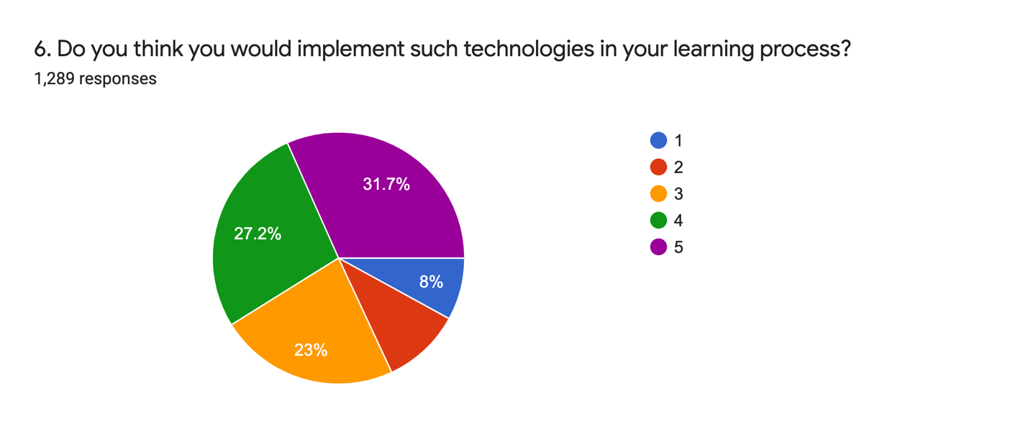
The sixth question takes the students feedback about implementation of virtual technologies in their learning process. 31.7% claimed that they would implement these technologies in their learning process, while only 8% stated that they would never use these technologies for learning activities.
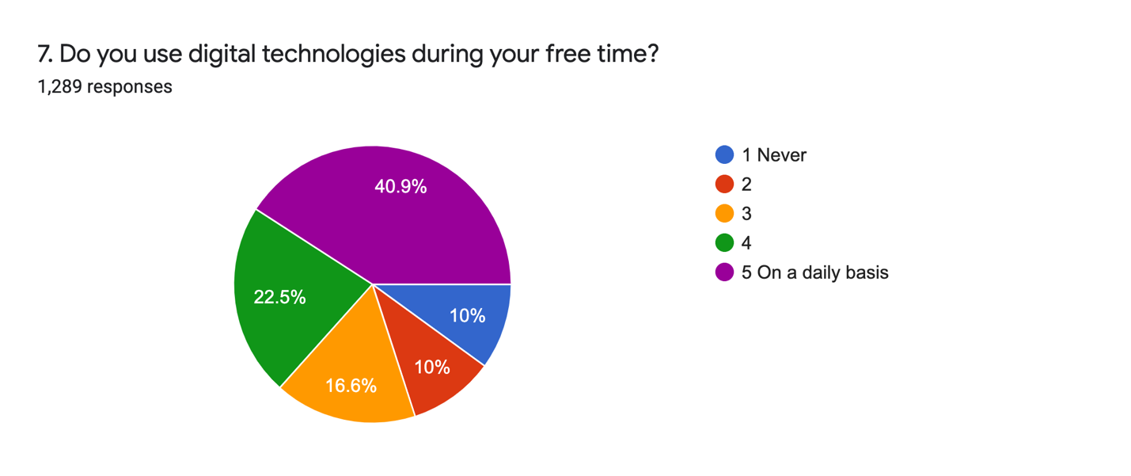
This question measures the frequency of usage of digital technologies by students in their free time. Almost half of the students claimed that they use these technologies in their free time (gaming), indicating that there is a high interest from students regarding these technologies. Only 10% stated that they never used virtual technologies in their daily activities.

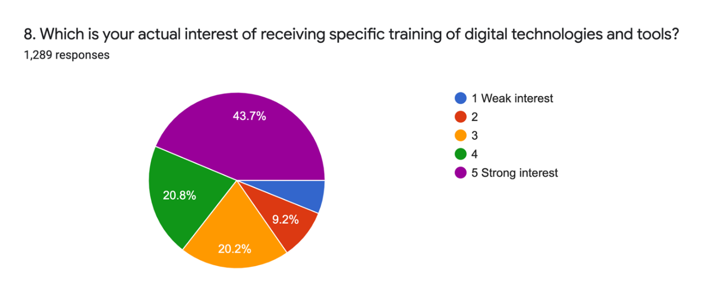
This question evaluates the interest of the students for receiving trainings in field of virtual technologies. From the graph, we can conclude that there is a high interest from the students’ side on learning about virtual technologies. Almost half of students declared that have strong interest for receiving trainings regarding virtual technologies. Only 6.1% of students showed weak interest for these technologies.
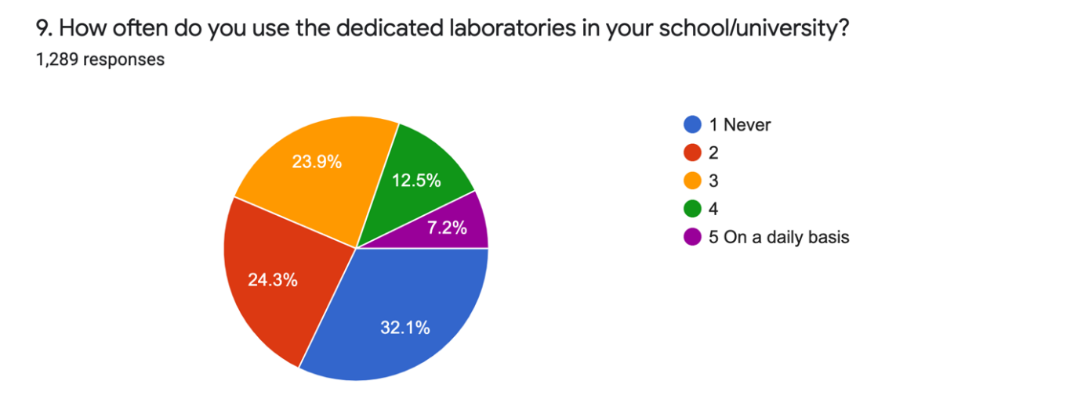

The ninth question measures the frequency of usage of dedicated laboratories in universities. From the above graph we can see that laboratories are not frequently used in universities. 32.1% of students claimed that they have never been in their university laboratories.

- Add any suggestion regarding which kind of technologies you would like to be implemented in your school and how
In the tenth question students gave their opinion about the kind of technologies that they want to be implemented in their univeristies. Most of the students stated that they would like to have a laboratory with all necessary equipments for implementing VR in their learning process.

Conclusion
This survey is conducted to measure the knowledge of students and teachers regarding virtual technologies in HEIs in Kosovo.
The samples were delivered electronically to students and teachers or researchers, in different universities country wide. The results were derived from 1289 student responses and 275 teachers.
According to the results taken from the teachers’ survey, we can conclude that teachers do not have background on virtual technologies and they do not use these technologies in their teaching process. They think that these technologies have strong impact in their specific fields and are very interested to learn more about these technologies. They stated that it is very important to integrate virtual technologies in the teaching process.
According to survey results, HEIs in Kosovo are not well equipped with hardware and it is highly recommended to have a VR laboratory for integrating VR technologies into different classes.
Students do not have knowledge on VR technologies too. They are not satisfied with the level of information shared between them and professors regarding VR technologies.
Students claimed that are very interested to receive any training regarding digital technologies because they think that these technologies have high impact in their specific study field.
Students declared that they use virtual technologies in their free time and they think that these technologies will enhance their learning process.
At the end we can conclude that both students and teachers have no background in VR technologies but they are willing to receive trainings for these technologies in order to integrate them in their learning and teaching process. VTech supported courses will be offered at each HEIs project partner.
Remark: we plan on publishing the results from this survey in a conference or journal paper.

