Accelerating Western Balkans University Modernization by Incorporating Virtual Technologies

VTech@WBUni

WP1 - Deliverable D1.3

REGIONAL RESULTS/FINDINGS ON THE USE OF VIRTUAL TECHNOLOGIES IN TEACHING METHODOLOGIES IN MACEDONIA

Project duration: 15/11/2019 - 15/11/2022
Due date of deliverable: 15/07/2020
Actual submission date: 25/02/2021
Dissemination Level: Consortium (Confidential, only for members of the consortium)
Version | Date | Change History | Author | Organization
01 | 10/01/2021 | Document drafted | Albana Halili | UAMD
02 | 15/01/2021 | First edition | Lejla Abazi Bexheti | SEEU
03 | 31/01/ 2021 | First revision | Arbana Kadriu | SEEU
04 | 08/02/2022 | Second revision | Albana Halili | UAMD

Table of Contents
1. Introduction 3
2. Objectives, methodology and scope of the survey 3
3. Sample (questionnaire) design 3
4. Results 4
4.1. Results of teachers/RESEARCHERS’ questionnaires 4
4.2. Results of students’ questionnaires 9
5. Conclusion 14

Introduction
VTECH is an Erasmus+ Capacity Building in Higher Education project led by the Aleksander Moisiu University of Durrës, Albania. The consortium has 11 partners out of which 6 are HEIs from Albania and Kosovo, and 5 partners HEIs from program countries namely Estonia, Poland, Slovenia and the Republic of North Macedonia.
VTECH project’s general aim is to introduce for the first time at Western Balkan universities the concept of Virtual Technologies as a tool for accelerating university modernization, while contributing to developing knowledge-driven society.
By incorporating Virtual Technology in the academic culture of universities, this project aims at increasing the quality and level of efficiency in teaching and knowledge retention through interactive learning methods, thus contributing to skills enhancement and further building of digital society at Western Balkans countries.

Objectives, methodology and scope of the survey
The future of VR and AR use in education will be determined by better awareness around this technology, as well as improved experience for the user. There is a false impression that VR and AR only have applications for entertainment and video games, and that they cannot be used as a business tool.
VR/AR technologies have excellent prospects in explaining complex concepts in fields such as medicine, healthcare, military, aviation, engineering, space etc., offering a unique advantage for virtual learning in higher education.
While there is a trend to include Virtual Technologies in academic culture of universities in developed countries, this is not the case with universities in developing WB countries. There is a need to introduce at Western Balkan universities the concept of virtual technologies as a tool for accelerating university modernization, while contributing to developing knowledge-driven society. This will increase the quality and level of efficiency in teaching and knowledge retention through virtual technologies, thus contributing to skills enhancement and further building of digital society in WB countries.

Sample (questionnaire) design
One of the project tasks was to prepare a questionnaire to gather inputs for a detailed gap analysis at country level. To have an overall picture and for the use of VR in the Balkans, the same questionnaire was used for Albania, Kosovo and North Macedonia.
Two questionnaires were prepared:
- Academic staff / researcher
- Students
For North Macedonia, the questionnaires were initially translated into local languages (Albanian and Macedonian). Next, the questionnaire was distributed to several universities in Macedonia.
- South East European University
- State University of Tetova
- Ss. Cyril and Methodius
- Mother Tereza University
The questionnaire was distributed during November and December 2020. The total number of the responses gained from the academic staff/researchers’ questionnaire was 60 and from the students’ questionnaire was 287.

Results
In this part are presented the results gained from the questionnaire both for teachers and students. For each question is included the corresponding chart of responses.
4.1. Results of teachers/RESEARCHERS’ questionnaires
The initial question for the academic staff was about their experience in teaching. As it can be seen from the chart in Fig.1, the responses came from a wide spectrum of experience. Starting with those with no experience in teaching (15%) and further on towards those with 33 years of experience in teaching (all of the categories with 2% to 8%). This distribution of the years of experience was very welcomed in order to gain a better quality of the questionnaire and include staff with different years of experience in teaching and consequently in applying digital technologies in the teaching and learning process.
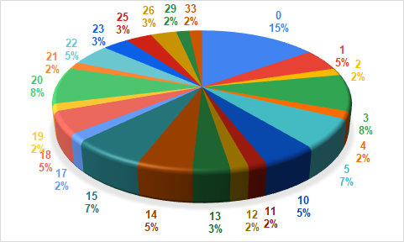
Fig.1 Chart showing the responses of Question 1
Q1: How many years have you been teaching?
The second question was regarding the knowledge on virtual/ digital technologies. As it can be seen in Fig.2, only 27% of the teaching staff considered that they are fully knowledgeable (level 5 on the scale from 1 to 5). The majority of the staff (70%) responded at level 3 and 4. A small percentage (3%) of respondents are at level 2, and there are no answers on the level 1 which corresponds to “no knowledge”.

Fig.2 Chart showing the responses of Q2:
Q2: Which is your actual knowledge regarding virtual/digital technologies?

The third question was about the staff experience in VR technologies. As it is shown in Fig.3, regarding this question almost half of the respondents (47%) have stated that they have had the opportunity to use and test virtual reality to supplement their traditional lecturing. The other half (53%) have stated that they have very little or no experience in using them to supplement their lessons.
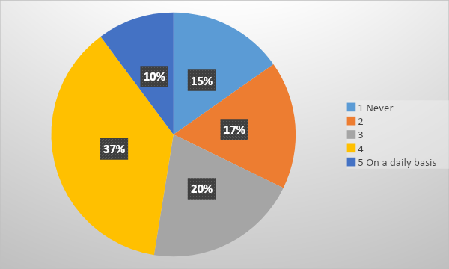
Fig.3 Chart showing the responses of Question 3
Q3: How much have you tested the use of virtual reality or augmented reality in order to supplement current classroom teaching?
Regarding the impact of virtual technologies in the teachers specific field of education, as shown in Fig.4, the majority of the answers on this question (56%), considered that VR has a strong impact in their field of education. Neutral are 25% of the respondents, and 19% of the respondents have stated that VR has very little (17%) or no impact (2%) in their field of education.

Fig.4 Chart showing the responses of Question 4
Q4: Rate the impact of virtual technologies in your specific field of education

Fig. 5 includes the responses on Question 5 which was on the expected time that VR will be present in their schools. Regarding this, only 7 % of the respondents think that this new technology can be part of their school within a few months and also 10% of the respondents are optimistic about VR in their school within a year or two.. The majority of the respondents, consisting of 44% are at level 3, meaning within approximately 5 years, and the other part (39%) are expecting the VR as part of their teaching nearly (15%) or within a decade (24%).

Fig.5 Chart showing the responses of Question 6
Q5: Thinking about the adoption of this new technology into education, how soon do you see virtual reality making it into your school?
Regarding the level of hardware equipment present in the school, as shown on Fig.6, only 20% of the respondents state that their institution has a high level of hardware infrastructure in their institution. Actually around 20% of the respondents state that their institution has a high level hardware, with 3% of the respondents stating that their institution is fully equipped (level 5) and 17% (level 4). The majority consisting of 36 % of the respondents are at level 3 (in the scale from 1 to 5), and the other 15% are rating the level of the hardware at their institution very low (12%), or not at all (3%).

Fig.6 Chart showing the responses of Question 6
Q6: Please rate the current level of the hardware present in your school/university.

The questionnaire also included textual questions in which the teaching staff was asked to write about the kind of digital technologies that they are interested in. More precisely, Question 7 was: Which kind of digital technologies and tools would you like to learn more about? Regarding this question the teaching staff have responded that they would like to see more augmented and virtual reality technologies present in their classrooms and to learn more about them.

Fig.7 Chart showing the responses of Question8
Q8: How confident do you feel when integrating digital technologies in your classroom?

As shown in Fig. 7 about the level of confidence in integrating digital technologies in their classroom, only 22% of the teachers have responded that they are fully confident and 32% are very confident. From the other half of the respondents, 31% of them at the medium level and the other 15% of them are little confident (12%) or not confident at all in integrating technology in their classroom (3%).

Fig.8 Chart showing the responses of Question 9
Q9: How often do you use the dedicated laboratories in your school/university?

Fig.8 includes the chart from the responses on the frequency of the use of dedicated laboratories in their school/universities. Only 10% of the respondents state that they use the labs on daily bases and 14 % of the respondents are on the next level of the frequency which would be approximately once or two times per week. 20% of the respondents are at the medium level, while 15% have stated that they use the labs rarely and 41% of them do not use the labs.
Question 10 was: “Add any suggestion regarding which kind of technologies you would like to be implemented in your school and how”. The responses were mainly for more VR technologies, more labs, more softwares that will support the topics delivered and similar.
Question11 was: “Give some examples on where, during your daily work, you would find the implementation of VR technologies useful (classes, topics, lab work, etc.)”. In this question the answers were mostly on the practical demonstration of the topic, capstone projects, creating various simulations during the lesson, laboratory work and similar. Also many answers were that the implementation of VR technologies would be useful especially on presenting objects from various perspectives.

4.2. Results of students’ questionnaires
The student questionnaire's initial question was on the level of their actual knowledge on virtual and digital technologies. As shown in Fig. 9, on the scale from 1 to 5, almost 70% of the students were at higher levels, more precisely at level 5 (28%) and level 4 (39%); 31% of the students responded at level 3 while only 2% at level 2 and 1% at level 1.

Fig.9 Chart showing the responses of Question 1 (students)
Q1: Which is your actual knowledge regarding virtual/digital technologies?

The second question was dedicated specifically to their experience in VR technologies. As shown in Fig. 10, 46% of the students have answered at level 1, meaning that they have never been introduced or trained in VR, the other 43% have responded that they have some experience, more precisely at level 2 (21%) and at level 3 (23%). The rest 12% of the students have responded that they have a good experience on VR with 8% at level 4 and 4% of the respondents at level 5.
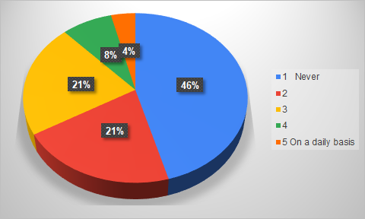
Fig.10 Chart showing the responses of Question 2 (students)
Q2: During your precedent years of study, have you ever been introduced or trained on VR/AI technologies?
On Fig. 11, are presented the results from question 3: “How often do you engage in digital learning activities?”, 35% of the respondents have stated that they engage often on digital activities with 15 % at level 4 and 20% at level 5 (on a daily basis); 27% of the respondents are at medium level 3, rarely or at level 2 are 14% of the respondents and 24% of them have stated that they are never engaged in digital learning activities.
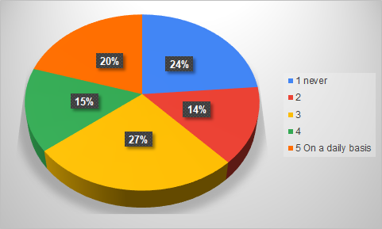
Fig.11 Chart showing the responses of Question 3 (students)
Q3: How often do you engage in digital learning activities?

Fig.12 Chart showing the responses of Question 4 (students)
Q4: Rate the impact of virtual technologies in your specific field of education

As presented in Fig.12, on question 4, about the impact of VR technologies in their specific field of study, the majority of the students have stated that it has a strong impact (with 31% of the responses at level 5 and 26% of the responses at level 4). 29% of the respondents are at medium level and the other 14 % are considering that the impact of VR in their specific field is pretty low, with (8% at level 2 and 6% at level 1).

Fig.13 Chart showing the responses of Question 5 (students)
Q5: How much is information regarding these technologies shared at school between students and professors?

In Fig. 13, are shown the results from question 5, which on the scale from 1(unsatisfying) to 5(satisfying) presents the response gained from the students on the level of information regarding the VR technologies shared with them in their institution. In this regard satisfied with the information at level 5 are 14% of the respondents and at level 4 are 27% of the respondents. At medium level 3 are 33% of the respondents. The other 26% are generally not satisfied with the level of the information shared (17% at level 2 and 9% at level 1).

Fig.14 Chart showing the responses of Question 6 (students)
Q6: Do you think you would implement such technologies in your learning process?
Question 6 from the students’ questionnaire was: “Do you think you would implement such technologies in your learning process? In this regard almost more than 50% of the responses are very positive with 23% at level 5 and 30% at level 4. At Level 3, are 34% of the respondents and a lower percentage of 14% ( 9% at level 2 and 4% at level 1) do not think they could implement such technologies in their learning process (Fig.14).

Fig.15 Chart showing the responses of Question 7 (students)
Q7: Do you use digital technologies during your free time?

Question 7 on the student questionnaire is about digital technology use by the students during their free time. As presented on Fig.15, the majority of 73% declare that they use it intensively (with 52% at level 5 and 21% at level 4). At medium level of usage are 16% and the other 12% declare that they do not use it often with 5% at level 2 and 7% at level 1.

Fig.16 Chart showing the responses of Question 8 (students)
Q8:Which is your actual interest of receiving specific training in digital technologies and tools?
In Fig. 16 is shown the student response on Question 8. The question is about their interest in receiving specific training on digital technologies and tools. In this regard, the majority of students show strong interest for training, with 39% at level 4 and 24% at level 5. 28% of them have responded at level 3, and the response on the level form the student questionnaire is about digital technology use by the students during their free time. As presented on Fig.15, the majority of 73% declare that they use it intensively (with 52% at level 5 and 21% at level 4). At medium level of usage are 16%. Only 9% of the students show weak interest at level 2 (6%) and level 1(3%).

Fig.17 Chart showing the responses of Question 9 (students)
Q9:How often do you use the dedicated laboratories in your school/university?

Question 9 is about the frequency of dedicated laboratories at their institution. As presented in Fig. 17, 24% of the students are using the dedicated labs regularly (14% on daily bases - level 5, and 10% - level 4). 24% of them are at level 3 which assumes that they have some specific lab activities in their courses. The other 20% of the students have responded that they use the labs rarely and 31% have stated that they never use the dedicated laboratories.
Question 10 on the students’ questionnaire was: “Add any suggestion regarding which kind of technologies you would like to be implemented in your school and how”. The overall message from their responses is that they would like to follow the trends, to have more practical and lab activities.

Conclusion
HEIs have continuously been vanguard of novel technologies, pushing progress and establishing the afterward generation of scientists, businesspersons and engineers. Virtual and augmented reality technologies are at the border line of enlargement nowadays.
Improving and expanding the learning practice is at the core of what Virtual Reality can offer to learners, and is one of the most effective ways that could transform the learning process. VR/AR technologies need to be directly practiced, because unlike a lot of other emerging technologies, virtual technologies are extremely visual. It’s all about presenting that information in a valuable way that helps applications in different areas to accomplish their objectives. It operates alongside the user.
There is a need for academic staff to be equipped with the necessary comprehension, skills and approach to get into the habit of using Virtual Technologies for teaching and learning. Once having their competencies for this purpose, they will be able to enhance teaching methodologies, which will increase student learning capability and enthusiasm.
Students also show great interest in training about new digital and VR technologies. However, while innovation is a progressive idea in itself, there is an issue of the availability of high-end technology that can disadvantage some students. The institutions should pay cautious awareness to the evaluation of innovative practices and monitor the effect of innovation on teaching and learning outcomes, while ensuring they become common practice requires appropriate provisions and managerial capacities.

