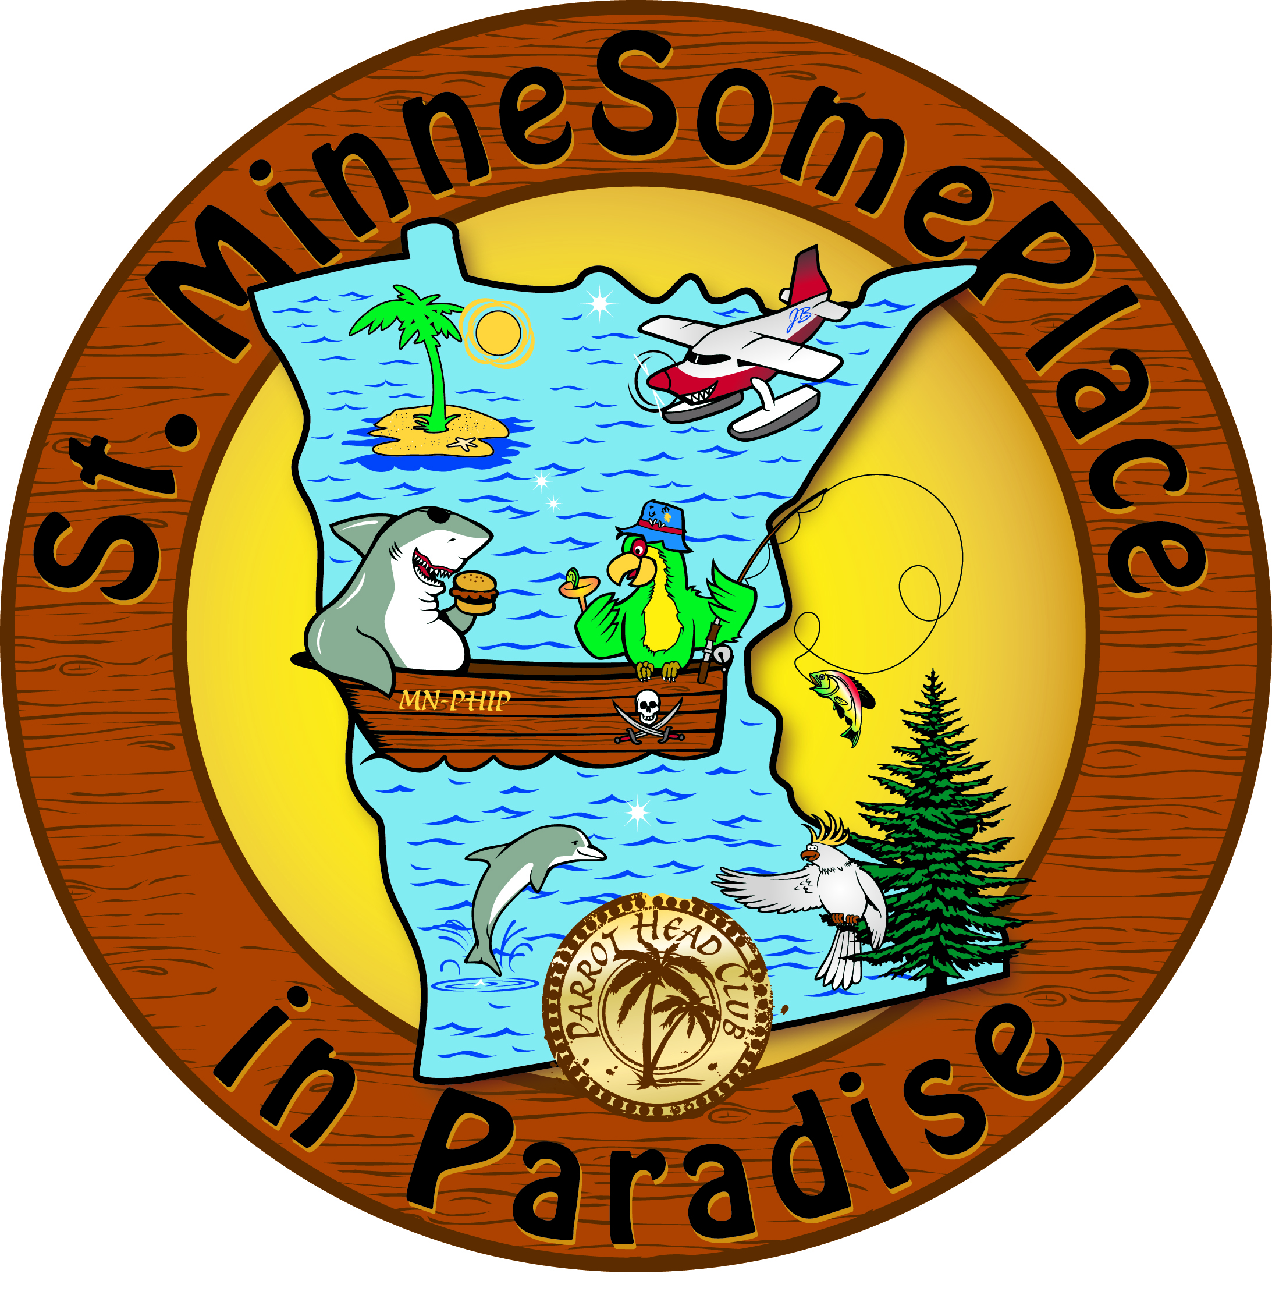

ST. MINNESOMEPLACE
IN PARADISE - PARROTHEAD CLUB, INC.
ISLAND RESIDENT APPLICATION

DATE: ______________

FIRST/LAST-NAME (1): (2):
STREET-ADDRESS:
CITY – STATE – ZIP:
HOME-PHONE #:
WORK.CELL-PHONE(S) #:
E-MAIL (1): (2):
PERMISSION TO SHARE E-MAIL ADDRESS WITH CLUB MEMBERS: ___YES ___NO
(NOTE: EMAIL ADDRESS WILL BE USED IN ST.MSP CORRESPONDENCE, BUT YOUR INFO WILL NEVER BE SOLD TO ADVERTISERS.)
OCCUPATION/COMPANY(1):
OCCUPATION/COMPANY(2):
AGE(S): UNDER 21 ___ OR OVER 20___ BIRTHDATE(S) (MM/DD):
FAMILY-MEMBER NAMES (& BIRTHDATES):
“HOW I BECAME A PARROTHEAD!” (AUTOBIOGRAPHY):
FAVORITE “BUFFETTISM” or JIMMY BUFFETT SONG:
MOST MEMORABLE PARROTHEAD EXPERIENCE:
PERSONAL INTERESTS + HOBBIES –- “HOW CAN I HELP?”:
HOW DID YOU HEAR ABOUT ST.MINNESOMEPLACE?
ANNUAL MEMBERSHIP FEE: SINGLE $30 __ COUPLE/FAMILY $40 __
“THIS FEE IS USED TO OFFSET CLUB ADMINISTRATIVE COSTS AND IS NOT DEDUCTIBLE AS A CHARITABLE CONTRIBUTION FOR INCOME TAX PURPOSES.”
Please Return Application and Payment to:
St.MinneSomePlace (in PARADISE ParrotHeadClub, Inc.)
P.O. Box 46135 Eden Prairie MN 55344.

PAYPAL AVAILABLE AT www.St-MinneSomePlace.com

QUESTIONS? Membership@St-MinneSomePlace.com

