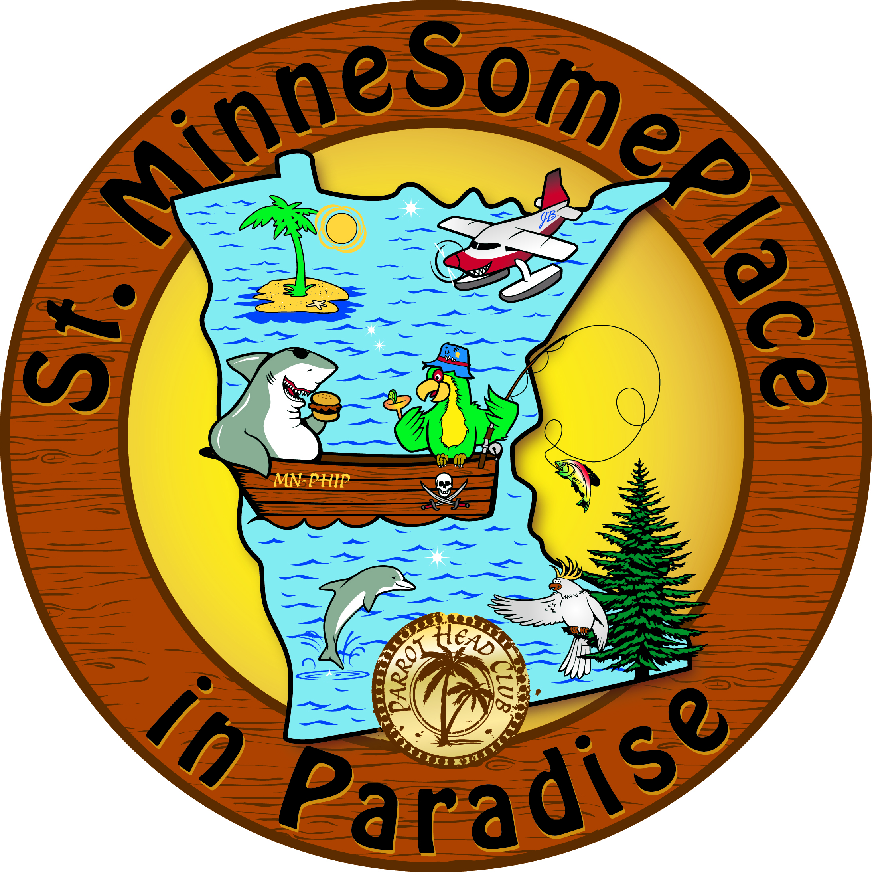
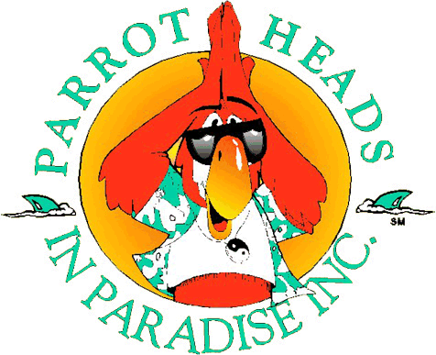
ST-MINNESOMEPLACE
IN PARADISE - PARROTHEAD CLUB, INC.
2025 MEMBER APPLICATION - NEW or RENEW
DATE: ____________
FIRST/LAST-NAME (1): (2):
STREET-ADDRESS:
CITY – STATE – ZIP:
CELL-PHONE(S) #:
WORK / HOME-PHONE #:
E-MAIL (1): (2):
PERMISSION TO SHARE E-MAIL ADDRESS WITH CLUB MEMBERS: ___YES ___NO
(NOTE: EMAIL ADDRESS WILL BE USED IN ST.MSP CORRESPONDENCE, BUT YOUR INFO WILL NEVER BE SOLD TO ADVERTISERS.)
OCCUPATION/COMPANY(1):
OCCUPATION/COMPANY(2):
AGE(S): UNDER 21 ___ OR OVER 21___ BIRTHDATE(S) (MM/DD):
FAMILY-MEMBER NAMES (& BIRTHDATES):
“HOW I BECAME A PARROTHEAD!” (AUTOBIOGRAPHY):
FAVORITE “BUFFETTISM” or JIMMY BUFFETT SONG:
MOST MEMORABLE PARROTHEAD EXPERIENCE:
PERSONAL INTERESTS + HOBBIES –- “HOW CAN I HELP?”:
HOW DID YOU HEAR ABOUT ST.MINNESOMEPLACE?
2025 FEE: SINGLE $20 __ COUPLE/FAMILY $30 __
“THIS FEE IS USED TO OFFSET CLUB ADMINISTRATIVE COSTS AND IS NOT DEDUCTIBLE AS A CHARITABLE CONTRIBUTION FOR INCOME TAX PURPOSES.”
Please Return Application and Payment to:
St.MinneSomePlace (In PARADISE ParrotHeadClub, Inc.)
19780 Java Path Lakeville MN 55044

PAYPAL AVAILABLE AT www.St-MinneSomePlace.com

QUESTIONS? Membership@St-MinneSomePlace.com

