

David Mielke Scholarship

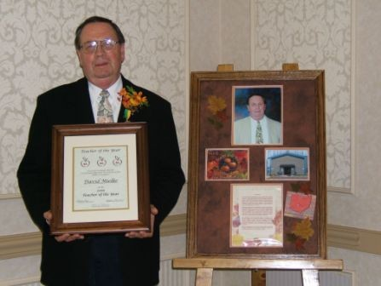

David Mielke Scholarship is named in honor of a correctional educator who was dedicated to life long learning. Dave was hired by DRC to work as a teacher at the Southeastern Correctional Institution. In 1994, Dave transferred to the Orient Correctional Institution as a teacher. In 1999, he became a Pre-Release Instructor at the Pickaway Correctional Institution (PCI) assisting inmates with issues that needed to be addressed before they re-enter society. In 2003, Dave switched from his involvement with Pre-Release to that of classroom teacher at PCI. He is the Correctional Education Association Teacher of the Year award recipient for 2006.

David Mielke was a lifelong learner who dedicated his professional career towards developing relationships that help and teach others. This scholarship is available to CEA members meeting the criteria listed below. The scholarship money is for a lifelong learner. It can be used for professional development in education attendance at CEA-O National or Regional Conference, an educational workshop, convention, or seminar related to teaching field.

David Mielke/2020 Page 1
The deadline to submit applications is September 1, 2020. Applications must be emailed or postmarked by using the following:

CEA-O
P.O. Box 1212
Grove City, OH 43123
Or
Email to: nikki.lewis@odrc.state.oh.us

Criteria for selection:

- CEA Member for 1 year as of the September 1, 2020 submission deadline

- Applicant must be in current position having direct contact with students for 5 years as of September 1, 2020.

- Write a one page summary explaining your philosophy of education and how you will utilize this scholarship

David Mielke Scholarship Application

Name ____________________________________________________

Work Address:
__________________________________

__________________________________

__________________________________

Employer / Site ___________________________

Position ___________________________

Work Phone Number __________________________

Years of Education Experience _________________________

Attach your summary

David Mielke/2020 Page 2

