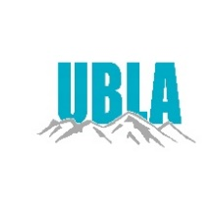
Utah Business Licensing Association
St George Abbey Inn
September 11-13, 2024
2024 Conference Abbey Inn
Certification Hours

CLASS TITLE | CLASSIFICATION  CATEGORY | HOURS EARNED | ATTENDED  Y/N
Tobacco | Regulatory | 1.5
Money Lenders  Check Cashers | Regulatory | 1.5
Hemp Program | Regulatory | 1.5
Alcohol  Local Consent | Alcohol | 1.5
Q&A | Customer Service | .75
DOPL | Regulatory | 1.5
Cedar City  Attorney | Law | 1.5
Motor Vehicle  Enforcement division | Enforcement | .5
Code Enforcement | Enforcement | 1.5
Health Department | Regulatory | 1.5
Q&A | Customer Service | 1
Sales Tax | Sales Tax | 1.5
Human & Health Svc | Regulatory | 1.5

