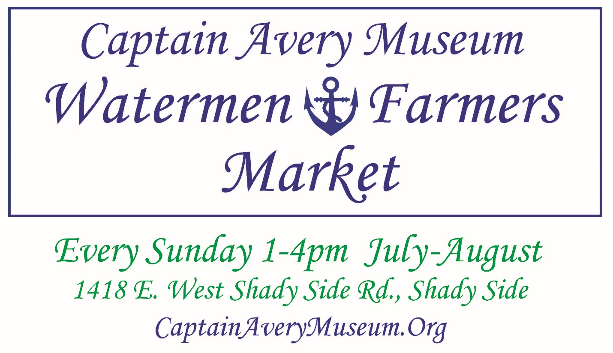

Vendor Application & Guidelines

Thank you for your interest in the Captain’s Watermen and Farmers Market. We aim to provide fresh local seafood, produce, and artisanal products to residents of Southern Maryland. We provide an exquisite market experience for our visitors to stay awhile. Located directly on the museum’s breathtaking waterfront grounds, customers will enjoy shopping the market as part of a relaxing Sunday afternoon where they can explore the museum, art exhibit, and picnic while listening to local live music.

To join the Captain’s Market, please submit the completed application and appropriate licensing/permit information by July 3, 2022

Questions, feedback and completed forms can be emailed to market@captainaverymuseum.org or mailed to:
PO Box 89, Shady Side, MD 20764, ATTN: Market Manager

Full Name:
Phone Number: Email:
Business Name:
Website (if applicable):

Which of the categories below best describes your business and what you want to sell at the Market (check all that apply)?
Fresh fruits/vegetables from my farm Brewpub or wine bar
Meat or poultry Retail Beer/Wine/Spirits (to take home)
Fish and/or other seafood Plants/nursery products
Milk Prepared foods for immediate consumption
Cheese Value-added foods: jams, salsas, pickles, etc.
Eggs Other retail (books, gifts, etc.)
Coffee/Tea Hand-made by you (art, jewelry, candles, etc.)
Other:

What, if any, licensing or permitting requirements do you need to operate your business within the market?

DO YOU ACCEPT: FMNP (WIC & Senior) ____yes ____no FVC (Fruit & Vegetable Checks) _____yes _____no SNAP (Supplemental Nutrition Assistance Program) _____yes _____no

PLEASE LIST ALL SEAFOOD PRODUCTS THAT WILL BE SOLD:
_______________________________________________________________________________________________________________________________________________________________________________________________________________________________________________________________

PLEASE LIST ALL FARM PRODUCTS THAT WILL BE SOLD: ____________________________________________________________________________________________________________________________________________________________________________________________________________________________________________________________________________________________________________________________________________________

CERTIFIED ORGANIC? ____YES ____NO CERTIFIED NATURALLY GROWN? ____YES ____NO CERTIFIED BIODYNAMIC? ____YES ____NO FOOD ALLIANCE CERTIFIED SUSTAINABLE? ____YES ____NO DO YOU USE INTEGRATED PEST MANAGEMENT PRACTICES (IPM)? ____YES ____NO

PLEASE LIST OTHER CERTIFICATIONS: _______________________________________________________________________________________________________________________________________________________________________________________________________________________________________________________________

PROCESSED FOOD (IF APPLICABLE, PLEASE CHECK OR LIST PRODUCTS OFFERED) CHEESE _____ BAKED GOODS/BREAD _____ HONEY _____ COFFEE _____
JAMS/JELLIES/PRESERVES _____ OTHER _______________________________________________

DESCRIBE THE PRODUCTS YOU WILL BE SELLING: __________________________________________________________________________________________________________________________________________________________________________

WHERE ARE YOUR PRODUCTS PROCESSED? (PLEASE INCLUDE A COPY OF ANY APPLICABLE LICENSING INFORMATION)

VENDOR SPACE

How much space will you need for your set up?
10’x10’ 12’x12’ 15’x15’
Describe any special requirements you will need to participate in this outdoor market.
Electricity:
Gas:
Lighting:
Drainage:
Water Supply:
Loading/Unloading:

MARKET VENDOR FEES
(Please do not submit payment until after you have been accepted into the Market.)

Contracts: $140 upfront flat seasonal fee ($10/ day) and must attend 10/14 markets

Refunds!
-Attend all 14 markets and receive 50% refund ($70)
-Attend 12/14 markets and receive 25 % refund ($35)

Please contact us if you are interested in making other arrangements.

MARKET VENDOR APPLICATION & GUIDELINES CONT.

- The market will operate on Sundays from 1-4 pm starting July10th, 2022, and ending on October 9, 2022. There is no market on July 3rd, 2022. Vendors can begin set up at 12:00pm and must clean up and vacate by 5pm.
- The market is in the shaded lawn of the Captain Avery Museum1418 East West Shady Side Road Shady Side, Maryland, 20764, weather permitting. Should it become necessary to cancel the Market, it will be posted on the Museum’s website and Facebook page along with a group email sent to all vendors. All efforts will be made to send cancellation of the market at the earliest time possible.
- Any changes in the products sold listed on your application must be submitted to Elaina Lill Uhl in advance for approval.
- Vendors must display a sign identifying the name and location of their farm/company as well as prices for all products.
- Each Vendor will be assigned a space for the duration of their participation with the market. Tents or canopies may be used and must be adequately secured for safety and to avoid injury or damage to property and/or patrons. Vendors are required to make immediate safety changes when directed to do so by the Market Manager.
- Vendors must comply with all applicable federal, state, and local laws along with health and safety requirements and with applicable County policies, procedures, and directives. Additionally, each vendor must obtain and provide the Market Manager with all applicable federal, state and/or local licenses, permits and certifications required for its Market activities.
- Bakers must provide certificates for an approved baking facility.
- Vendors that make cheese or any other value-added products from milk that is purchased from regional dairy farms must provide certificates for cheese making facility.
- Meat producers who primarily operate a food processing facility that processes meat raised by local farmers must provide state and federal (USDA) certificates for their processing facility.
- The applicant agrees to hold harmless and indemnify the Captain Avery Museum and staff for all liabilities, losses, claims, damages and expenses to the property and personal injury arising from or out of the installation, set-up, operations, dismantling and/or removal of materials if caused in whole or by part the act of omission of the vendor, its agents, contractors, or employees.
- Liability Insurance: Vendor is required to maintain an insurance policy covering both general liability and product liability with a minimum of $1,000,000 in coverage. The insurance policy must name the Market as an additional insured. The Vendor must show proof of such insurance prior to selling at the Market and produce a copy of the insurance certificate upon request. The Market does not provide any insurance for Vendor.

I, THE UNDERSIGNED, AGREE TO COMPLY AND ABIDE BY THE TERMS DEFINED IN THE CAPTAIN’S WATERMEN AND FARMERS’ MARKET GUIDELINES.

NAME: _________________________________________________
SIGNATURE: ____________________________________________
DATE: _________________________________________________
BEST WAY TO BE CONTACTED: ____________________________

FOR OFFICE USE ONLY

ACCEPTED for participation in the Captain’s Watermen and Farmers’ Market.
BY: _________________________________________________________________________

