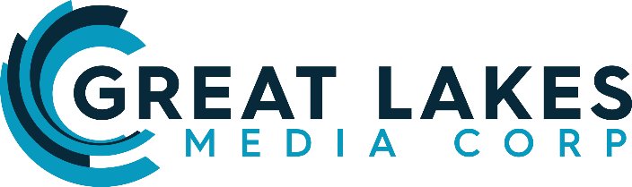

**FOR IMMEDIATE RELEASE**

**New Media Company Appoints Leadership Team**

**Seeks Larger Local Digital/Radio Opportunities**

**MILWAUKEE,** Wisconsin, March 6, 2018 -- **Great Lakes Media Corp.** today announced the first of several appointments to its Board of Advisors and Senior Leadership Team – and simultaneously proclaimed a strategic shift in the company’s focus toward larger market acquisition opportunities. **Tom Langmyer,** Founder & CEO of Great Lakes Media Corp., has added several highly experienced and well-respected names to the team as the Company moves to become a significant local media player in the U.S.

**John Gehron**, Chairman of AccuRadio, joins Great Lakes Media Corp. as Vice Chairman, bringing his legendary major-market experience as a highly accomplished executive with some of the nation’s premier media companies.

**Gabe Hobbs**, Sr. Vice President, Broadcast, is well-known as a leader in media and brings a wealth of experience in the areas of audience acquisition, content creation, talent development and leadership.

“In building our company, we’ve been fortunate to partner with some of the most successful, respected and admired leaders in media,” stated Tom Langmyer, Founder & CEO of Great Lakes Media Corp. “John Gehron and Gabe Hobbs represent the first announced in a stellar group of people that will build tomorrow’s LOCAL media platform model.”

Great Lakes Media Corp. was formed in November of 2018 with the initial intent to target media acquisitions in small communities. In a very short time, interest and support shifted Great Lakes’ focus toward the media properties and groups which operate in larger markets. The vision remains the same, which is to invest in radio stations and digital platforms and to grow them as true “local” brands.

The company is meeting with investors, brokers and others who are interested in specific markets; and has plans to announce appointments of additional officers and partners in the weeks ahead.

“The current media model we’ve seen has been ‘top-down’ and focused on national distribution of national and white-labelled content. The Great Lakes difference is a media model built from the ‘bottom-up’ and focused on local people creating local content and driving local revenue, while benefitting from the efficiencies technology provides us all,” said Langmyer. “Radio ***and*** Digital complement each other, as it’s not an either/or proposition. There’s great open space in creating more personal local experiences by leveraging these platforms and expanding the emotional connection between local consumers and brands.”

These announced leadership appointments are effective immediately. For full leadership bios, click here: <https://greatlakesmediacorp.com/our-team>

**-#-**

**About Great Lakes Media Corp.**

Founded by CEO Tom Langmyer, Great Lakes Media Corp. is a local media company which is acquiring radio stations, digital and other local media platforms in the interest of serving, engaging and activating U.S. markets with news, information, entertainment and local advertiser & business connection.

**Media Contact/Website/Facebook/Twitter**

[News@GreatLakesMediaCorp.com](mailto:News@GreatLakesMediaCorp.com)

(312) 320-4700 (main)

GreatLakesMediaCorp.com

Facebook.com/GreatLakesMediaCorp

[@GRTLakesMedia](mailto:twitter.com/@GRTLakesMedia)