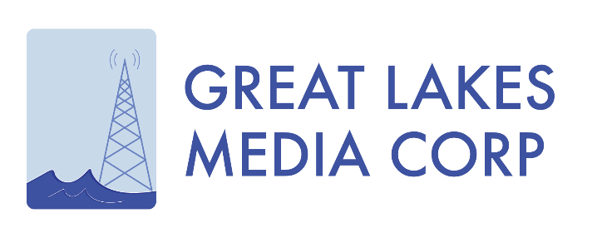
FOR IMMEDIATE RELEASE

New Broadcast and Media Company Forms
Seeks Local Radio and Digital Acquisitions

MILWAUKEE, Wisconsin, November 8, 2018 -- Great Lakes Media Corp. today announced its intentions to invest in local broadcasting and digital media opportunities through the acquisition of local radio stations and digital platforms in small markets.

The company is looking to acquire properties in small markets, focusing on opportunities in New York, Pennsylvania, Ohio, Michigan, Indiana, Illinois, Minnesota and Wisconsin.
“Smaller communities are making a big comeback. This new generation of people, to whom quality of life and community are very important, are building their lives and businesses in these places,” says Tom Langmyer, President & CEO of Great Lakes Media Corp. “Over the years, the shifting economy and technology had ended an era of localism in media. Today, people are once again in search of real community and the greater connection that comes with being a part of a ‘place.’ Local media builds that connection - particularly in smaller markets.”

The company is meeting with investors and brokers - and others who are interested in specific markets; and plans to announce appointments of officers and partners in the weeks ahead.

Langmyer, a longtime media executive, believes in the opportunity to better develop a deeper local content experience in markets - and he looks favorably at radio as the way to bring more consumers to the mix.

“The need is clear as many of the broadcast media platforms have been providing white-labelled, generic, unremarkable content. And while it’s growing, the digital space is in dire need of compelling content to make it a more robust advertising and revenue platform. Radio and Digital complement each other, as it’s not an either/or proposition. There’s great open space in creating more personal local experiences by leveraging these platforms - and expanding the emotional connection between consumers and local brands,” stated Langmyer.

About Great Lakes Media Corp.

Led by President & CEO Tom Langmyer, Great Lakes Media Corp. is a local media company, which is acquiring radio stations and other local media platforms in the interest of serving smaller markets and communities with news, information and local business connection.

Media Contact/Website/Facebook/Twitter

(312) 320-4700 (main)

GreatLakesMediaCorp.com, Facebook.com/GreatLakesMediaCorp, @GRTLakesMedia

