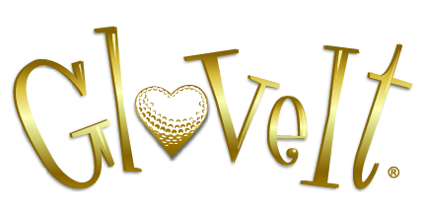

2024 Tournament Discount Program
72-143 Units - 10% Discount
144-276 Units - 12% Discount
277+ Units- 15% Discount

(Closeouts excluded from additional discounts)

Course, event, and corporate logo available

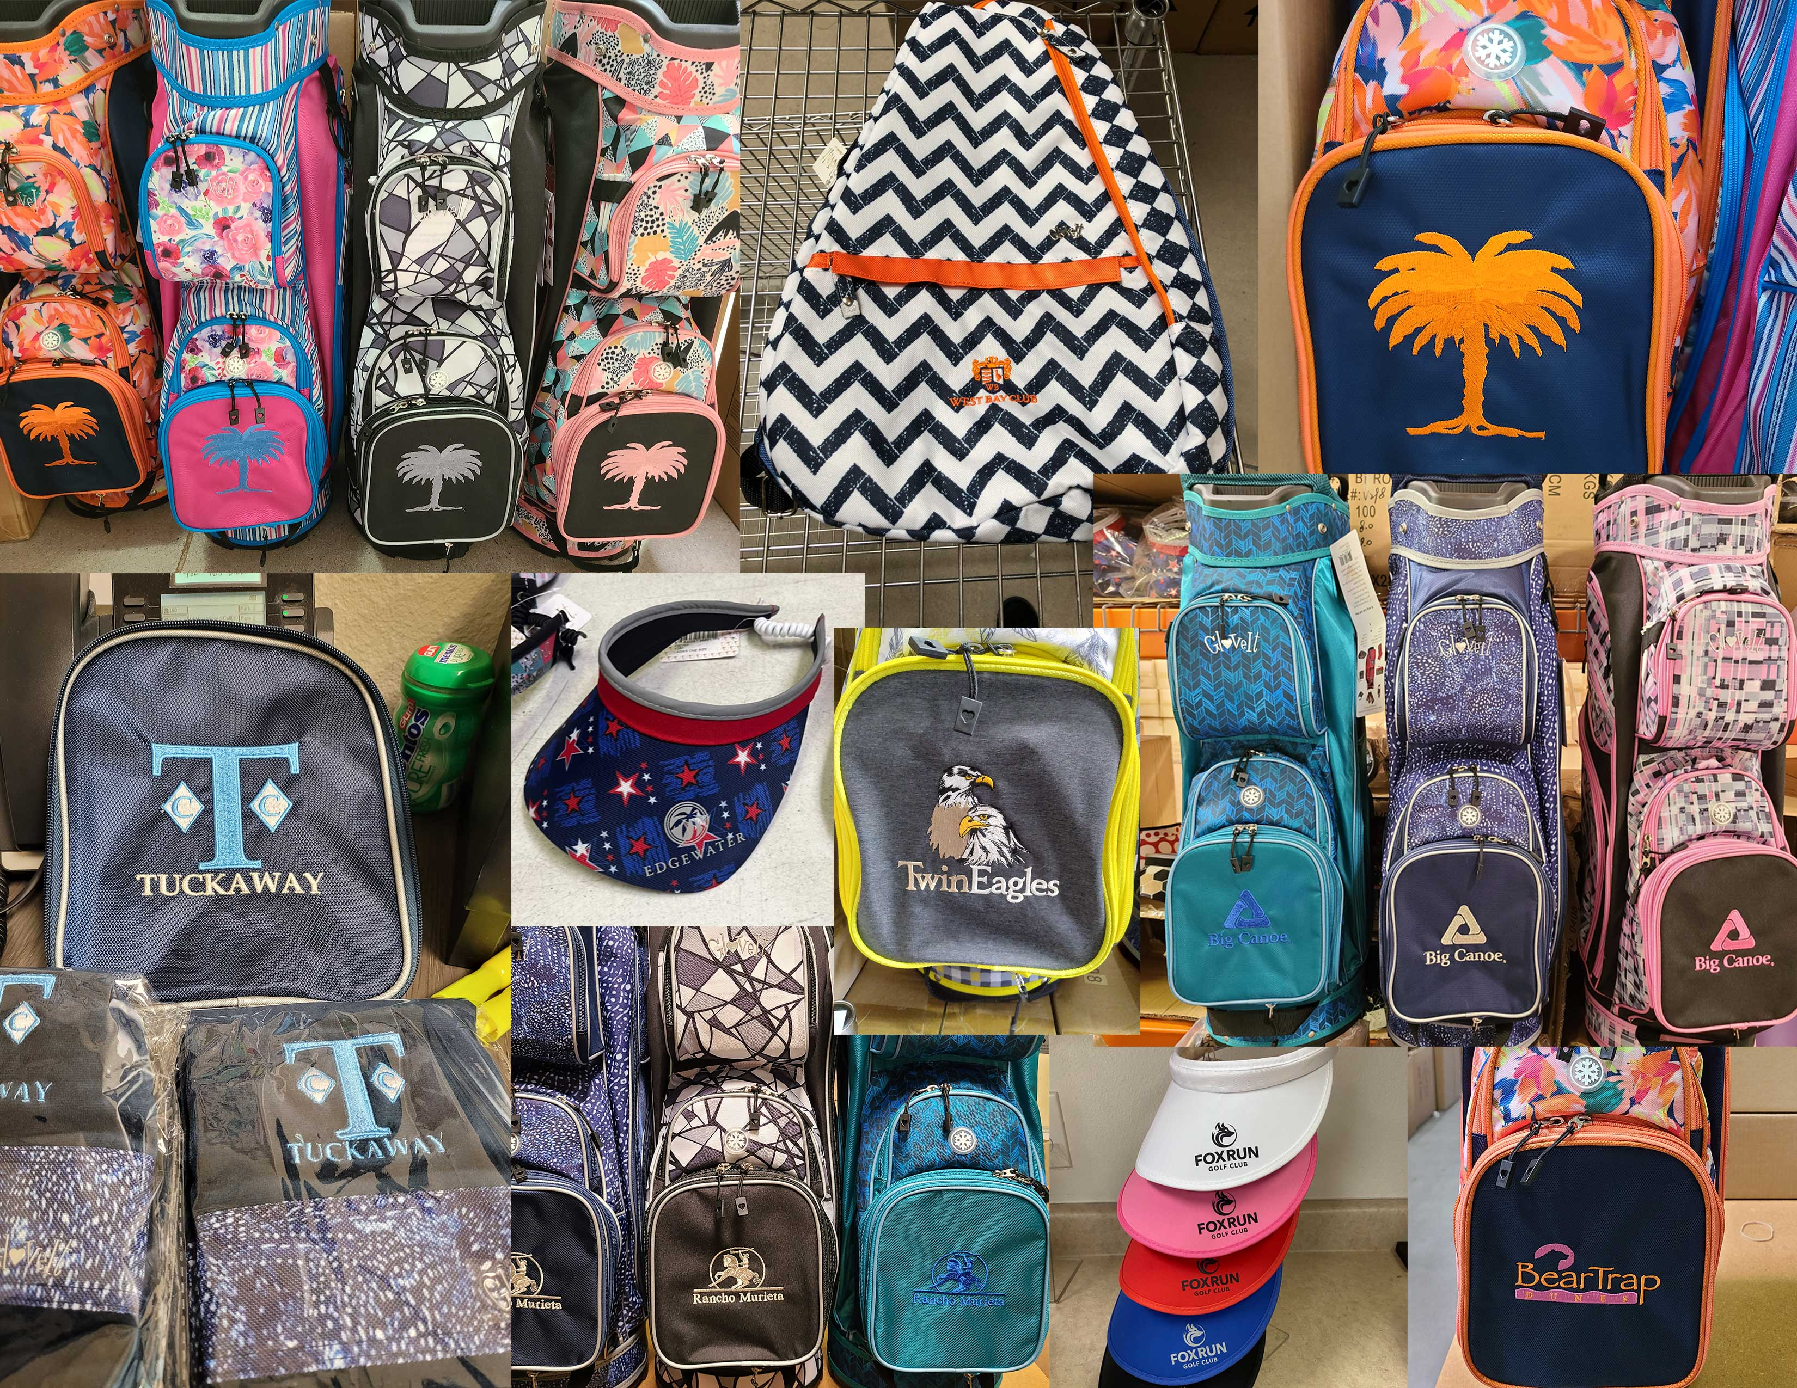

www.gloveit.com
order@gloveit.com
16051 N 82nd St. Scottsdale, AZ 85260
Tel: 480-969-2021 Fax: 480-968-2380

