Mound City Public Library

2021 Summer Library Program
Catch a Story by the "Tale" Registration
and
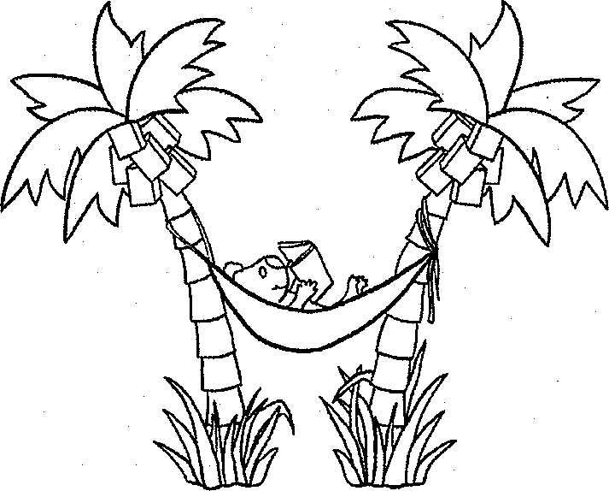
Permission to Video and/or Photograph

Each child must be registered separately. Thank you!

Child's name: Address: Phone: Age today:
School: Grade in September:
Circle one: Independent Reader Family Reader
Has child been in Summer Reading Program before? Yes No

~ ~ ~ ~ ~ ~ ~ ~

I understand the City of Mound City may photograph or videotape the events or activities in which I am (or my child is) participating. I give my permission for the City to use photographs or video of
me (or my child) for the purpose of promoting the City of Mound City and its services/programs. I give my permission with the following understanding: No compensation of any kind will be paid to me (or my child) at this time or in the future for the use of my (or my child's) likeness.

~ ~ ~ ~ ~ ~ ~ ~

I certify that I am 18 years or older and am the parent or legal guardian of the above named child.

Signature: Date:

Address (if different from above): City, Zip:

