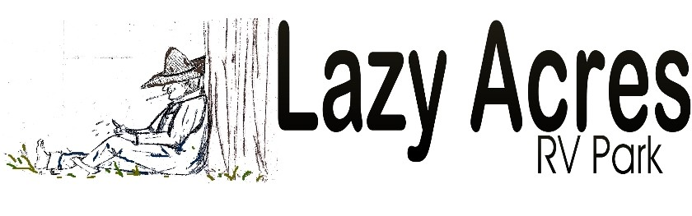

Names Age of Children  staying at park | ADDRESS | PHONE NUMBER
 | Address 1 | Home:
 | Address 2 | Cell:
 | City | Emergency:
 | State/Zip Code | E-Mail:

Year of RV | Rig Type: i.e., 5th wheel, motor home, etc. | Size of RV | RV Tag Number | Vehicle Tag Number | Driver’s License Number

# Of Pets | Breed | Up to date  Vaccines | Electric Meter  Start: | Electric Meter  Final: | Monthly : _________
 |  | Yes:________  No:_ _______ |  |  | Daily Stay: ________

#Days | Site# | Arrival  Date | Departure  Date | Daily & Reg. Fee | Credit Card information: ONLY if you want to pay with card when the office is closed | Name on Card  Signature
 |  |  |  | $________________  $__5.00__________  $________________ | Exp: Code:  Zip code:______________  _ _ _ _ - _ _ _ _ - _ _ _ _ - _ _ _ _ | Print:  Date:___________________________  X.

By signing this form you acknowledge that you have received a copy of the park rules, WIFI code and Bathhouse code X._______________________
We hope you have a pleasant stay at our park. Please do not hesitate to call the office if you have any concerns that need to be addressed.

Our Wi-Fi is a free service, not included in your rate. We cannot guarantee our Wi-Fi will work at every site at all times. We strive every day to be as diligent as possible to provide you with the best networking possible. Wi Fi antennas offered at the office during your stay.
All reservations are non-refundable and non-transferable.

