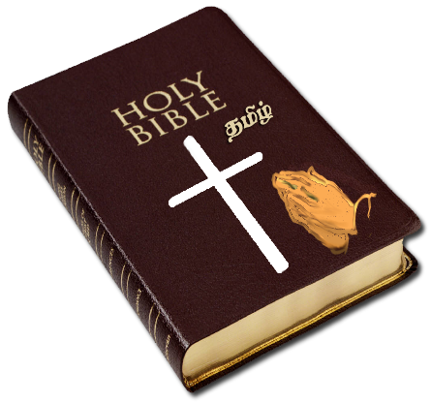
Generation to Generation
This Photo by Unknown Author is licensed under CC BY-NC
Bible Study Nuggets

Monday-Guard Your Heart and Mind
(Proverbs 23:15-19)
Wisdom is the most principal thing in life. We Christians must guard out heart and minds. King David pleaded with his people not to harden their hearts in rebellion against God as they did in the wilderness. With wisdom we get an understanding.

Tuesday-Walk Uprightly
(Psalm 84:8-12)
Upright is defined as honest, honorable, and straightforward; having or showing a strict regard for what is morally right. Upright implies a strict adherence to moral principles. The psalmist trusted in God, God was his hope, joy and his everything. God doesn’t bless mess. Walking upright is trading stress for peace and contentment and tic tacs for a banquet. God wants to give us everything good; we as Christians just must hold on and have faith.

Wednesday- Keep God’s Commandments
(Joshua 23-1-8)
Joshua reminded the people of how God had protected them. He advised the people to be brave and remain faithful to God’s laws. He told them not to associate with others that did not worship our God. Just like the Israelites we are troubled as well. When trouble comes, you are not to panic, remember who you are and seek the Lord. Keep the faith saints.

Thursday-Lifelong Protection
(Psalm 91:9-16)
Christians should have faith, trust and assertion in God. We must remember that God is the angels, and it is through him that gives the direction to protect. The protection of God to his people extends among all things. God seeks those who show love for him. To set love upon God is to do it by choice. This includes spending time with God rather it be in prayer, speaking about him to others etc. Blessings are for those that love God and call upon his name. The blessings of God’s protection, promotion and presence are given to those that love him.

Friday-Walk in your Parents’ Paths
(Proverbs 1:8-15)
Throughout the book of Proverbs, Solomon makes it clear that the path of wisdom is by choice. To get on the path of wisdom is to have fear of the Lord. Solomon is not speaking of any kind of knowledge, its knowledge of God. To fear the Lord, we must have reverence for him. We don’t just share our treasure or our hears with anyone. God wants us to fear him, but he wants to share his wisdom and knowledge with us. We can ask God for wisdom. As we walk with God, he sharpens our wisdom so that we can apply knowledge. This only comes when and while we are walking with the Lord. Apply the knowledge that you have learned. The ornament and the chain represent honor, guidance and protection these are things provided as a result of walking in the path with God. We as Christians need to stay away from the wicked paths. In order to live life to the fullest we must stay on God’s path.

Saturday-Prize Wisdom
(Proverbs 4:1-9)
Those who keep their way in Godly wisdom in return will be guarded by God. Wisdom and understanding are principals. Wisdom perfects our plan. God has a plan for all his children if we walk in our paths, the walk may not be easy, but we will be protected by the will of God. Buy the truth but sell it not. Treat wisdom as though we treat our mother-hung her, embrace her and love her. Embrace wisdom and you will have honor and beauty. Solomon wants to teach his children wisdom for the present and the future. We must trust God’s word and apply his word to our daily lives and he will direct our paths.

