Slough
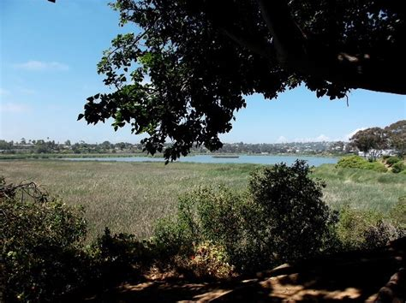
The sign said "Maxton Brown Bird Sanctuary", but that was pretty pretentious. To us, the 200 acre brackish, tule-filled pond was the slough, a world of never-ending adventure and fascination. However, it was indeed a bird sanctuary which meant that the occasional gunfire one heard early in the morning must have come from somewhere else, and if it didn't, the numbers and types of birds seemed to take it in stride. Ducks (mostly mudhens though there were mallard, spoonbill, teal, and canvasback in residence), geese, and wading birds of all feather abounded, along with hummingbirds, bees, and dragonflies just to keep things lively. Skitter-bugs - I'm sure there is a real name for them, but you get the picture - darted across the surface of the water sending miniscule eddies in the gentle lap, and bubbles suggested the possible presence of a sluggardly catfish or two.

The slough was split by the Santa Fe railroad tracks and Highway 101 so that it was in fact three distinct ponds, each with a different personality. The westernmost was cut off from the ocean by a 100 yard strand of beach sporting a dozen or so houses, access road, life-guard cabana, and tennis court. Being the closest pond, it was the most familiar and therefore the least mysterious. The middle pond, lying between the tracks and highway was the deepest and widest and was the buffer-zone between us and the enemy. The enemy - them in whatever guise struck our fancy - skulked in the far pond, a triangular body pointing east toward Vista and Escondido and other alien territories.

Mostly, the enemy were Japanese soldiers and spies and even after the war was over we had to be wary lest they take us by surprise. Make no bones about it, they were wily opponents, worthy of our special attention. Proof of this lay in the fact that none of us ever captured one, though there were a number of close calls.

The plan was simple. You launched silently into the first pond and worked your way east, keeping to the tules so no one would see you. My method was to move as quickly as possible to the middle pond and then wait and watch from my secret place, which allowed me to observe most of the slough. I was very careful of my secret place and I'm pretty certain that none of the others knew where it was or perhaps that it even existed. I kept my binoculars there as well as a good supply of K-rations, waxed boxes, each containing enough items for a meal.

K-rations were wonderful. Each packet came complete with two tins of food such as macaroni and cheese and pork and beans, a chocolate bar, crackers, coffee, chewing gum, five cigarettes, matches, toilet paper, and a hinged triangular can opener. There were minor variations, such as peanut butter and jelly or pound cake, but what K-rations may have lacked in culinary excellence, they more than made up for in adolescent ambiance.

A thorough job of polishing off a K-ration pack took about an hour, and if nothing moved during that time it meant that I was the first one into the slough which opened up a new set of options. Usually, however, something would move and the chase was on.

My binoculars were dented and scratched, but they were better than nothing, and besides, they, along with the plastic map case and camouflaged shelter half had tasted battle both in Guadalcanal and Bougainville. That above all made them special. At least they were good enough to allow me to identify my adversary which was valuable because most people do the same thing over and over.

For instance, the Stovers, Roddy and his younger brother Hank, usually worked as a team. Roddy used Hank as cannon-fodder, sending him out to attract attention while remaining hidden himself. If I waited long enough, Hank would get out of Roddy's sight and he'd have to shift positions. I'd set up an intercept for Roddy and capture him which meant snatching his legs out from under him and dumping him head-first into the slimy, warm, black, gelatinous, fecund ooze that made this a slough to be reckoned with.

The rules said that "caught was caught," but it rarely worked out that way. Instead we would wrestle around until we were totally filthy and out of breath. At that point there was nothing for it but to head quickly to the ocean where it would take a lot of scrubbing in the wet sand to get rid of the glop.

Over the years, a lot of black sludge got tracked across the salt-white strand, but time has caught up with the slough. Now, where once soldiers and spies roamed the countryside, a shopping center and apartment complex encroach to water's edge and a retirement community catapults strains of vintage Lawrence Welk into the drifting currents of exhaust-scented air. The tules have been uprooted, black slime dredged and replaced with an anti-biotic fill. Ducks and geese still make a low pass or two, but the only form of wading bird one sees these days is made of pink plastic.

