Support the Y.E.T. Center BOOK FUNDRAISER
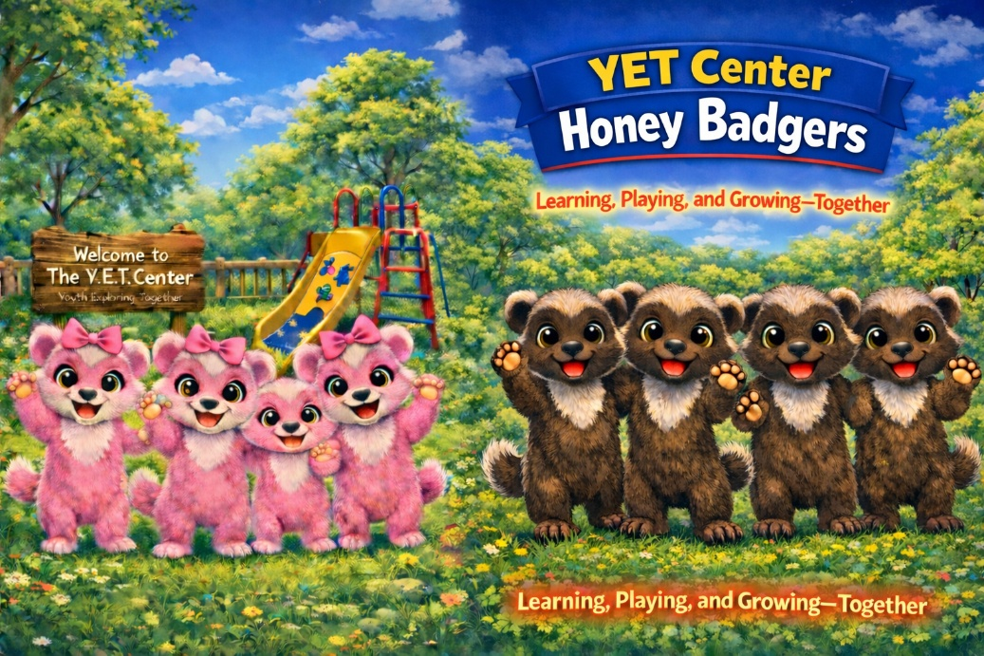
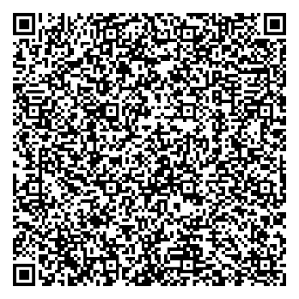
Join us in supporting our children and families though our community non-profit, The Y.E.T. Center.
When you purchase the children’s book: (A Gift to Santa) or (YET Center Honey Badgers). Bye: W Spann III
100% of author proceeds support our mission to uplift, encourage, and empower families.
Scan the QR code below to purchase your copy.
Thank you for your support!

