Preschool Newsletter
Welcome back, we hope everyone enjoyed their Christmas break.
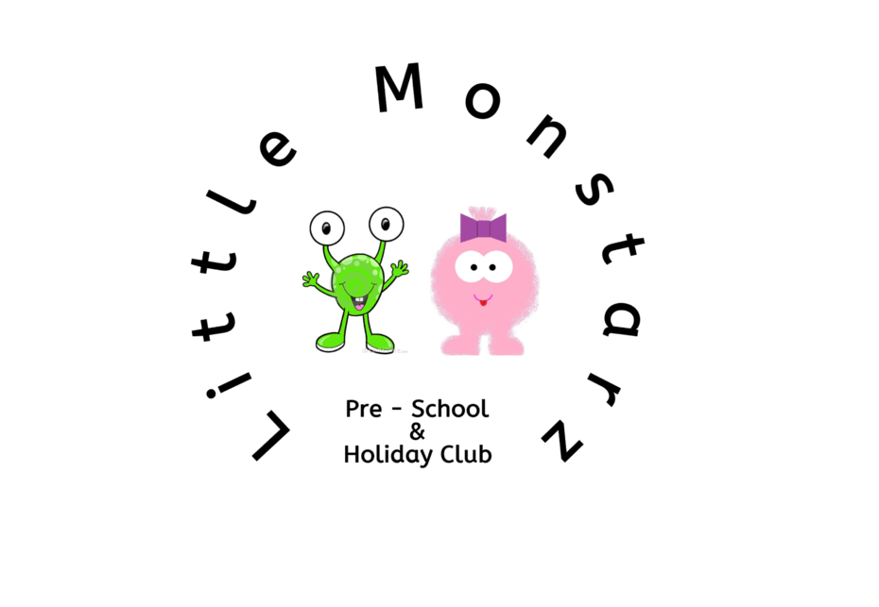

Questionnaires
We had a lot of amazing feedback from the questionnaires that we sent home before half term, we really appreciate the feedback. Thank you.
If you have not sent back your parent questionnaire or all about me questionnaire please hand them in asap as these help us to ensure we are meeting your expectations and including your child’s interests in our planning.

Holiday Club
We are now taking bookings for holiday club for February half term.
Half term runs from 12th – 16th February.
If you require childcare during this time we recommend you book early due to high levels of interest.
Full day £18
Half day £10 (4.5 hours used flexibly throughout the day)

Opening hours
We are now open until 6pm on Tuesday’s and Thursday’s. If you require childcare during this time please speak to a member of staff.

This term we will be learning all about animals. We have lots of fun filled activities planned and will be having animal encounters at preschool.
As a result of the all about me questionnaires that were sent home before half term, we are aware that a lot of parents would like their child to learn to write. We would like to take this chance to explain how we plan to implement this to fit with each child individually.
At the beginning of this term we will focus on correct pencil grip, from there we will move on to being able to draw a picture with meaning e.g. being able to add features to a face they have drawn, drawing an animal with the correct amount of legs etc. We will then move onto drawing shapes to build on fine motor skills. All of these skills are a base to learning to write. Once all of these are mastered we can teach letter formation.
We have made a new self-registration board, each child now has a new picture with their name, on our registration tree. This is to help with name recognition, we will also be using name cards at lunch and snack time for children to find their seat.
We do daily phonics sessions as part of our adult led activities, these last 10-20 minutes daily and focus on the pronunciation of sounds when speaking and recognising letters by sound and name. This will also help with teaching children to write.

Our family board
If you have not provided a family picture for our board please send one into us. You can print one and pass to a member of staff, you can send the picture via the Facebook page or email to little.monstarz.preschool@gmail.com and we can print them for you. The children really enjoy looking at the family board and talking about their family members and pets.

