|  |
| --- |
|  |
| Preschool Newsletter April 2018 |
|  |

Welcome back, we hope everyone enjoyed their Easter break.

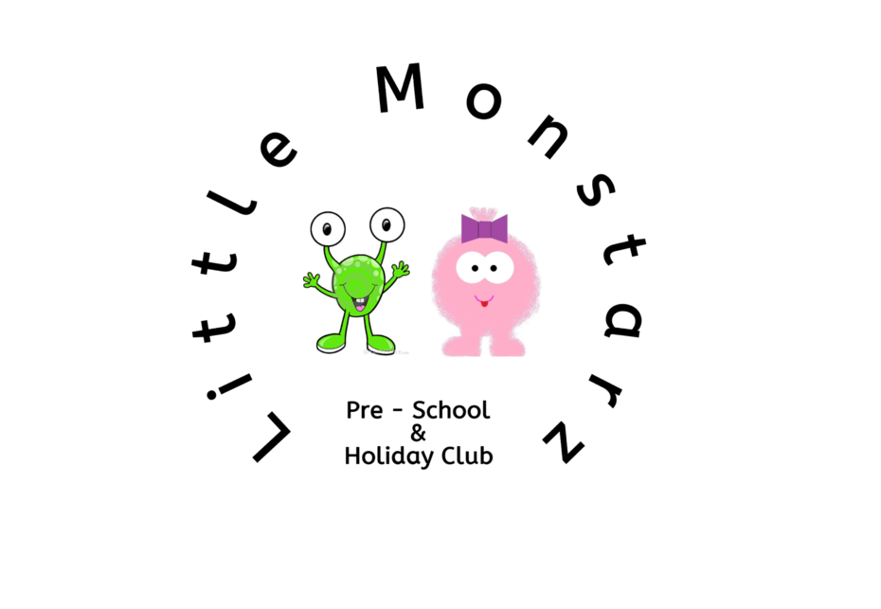

# Lunchboxes

Please remember that we have a **no nut & no egg** policy at preschool. We are unable to allow children to eat any products containing nuts or food that has a high egg content e.g. egg sandwiches, savory eggs or similar products. Any such products will be sent home and children will not be allowed to consume them at lunchtime. Also you do not need to provide a drinks bottle for your child, as we provide milk and water throughout the day.

We also no longer need you to provide calpol for your child, the preschool has purchased calpol sachets for our first aid kit, we feel this is safer than having bottles of calpol in backpacks. Please remove calpol from backpacks asap.

|  |
| --- |
|  |
| Holiday Club We are now taking bookings for holiday club for May half term.  Half term runs from 28th May – 1st June 2018.  If you require childcare during this time we recommend you book early due to high levels of interest.  Full day £18  Half day £10 (4.5 hours used flexibly throughout the day)  **Please remember that preschool is not open on bank holidays.** |

|  |
| --- |
|  |
| This term we will be learning all about kindness and how we feel, We will be using the story ‘rainbow fish’ to aid our feelings topic. We will then move on to learning about mini beasts, during our minibeasts topic we will be building a bug hotel and hatching caterpillars into beautiful moths which we will then keep at preschool as pets.  **Speech and language**  We are taking part in the ‘let’s talk more’ strategy for two year olds. This programme helps younger children to improve their speech and language skills therefore reducing the number of children to develop a speech and language delay. The strategies are very simple but can have a huge impact on your child speech development.  This month’s strategy is: When you are talking with your child point things out or hold things up to show them. Showing objects or pictures that go with what you say, this really helps children learn what words mean e.g. holding up a nappy and saying “nappy time”.  If you are concerned about your child’s speech there is a very useful website <http://www.talkingpoint.org.uk/> which is for parents to use. On this website you can use a monitoring tool to assess your child’s speech to find out if there is a delay/ concern. There is also lots of tips on how to support a child with a speech delay.  In our last newsletter I told you about our new phonics sessions, which the children now take part in daily. The children are learning quickly, some now recognise letters and sounds and can even blend sounds to create words, the younger children have been learning to draw pictures with meaning, this is also progressing well and they now have lots of ideas when asked what they would like to draw. |
|  |

# Our family board

If you have not provided a family picture for our board please send one into us. You can print one and pass to a member of staff, you can send the picture via the Facebook page or email to [little.monstarz.preschool@gmail.com](mailto:little.monstarz.preschool@gmail.com) and we can print them for you. The children really enjoy looking at the family board and talking about their family members and pets.