##### ***Heather Manfre, Canine Therapeutic Massage Therapist***

##### **Encounter Intake Form**

**Date:_________________ Type: Equine / Canine / Other_____________**

**Animal’s Name:_________________ Breed:________________________**

**Male / Female Altered / Unaltered Age:_______ Color:_____________**

**Weight:_________ Exercise / Job:________________________________**

**Diet:________________________________________________________ Supplements:_________________________________________________**

**Appetite:____________ Stools:________ Coat:______________________**

**Veterinarian Name and Phone:__________________________________**

**Illness/Injuries:______________________________________________**

**Surgery/X-Rays_______________________________________________**

**Orthopedic / Joint Issues:______________________________________**

**Pain Management Protocol:_____________________________________**

**Medications:_________________________________________________**

**Referred by:________________________________________________**

**Years with Current Guardian:___________________________________**

**Previous Home:______________________________________________**

**Environmental Influences (living environment, new animals, changes, etc.)_______________________________________________________**

**Guardian’s Goals and Objectives:_________________________________**

**___________________________________________________________**

**Disposition Today:____________________________________________**

##### **Guardian and Contact Information**

The practitioner reserves the right to contact your veterinarian with any questions about your animal(s).

**Guardian Name:_____________________________________________ Address:___________________________________________________**

**Phone(s):_______________________________ Email:_____________**

##### **Consent and Acknowledgment to Therapy**

I have read and understand the below disclosure statement in regard to the therapy to be given to my animal(s)_____________________________ by (name of practitioner and/or business).

I understand that this person is not a veterinarian, that the therapy given is not to be considered as veterinary treatment, and that comments, suggestions, or recommendations proffered in the course of this therapy are not to be construed as veterinary medical advice. Massage/touch therapy and other holistic modalities are not a substitute for veterinary medical care, but rather they are a cooperative form of therapy.

I, _______________________________________ (owner or agent of owner) wish to have this therapy for my animal(s) and give my consent and acknowledgement by signing below, in compliance with the Colorado Veterinary Practice Act.

I, _______________________________________ (owner or agent of owner) certify that my animal has received regular veterinary care and vaccinations, as needed.

In signing this document, I acknowledge that I have read and fully understand the previous statements and consent to (name of practitioner and/or business) performing massage and/or acupressure on my animal. I understand that I am waiving any and all claims that I may have against (practitioner name and/or business).

Signed______________________________________ Date____________

Witnessed___________________________________ Date____________

##### **Statement of Disclosure**

I am not a veterinarian; I do not diagnose medical issues, offer medical advice, prescribe drugs, or perform surgery. My role is that of a facilitator, assisting your animal to attain and maintain a naturally healthy state. The specific results of the bodywork sessions will be different for each animal: beneficial effects of massage and bodywork include blood and lymph circulation, endorphin release, increased trust and mood elevation, improved flexibility, body awareness, muscle efficiency, increase in performance, shortened recovery time from illness, injury, or surgery, emotional calming, and injury prevention.

*****Heather Manfre- Certified Canine Massage Practitioner***

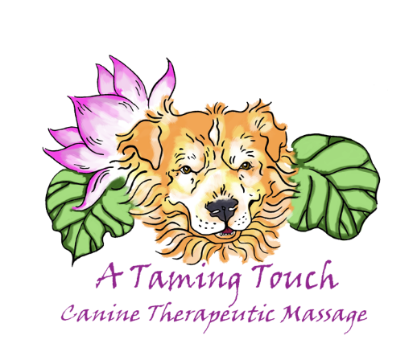

*Photo Release Form for Website & Social Media*

*I, _______________________, give Heather Manfre the Founder of A Taming Touch LLC, permission to take and share photos of my animals:*

1. ________________________(animal name) _____________________(animal species/breed)
2. ________________________(animal name) _____________________(animals species/breed)
3. ________________________(animal name) ______________________(animal species/breed)

Intended to be used on the website ATamingTouch.com, as well as other social media pages used to promote the business and services of A Taming Touch LLC.

Signature of Pet Parent: ____________________________ Date:____________

