Greater Waterbury Area Alumnae Chapter
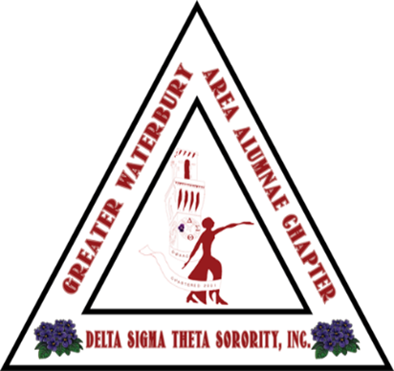
Delta Sigma Theta Sorority, Inc.

January 9, 2026
Dear Scholarship Applicant:
Attached you will find the annual scholarship application for the Greater Waterbury Area Alumnae Chapter of Delta Sigma Theta Sorority, Inc.
We plan to offer a $1, 000 scholarship to a female high school senior of color who will be attending a four-year college or university in the fall. Please take the time to review the entire application and be sure to include all required documents.
Please know that pages #1 and #2 are designed to capture your personal information and page #3 requests information regarding your character and current/future goals. Include any and all information that you think would help us in considering you for this scholarship, including if you have been a participant in one of our youth programs. Please make sure you have completed the annual income section. Financial need will be considered when reviewing your application.
On page #4, you will find the essay question. Your response to this essay should be typed, doubled-spaced in 12-point font. Allot yourself ample time to complete the application in its entirety and allocate time to craft, edit, and revise your essay prior to submission. You may also want to ask one of your English teachers to review your essay as it will be reviewed for flow, content, and grammar.
Please add a photo of yourself to your application.
Lastly, please attach the two letters of reference and high school transcript when submitting your completed application. One of the letters should be from a current educator and the other from your employer or other non-relative. Please be sure to include evidence of your community service provided as list or in a chart. All letters must be addressed to Greater Waterbury Area Alumnae Chapter Scholarship Committee. The completed application, transcripts, and letters of recommendation must be received to the sorority’s email address gwaacscholarship@gmail.com below by Friday, March 13, 2026. All information should be sent in one email. Your application will not be reviewed if all necessary materials are not submitted by the due date. If you have any questions, please contact us at the email address listed below.
Best wishes!
Sharell Herbert & Michane Dansby
GWAAC Scholarship Co-Chairs

