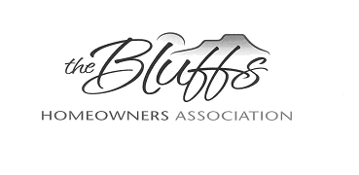

**The Bluffs HOA Board Meeting Minutes**

***Zoom*: September 14, 2021**

Members present: Sally Maddocks, Lynne Stefonik, Vivian Patton, Laura McKee, Lynne Noel, Bill Mager, Andy Gilbert, Imi Mager

Sally called the meeting to order at 6:03 pm. The Minutes were motioned for approval by Sally and Vivian seconded the motion. The Treasurer’s report showed a current balance of $5,291.90.

Two New Member packets have been given to residents on Winding Circle.

Preparations for the Annual Meeting/Barbecue were discussed. Sally explained the agenda for the meeting and Bill presented the arrangements for food and drink, with meat and sides coming from Dickey’s Barbecue. Sally and Nathan will host the event, chairs/tables have been rented, coolers are available, and utensils will be provided. Lynne will send out a reminder to HOA residents.

Lynne will prepare the ballot for the election of officers at the Annual Meeting. She needs names of new volunteers to include on this ballot.

Members of the ACC and CCC Committees will get together to discuss the placement of fences within *The Bluffs* neighborhood. Several concerns have been raised and more research is needed. New construction projects should not be started without consulting the ACC or CCC Committees.

The Bluffs Yard Sale had 12 participants. Usually, there are at least 20 participants. Signs for this event were placed in the neighborhood.

Two cars on Whispering Circle were broken into in the past 2 weeks. Lynne will notify residents of this in the reminder email for the Annual Meeting/Barbecue.

Campers, RV’s, and boats need to be stored and out of the neighborhood by October 1. Residents will be reminded of this at the Annual Meeting.

The meeting was adjourned at 7:30 pm. The next Board Meeting will be on October 12, 2021, at

6:00 pm.