**Minutes for the Bluffs HOA Board Meeting-March 2022**

Members attending: Chris Patton, Vivian Patton, Sally Maddocks, Imi Mager, Lynne Stefonik

Call to Order: 6:00 pm

Minutes: Passed as written. Motion and second by Vivian and Imi.

Agenda from Timeline:

* Audit of checking account and funds?
* Collection of dues payments and late dues letters
* Tax Return
* 2 Welcome Packets given out

CCC Report: A resident on Whispering Ct. applied for a building permit and it was accepted.

ACC Report: Discussion occurred about the importance of making members of the Bluffs HOA more aware of HOA Covenants and rules of the HOA.

Old Business:

1.) When Pr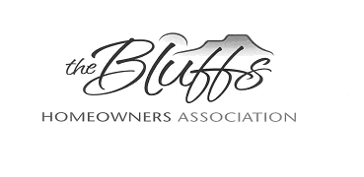esident Sally Maddocks sells her house, Vice President Chris Patton will take over as president of the HOA. Board members discussed other adjustments that will probably have to be made for officers on the HOA Board, so that we are assured of reaching a quorum and have a larger attendance at meetings.

2.) Campers/Trailers not stored after October 1, 2021-Letters?

April Agenda from the Timeline:

* Dues Letters and review of unpaid assessments
* Welcome Packets

Approval of CCC and ACC Actions: All actions of the ACC and CCC Committees were voted on and accepted by the HOA Board.

**Next Board Meeting: April 4, Zoom, 6:00 pm**

Adjournment: 7:00 pm